CHAPTER II
GENERAL DESCRIPTION OF
HOTEL INDONESIA KEMPINSKI JAKARTA
2.1 About Hotel Indonesia Kempinski Jakarta
Hotel Indonesia is the first hotel in Indonesia that was built to international standards. Officially inaugurated by Indonesia’s first president, Sukarno, on 5 August 1962, Hotel Indonesia has become a historic landmark, a national pride. Right in front of the hotel, which is strategically located in the heart of the capital, stands the “Welcome Statue”, intended to welcome the guests who visited Jakarta on the occasion of the 4th Asian Games in 1962.
Hotel Indonesia is a modern and efficient hotel and, at the same time, showed elements of local architecture (West Sumatra) that blended in a nuance of modern Indonesian architecture. After a total refurbishment, commenced in 2004, the historic hotel re-emerged as Hotel Indonesia Kempinski, managed under Kempinski Hotels S.A., the oldest luxury hotel group in Europe, which is synonymous with individualistic luxury in hospitality. Hotel Indonesia Kempinski Jakarta comprises 289 luxurious rooms, six restaurants, multiple venues and five-star facilities and services.
The area around Hotel Indonesia was also developed into a superblock capable of accommodating the main needs of urban communities and is now a multi-use complex under the name Grand Indonesia, which consists of office buildings (Menara BCA and Grand Indonesia Office Tower), apartments and a etc.
Even though it has been renovated, Hotel Indonesia Kempinski still retains its distinctive features, such as the shape and colour of the buildings from Hotel Indonesia. Likewise, historical objects are still kept, such as the scissors used by President Sukarno when cutting the ribbon for the inauguration ceremony of Hotel Indonesia on 5 August 1962, as well as the tableware that was used at the inauguration ceremony.
To provide guests with even more comfort and the highest-quality standards, the hotel has been constantly refurbished and extended in recent years. Refurbishments have included the hotel’s legendary Signatures Restaurant, which is famous for its Indonesian cuisine.
After a major enhancement, Hotel Indonesia Kempinski Jakarta has launched Signatures Restaurant with a new concept, an artistic interior design with a fresh ambiance and an impressive array of food. The newly launched Signatures Restaurant features various food stations, ranging from Indonesian and Asian to Western food, along with spacious interiors and modern traditional decor. Discover the famous “Bubur Ayam Hotel Indonesia” at the all-day dining restaurant that highlights local and international cuisines in the best buffet array. Providing an unbeatable dining experience, this all-day-dining restaurant serves both buffet and à la carte and has a 304 seat capacity, including two private dining rooms, with 36 outdoor seats and a kids play area. The kids area also makes it suitable as a Family Restaurant.
Beside that, Hotel Indonesia Kempinski has managed several restaurant. Such as OKU, the award-wining Japanese fine-dining restaurant and stylish bar in a zen-like ambiance. And Paulaner Brauhaus, that provide you an authentic German cuisine and home-brewed beer. Also Kempi Deli, a take away shop of freshly baked pastries and other deli items. And many more.
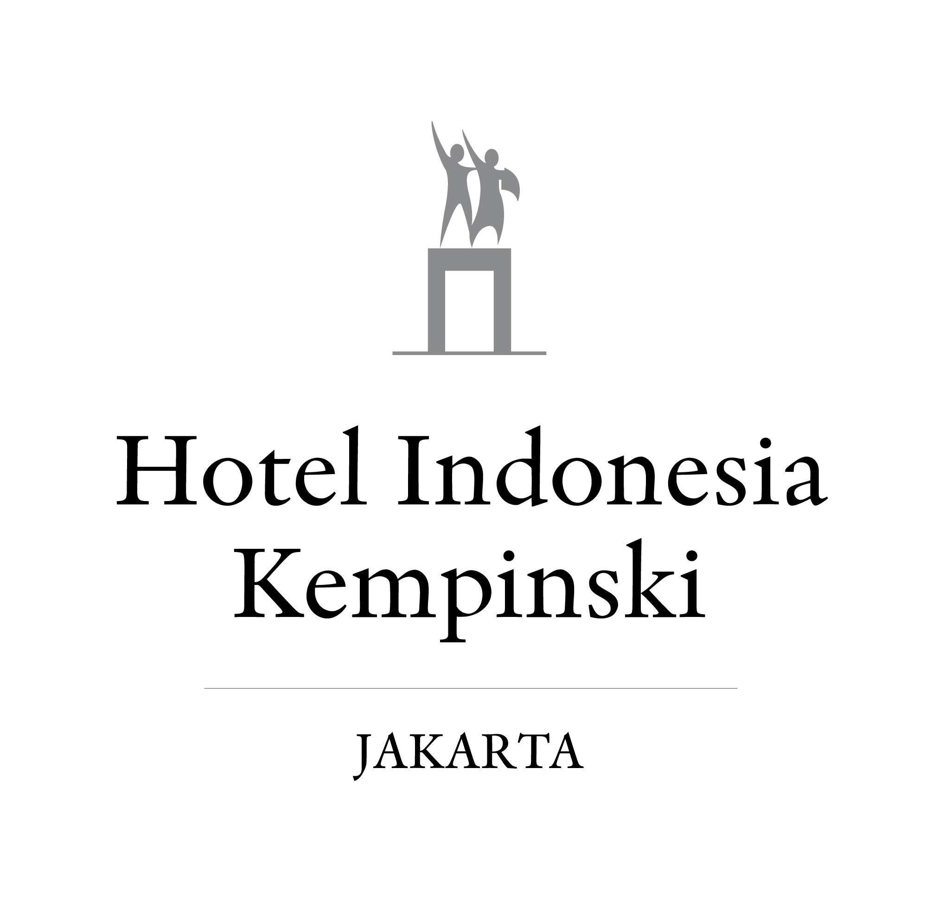

Picture 1. Logo of Hotel Indonesia Kempinski (Kempinski Carrer, 2021)
  - Location & Operational Hours
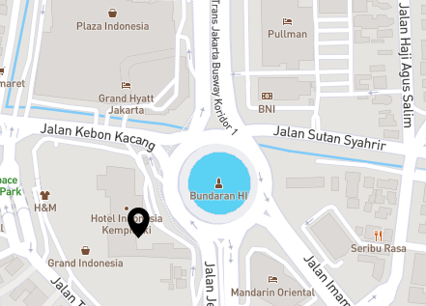
Picture 2. Location of Hotel Indonesia Kempinski (Kempinski,2021)

Hotel Indonesia Kempinski Jakarta (Signatures Restaurant)
Addres : Jl. M.H. Thamrin No. 1, RT. 1/RW. 5, Menteng, Kec. Menteng, Kota Jakarta Pusat, Daerah Khusus Ibukota Jakarta 10310
No. Telp : (021) 23583800
Operational Hours:
Signatures Restaurant:
- Breakfast buffet 06.00 am – 10.30 am
- Lunch buffet 12.00 pm – 15.00 pm
- Dinner buffet 18.00 pm – 22.00 pm
- Ala carte 06.00 am – 10.00 pm

  - Features of Hotel Indonesia Kempinski Jakarta
Hotel Indonesia Kempinski Jakarta has managed several outlet,
- Signatures Restaurant
Satisfied guest with fresh ambiance and a touch of Indonesian embellishment, Signatures Restaurant is ready to serve you a legendary culinary experience. Delight your senses with an extensive buffet spread featuring authentic Indonesian, Asian and Western delicacies. Rich in Indonesian heritage and replete with art and photography celebrating the history of Hotel Indonesia.
Signatures restaurant located at lobby floor of Hotel Indonesia Kempinski Jakarta. The concept of the restaurant is all day dining and served buffet menu. The concept of the kitchen is open kitchen and live cooking for buffet and back of the house kitchen for preparation an ala carte. Signatures kitchen as all day dining kitchen operate 24 hours and serving dishes for outlet:
- Buffet and ala carte at signatures restaurant
- Ala carte in room dining
- Ala carte Nirwana Lounge at lobby floor
- Buffet breakfast Executive Lounge at 7th floor
- Control Sky Pool kitchen operational at 17th floor
Signatures Restaurant have some dishes that highlighted as Signatures Dish such as Bubur Ayam Hotel Indonesia and Nasi Gandul from Pati, Central Java.
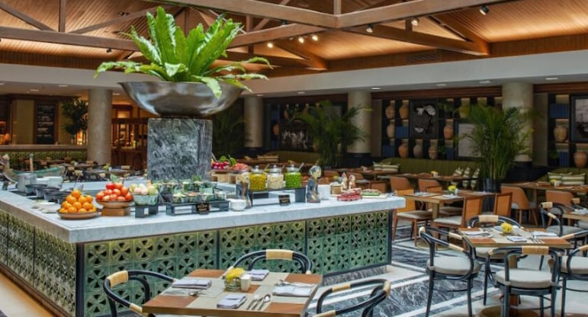
Picture 3. Signatures Restaurant (kempinski,2021)

- Paulaner Brauhaus
Located in Grand Indonesia Shopping Town Thamrin, Paulaner Brauhaus has become the only micro-brewery restaurant in Jakarta. This stellar Bavarian Restaurant is a perfect place for a night out with friends to chat over a beer while watching a game of football and listening to live music. The great classics of the cuisine are all here, including a massive Bavarian Sausage Platter served with a side of creamy mashed potato and finely chopped sauerkraut. There’s also the famous Crispy Pork Knuckle, served with steamy bread dumplings and sauerkraut. Savour some Beef Goulash, a rich beef stew given extra layers of flavours to soak up all that delicious gravy. To top it off, end your meal with the Emperors Pancake, decorated apple compote and caramelized pancakes.
The only microbrewery restaurant in the country, Paulaner Bräuhaus Jakarta is a 200-seat establishment that serves traditional Bavarian food and its famed German beer, which is made only with authentic imported ingredients. The Bräuhaus offers a lounge with city views, nightly live music performances, and screens for major sports broadcasts. Every year, Paulaner also holds the only authentic Oktoberfest in the country.
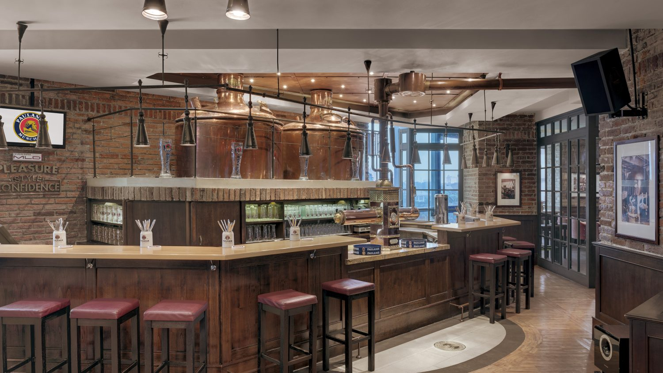
Picture 4. Paulaner Brauhaus (Grand Indonesia, 2021)

- OKU Japanese Restaurant
Japanese premium restaurant OKU at Hotel Indonesia Kempinski Jakarta is helmed by Chef Kazumasa Yazawa. OKU offers a modern take on Japanese dishes combined with traditional flair. Fresh seafood is imported from Toyosu fish Market, Tokyo, twice per week to ensure that the restaurant only serves the freshest and top-notch-quality sashimi, sushi and other seafood-based items.
Its Zen-like atmosphere and laid-back jazzy vibes makes it perfect for business lunches, special-occasion dinners and after-work destinations.
Adjacent to the restaurant, the bar and lounge offers the same laid-back ambiance. It is here that diners head for relaxing pre-dinner cocktails or enjoy a post-dinner drink in a cool, jazzy and Zen-inspired setting. Stocked with a wide array of premium sake, whiskies and other spirits, it’s the perfect place for that post-work pick-me-up or an afternoon sip.
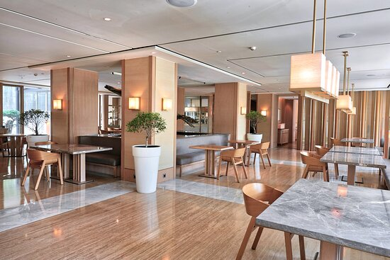
Picture 5. OKU Japanese Restaurant (Kempinski,2021)

- Kempi Deli
Kempi Deli is a fine-food delicatessen that showcases Hotel Indonesia Kempinski’s home-made products, including sausages, cold cuts and up to 30 types of authentic European bread and pastry. The Deli also caters to foodies who like to just “grab and go” or pick the best products to cook at home.
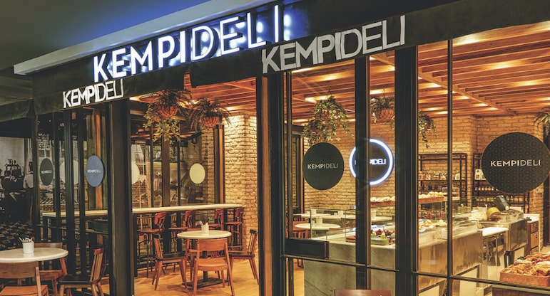
Picture 6. Kempi Deli (Kempinski, 2021)

- Nirwana Lounge
Nirwana Lounge is located in lobby of Hotel Indonesia Kempinski Jakarta. This lounge is a sleek and contemporary space serving daily afternoon teas with sandwiches and freshly baked scones, pastries and cakes. You can also enjoy the legendary “Bubur Ayam Hotel Indonesia” here, or savour their Nasi Goreng Kampung (villager’s fried rice) and some snack selections such as Pisang Goreng (Indonesian banana fritters), Bitterballen or Bakwan (vegetable fritters), as some of the favourite ones. In the evening, unwind with their signature cocktails – The Heritage, East Jakarta, The Journey, and Summer in Jakarta – in a sophisticated ambiance.
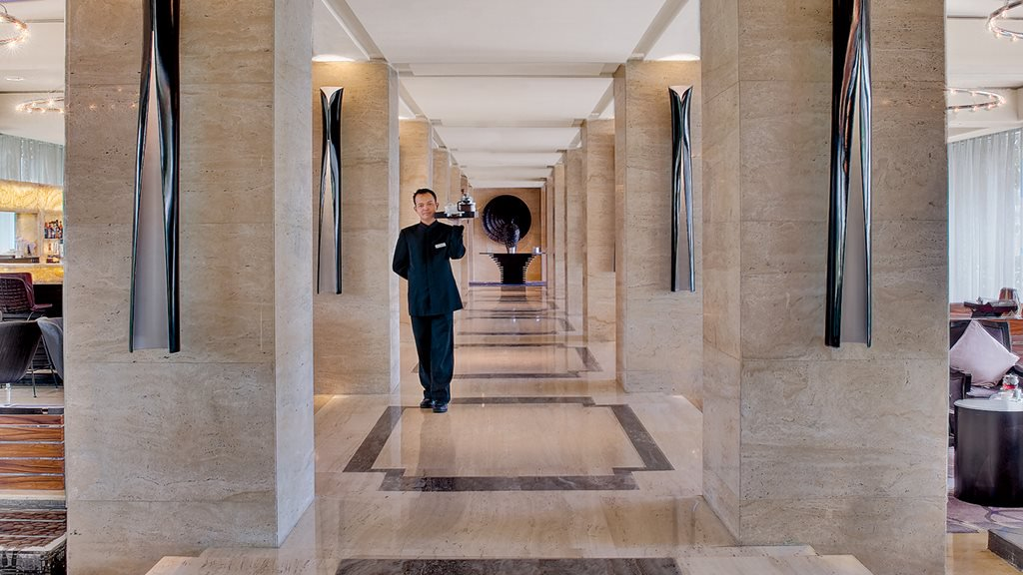
Picture 7. Nirwana Lounge (Kempinski, 2021)

- Sky Pool Bar Café
With exhilarating views of vibrant Jakarta set amid lush botanical gardens, this rooftop, poolside café offers light bites as well as an array of beverages, including a spectacular range of cocktails; Long Island iced teas, mojitos, tequila sunrises, turquoise margaritas and Sky Strawberry Fruits. Or simply have a refreshing glass of our fresh fruit juice to ease your strenuous day.
This is the perfect place to unwind and escape the frenetic pace of the city. The Sky Pool Bar & Café is open daily and its most sought-after date is 14 February for a uniquely intimate dinner date.
Sky Pool Bar Café is open daily and is accessible from the 17th floor of the Ramayana wing of the hotel or from the 11th floor of Kempinski Residence.
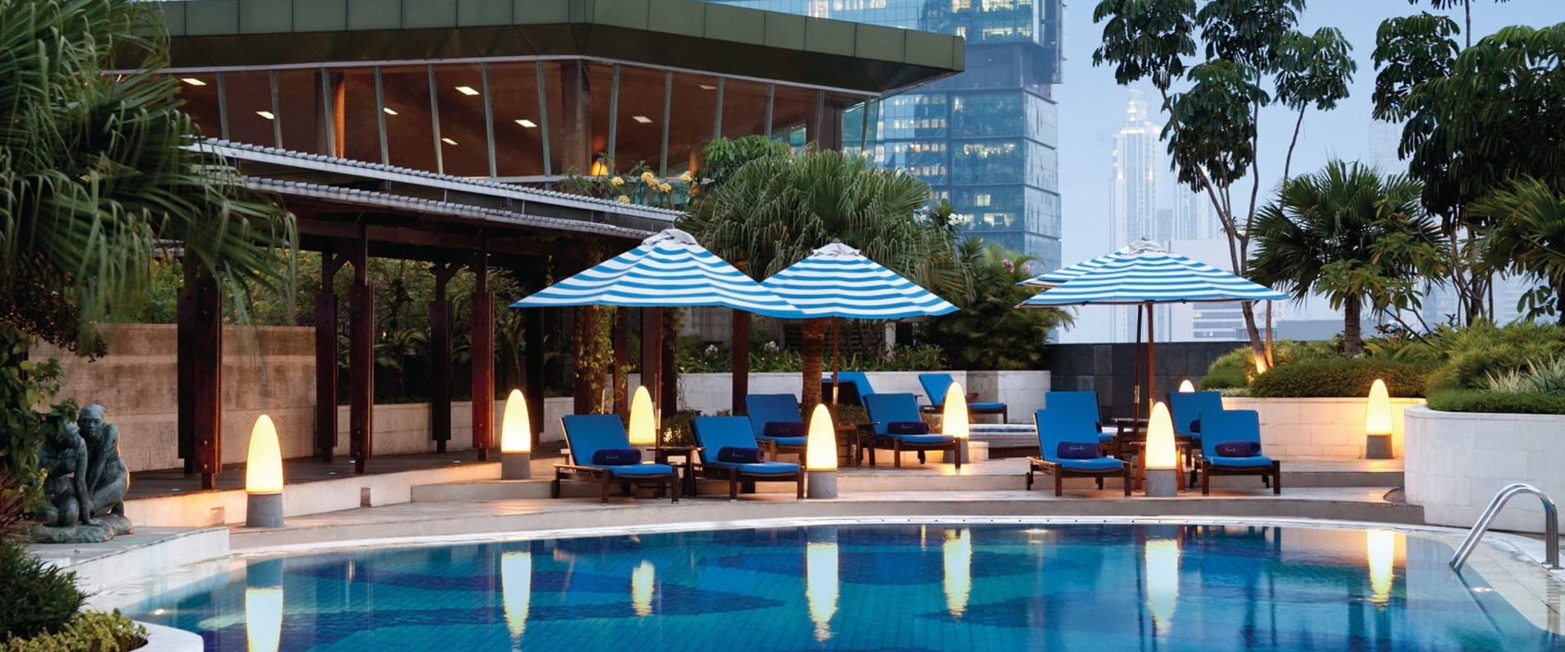
Picture 8. Sky Pool Bar Café (Kempinski, 2021)

- Kempinski Grand Ballroom
Grand Ballroom Hotel Indonesia Kempinski Jakarta, with a capacity of up to 3,000 persons, has a tradition of making history.
This impressive hotel grand ballroom, which has successfully held various corporate activities, meetings, conferences, exhibitions, luxurious wedding receptions and grand events, is one that can cater to all your needs when it comes to a perfect venue for any function.

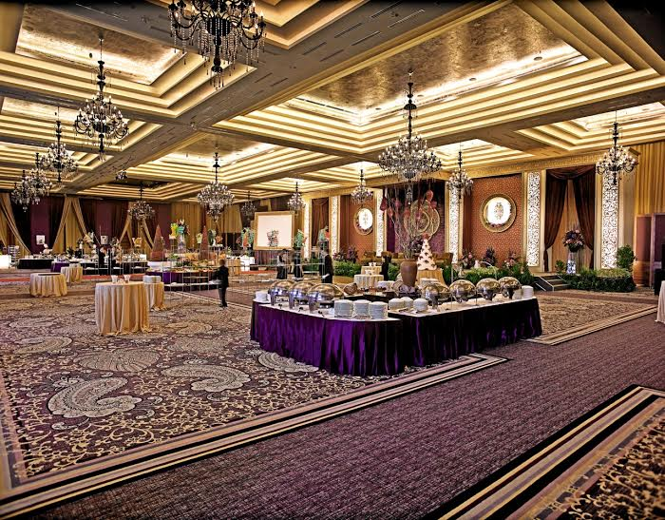
Picture 9. Kempinski Grand Ballroom
(Bridestory,2021)
- Bali Room
The Bali Room is another venue within the hotel for social events and weddings for smaller parties. Formerly used to host state dinners, the historical oval-shaped room is adorned with hand-carved wood panelling on the walls. During its beautiful restoration that started in 2004 by Kempinski, the Bali Room was fitted with colour-changing LED lighting to suit any mood. The only oval-shaped function room in the city, it can comfortably accommodate up to 1,000 people in a cocktail arrangement.
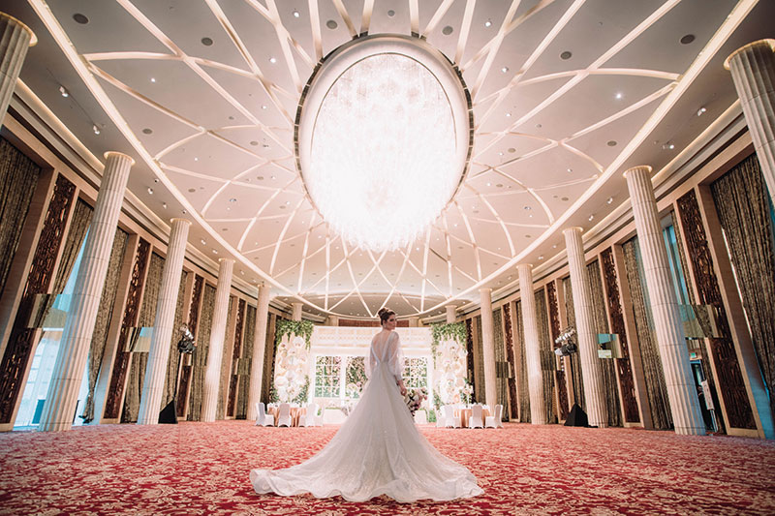
Picture 10. Bali Room (Kempinski,2021)

- Ramayana Terrace
For something more intimate, the Ramayana Terrace is the perfect venue for couples wishing to celebrate their wedding with close friends and family only. Located outdoors and with a tropical garden setting, it features both indoor and outdoor spaces that are packed with Indonesian history. The dome-shaped venue is pillarless with high ceilings that are beautifully adorned with classic artwork from some of Indonesia’s most celebrated artists. Meanwhile, the outer courtyard has amphitheatre-style steps for a unique semi-public space that offers a breath of fresh-air respite from the hustle and bustle of its central city location.
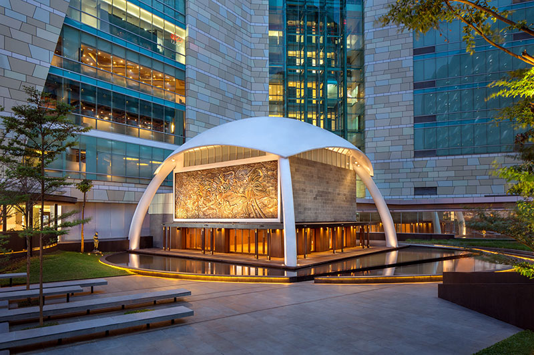
Picture 11. Ramayana Terrace (Kempinski, 2021)

  - Organizational Structure and Main Task
Signatures Restaurant has many section in the kitchen such as Japanese section, Asian section, Western section, Pasta and Pizza station, Cold kitchen. The staff and intern are devided into 2 shift, morning shift and evening shift. 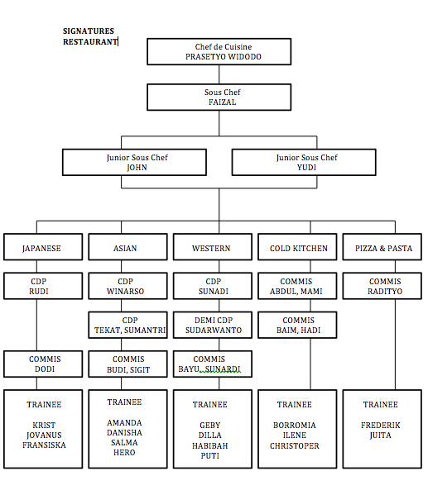
Picture12. Kitchen Organizational (Signatures Restaurant)
(Personal Documentation, 2021)

- Chef Prasetyo Widodo as Chef de Cuisine
- Ensuring that all food meets the highest quality standarts and served on time
- Planning the menu and designing the plating presentation for each dish
- Coordinating kitchen staff and assisting the as required
- Hiring and training staff to prepare and cook all the menu
- Stocktaking ingredients and equipment and placing orders as needed
- Enforcing best practices for safety and sanitation in the kitchen
- Creating new recipes to regularly update the menu
- Keeping track of new trends in the industry
- Incorporating feedback from restaurant staff and patrons to make improvements or resolve issues.

- Chef Faizal as Sous Chef
- Develop new menu options based on trends and customer demand
- Assist with the preparation and planning of meal designs
- Ensure that kitchen activities operate in a timely manner
- Resolve customer problems and concern personally
- Monitor and record inventory
- Provide support to junior kitchen employees with various tasks including line cooking, food preparations and dish plating
- Recruit and train new kitchen employees to meet restaurant and kitchen standarts
- Create schedule for kitchen employees and evaluate their performance

- Chef John and Chef Yudi as Junior Sous Chef
- Ensure consistent and smooth running of food production
- Ensure effective stock purchase, its receipt and storage
- Ensure that working areas are always kept clean
- Assist other kitchen staff as need arises
- Supervise performance of kitchen staff to ensure proper activity
- Ensure that required standards are adhered to in the production and preparation of food – in quality, quantity and safety
- Ensure all complaints, inquiries, and suggestions by customers are attended to accordingly
- Ensure all dishes are prepared according to specification and served at the correct quality, portion size, and temperature
- Partly responsible for the preparation of kitchen cleaning rosters and the supervision of cleaning schedules
- Monitor the quality and quantity of food prepared
- Assist in recruiting, hiring, and training employee cooks
- Report the need for maintenance to appropriate staff

- Japanese section staff
- Responsible for sushi, sashimi, and Japanese hot item for buffet and ala carte
- Inspecting the quality of ingredients used to prepare sushi and japanes dishes
- Prepafing various type of sushi and Japanese dishes according to established guidelines on quality, portion size, presentation, and food safety
- Maintaining a clean work environment in order to prevent food contaminating
- Regularly taking inventory of food supplies and other products

- Asian section staff
- Responsible for preparation and cooking Indonesian and Asian dishes for buffet and ala carte
- Ensure the highest standards and consistent quality in the daily preparation and keep up to date with the new Indonesian and Asian recipes and preparation techniques
- Update menu recipe cards and menu planning for promotions
- Coordinate and participate with other sections of requirements, cleanliness, wastage and cost control
- Constantly be alert on freshness, presentations and temperature of food served in restaurants or functions

- Western section staff
- Responsible for preparation and cooking western dishes for buffet and ala carte
- Prepare ingredients to use in cooking (chopping and peeling vegetables, cutting meat etc.).
- Ensure great presentation by garnishing dishes before they are served.
- Keep a sanitized and orderly environment in the kitchen and ensure all food and other items are stored properly.
- Check quality of ingredients and monitor stock and place orders when there are shortages
- Seasons food according to recipes or company need
- Ensure compliance with all health and safety regulations within the kitchen area

- Cold Kitchen section staff
- Responsible for preparation appetizer, salad, sandwich and other cold dishes for buffet and ala carte
- Keep work area at all times in hygienic conditions according to the rules set by the hotel
- Control food stock and food cost in your section
- Prepare the daily mis-en-place and food production in different sections of the main kitchen or satellites
- Follow the instructions and recommendations from the immediate Superiors to complete the daily tasks
- Ensure the highest standards and consistent quality in the daily preparation and keep up to date with the new products, recipes and preparation techniques

- Pizza and Pasta section staff
- Responsible for mise en place and cooking pizza and pasta for buffet and ala carte
- Setting up, cleaning, and organizing work stations
- Preparing ingredients for the shift; prepare pizza and pasta ingedients, prepare pizza dough, etc.
- Sanitizing and cleaning work stations and utensils
- Assisting other cooks in preparing food or helping other team members when needed

- Trainee
- Preparing meals as ordered;
- Responsible for the preparation of all food items ensuring a high standard of taste, temperature and preparation;
- Assists in the preparation of several parts of a major meal by mixing and stirring, ladling, adjusting heat, etc.;
- Prepares breakfasts on an independent basis by cooking eggs and meat, and preparing cereals, coffee and similar items;
- Performs other related work as required;
- Prepares mise-en-place for next day;
- Assists with another station as assigned by the Chef de Partie;
- Collects store items as required from the main kitchen;
- Cleans and maintains kitchen equipment and reports any repair or maintenance needed.

