BIBLIOGRAPHY

Anonymous. 2021. “Java Paragon Hotel And Residences”. https://www.javaparagon.com/ . 24th November 2021.

Anonymous. 2016. “Visi Misi Java Paragon Surabaya”. https://dewey.petra.ac.id/repository/jiunkpe/jiunkpe/s1/hotl/2016/jiunkpe-is-s1-2016-33411002-36375-bauran-chapter4.pdf . 24th November 2021.

Minantyo, Hari. 2011. “Dasar-Dasar Pengolahan Makanan (Food Product Fundamental)”. Yogyakarta : Graha Ilmu.

APPENDIX
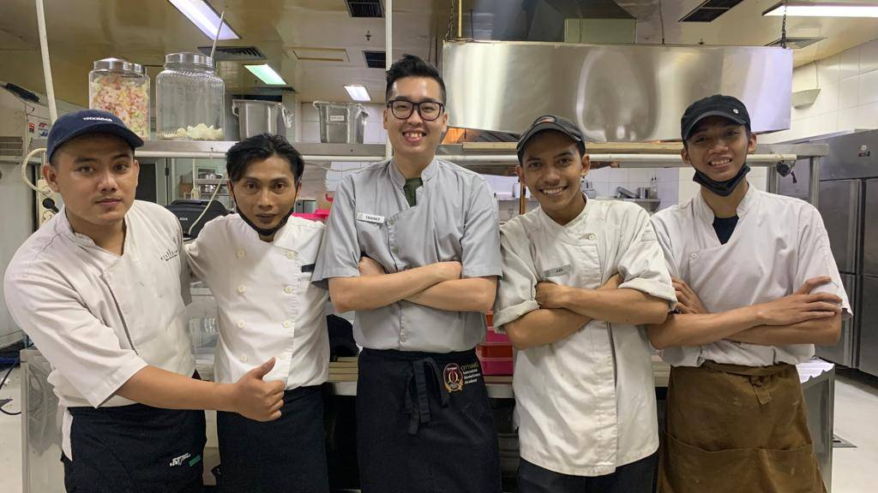
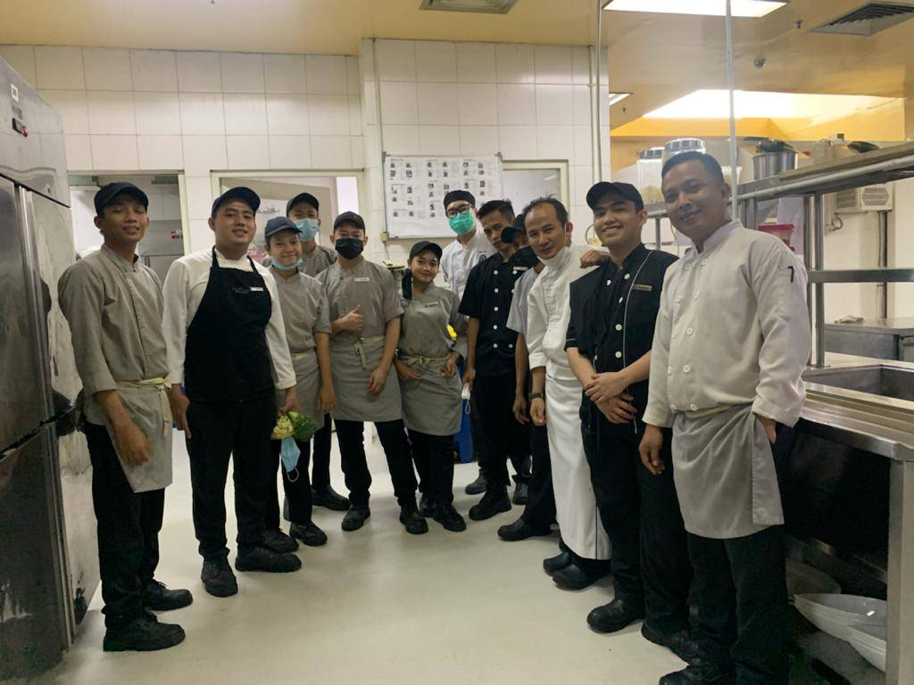
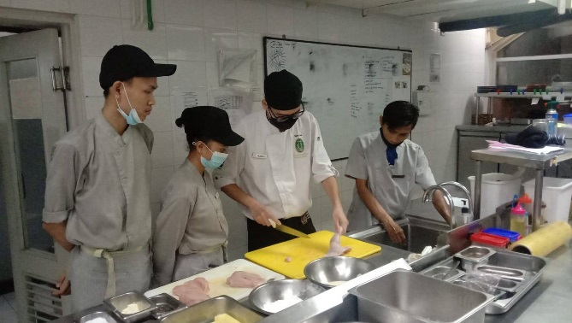

Picture 4. Author and the staff

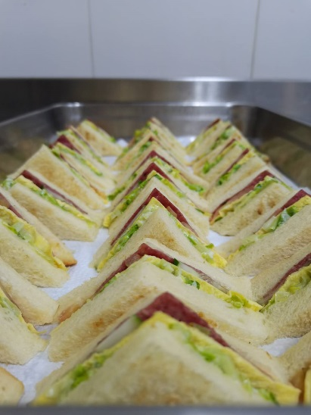
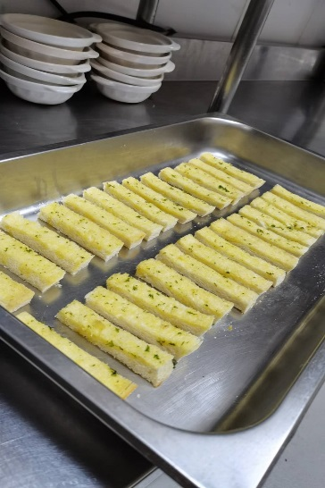
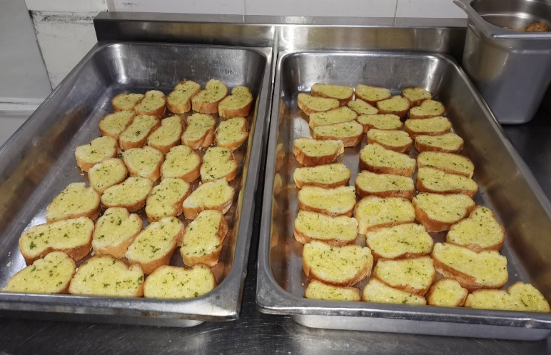

Picture 5. Sandwich, Crouton, Garlic Bread

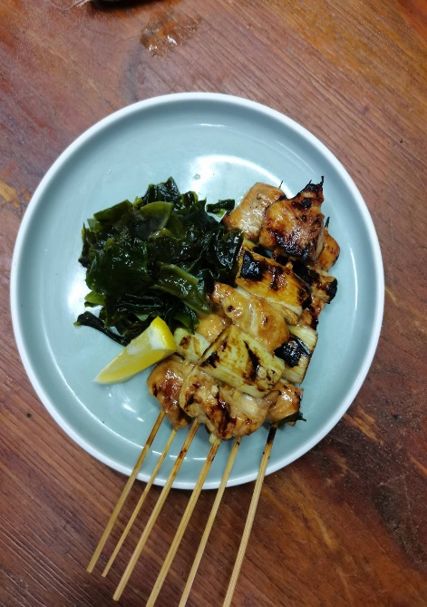
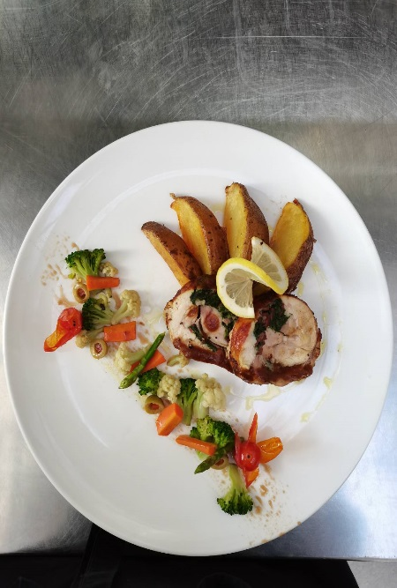
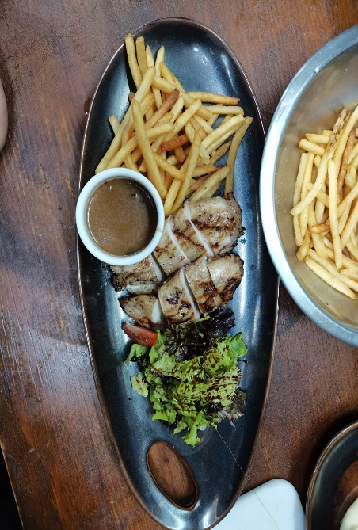

Picture 6. Chicken Yakitori, Stuffing Chicken and Vegetables, Chicken Double Breast

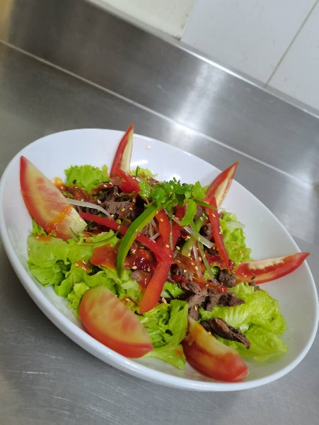
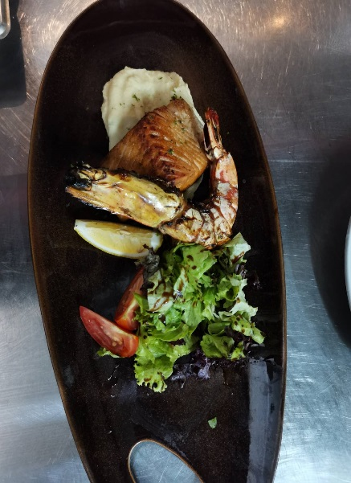
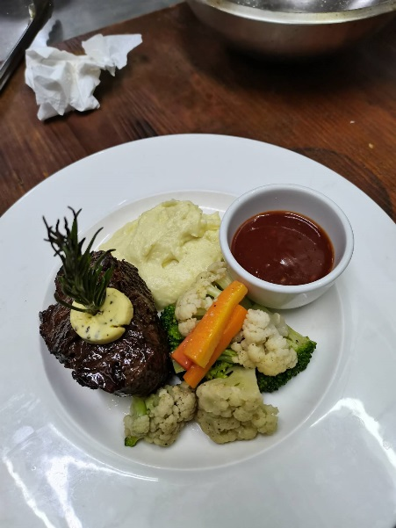

Picture 7. Thai Beef Salad, King Prawn Salmon Trout, Beef Tenderloin with Black Pepper Sauce

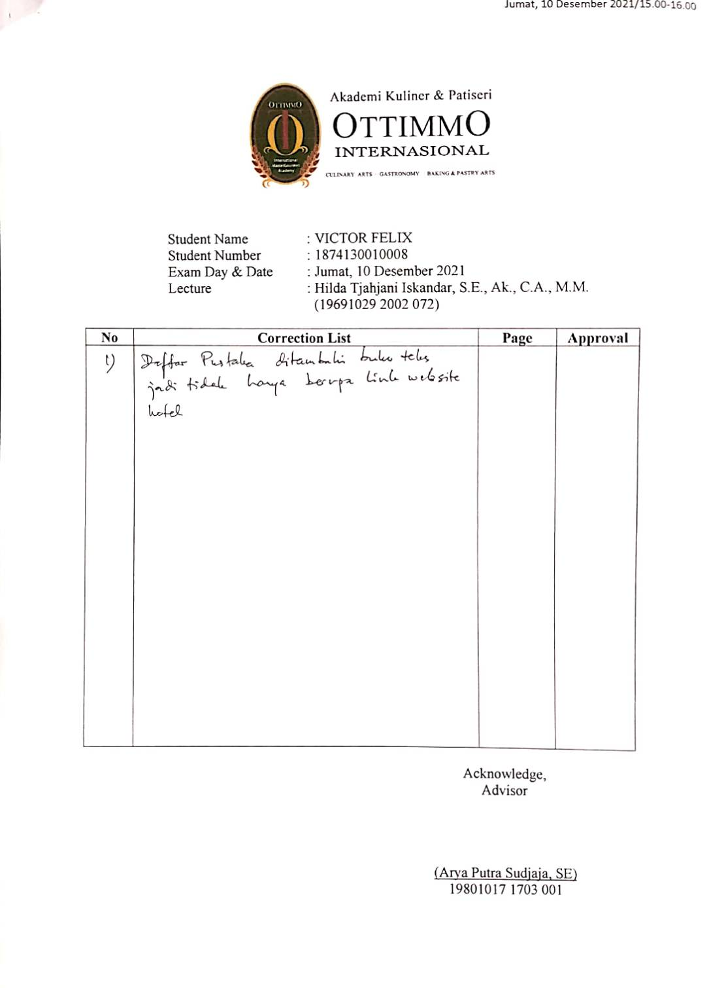
REVISE FORM

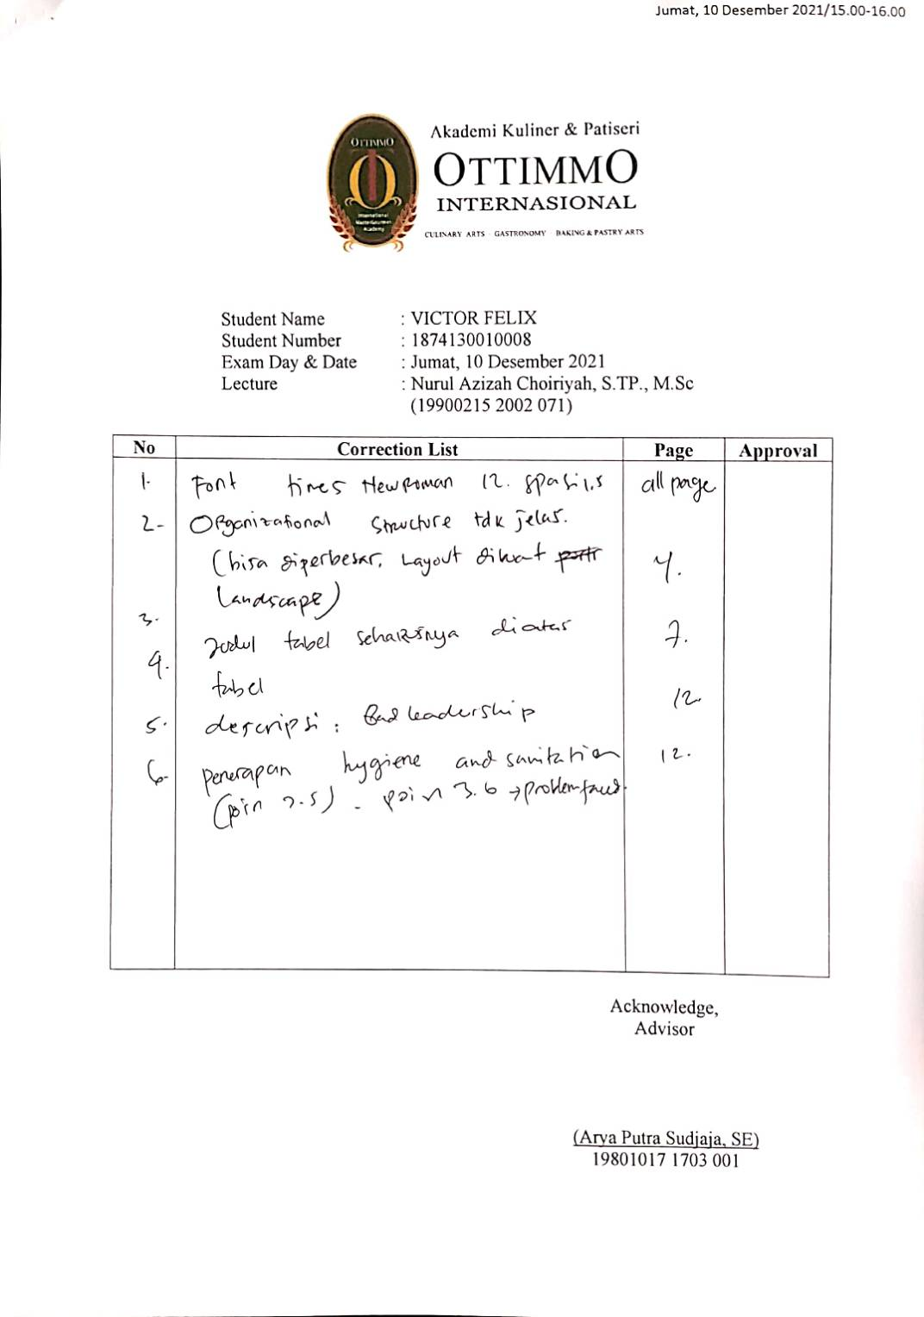

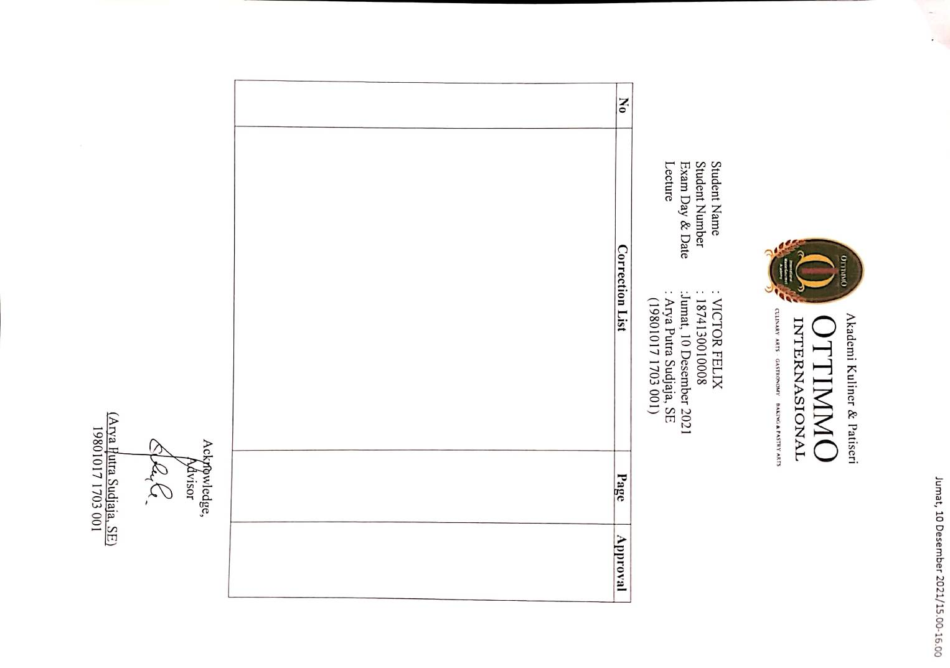

INTERNSHIP CERTIFICATE
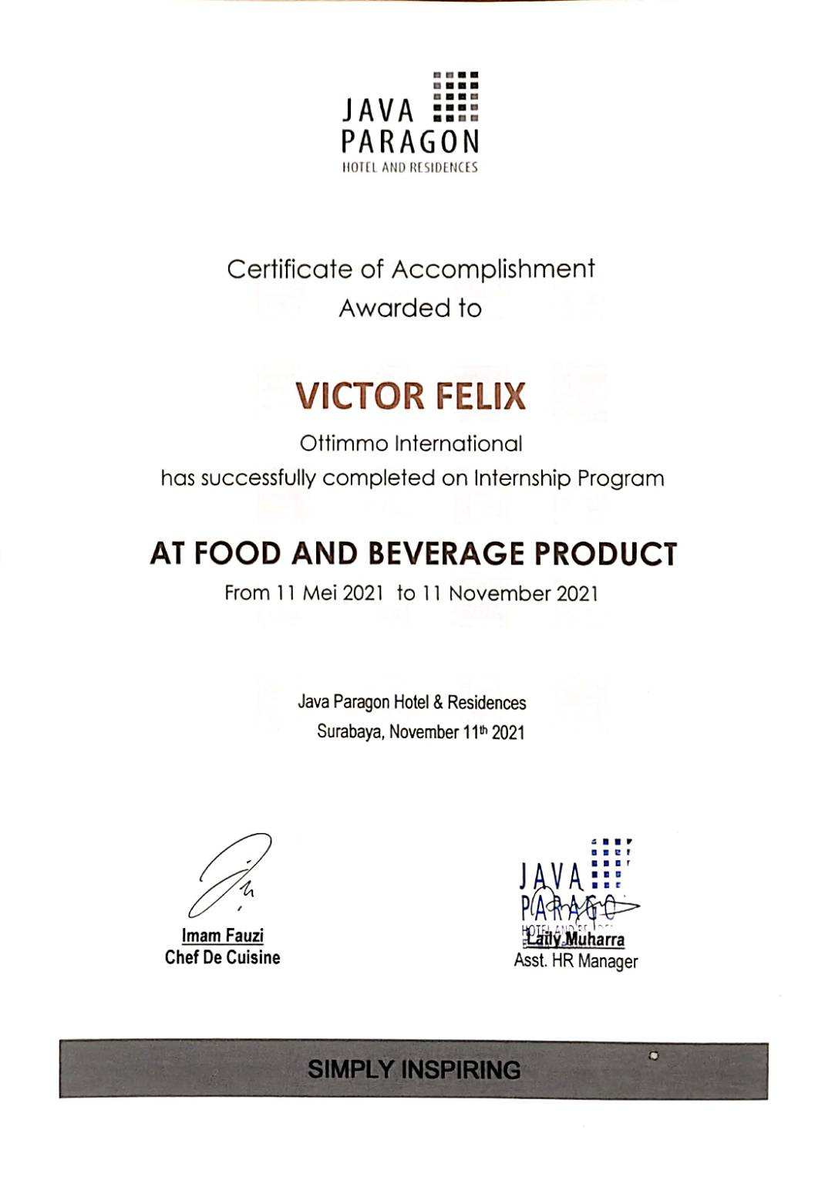

INTERNSHIP APPRAISAL FORM

- Internship Appraisal Form Java Paragon Hotel and Residences
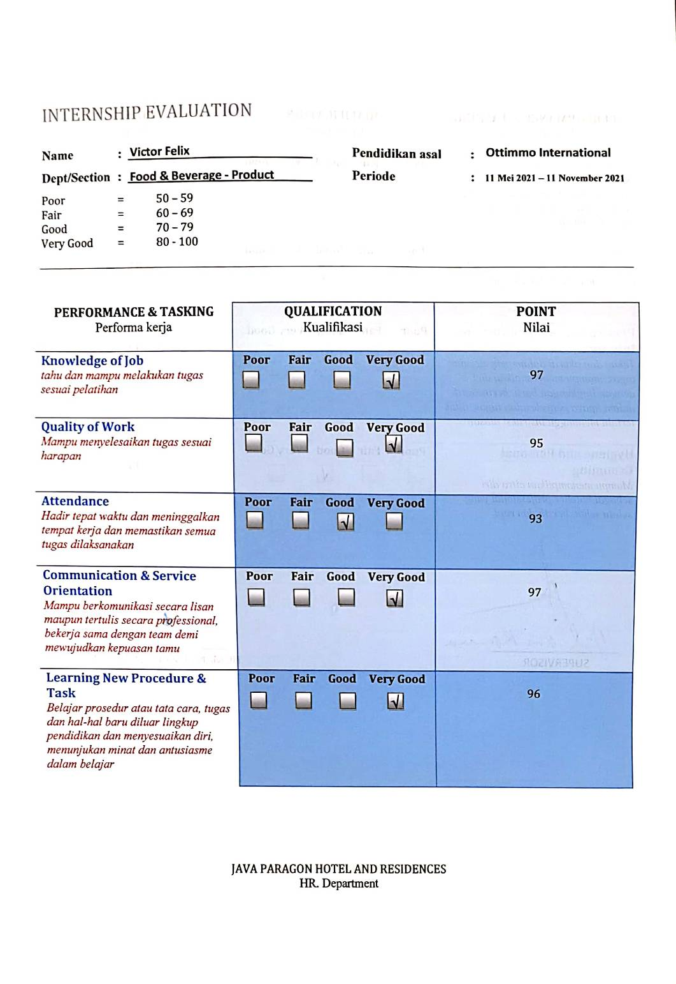

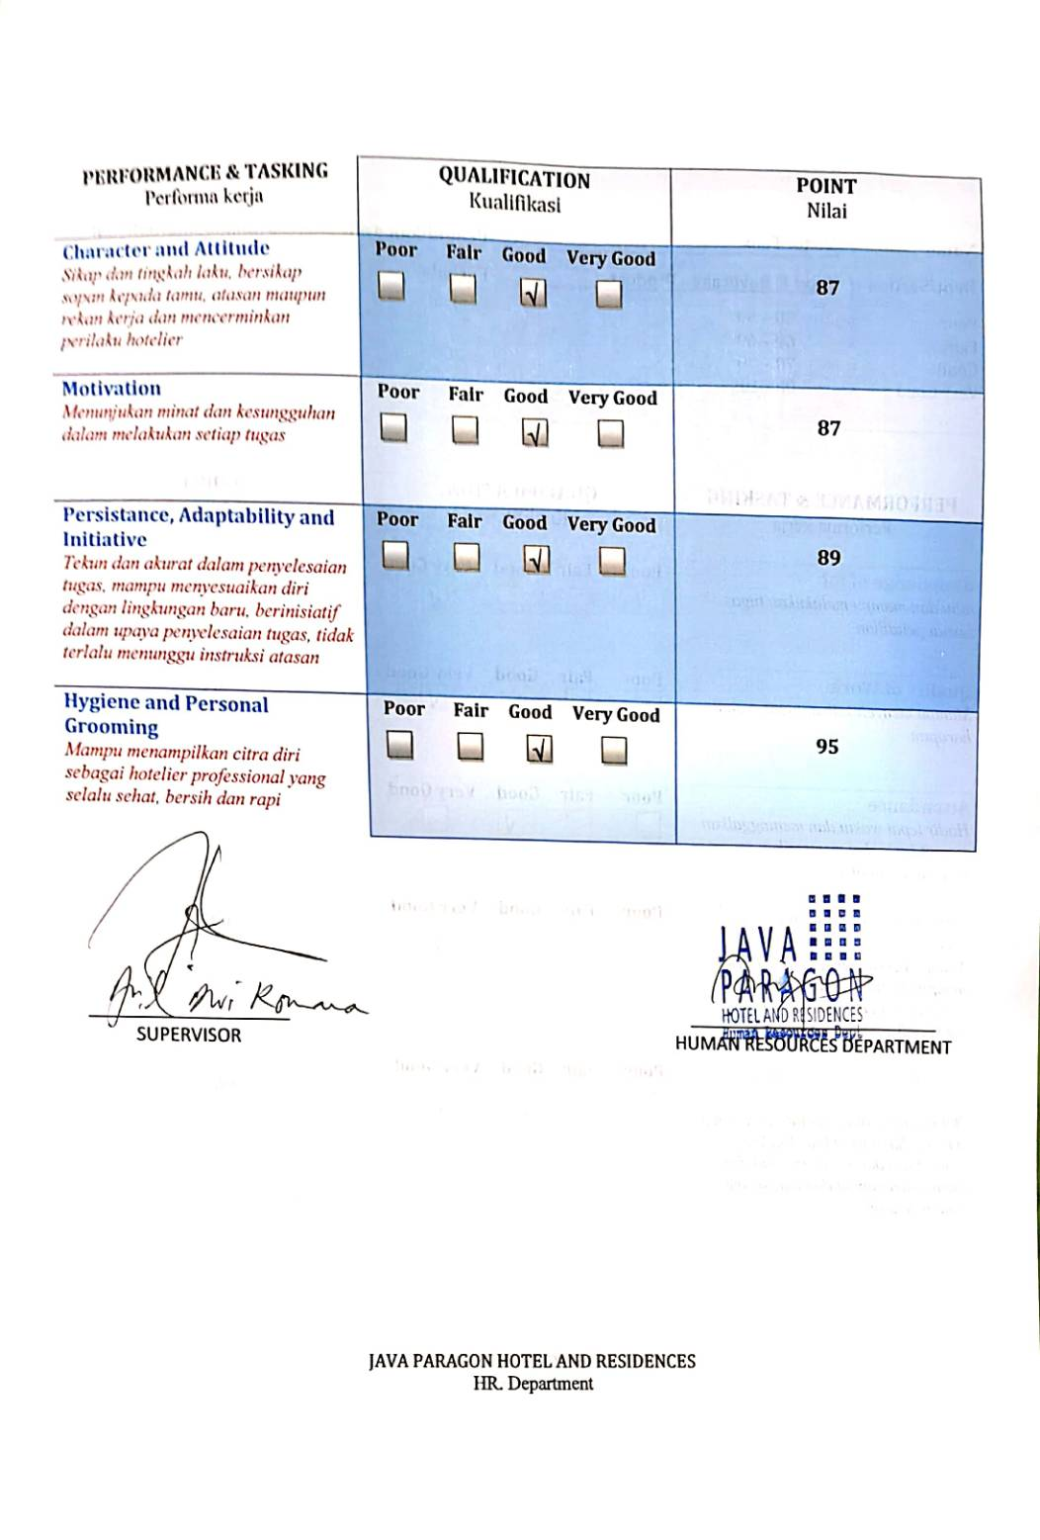

- Internship Appraisal Form Ottimmo International

