CHAPTER II
GENERAL DESCRIPTION OF COMPANY

  - HISTORY OF COMPANY
It is start in 1993 when PT. Bhakti Intiland build a Paragon Apartments. Paragon Apartments consist of 2 towers, which each has 18 floors. The company sees that the hospitality business market in Surabaya has better prospects because the market demand for room is more than apartment. Therefore, PT. Bhakti Intiland renovated a tower which is located at the back into a hotel. This renovation was accompanied by the change of the name “Apartment Paragon” become “Java Paragon Hotel and Residences”. Java Paragon Hotel & Residences was found on 8 August 2008, is a four-star business hotel that carries a new modern minimalist concept. Java Paragon Hotel & Residences has 230 bedrooms and 62 unit apartments.

  - VISION, MISSION, AND COMPANY OBJECTIVES.
2.2.1 Vision
Java Paragon Hotel & Residences vision is “to provide a service which is warm, unique, with a strong emphasis on staff”. Other than that, Java Paragon make sure that their employee well trained by giving them Hospitality Training.
2.2.2 Mission
Java Paragon Mission is “to be number one business hotel in Surabaya”. This mission show us that Java Paragon want to be the biggest business hotel in Surabaya.
2.2.3 Company Objectives
Java Paragon has a company objective which is “to be one of the most classic and iconic hotel in Surabaya”. That is why Java Paragon still keep maintaining their appearance that way as the first as they first appearance.

  - Organizational structure and main task

Table 1. Organization Structure
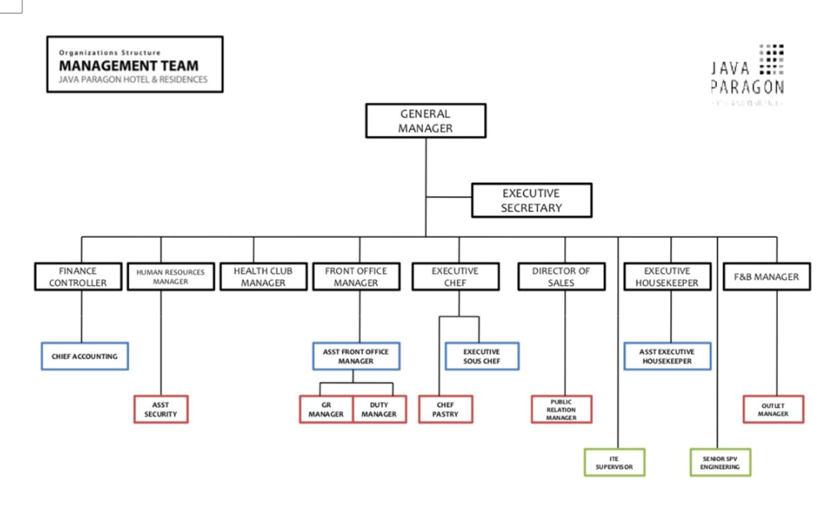

- General Manager
The General Manager of the Hotel is the person who is responsible for all operations and controls all quality related to service, finance, housekeeping, decoration, interior, food as well as setting norms that must be followed by all staff in providing services to guests. The General Manager's duties include Inspecting hotel purchasing and bookkeeping activities, supervising the selection of human resources and training hotel staff, Determining the making of the operational budget and hotel procurement, Assessing and checking team satisfaction.
- Executive Secretary
The Executive Secretary is tasked with providing administrative assistance to upper-level management by making statistical reports, handling requests for information, conducting research, collecting data and preparing papers for consideration and presentations.
- Finance Controller
The Finance Controller provides contributions and analyzes related to the company's budget and finances so that they can be managed properly and with the right techniques also have the task of monitoring and evaluating monthly financial reports, designing, coordinating and evaluating administrative finance policies, reviewing the company's work realization on a regular basis or routinely, evaluate the company's monthly plans.
- Chief Accounting
Assigned to oversee the implementation of administration and accounting carried out by accountant staff, starting from the process of collecting and sorting proof of transactions, calculations, to inputting data into the system in accordance with procedures that have been made by the company.
- Human Resources Manager
HRD is tasked with preparing and selecting workers, starting from preparation which includes internal and external factors, recruitment of workers, and selection of workers. HRD is in charge of employee development and evaluation. So that every employee can contribute optimally to the company or organization, he must master the work that is his duty and responsibility.
- Health Club Manager
Each Health Club Manager is responsible for 4 areas: membership sales, health club operations, fitness management and group exercise. They are responsible for achieving the target every month and contributing to the development of the company.
- Front Office Manager
A Front Office Manager (FOM) is the number 1 person in the FO Department and has the main task of directing direct supervision of all subordinates and to ensure that day-to-day operations at the front office run properly and safely, Handle guest complaints quickly, efficiently and fully friendliness, obtaining updated data from guests who come in groups, establishing good relations with travel agents, checking and re-examining reports and budget allocations that have been set.
- Executive Chef
Executive chef is the highest champion in the kitchen department who has full authority in maintaining the stability of the work and tasks in accordance with operational standards that have been set by the company or hotel itself.
- Director of Sales
Marketing and Sales Director is a person (official) who plans business activities, determines prices, promotes and distributes hotel products that can meet the needs and desires of consumers in order to achieve sales targets and develop markets effectively and efficiently. Tasks The following are the duties of a Marketing in a hotel, 1. Determine the selling price, the product (service) to be launched, the visit schedule and the promotion system to ensure the achievement of the target. 2. Monitor the acquisition of orders or requests and summarize forecasts to ensure that the target demand can be met optimally.
- Executive Housekeeper
Executive Housekeeper is the highest part contained in the organizational chart where the main task of Executive Housekeeping is in charge of all housekeeping operations at the hotel which is fully responsible for coordinating the full housekeeping department with other departments, especially the hotel front office, supervising, supervising the employees. Employees, work planning, work equipment, as well as controlling daily operations in housekeeping so that it can run smoothly.
- F&B Manager
Food and Beverage Manager. An F&B Manager is responsible for managing human resource management, overseeing the work of other F&B positions, and ensuring the profit of the department he leads.
- Assistant Security
Assistant security has duties including making operational planning and site security systems, preparing annual, monthly and weekly work plans, making operational schedules for all location security and control, making plans for development / modification / upgrading & improvement of security systems and placement of members, planning human resources in supporting operations environmental security and order, Planning the management of funds needed to support their duties, Carrying out operational organization.

