INDUSTRIAL TRAINING REPORT
INTERNSHIP AT JAVA PARAGON

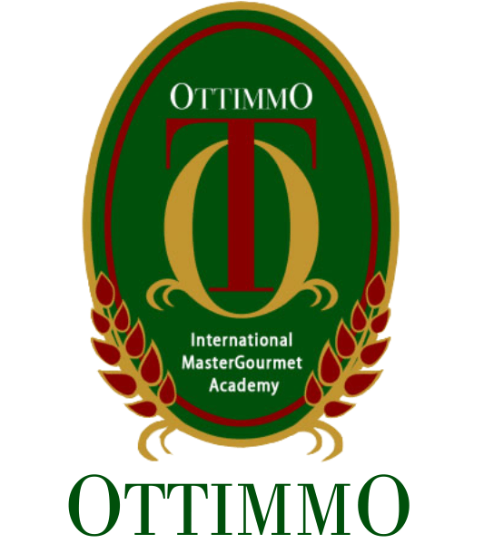

By
Victor Felix
1874130010008

CULINARY ARTS PROGRAM STUDY
OTTIMMO INTERNATIONAL MASTERGOURMET ACADEMY SURABAYA
2021

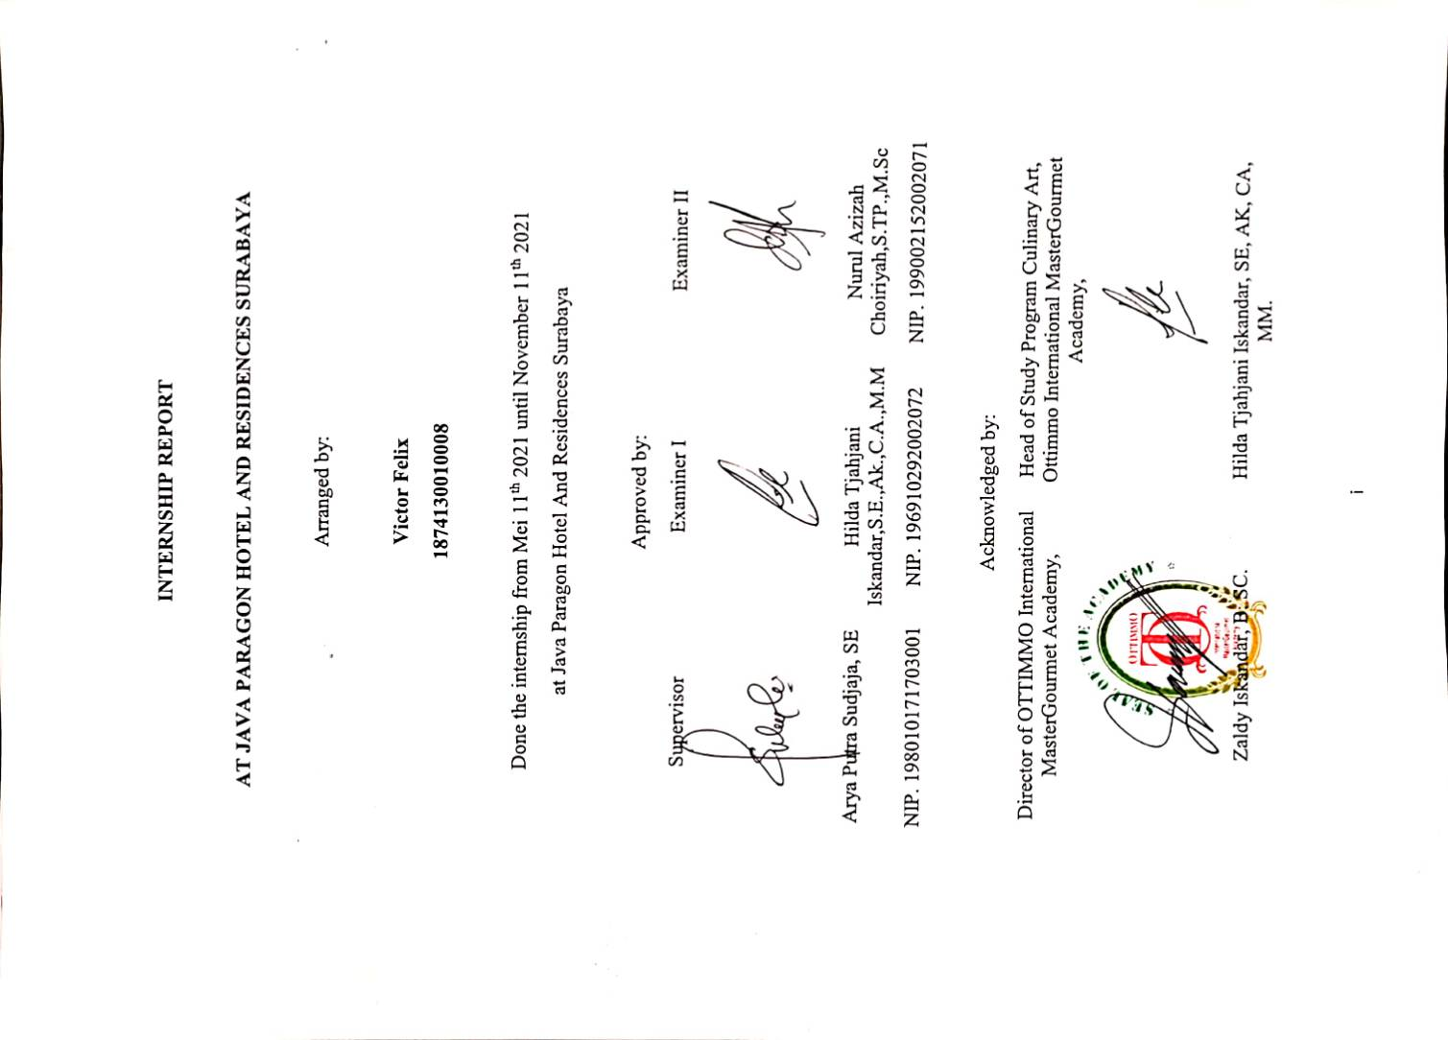

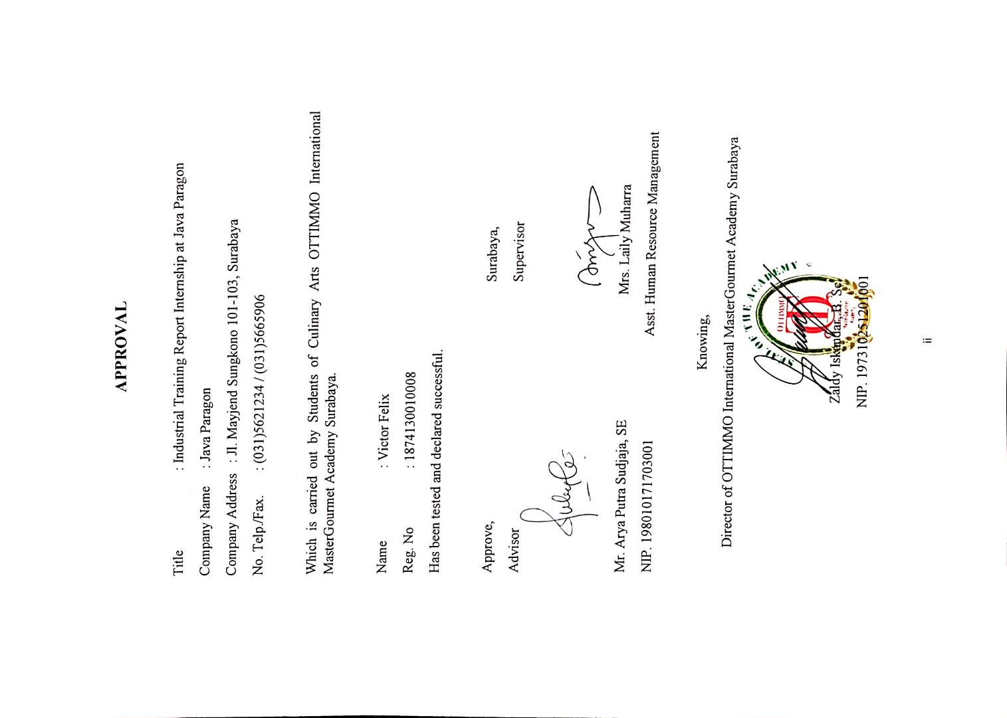

ACKNOWLEDGMENT

Praise and thanks to God Almighty for the successful completion of this report. This report is prepared based on industrial training result conducted by the Authors during 6 months in Java Paragon. This report is prepared as one of the requirements to complete the Diploma III of Culinary Arts.
In the process of completion of this report, the Author has received much guidance and assistance from various parties. To that end, the author express their sincere thanks to:
- My parents who have supported and provided me to achieve good education and as a family role to help me in personally.
- Mr. Arya Putra as Advisor who has guided, provide guidance and suggestion until the completion of this report.
- Mrs. Laily Muharra who has given the place of industrial training implementation.
- Mrs. Hilda Tjahjani Iskandar, S.E., M.M as Head of the Culinary Arts Programme.
- Mr. Zaldy Iskandar, B. Sc. as Director of OTTIMMO International MasterGourmet Academy Surabaya.
- Mr. Aril Dwi Romana as Sous Chef in Java Paragon Hotel and Residences.
- Mr. Satriyo Priyo Utomo as Chef de Partie in Java Paragon Hotel and Residences.
Finally, the Author hope that this report can be useful for us all.

Surabaya, 20 November 2021

Victor Felix

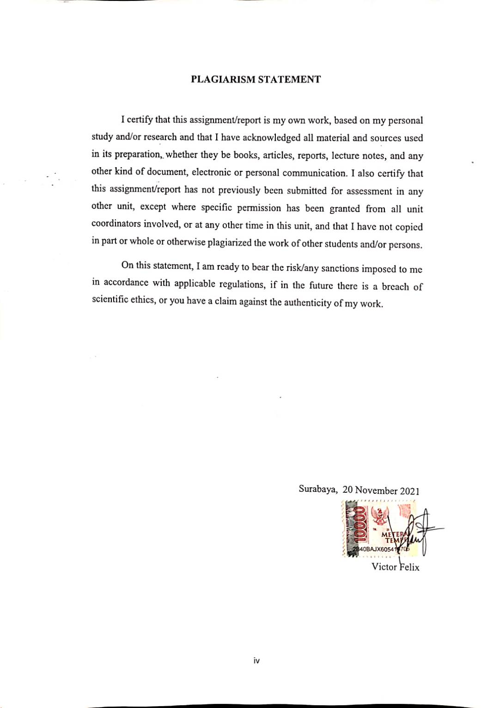

TABLE OF CONTENT

HARD COVER ………………………….………………………………….…... 0
TITLE ………………………….………………………………………………... 0
APPROVAL I ………………………...………………………………… ……... i
APPROVAL II …………………………...……………………………………... ii
ACKNOWLEDGMENT ………………………………………………………. iii
PLAGIARISM STATEMENT ………………………………………………... iv
TABLE OF CONTENT ………………………………………………………... v
LIST OF TABLES ……………………………………………………………... vi
LIST OF PICTURES ………………………………………...………………... vii
EXECUTIVE SUMMARY …………………………………………………... viii
CHAPTER 1 INTRODUCTION ……….………………………….…………... 1
  - Background of Study ………………………………………… 1
  - Industrial Training Objectives ………………………………... 1
  - The Benefits of Industrial Training …………………………... 2
CHAPTER 2 GENERAL DESCRIPTION OF COMPANY …….….……….. 3
  - History of Company ………………………………………….. 3
  - Vision, Mission, and Core Values …………………………… 3
  - Organizational Structure and Main Task …………………….. 5
CHAPTER 3 INDUSTRIAL TRAINING ACTIVITIES …………...………... 9
  - Place of Assignment ………………………………………….. 9
  - Activities Performed ………………………………………..... 9
  - Job Description Based On Workmanship ………………….... 10
  - Internship Product ………...………………………………… 13
  - Hygiene And Sanitation Application …….………………….. 15
  - Problem Faced And How To Solve Them …………………... 15
CHAPTER 4 CONCLUSION ………………………………………………… 17

  - Conclusion ………………………………………………….. 17
  - Suggestion …………………………………………………... 17
BIBLIOGRAPHY ……………………………………………………………... 19
APPENDIX …………………………………………………………………….. 20

LIST OF TABLES

Table 1. Organization Structure ………………………………………………….. 5
Table 2. Job Description ………………………………………………………… 10

LIST OF PICTURES

Picture 1. Oxtail Soup ………………...……………….………........................... 13
Picture 2. Chicken Yakitori ………………………………..……………………. 14
Picture 3. Thai Beef Salad ……..……………………………………………….. 14
Picture 4. Author and the staff……………………………………....…………… 20
Picture 5. Sandwich, Crouton, Garlic Bread ………………………..…………… 21
Picture 6. Chicken Yakitori, Stuffing Chicken and Vegetables, Chicken Double Breast ……………………………………………..………………… 21
Picture 7. Thai Beef Salad, King Prawn Salmon Trout, Beef Tenderloin with Black Pepper Sauce ………………………………………………………… 22

EXECUTIVE SUMMARY

The main purpose of this industrial report is one of the requirement from Ottimo International MasterGourmet Academy Surabaya for all the student must do in order for them to achieve graduation, where this report is done by the author based on his experience or activities during the internship which is start from Mei 11th, 2021 until November 13th, 2021 at Java Paragon.
Java Paragon Hotel and Residences has given the author a lot of experience in the hospitality sector, especially in the culinary by placing the author in three different departments, namely hot/main kitchen, Citilites Sky Club and Resto, and Garde Manger.
During the internship, the author experienced quite a number of challenges. Where it does not only come from guests but also from staff who are not supportive of trainees. So it forces the author to find a solution to deal with staff like that by remaining calm, being professional and not taking it personally of what the staff does or says.
This internship has built the author's skills, character and mentality. Where during this internship the author met with various kinds of problems and faced with many characters of people who made the author experience a lot of development and knowledge to be prepared in the real world of professional work which is very helpful for the author in the future.

