BIBLIOGRAPHY

Anonymous. 2021. “Marriott International Foundation & Growth Story”. https://hotel-development.marriott.com/our-story/ . 14th October 2021.
Bill Marriott J. W. and Kathi Ann Brown. 2012. Without Reservations: How a Family Root Beer Stand Grew Into a Global Hotel Company. San Diego: Luxury Custom Publishing.
Parker, B. 2020. “Marriott: Vision Mission Core Value 2021 (A Complete Analysis)”. https://bstrategyhub.com/marriott-vision-mission-core-values-2019-a- complete-analysis/ . 14th October 2021.
Wikipedia. 2021. “Four Points by Sheraton”. https://en.wikipedia.org/wiki/Four_Points_by_Sheraton . 14th October 2021.

APPENDIX

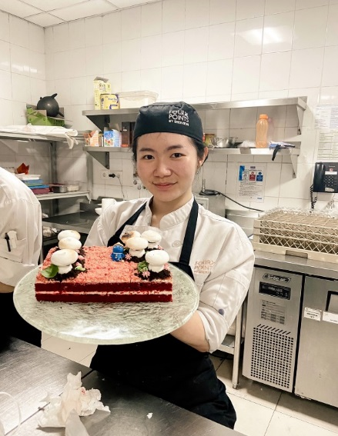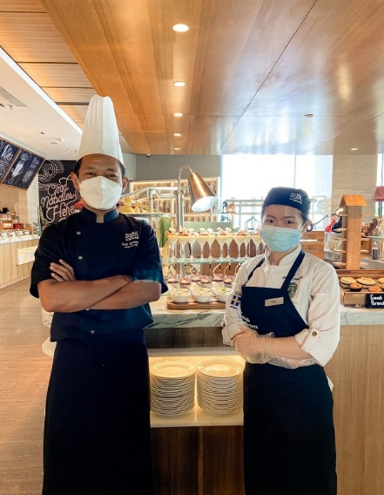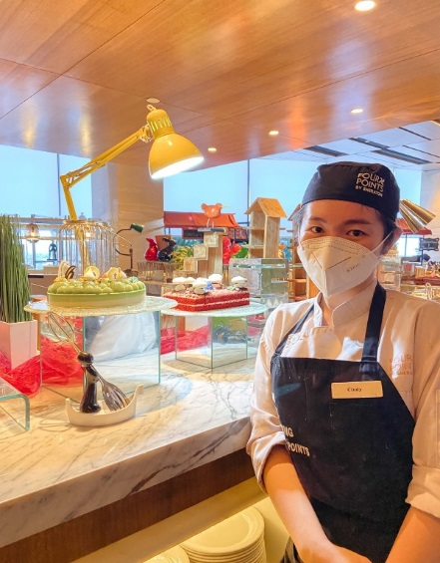
Picture 6. Author and The Head Chef
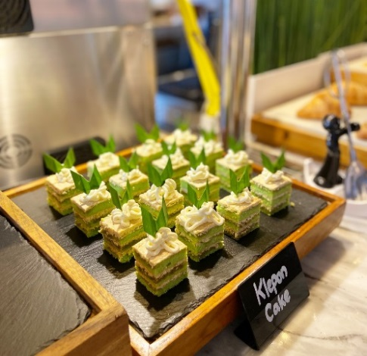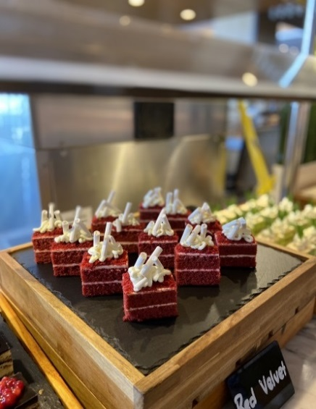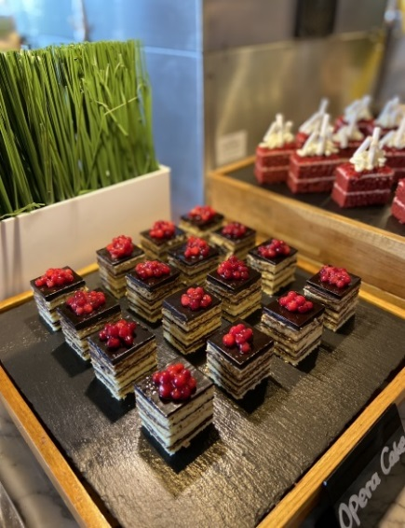
Picture 7. Red Velvet Cake, Klepon Cake, Opera Cake
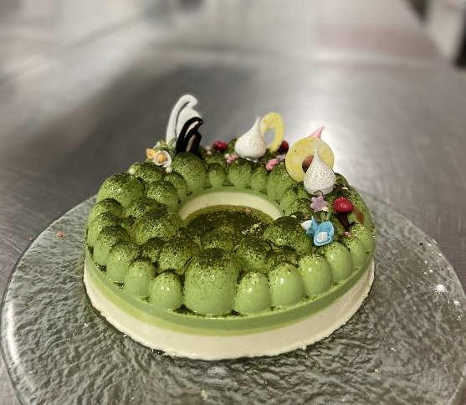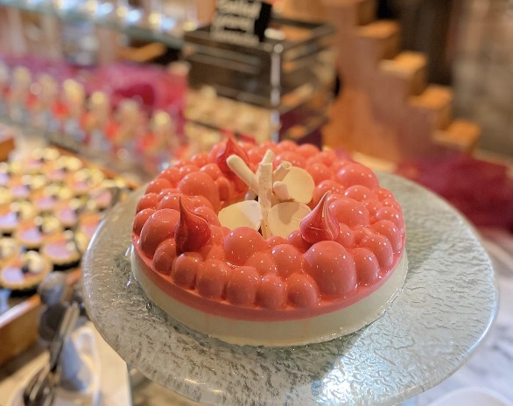
Picture 8. Raspberry Mousse & Green Tea Mousse
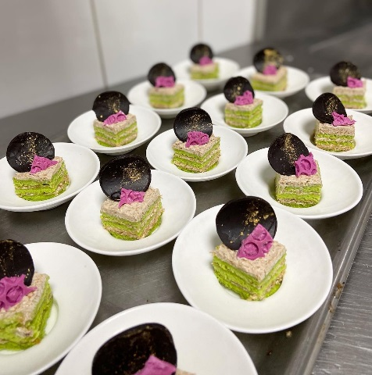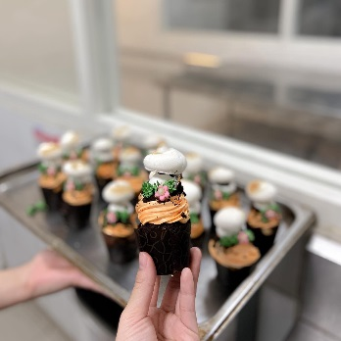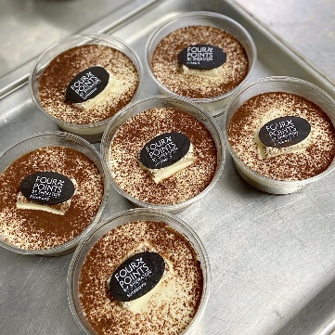
Picture 9. Double Choco Pudding, Chocolate Cupcakes, Pandan Cake
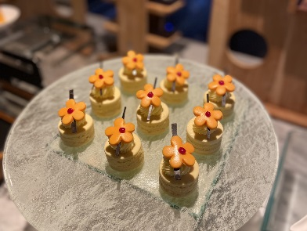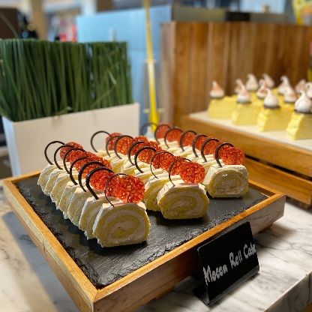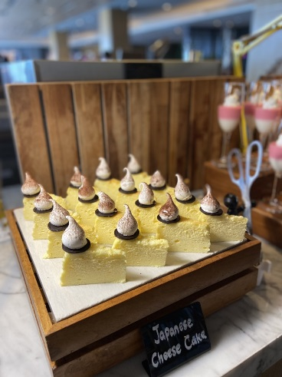
Picture 10. Mocca Roll Cake, Peanut Butter Cake, Japanese Cheesecake
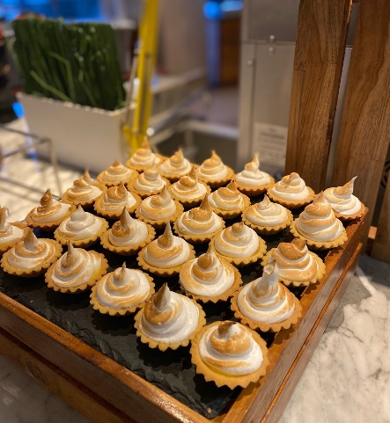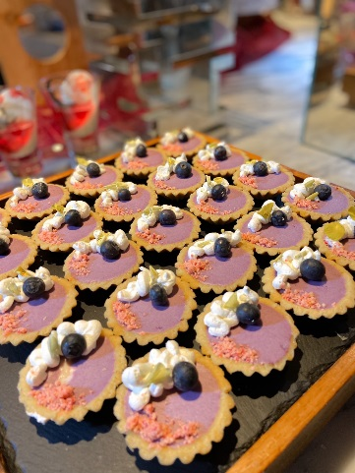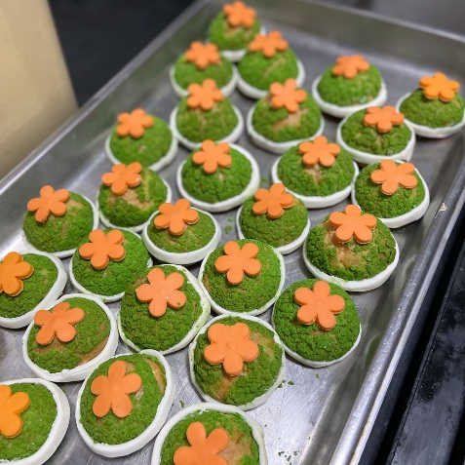
Picture 11. Choux, Blueberry Tarts, Lemon Meringue Tarts
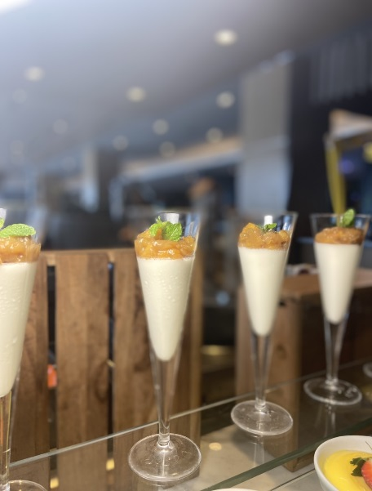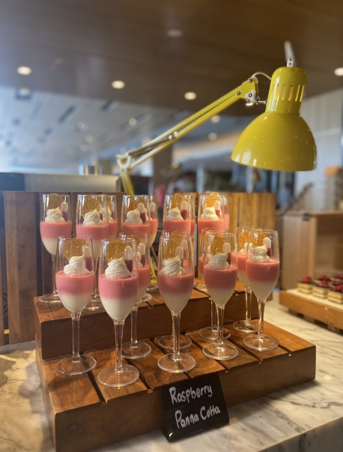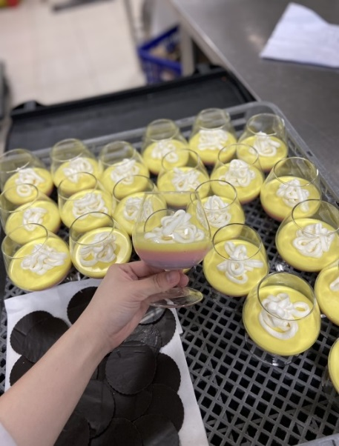Picture 12. Berries Pannacotta, Raspberry Pannacotta, Banana Caramel Pannacotta
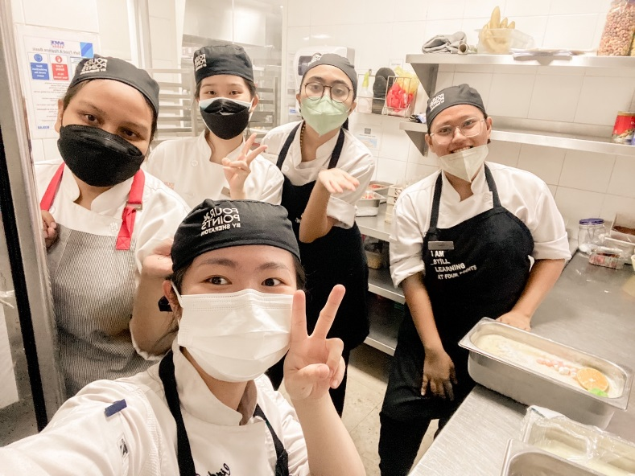
Picture 13. Pastry Team Member

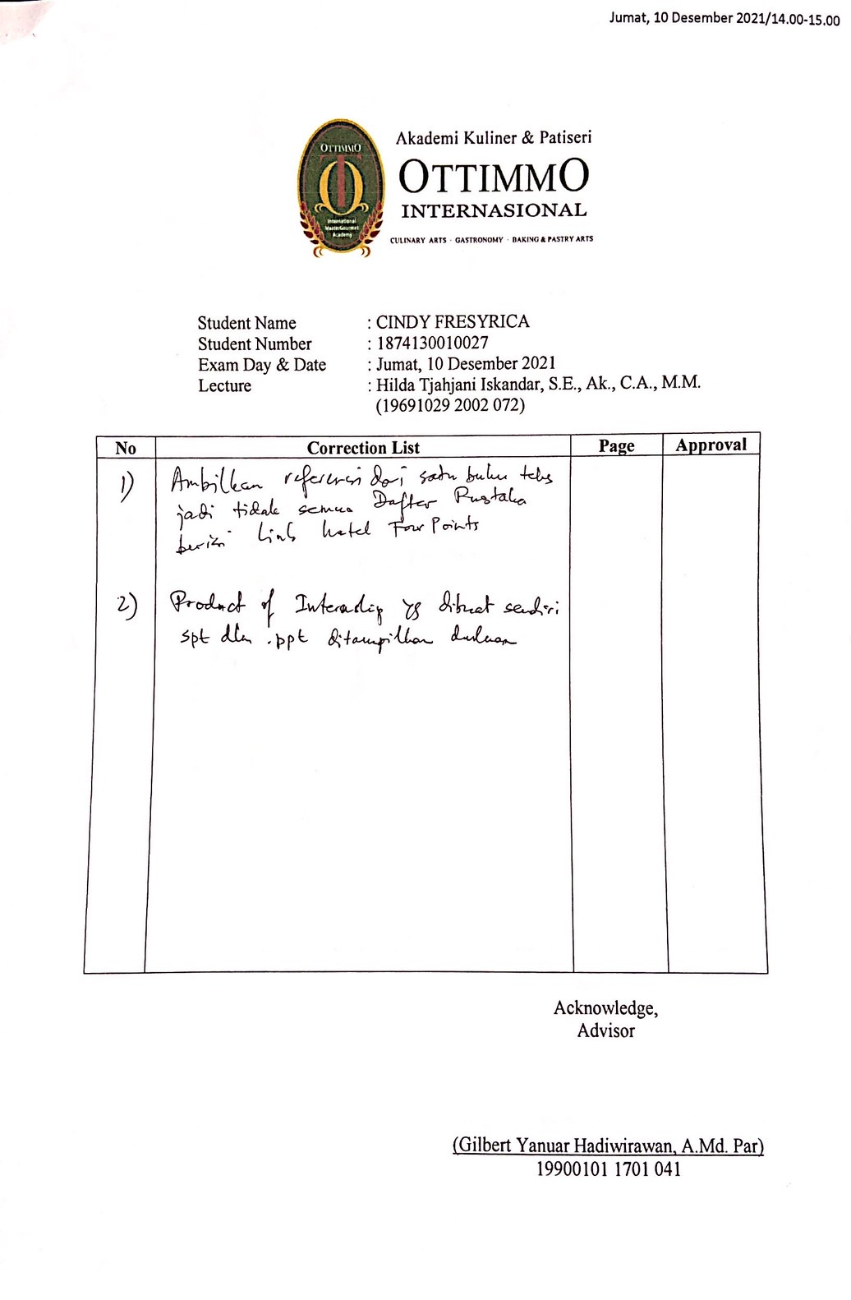
REVISE FORM

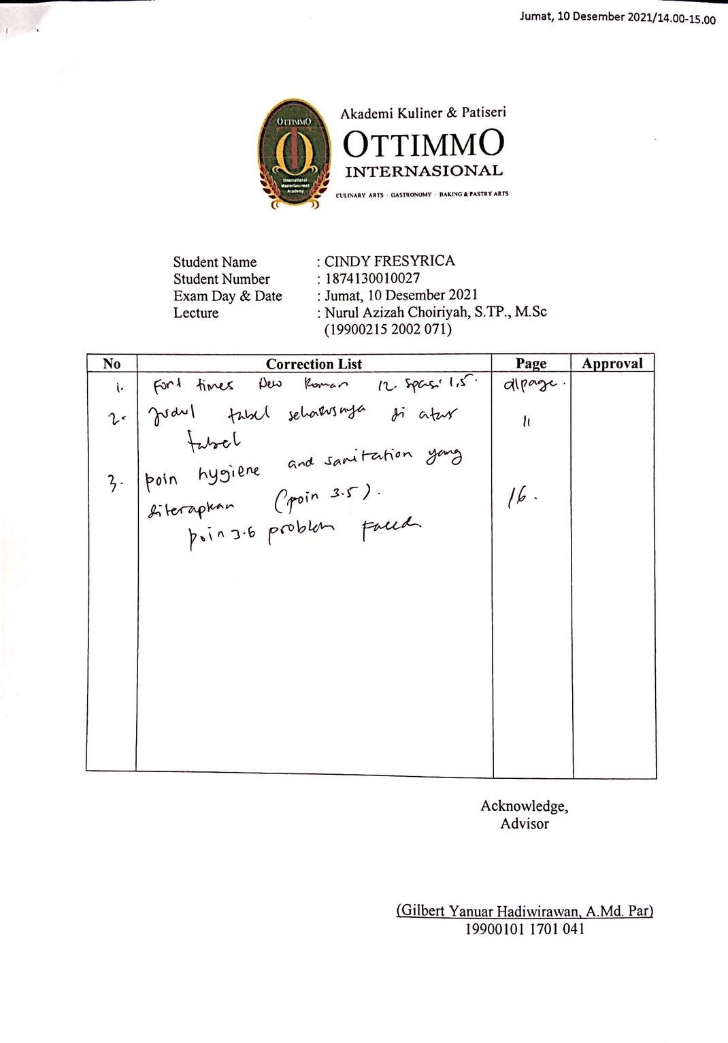
INTERNSHIP CERTIFICATE

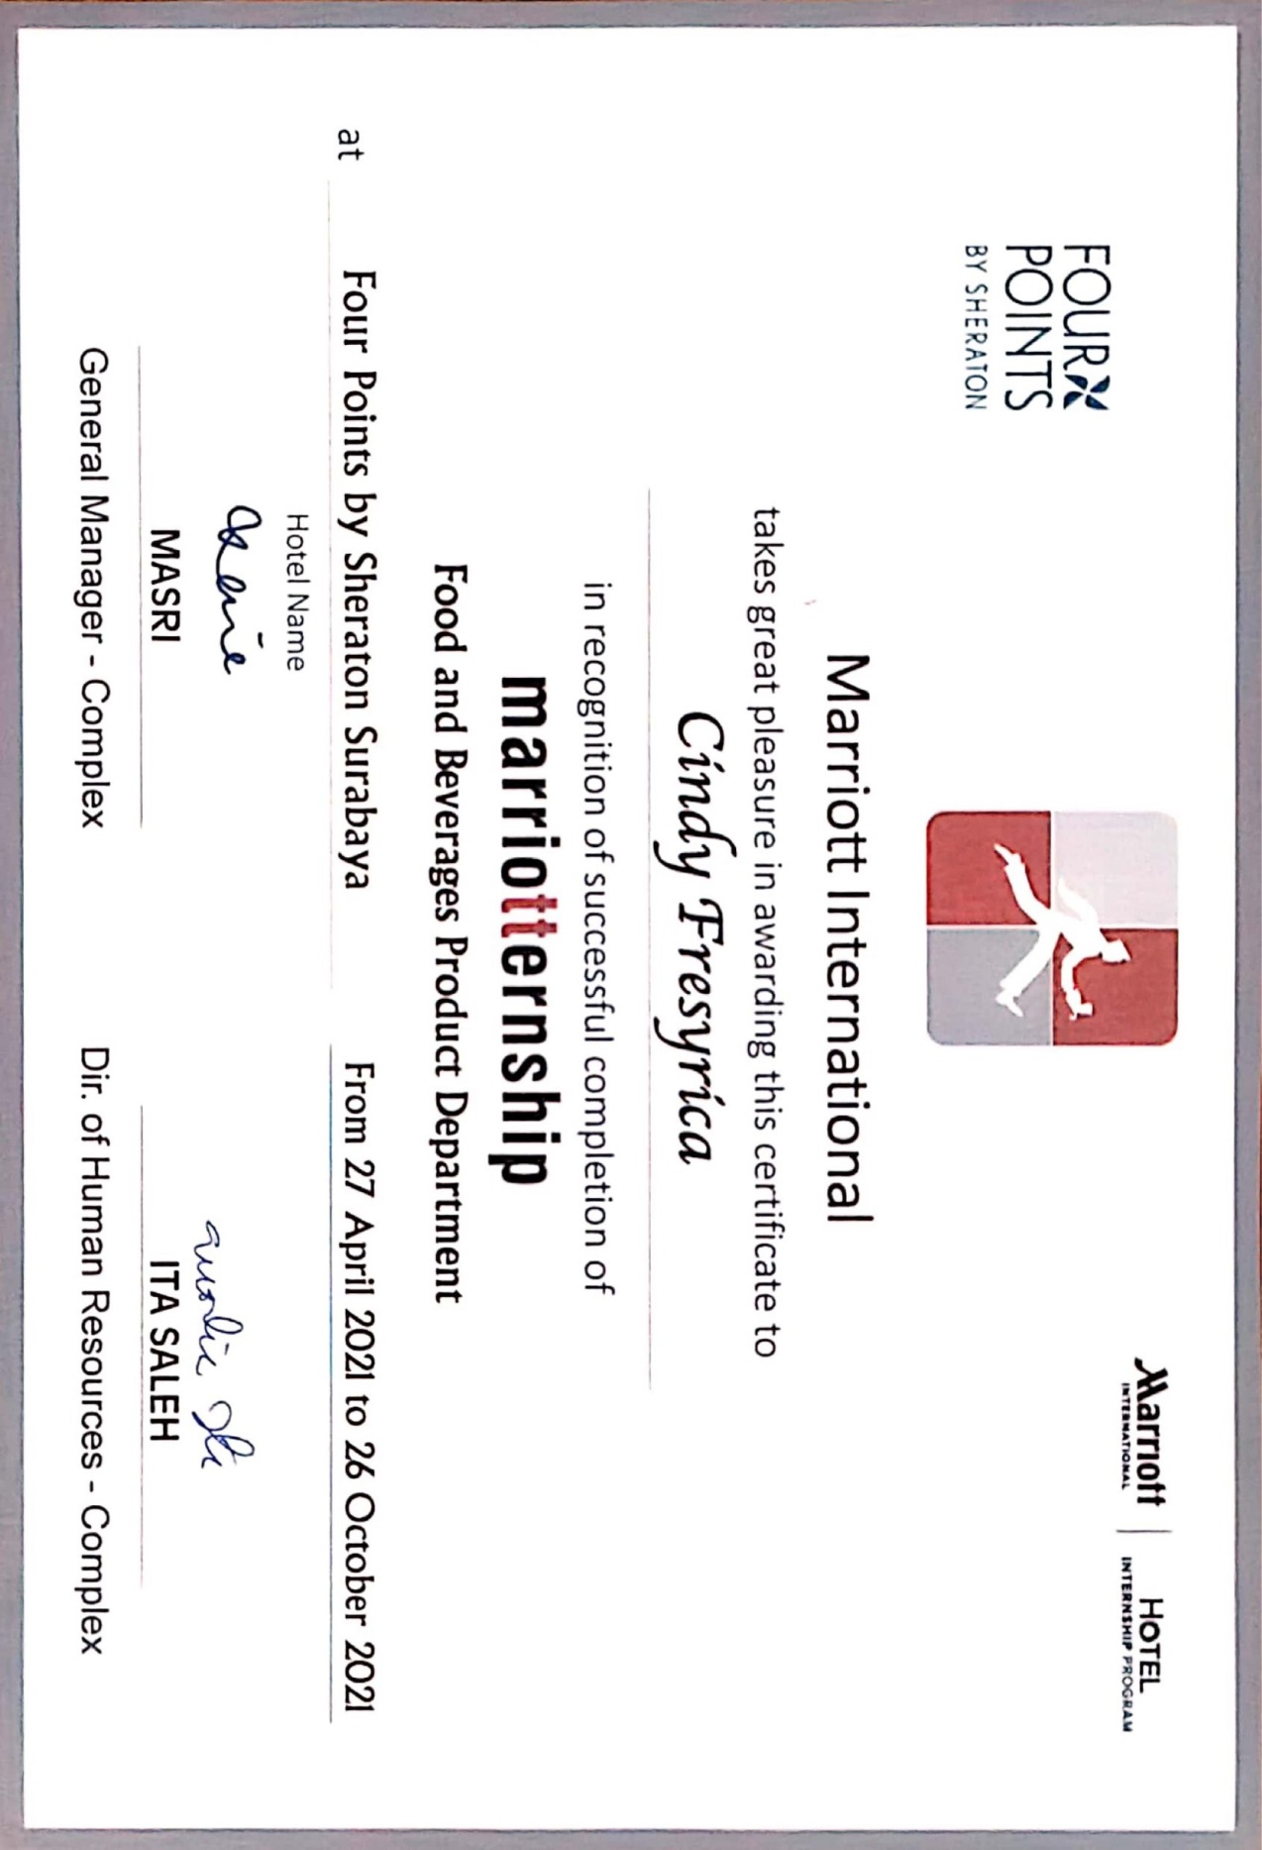
INTERNSHIP APPRAISAL FORM

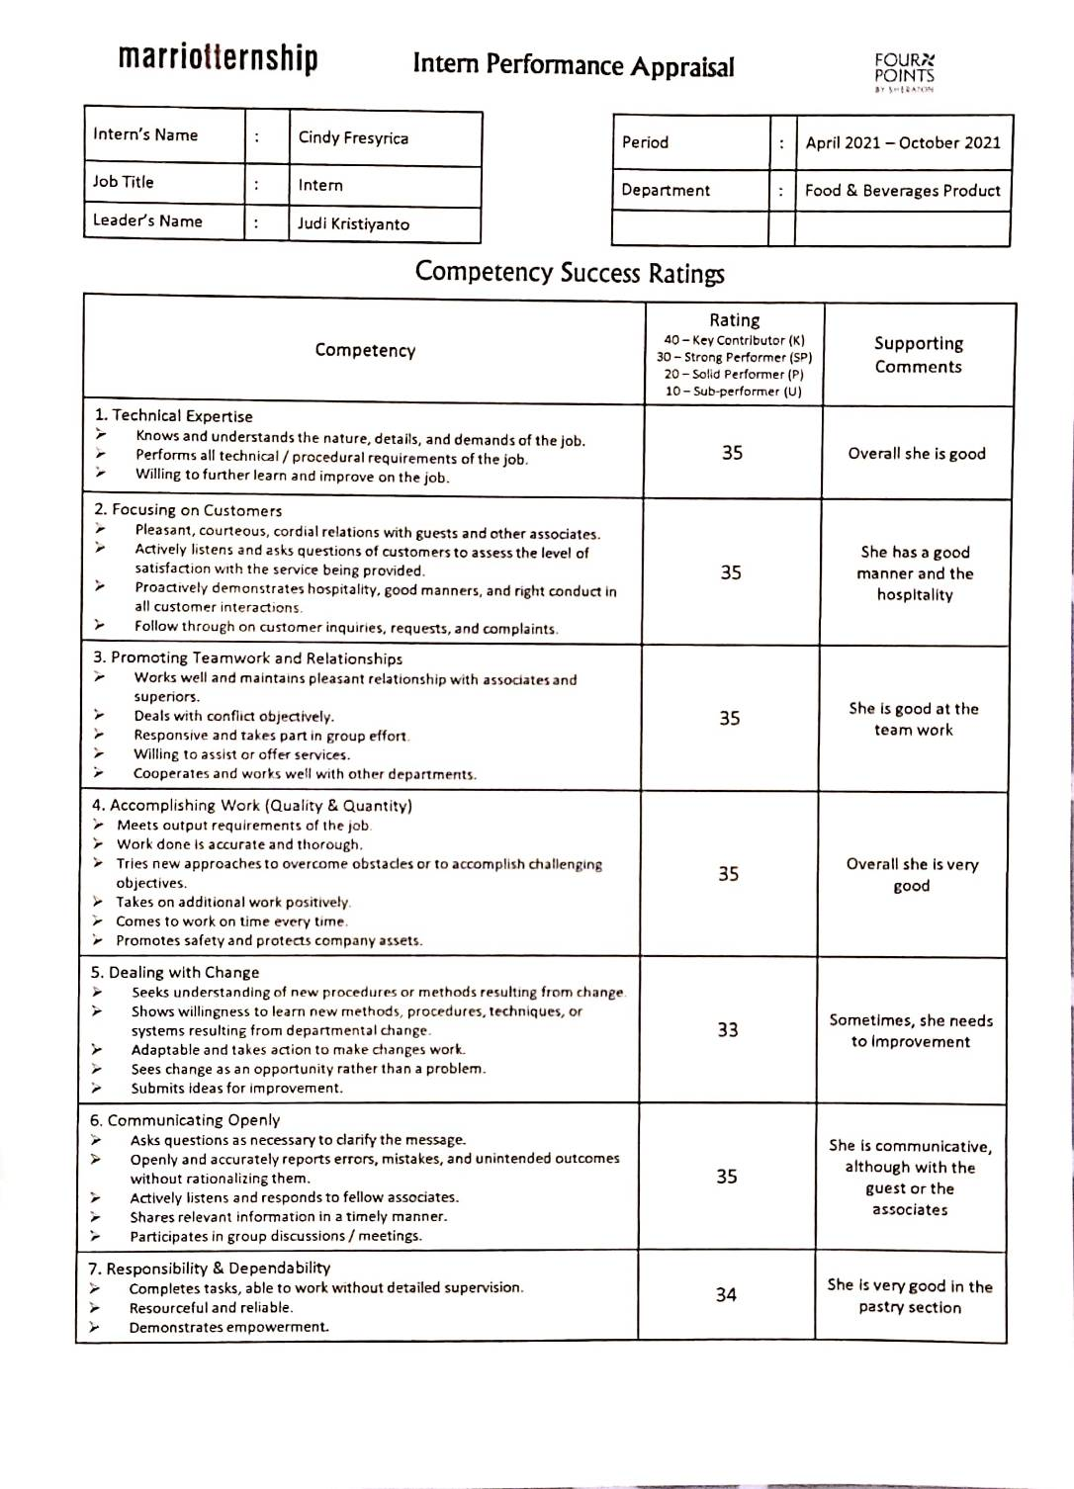
- Internship Appraisal Form Four Points by Sheraton
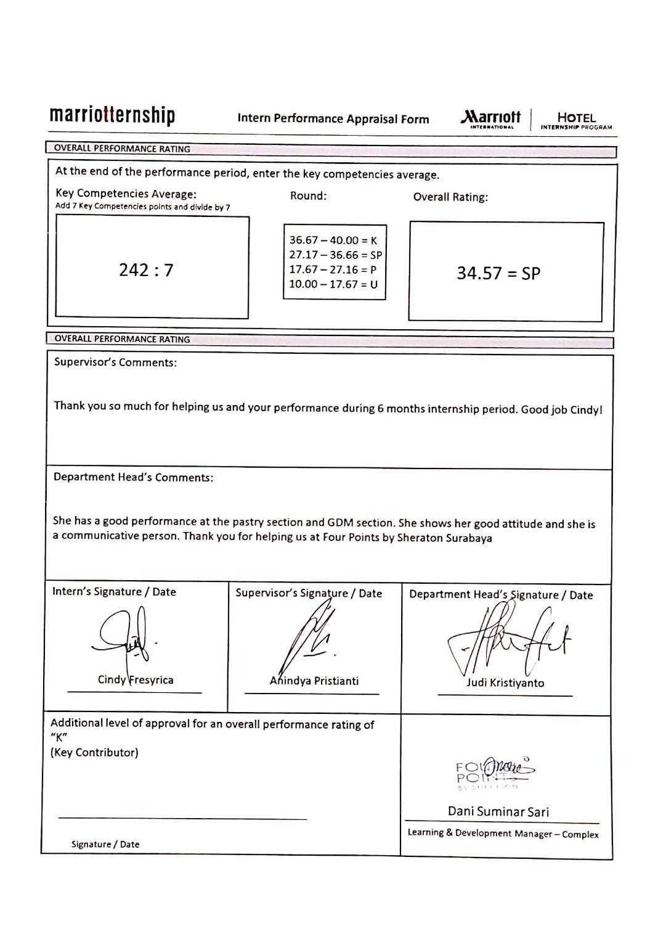

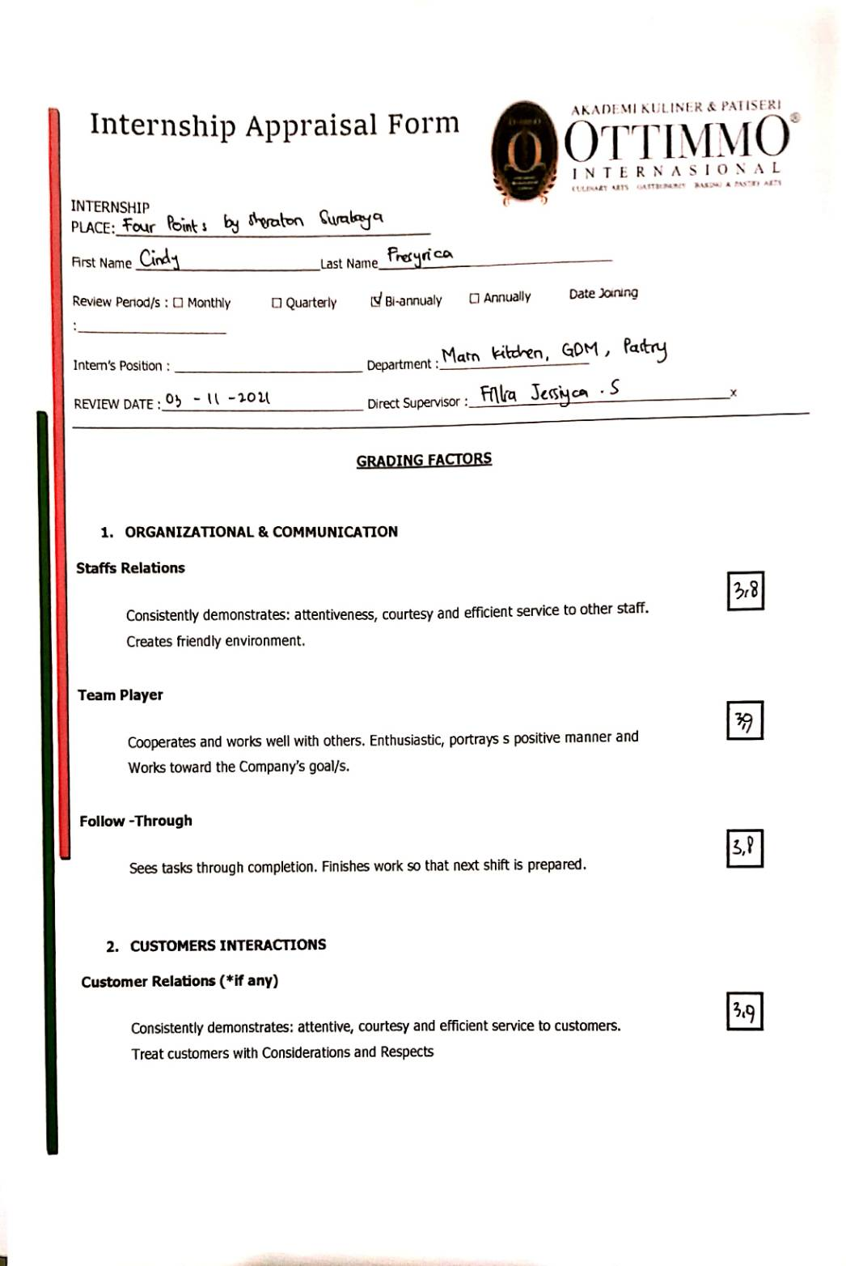
- Internship Appraisal Form Ottimmo International
