INDUSTRIAL TRAINING REPORT
INTERNSHIP AT FOUR POINTS BY SHERATON SURABAYA

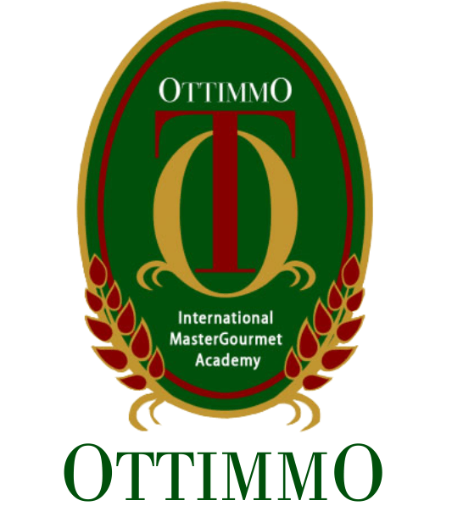

By
CINDY FRESYRICA
1874130010027

CULINARY ARTS PROGRAM STUDY
OTTIMMO INTERNATIONAL MASTERGOURMET ACADEMY SURABAYA
2021

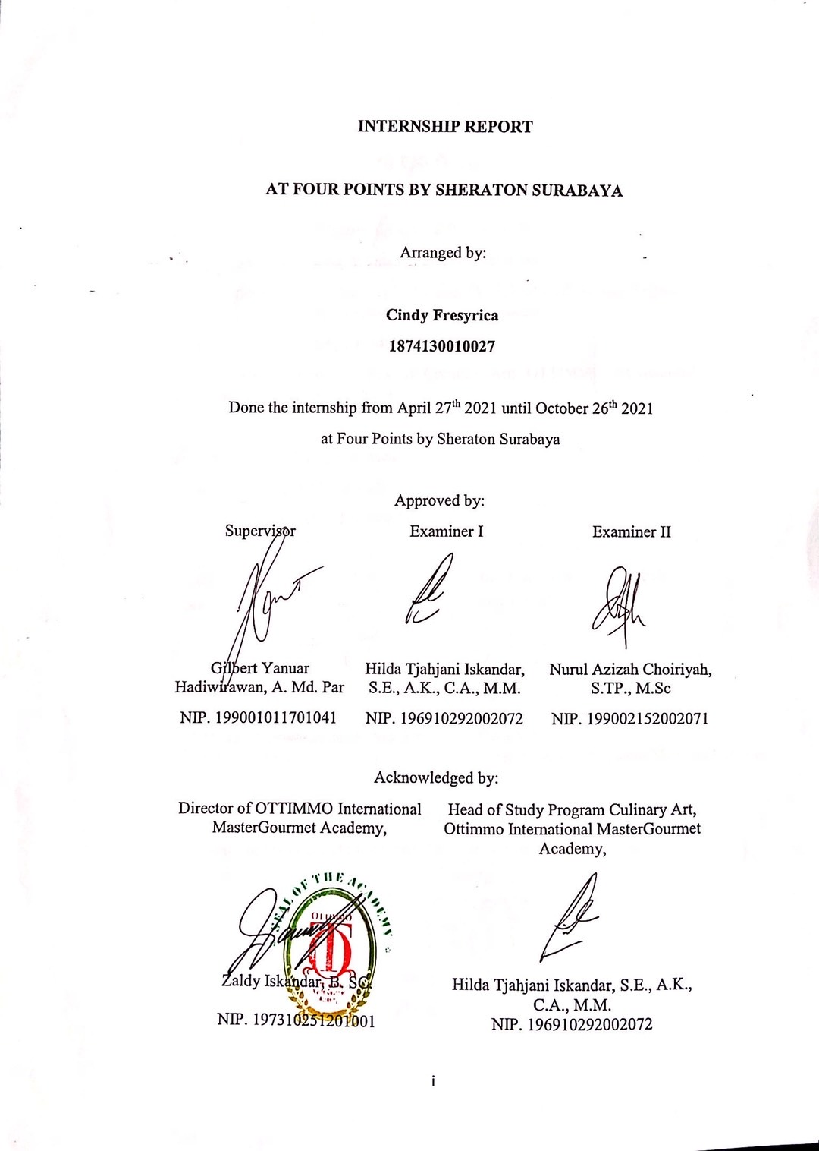
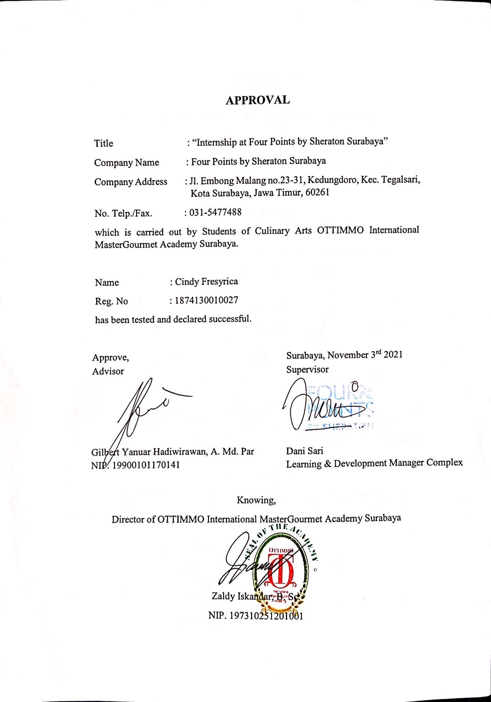
ACKNOWLEDGMENT

Praise and thanks to God Almighty for the successful completion of this report. This report is prepared based on industrial training result conducted by the Authors during 6 months in Four Points by Sheraton Surabaya. This report is prepared as one of the requirements to complete the Diploma III of Culinary Arts.
In the process of completing this report, the Author has received much guidance and assistance from various parties. To that end, the author express their sincere thanks to:
- My parents who have supported and provided me to achieve good education and as a family role to help me in personally.
- Mr. Gilbert Yanuar Hadiwirawan as Advisor who has guided, provide guidance and suggestion until the completion of this report.
- Mrs. Dani Sari as Learning & Development Manager Complex who has given the place of industrial training implementation.
- Mrs. Hilda Tjahjani Iskandar as Head of the Culinary Arts Program.
- Mr. Zaldy Iskandar as Director of OTTIMMO International MasterGourmet Academy Surabaya.
- All chefs and staffs at Four Points by Sheraton Surabaya for the encouragement and endless support during my internship program.
Finally, the Author hope that this report can be useful for us all.

Surabaya, November 3rd 2021
Cindy Fresyrica
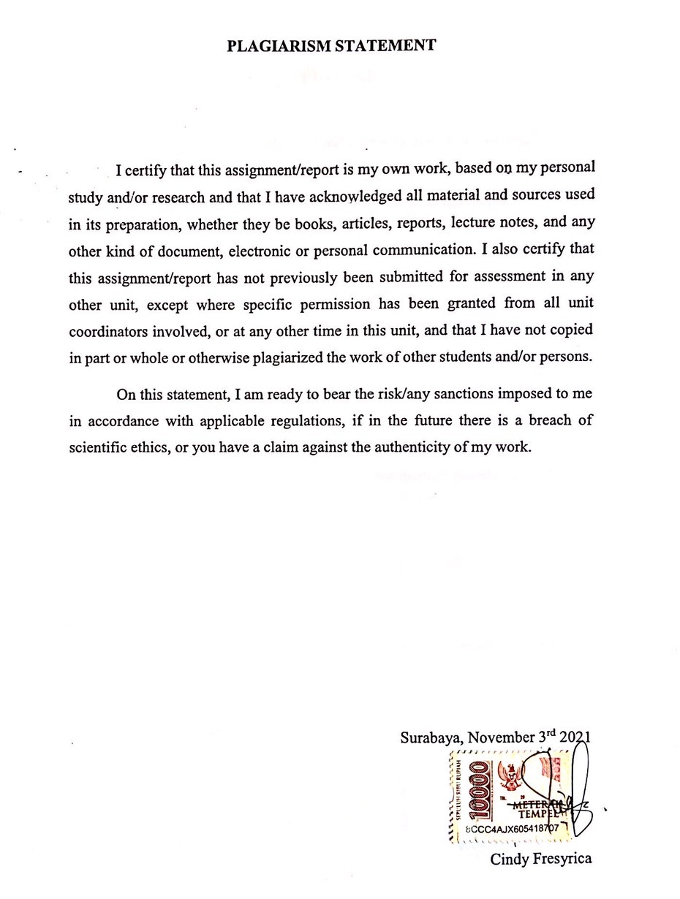
TABLE OF CONTENT

HARD COVER ………………………….………………………………….…... 0
TITLE ………………………….………………………………………………... 0
APPROVAL I ………………………...…………………………………..……... i
APPROVAL II …………………………...……………………………………... ii
ACKNOWLEDGMENT ………………………………………………………. iii
PLAGIARISM STATEMENT ………………………………………………... iv
TABLE OF CONTENT ………………………………………………………... v
LIST OF PICTURES ……………………………………………………..…... vii
LIST OF TABLES …………………………………………...…………...…... viii
EXECUTIVE SUMMARY ………………………………………………..…... ix
CHAPTER 1 INTRODUCTION ……….………………………….…………... 1
  - Background of Study ………………………………………… 1
  - Industrial Training Objectives ………………………………... 1
  - The Benefits of Industrial Training …………………………... 2
CHAPTER 2 GENERAL DESCRIPTION OF COMPANY …….….……….. 3
  - History of Company ………………………………………….. 3
  - Vision, Mission, and Core Values …………………………… 5
  - Organizational Structure and Main Task …………………….. 7
CHAPTER 3 INDUSTRIAL TRAINING ACTIVITIES …………...……….. 11
  - Place of Assignment ………………………………………… 11
  - Activities Performed ………………………………………... 11
  - Job Description Based On Workmanship …………………… 12
  - Internship Product ………...………………………………… 18
  - Hygiene and Sanitation ...…………………………………… 20
  - Problem Faced And How To Solve Them …………………... 20
CHAPTER 4 CONCLUSION ………………………………………………… 22

  - Conclusion ………………………………………………….. 22
  - Suggestion ………………………………………………….. 22
BIBLIOGRAPHY ……………………………………………………………... 24
APPENDIX …………………………………………………………………….. 25

LIST OF TABLES

Table 1. Organization Structure ………………………………………………… 7
Table 2. Job Description ………………………………………………………… 12

LIST OF PICTURES

Picture 1. First A&W Root Beer Stand ………………...……………….………... 3
Picture 2. Paleo Chicken Wrap ………………………………..………………… 18
Picture 3. Quiche Lorraine ……..……………………………………………….. 18
Picture 4. Choco Caramel Macarons, Beef Bacon Vol Au Vents,
Salted Popcorn Macarons ……………………………….…………… 19
Picture 5. Berries Panna Cotta ………………………………………..…………. 19
Picture 6. Author and The Head Chef …………………………………………… 25
Picture 7. Red Velvet Cake, Klepon Cake, Opera Cake ………………………… 25
Picture 8. Raspberry Mousse & Green Tea Mousse ……………………..……… 25
Picture 9. Double Choco Pudding, Chocolate Cupcakes, Pandan Cake ………… 26
Picture 10. Mocca Roll Cake, Peanut Butter Cake, Japanese Cheesecake ……… 26
Picture 11. Choux, Blueberry Tarts, Lemon Meringue Tarts …………………… 26
Picture 12. Berries Pannacotta, Raspberry Pannacotta,
Banana Caramel Pannacotta ………………………………………… 27
Picture 13. Pastry Team Member ……………………………………………….. 27

EXECUTIVE SUMMARY

The writing of this industrial training report is one of the requirements from Ottimmo International MasterGourmet Academy Surabaya to fulfill the graduation regulation. This report is completed based on six months of industrial training program at Four Points by Sheraton Surabaya start from April 27th, 2021 until October 26th, 2021. This internship report highlights and describe major analysis carried out, experiences gained and the achievements as an intern.
Four Points by Sheraton Surabaya has given the Author an opportunity to learn and gain so many experiences on how the hospitality industry’s kitchen work. For six months, the Author also got the opportunity to learn from three different departments which is the main kitchen, cold kitchen, and pastry section. All the chefs and staffs are so humble, they are willing to teach, and also so transparent about the recipes they have.
During the internship program, The Author also faced some difficulties, one of them was having unsupportive and moody mentor. When we already did and gave our best effort but it is hardly appreciated by this mentor who often think and judge someone in negative ways. The only solution for this problem is to understand that hard work doesn’t always get noticed, and we might get ignored and unappreciated sometimes but we should try to not feel dejected and keep continuously perform well.
The most important things the Author aware while working in hospitality industry is to balance our hard and soft skills. The Author learnt to be qualified in both especially while handling rude guests and teammates. But, all the good and bad experiences will help the Author grow to be the better person and prepare the Author to enter the real professional life.
Keyword: Four Points Hotel by Sheraton, Internship, Hospitality

