BIBLIOGRAPHY

Plataran. 2017. Plataran Indonesia. About Plataran.
Availaible: https://www.plataran.com/about/. Accessed on November 23th 2021.

Plataran. 2017. Plataran Borobudur. Plataran Borobudur Villas.
Available: https://www.plataran.com/plataran-borobudur/villas/. Accessed on November 23th 2021.
Plataran. 2017. Plataran Borobudur. Dining.
Available: https://www.plataran.com/plataran-borobudur/dining/. Accessed on November 23th 2021.
Plataran. 2017. Plataran Borobudur. Gallery.
Available: https://www.plataran.com/plataran-borobudur/gallery/. Accessed on November 23th 2021.
Plataran. 2017. Plataran Borobudur. Ala-carte Menu. Available: https://www.plataran.com/plataran-borobudur/wp-
content/uploads/sites/3/2021/10/PLB-Patio-Ala-Carte-Menu.pdf. Accessed on November 23th 2021.

APPENDIX

Patio Hot Kitchen

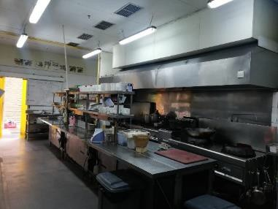

Figure 99. Patio Hot Kitchen

Source: Personal Documentation, 2021

Patio Cold Kitchen
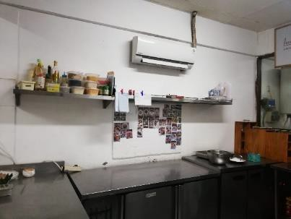
Figure 100. Patio Cold Kitchen Source: Personal Documentation, 2021

Patio Pastry Kitchen
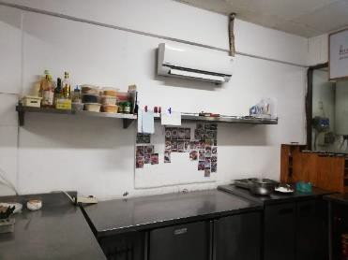
Figure 101. Patio Pastry Kitchen Source: Personal Documentation, 2021

Schedule
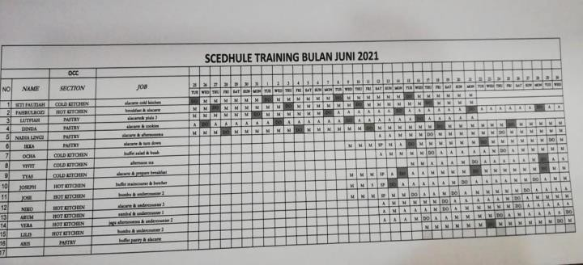

Figure 102. Schedule

Source: Personal Documentation, 2021

Menu

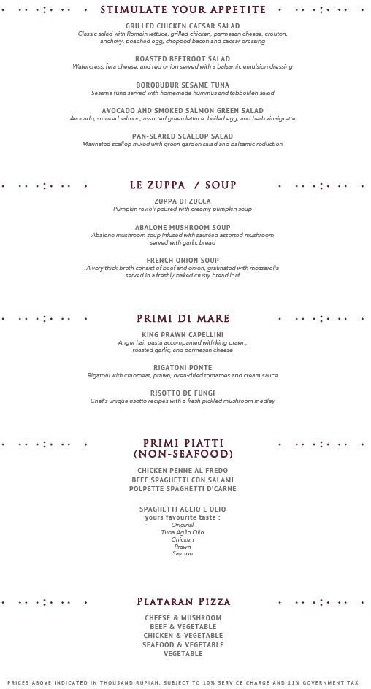

Figure 103. Patio Menu 1

Source: Plataran, 2017

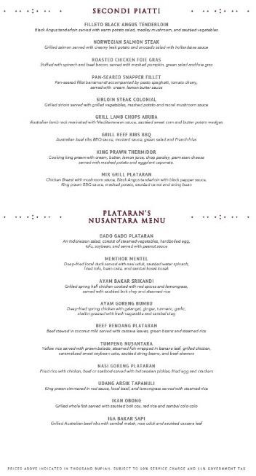

Figure 104. Patio Menu 2

Source: Plataran, 2017

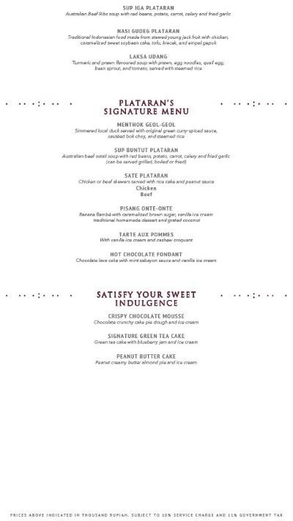

Figure 105. Patio Menu 3

Source: Plataran, 2017

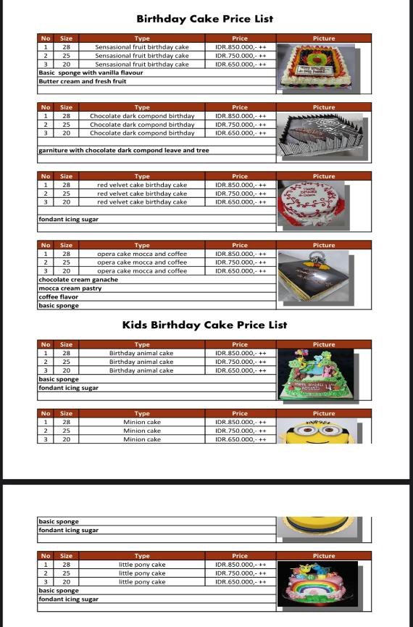
Figure 106. Patio Birthday Cake Price List Source: Plataran, 2017

Patio Kitchen Team

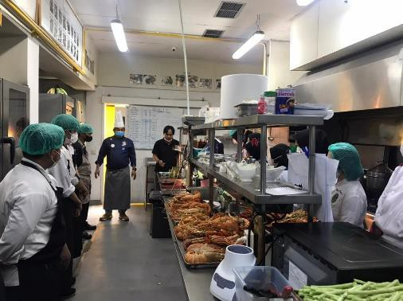
Figure 107. Patio Kitchen Team Source: Personal Documentation, 2021

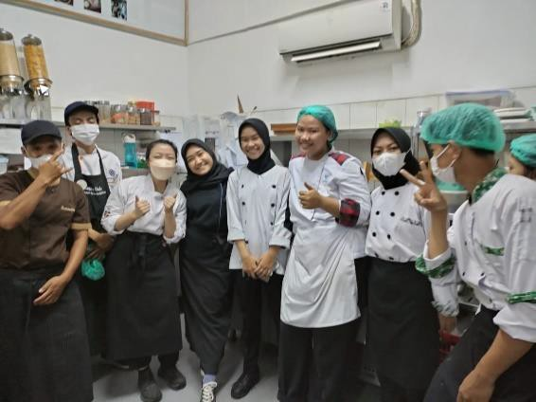

Figure 108. Patio Pastry Team

Source: Personal Documentation, 2021
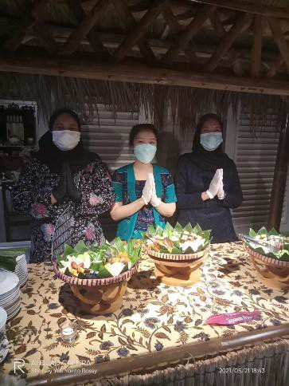
Figure 109. Patio Trainees Source: Personal Documentation, 2021

