CHAPTER II
GENERAL DESCRIPTION OF COMPANY

History of The Company

To increase the income of a region, one way is to take advantage of existing local tourism potential. The city of Magelang is an example of a city rich in tourism destinations. Precisely in Magelang Regency, there are tourist sites an iconic name whose name is known to the world, and has even been included in a heritage site world that has been designated by UNESCO in 2006. The tourist spot is named Borobudur temple.
In Magelang Regency, of course, there is not only one temple tourist location, but also There are six other temple tourist sites in the Regency, including Mendut Temple, Borobudur Temple, Pawon Temple, Asu Temple, Ngawen Temple, and Gunung Wukir Temple. From The six tourist sites of the existing temples, of course, Borobudur Temple has an attraction biggest in terms of winning the hearts of tourists, both domestic tourists and tourists foreign countries while on vacation in Magelang City.
In addition to offering tours about temples, Magelang Regency also presents natural potential in the form of expanses of mountains and mountains hills that surround this area. From the past few years, the existence of Candi Borobudur can be said to be the main magnet in Magelang Regency as an attraction to attract tourists, both domestic and foreign tourists.
This situation has attracted the attention of the government and businessmen to build lodging in the city of Magelang in order to take advantage of existing opportunities, namely domestic and foreign tourists who are on vacation and want to know and promote Indonesia's natural tourism so that it is better known by residents of Indonesia and other countries.

Vision, Mission, and Company Objectives

Vision of Plataran Borobudur
to contribute to Indonesia and Indonesians by showcasing to the world the rich and diverse natural and cultural heritage of this remarkable archipelago.

Mission of Plataran Borobudur
Providing a unique destination experience and warm personalization serviced embodied in the property's architecture and interior design also culinary offerings as well as thoughtfully crafted to deliver a completely authentic and enriching guest experience.

Core Values
The core values are 3 X factors that consists of :
      - eXoticism
Presenting the architecture and the interior design of properties while enjoying the nature.
      - eXperience
Providing unique traditional entertainment and relaxing staycation
      - eXcellence
Excellence and the beautiful spirit of Indonesia reside in every detail of our exquisite culinary offerings and warm personalized service.

The Collections

Mirroring the rich diversity of Indonesia, the Plataran brand comprises four collections, each with its own distinct style and character also are located in remoted area. It is consists of:

Sanctuary
The highest category from Plataran Indonesia offers the true experience of a tranquil haven with pristine natural surroundings. Provides absolute privacy in seclusion with personal butler services:
      - Plataran Komodo
      - Plataran Menjangan

Signature
Refined and sophisticated, our signature masterpieces offer the ultimate Indonesian experience, with authenticity in every luxurious detail and unparalleled personalised service:
      - Plataran Borobudur
      - Plataran Bromo
      - Plataran Canggu

Classic
Our Classic collection is defined by comforting elegance with a tropical touch, embraced by the warmth of traditional Indonesian hospitality:
      - Plataran Heritage Borobudur
      - Plataran Ubud

Lifestyle
Our Lifestyle collection offers experiences to excite the senses, from vibrant dining and social scenes to ocean adventures, with an ambience that is lively, fun and laidback:
      - Plataran Ecolodge
      - Villa puncak by Plataran

About Plataran Borobudur and Patio Restaurant

Plaran Borobudur is a villa concept staycation. An enchanting hideaway set against the backdrop of magnificent Borobudur Temple and the picturesque Menoreh Hills Features of Plataran Heritage Borobudur. Surrounded by lush teak forests, Plataran Borobudur Resort & Spa transports guests to another time and place, where days gently unfold against the backdrop of magnificent Borobudur Temple and the picturesque Menoreh Hills.

Amid this unbelievably beautiful and atmospheric setting, people can experience the utmost peace and privacy within traditional Javanese villas, spacious havens of supreme comfort with a private pool. Indulge in sublime, soul-soothing spa pampering, and exquisite gastronomy with an unparalleled view of Borobudur Temple at every turn. They can Walk the long corridor that stretches between Patio restaurant’s Joglo and colonial buildings, and be awed by the feeling that wherever you stand, “Borobudur Follows” – an experience unique to Plataran Borobudur. Get off the beaten path and the guests can discover the real Indonesia with tailored destination activities, enjoyed in the gaze of one of the most awe-inspiring ancient wonders of the world. Mystical, magical, and unforgettable.

Standard Operating Procedure During Pandemic
Plataran Borobudur is implementing enhanced hygiene and safety protocols to provide guests with peace of mind when visiting us during ‘the new normal. Some key elements of this policy include physical distancing, reinforced cleaning procedures, mandatory hand washing, regular use of hand sanitizers and PPE, sterilizing of operational equipment, and a disciplined schedule of staff training, as recommended by the tourism and health authorities. Alongside these new measures, our aim is to ensure that hygiene and safety protocols do not compromise Plataran Borobudur guests’ happiness or hospitality experience.

Our resort’s natural design lay out – consisting of private, serene and very exclusive and limited number of villas spread across our sizeable property, combined with our environmental friendly and well ventilated indoor and outdoor amenities – perfectly conforms with “New Normal” Safety Protocol Configurations to support social distancing, cleanliness and fresh air. Our resorts are also well known for its strong Indonesian environmental and cultural friendly outdoor activities and experiences amongst people who love to make peace with the earth and appreciate the sun and the moon.

The steps being taken at Plataran Borobudur’s Resorts:
      - All staff trained in appropriate guidelines, according to WHO
      - Management in each location is constantly monitoring the situation
      - Hand hygiene has been elevated in all resorts and hotels
      - Increased frequency and intensity of cleaning protocols
      - Regular disinfection of commonly touched surfaces (door handles, card readers, elevators etc.)
      - Hand sanitizers made available to all guests in public areas
      - Staff members who are currently ill are not permitted to enter the property
      - Temperature checks and screening on arrival to identify those at risk of infection or transmission
Plataran Borobudur has increased its already-strict health and safety precautions, in order to ensure the safety of both guests and employees.
    - Body Temperature Check
All guests’ and employees’ temperatures will be checked upon arrival. For the safety of all, anyone who registers a temperature above 37.5°C will not be permitted to enter the premises. Sick employees will not be permitted to work until they have fully recovered.
    - Mask and Hand Sanitizer Provided Upon Arrival
We have provided hand sanitizers and face masks upon arrival for guests to use. Guests displaying flu-like symptoms are kindly requested to use face masks or tissues to ensure the safety of others. Masks and gloves are also provided for employees to further increase kitchen and operational safety.
    - Sterilization and Disinfection Procedures
We consistently do disinfection before opening, after closing and in between table turnovers. All other public areas, such as restrooms, door handles, kitchens and other operational tools are also sanitized continuously. We also offer single-use paper on top of our linens, to ensure we limit any possible germ transmission between guests.
    - Maintaining Safe Distance

Our outlet layout comprises multiple access points and private rooms, allowing guests to easily maintain safe distances between each other, while also increasing the exclusivity of their experience.
    - Healthy Dishes without MSG
We pride ourselves on serving food free of MSG and other harmful preservatives, and all the food processing in our kitchen uses special, high- quality and hygienic materials.
    - Waste Water Special Treatment
We also implement our special Waste Water Treatment, to ensure we comply with our environmental responsibilities. Maintain social distancing wherever possible

Location and Opening hours

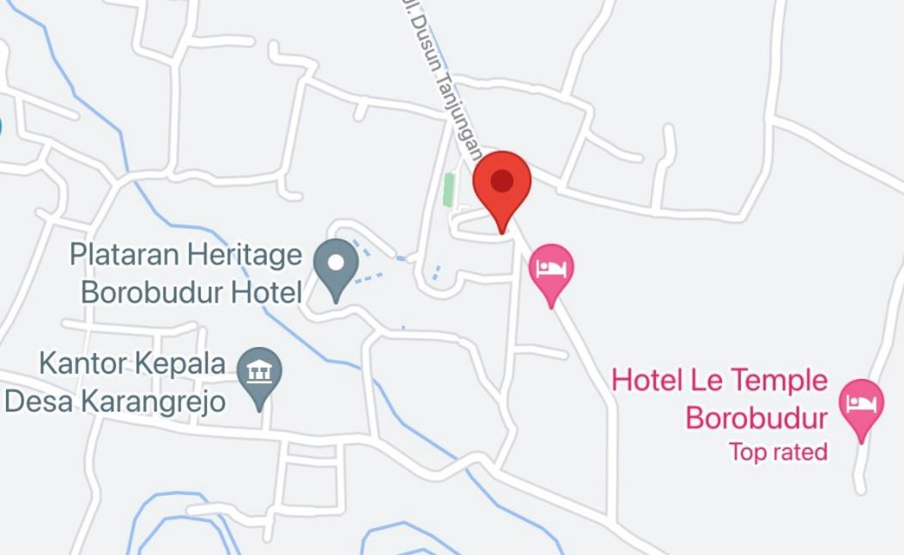
Figure 1. Plataran Borobudur Map Location Source: Plataran, 2017
Plataran Borobudur Resorts & Spa
Address : Dusun Tanjungan, Borobudur, Magelang, Central Java 56553, Indonesia
Email :borobudur@plataran.com
Telp/Fax : +62 293 788 888 / +62 293 788 699
Website : www.plataran.com

Opening Hours:
- Receptionist : 24 hours
- Patio Colonial hall : 07.00 am – 11.00 pm
- The Kastil : 06.00 pm – 11.00 pm
- Padma Spa : 09.00 am – 09.00 pm
- Pool : 08.00 am – 08.00 pm
- Gym : 09.00 am – 09.00 pm

Features of Plataran Borobudur Resorts & Spa

Plataran Borobudur is located in the Magelang Regency in the heart of Central Java, surrounded by a spellbinding landscape of rolling hills and volcanic peaks. Borobudur Temple, the largest and most iconic Buddhist temple in the world, remains one of Indonesia’s most visited destinations. Head to the top of nearby Punthuk Setumbu hill for a spectacular sunrise view of this magnificent monument, and visit its sister temples, Mendut and Pawon. The region is also home to the awe-inspiring Prambanan Hindu temple complex, worthy of a day trip, driving through stunning scenery. The attractions of the neighborhood city of Magelang, including several historical sites from the Dutch colonial era. The resort’s picturesque location also makes it a great base for outdoor adventures.

This charming resort sits atop Tanjungan Village’s hills in Central Java, 1 km from Borobudur Temple. Operating a 24-hour front desk, Plataran Borobudur features the richness of Indonesian architecture, offering a spa and outdoor pool. Free WiFi access is available in all areas. Guests also enjoy free scheduled shuttle service to Borobudur Temple.

Plataran Borobudur is approximately a 90-minute drive from Yogjakarta Adisucipto International Airport, while Semarang Achmad Yani International Airport is a 2-hour drive away.

At this property, air-conditioned villas are fitted with a telephone and a TV. En suite bathrooms offer a bathtub, complete with toiletries. Some units offer views of the surrounding hills and private plunge pools.

Guests can enjoy free afternoon tea on their terrace, take the complimentary drop-off service to Borobudur temple, or participate in the daily yoga session. Get pampered at Padma Spa or meditate in the open view of Menoreh Hills. Cycling or trekking can also be done in the village or around the resort. Colonial charm and views of Borobudur accompany guests who dine at Patio Venue, where Indonesian and International cuisine made of fresh local ingredients are served. The Kastil Restaurant offers European-style dining rooms where guests can enjoy the traditional Indonesian Rijsttafel or a romantic dinner. A variety of dishes from throughout the Indonesian Archipelago also can be enjoyed al fresco at Stupa.

Lobby Lounge

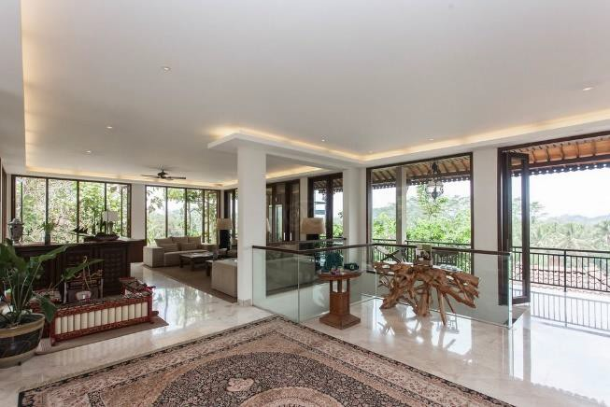

Figure 2. Lobby Lounge Source: Plataran, 2017

Dining

- Patio Colonial Hall

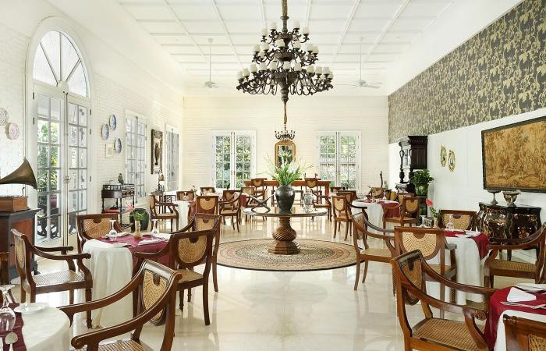

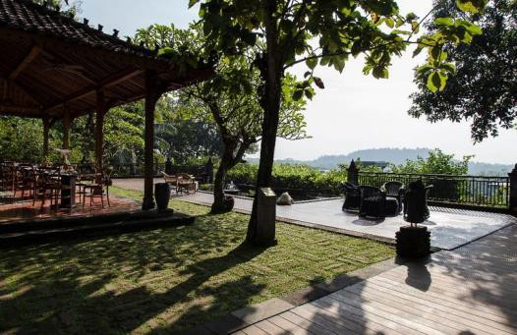
Figure 3. Patio Colonial Hall Source: Plataran, 2017

Figure 4. Patio Joglo Source: Plataran, 2017
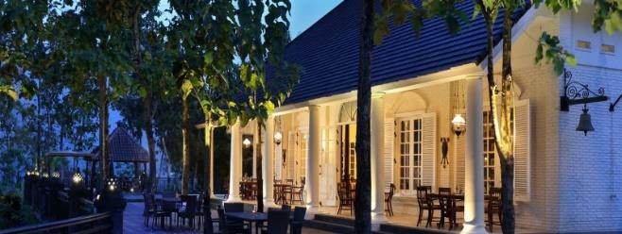

Figure 5. Patio Colonial

The Kastil
Source: Plataran, 2017

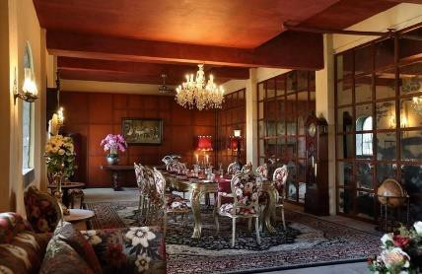
Figure 6. The Kastil Source: Plataran, 2017

Wellness

Padma Spa

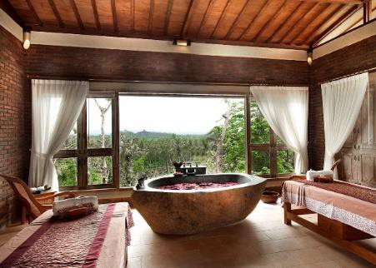

Figure 7. Padma Spa

Pool
Source: Plataran, 2017

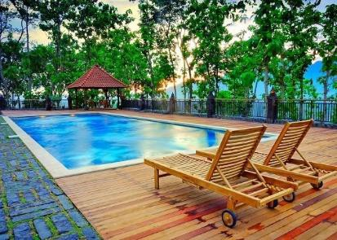

Figure 8. The Pool

Gym
Source: Plataran, 2017

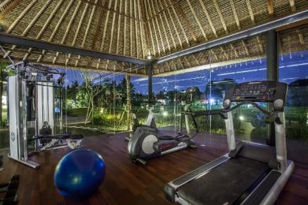

Figure 9. The Gym Source: Plataran, 2017

Putri Dewi

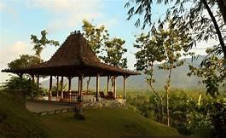

Figure 10. Putri Dewi

Mini zoo
Source: Plataran, 2017

Figure 11. Mini Zoo

Bar
Source: Plataran, 2017

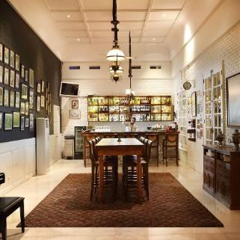

Figure 12. The Bar Source: Plataran, 2017

Langit Borobudur

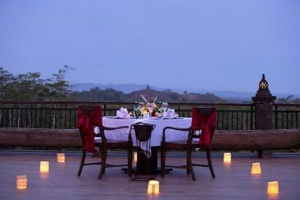
Figure 13. Langit Borobudur Source: Plataran, 2017

Horseback Riding Trail

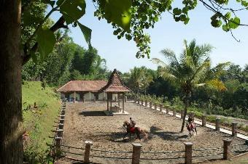
Figure 14. Horse-riding Trail Source: Plataran, 2017

The Heritage Convention Center

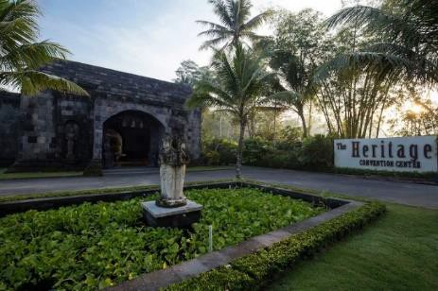
Figure 15. The Heritage Convention Center Source: Plataran, 2017
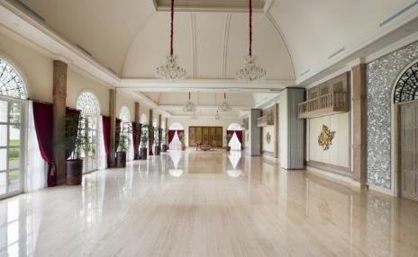

Figure 16. Meeting Hall

Paon Bali
Source: Plataran, 2017

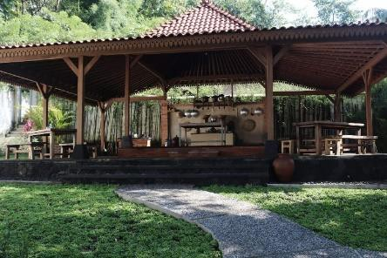

Figure 17. Paon Bali

Accommodation
Source: Plataran, 2017

Plataran Borobudur Resort & Spa have 21 villas and 24 rooms. Here are some kinds of the villa

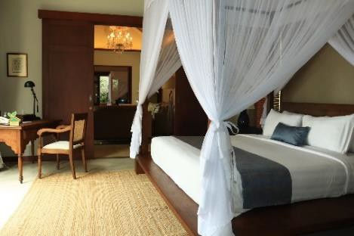
- Founder’s home (1 villa)

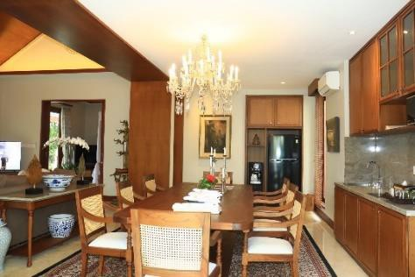
Figure 18. Fouder's Villa Bedroom Source: Plataran, 2017

Figure 19. Founder's Home Dining Room Source: Plataran, 2017
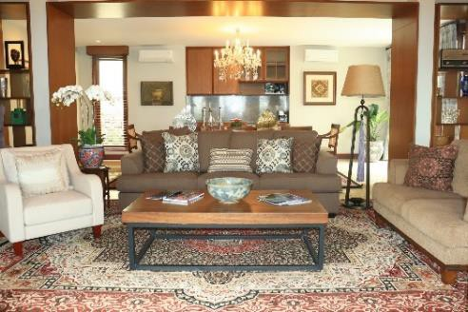

Figure 20. Founder's Home Living Room Source: Plataran, 2017

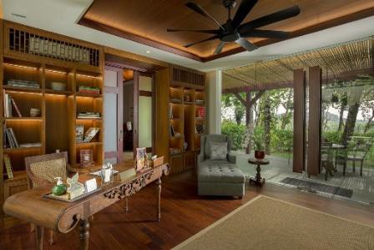

Figure 21. Founder's Home Library

Source: Plataran, 2017
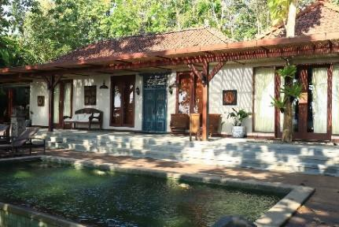

Figure 22. The Pool and Sun Lounge Source: Plataran, 2017
Stylish and sophisticated, the Founder’s Home combines minimalist design with a range of cozy home comforts and touches of Indonesian craft. From elegant bedrooms to spacious living room and even its very own library, the villa adds a modern twist to vintage style. Whether lounging in the living room, strolling on the Borobudur Viewing Deck or taking a dip in the pool, guests will experience the timeless grace of Java with every step. There is only one Founder’s Home villa in Plataran Borobudur.

Room features :

- 652 sqm
- 4 people
- Two-king size bed
- En-suite

Room facilities :

- 2 Bedrooms
- 2 Bathrooms (en suite) and separate wardrobe

- Living room
- Dining room and kitchenette
- Library
- Swimming pool
- Sun lounge
- Borobudur viewing deck
- Butler room Room amenities :
- LCD TVs
- Minibar
- Coffee & tea-making facilities
- Complimentary bottled water
- Welcome fruit platter
- Garden Plunge Pool Villa (3 villa)

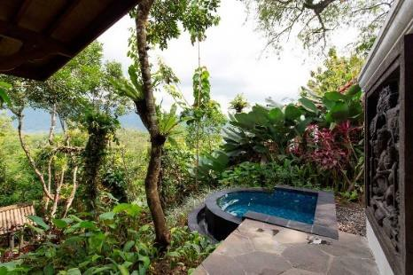
Figure 23. Garden Plunge Pool Source: Plataran, 2017

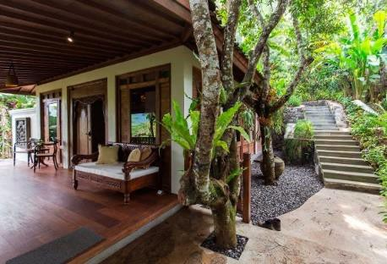

Figure 24. The Terrace Source: Plataran, 2017

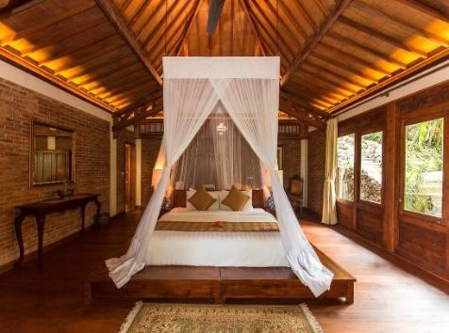

Figure 25. Garden Plunge Bedroom Source: Plataran, 2017

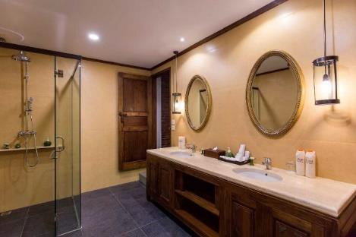
Figure 26. Garden Plunge Bathroom Source: Plataran, 2017
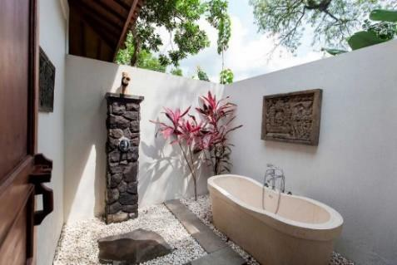

Figure 27. Garden Plunge Bathtub Source: Plataran, 2017
These enchanting hideaways inspire relaxation, equipped with a king-
size bed, bathroom with rain shower and bathtub, outdoor terrace and private plunge pool. Enjoy the sense of space and seclusion with a view of lush gardens and the Menoreh Hills.
Room features :
- 218 sqm
- 2 people
- One - king size bed

- Rain shower & bathtub Room Facilities :
- Bathroom amenities
- Bathrobe, slippers and hairdryer
- Personal digital safe
- Wi-Fi internet access
- IDD phone
- Daily turndown service
- Umbrella and torchlight
- Mosquito coil and repellent
- Complimentary drop-off service to Borobudur Temple Room Amenities :
- 32“LCD TV
- Minibar
- Coffee & tea-making facilities
- Complimentary bottled water
- Welcome fruit platter

- Executive Pool Villa (2 villa)
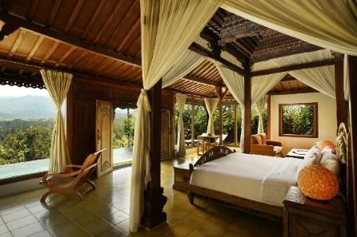
Figure 28. Executive Bedroom Source: Plataran, 2017
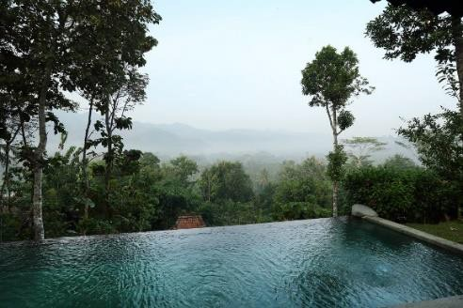

Figure 29. Executive Pool

Source: Plataran, 2017

e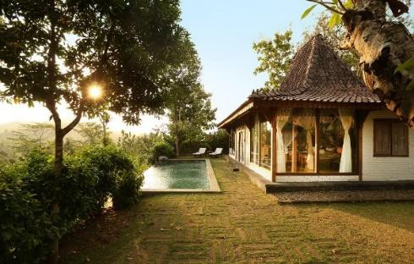

Figure 30. Executive Terrace Source: Plataran, 2017
The Executive Pool Villas combine luxury comforts with a traditional
touch, set in lush gardens with breathtaking garden views. Retreat to this haven of privacy and tranquility featuring a spacious bathroom with rain shower and bathtub, an outdoor terrace and a private swimming pool.
Room features:
- 403 sqm
- Private pool 7 x 3 M
- Two adult
- One – king size bed
- Rain shower & Bathtub Room Facilities :
- Writing desk
- Bathroom amenities
- Bathrobe, slippers and hairdryer
- Personal digital safe
- Wi-Fi internet access
- IDD phone
- Daily turndown service
- Umbrella and torchlight
- Mosquito coil and repellent
- Complimentary drop-off service to Borobudur Temple Room Amenities :
- 32″ and 42″ LCD TVs
- Minibar

- Coffee & tea-making facilities
- Complimentary bottled water
- Welcome fruit platter
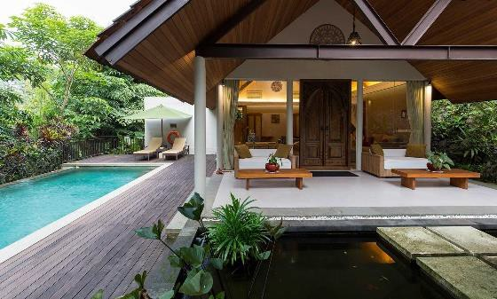
- Exclusive Modern Pool Villa (3 villa)

Figure 31. Exclusive Modern Terrace Source: Plataran, 2017
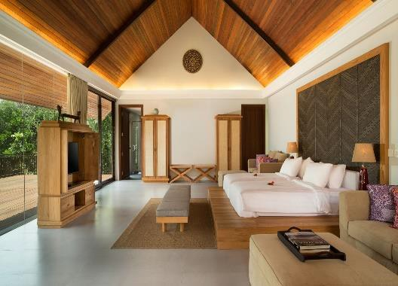
Figure 32. Exclusive Modern Bedroom Source: Plataran, 2017
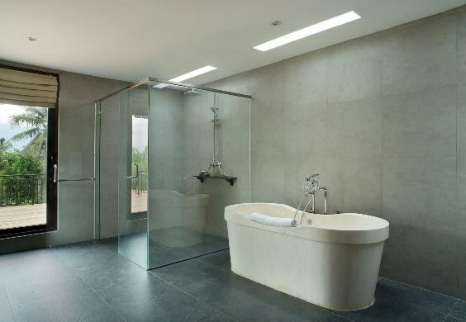

Figure 33. Exclusive Modern Bathroom Source: Plataran, 2017
Available in contemporary style, the Exclusive Pool Villas offer the
height of luxurious comfort, equipped with a king-size bed, spacious bathroom with rain shower and bathtub, outdoor terrace, and a separate living/dining area

in selected villas. A private pool in a lush garden setting completes this tropical oasis.
Room Features :
- 403 sqm
- Private Pool 7 x 3 M
- 2 adults
- One – king size bed
- Rain shower & bathtub Room Facilities :
- Writing desk
- Bathroom amenities
- Bathrobe, slippers and hairdryer
- Personal digital safe
- Wi-Fi internet access
- IDD phone
- Daily turndown service
- Umbrella and torchlight
- Mosquito coil and repellent
- Complimentary drop-off service to Borobudur Temple Room Amenities :
- 42″ LCD TV
- Minibar
- Coffee & tea-making facilities
- Complimentary bottled water
- Welcome fruit platter

- Exclusive Traditional Pool Villa (2 villa)

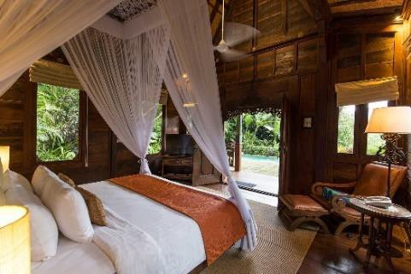

Figure 34. Exclusive Traditional Bedroom

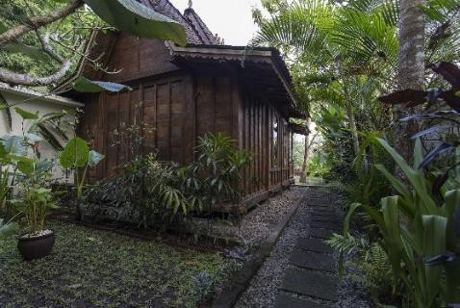
Source: Plataran, 2017

Figure 35. Exclusive Traditional Terrace Source: Plataran, 2017
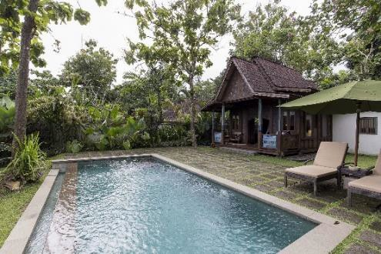
Figure 36. Exclusive Traditional Pool Source: Plataran, 2017
Available in contemporary or traditional Javanese Joglo style, the Exclusive Pool Villas offer the height of luxurious comfort, equipped with a king-size bed, spacious bathroom with rain shower and bathtub, outdoor terrace, and a separate living/dining area in selected villas. A private pool in a lush garden setting completes this tropical oasis.

Room Features :

- 403 sqm
- Private Pool 7 x 3 M

- 2 adults
- One – king size bed
- Rain shower & bathtub Room Facilities :
- Ethnic Traditional Villa
- View to Menoreh Hills
- Bathroom amenities
- Bathrobe, slippers and hairdryer
- Personal digital safe
- Wi-Fi internet access
- IDD phone
- Daily turndown service
- Umbrella and torchlight
- Mosquito coil and repellent
- Complimentary drop-off service to Borobudur Temple Room Amenities :
- 42″ LCD TV
- Minibar
- Coffee & tea-making facilities
- Complimentary bottled water
- Welcome fruit platter

- Residence Villa (3 villa)

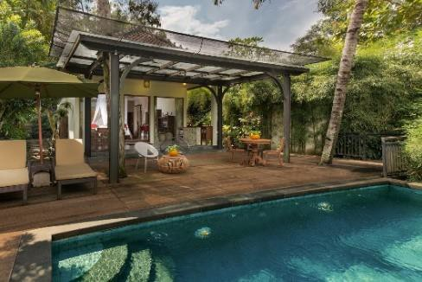
Figure 37. Residence Pool

Source: Plataran, 2017
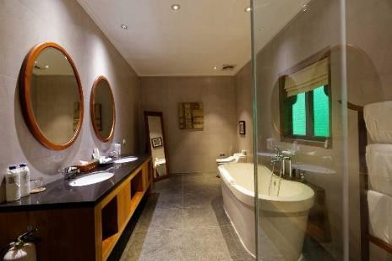
Figure 38. Residence Bathroom Source: Plataran, 2017

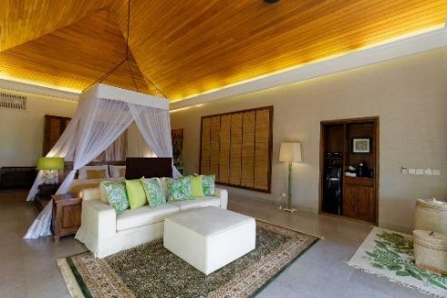
Figure 39. Residence Bedroom Source: Plataran, 2017
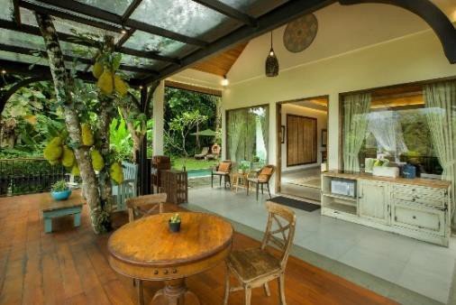

Figure 40. Residence Terrace

Plataran Residence Villas blend the luxury of modern comforts with traditional touches, to create a tranquil haven for your holidays. Nestled in lush gardens and with breathtaking views of the Menoreh Hills, these spacious and secluded hideaways each feature a large bathroom with rain shower and bathtub, a kitchenette with dining table, an outdoor terrace and a private swimming pool.

Room Features :

- 405 sqm

- Private Pool 7 x 3 M
- 2 adults
- One – king size bed
- Rain shower & bathtub Room Facilities :
- Writing desk
- Bathroom amenities
- Bathrobe, slippers and hairdryer
- Personal digital safe
- Wi-Fi internet access
- IDD phone
- Daily turndown service
- Umbrella and torchlight
- Mosquito coil and repellent
- Complimentary drop-off service to Borobudur Temple Room Amenities :
- 42“LCD TV
- Minibar
- Coffee & tea-making facilities
- Complimentary bottled water
- Welcome fruit platter
- Borobudur View Villa (3 villa)

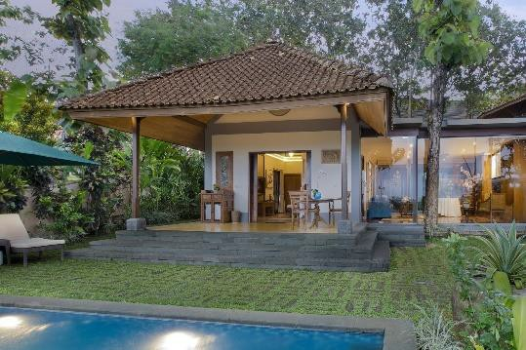

Figure 41. Borobudur Terrace

Source: Plataran, 2017
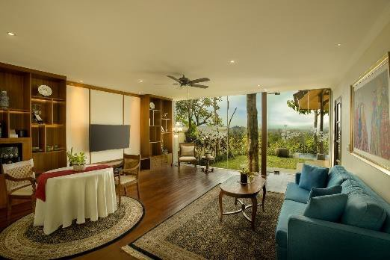

Figure 42. Borobudur Living Room

Source: Plataran, 2017

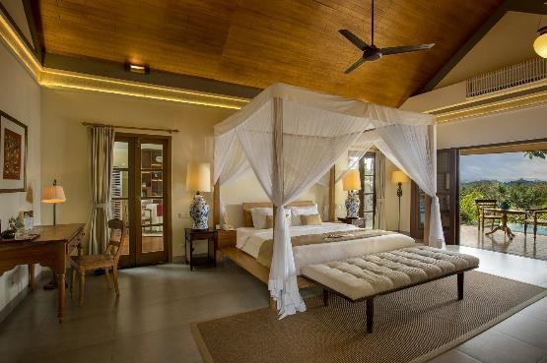
Figure 43. Borobudur Bedroom Source: Plataran, 2017
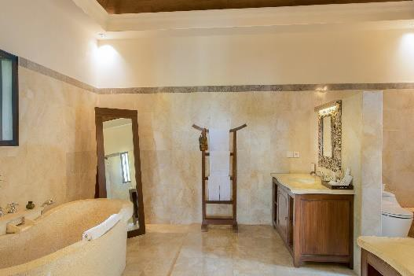

Figure 44. Borobudur Bathroom Source: Plataran, 2017
Experience the majesty of Borobudur View Pool Villas in a
sophisticated luxury of a contemporary Villa. The generous space is furnished

with a king-size bed, spacious bathroom with rain shower and bathtub, and a separate living/dining area in selected villas. Immerse in a private outdoor terrace and pool for wondrous relaxation amid lush tropical views.
Room Features :
- 652 sqm
- Private Pool 7 x 3 M
- 2 adults
- One – king size bed
- Rain shower & bathtub Room Facilities :
- Writing desk
- Bathroom amenities
- Bathrobe, slippers and hairdryer
- Personal digital safe
- Wi-Fi internet access
- IDD phone
- Daily turndown service
- Umbrella and torchlight
- Mosquito coil and repellent
- Complimentary drop-off service to Borobudur Temple Room Amenities :
- 42“LCD TV
- Minibar
- Coffee & tea-making facilities
- Complimentary bottled water
- Welcome fruit platter
- Grand Spa Pool Villa (1 villa)

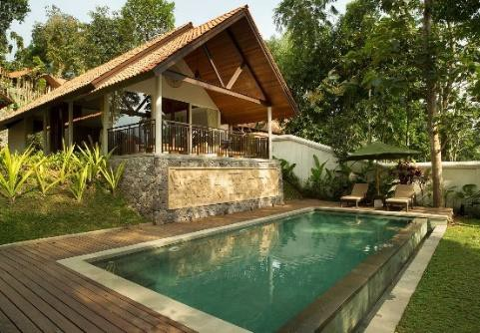

Figure 45. Grand Spa Pool

Source: Plataran, 2017
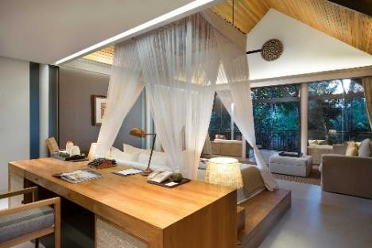

Figure 46. Grand Spa Bedroom Source: Plataran, 2017

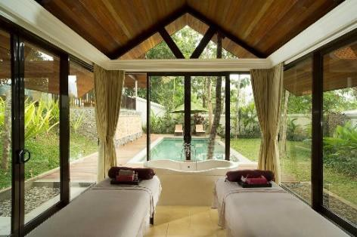
Figure 47. Spa Private Room Source: Plataran, 2017
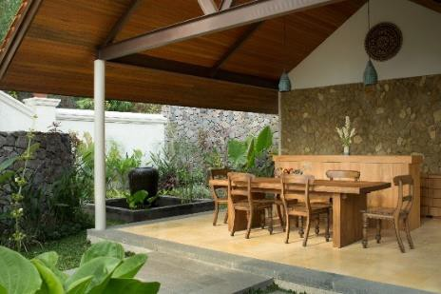

Figure 48. Grand Spa Terrace Source: Plataran, 2017

Indulge in the ultimate romantic retreat in a Grand Spa Pool Villa, featuring a couple’s spa room where one can experience pampering spa treatments in complete privacy. These spacious, open-to-the-outdoor villas include a private dining area, a terrace lounge and a private pool set in a tranquil garden.
Room Features :
- 719 sqm
- Private Pool 9 x 3,5 M
- 2 adults
- One – king size bed
- Rain shower & bathtub Room Facilities :
- Writing desk
- Bathroom amenities
- Bathrobe, slippers and hairdryer
- Personal digital safe
- Wi-Fi internet access
- IDD phone
- Daily turndown service
- Umbrella and torchlight
- Mosquito coil and repellent
- Complimentary drop-off service to Borobudur Temple Room Amenities :
- Couple’s spa room
- 42″ LCD TV
- Minibar
- Coffee & tea-making facilities
- Complimentary bottled water
- Welcome fruit platter
- Duplex Royal Pool Villa (3 villa)

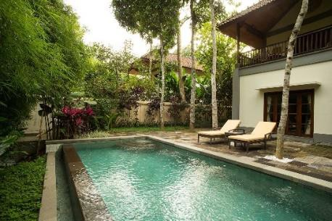

Figure 49. Duplex Royal Pool

Source: Plataran, 2017
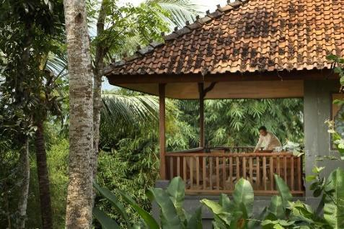
Figure 50. Duplex Royal Second Floor Source: Plataran, 2017

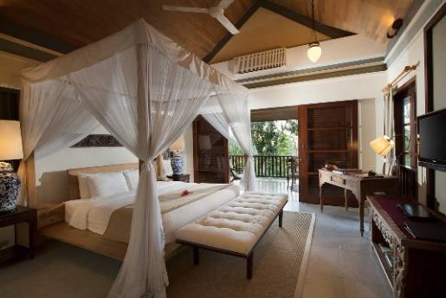
Figure 51. Duplex Royal Bedroom Source: Plataran, 2017
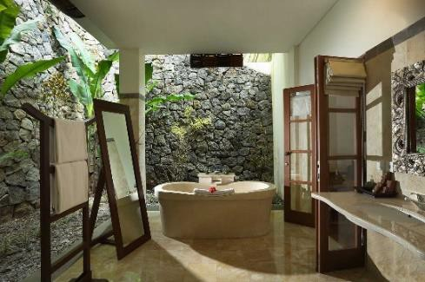

Figure 52. Duplex Royal Bathroom Source: Plataran, 2017

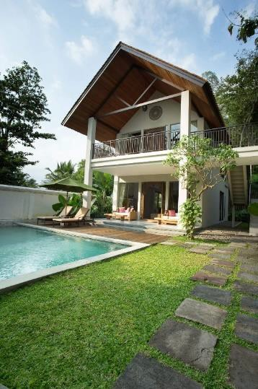

Figure 53. Duplex Royal Pool Source: Plataran, 2017
The two-storey villas make ideal family retreats with two spacious
bedrooms, bathrooms with rain shower and deep soaking tub, private garden with swimming pool, and a large balcony offering panoramic views of the picturesque landscape.
Room Features :
- 473 sqm
- Private Pool 7 x 3 M
- Two – king size bed
- Rain shower & Bathtub Room Facilities :
- Writing desk
- Bathroom amenities
- Bathrobe, slippers and hairdryer
- Personal digital safe
- Wi-Fi internet access
- IDD phone
- Daily turndown service
- Umbrella and torchlight
- Mosquito coil and repellent
- Complimentary drop-off service to Borobudur Temple Room Amenities :

- 42″ LCD TV
- Minibar
- Coffee & tea-making facilities
- Complimentary bottled water
- Welcome fruit platter

Organizational Structural and Main Task
Vivek Khumar
General Manager
Yuliyanto Rossy
Executive Chef
Aan Ghaisan
Sous Chef
Marselia
Chef de Parttie
Galuh Ariano
Chef de Partie
Natalia
Chef de Partie
Fitri
Commis
Nadya
Trainee

    - General Manager
      - Analyze data for all employees as a reference material to improve future performance.
      - Controlling the daily operations of the various department in order to create a harmonious working climate.
      - Work in accordance with the company's vision and mission in order to achieve the goals that have been determined.
      - Maintain good cooperation between cooperation partners by maintaining continuous connections.
      - Attending seminars or invitations in order to increase channels and networks as an effort to expand the marketing network
      - Work quickly and effectively as a role model for employees because as someone with that position we become model workers to be imitated.
      - Work with high loyalty and full of professional skills relevant to the field of work.
      - Managing the hotel’s budget and finances with the aim of achieving efficiency and cost-effectiveness
      - Responding to customer complaints in a timely manner

Executive Chef
      - Checking the list of orders for goods to the warehouse, as a kitchen request (Ordering goods for kitchen purposes)
      - Type menus or create menus for sale by waiters or food and beverage product staff.
      - Make an annual budget to prepare food ingredients to be sold.
      - Make an annual work plan as a work target or annual revenue to become an order for achieving targets in the future.
      - Always attend meetings between the heads of other sections, as determined by the General Manager.
      - Organize & supervise all kitchen tasks, especially in the process of procuring and processing food in accordance with established standards.

      - Supervise the implementation of work procedures, work safety, and fulfill the completeness or work attributes in order to create a safe work environment.
      - Fully supervise the food storage area and equipment that will be used for smooth work operations.
      - Maintain a standard food cost (standard price) which is directly proportional to the standard portion, so that the prices listed on the menu have been carefully calculated.
      - Fully control and carry out overall food production activities.
      - Cooperating with the F & B manager, especially in terms of providing food and drinks at banquets or meetings organized by the hotel.
      - Be creative in creating new menus, in an effort to attract consumers, but this is an additional task.
      - Supervise the order in the preparation of buffet menus so that they run regularly and well.

Sous Chef
      - Taking charge of kitchen opening, closing and other side duties as directed by the Executive Chef
      - Preparing meals and food to meet the specifications of guests in a timely manner
      - Properly measuring kitchen ingredients and food portions
      - Ensuring kitchen staff adhere to set standards, procedures, department rules and sanitation requirements
      - Managing the kitchen inventory and ensuring supplies are fresh and of high quality
      - Ensuring proper food temperatures when cooking and proper storage afterward
      - Keeping the workstation and kitchen equipment clean, organized and sanitized

      - Provide support to junior kitchen employees with various tasks including line cooking, food preparation, and dish plating. Create schedules for kitchen employees and evaluate their performance.

Chef de Partie
      - Takes care of daily food preparation and duties assigned by the superiors to meet the standard and the quality set by the Restaurant.
      - Follows the instructions and recommendations from the immediate superiors to complete the daily tasks.
      - Coordinates daily tasks with the Sous Chef.
      - Responsible to commis.
      - Able to estimate the daily production needs and checking the quality of raw and cooked food products to ensure that standards are met.
      - Ensure that the production, preparation and presentation of food are of the highest quality at all times.
      - Ensure highest levels of guest satisfaction, quality, operating and food costs on an ongoing basis.
      - Knowledge of all standard procedures and policies pertaining to food preparation, receiving, storage and sanitation.
      - Full awareness of all menu items, their recipes, methods of production and presentation standards.
      - Follows good preservation standards for the proper handling of all food products at the right temperature.
      - Operate and maintain all department equipment and reporting of malfunctioning.
      - Ensure effective communication between staff by maintaining a secure and friendly working environment.
      - Establishing and maintaining effective inter-departmental working relationships.
      - Have excellent knowledge of menu creation, whilst maintaining quality and controlling costs in a volume food business.
      - Personally responsible for hygiene, safety and correct use of equipment and utensils.

      - Checks periodically expiry dates and proper storage of food items in the section.
      - Consults daily with Sous Chef and Executive chef on the daily requirements, functions and also about any last minute events.
      - Guides and trains the subordinates on a daily basis
      - Daily feedback collection and reporting of issues as they arise.
      - Assess quality control and adhere to hotels service standards.
      - Carry out any other duties as required by management.

Commis
      - Measuring meal ingredients accurately for the chef de partie
      - Preparing mise en place, as directed by the chef de partie
      - Receiving deliveries and verifying that all ordered items are received and are good quality
      - Taking inventory of restaurant supplies and notifying the supervisor when stock is low
      - Disposing of the expired and spoiled food items stored in stock rooms, refrigerators, and freezers
      - Cleaning and ensuring that all the work stations are organized and properly sanitized
      - Assisting other chefs
      - Monitor the quality and quantity of food that is prepared

Trainee
      - Assisting the commis preparing mis en place
      - Responsible to do set up, restocking, maintain and closing buffet area
      - Responsible to do live cooking in the show kitchen and buffet area
      - Cleaning work areas and utensils, and personally participates in such tasks when required.
      - Assisting others when there is an order or in rush hour
      - Collecting stocks and ingredients from store area
      - Arranging the inventory area and assisting commis to update stock

