APPENDIX

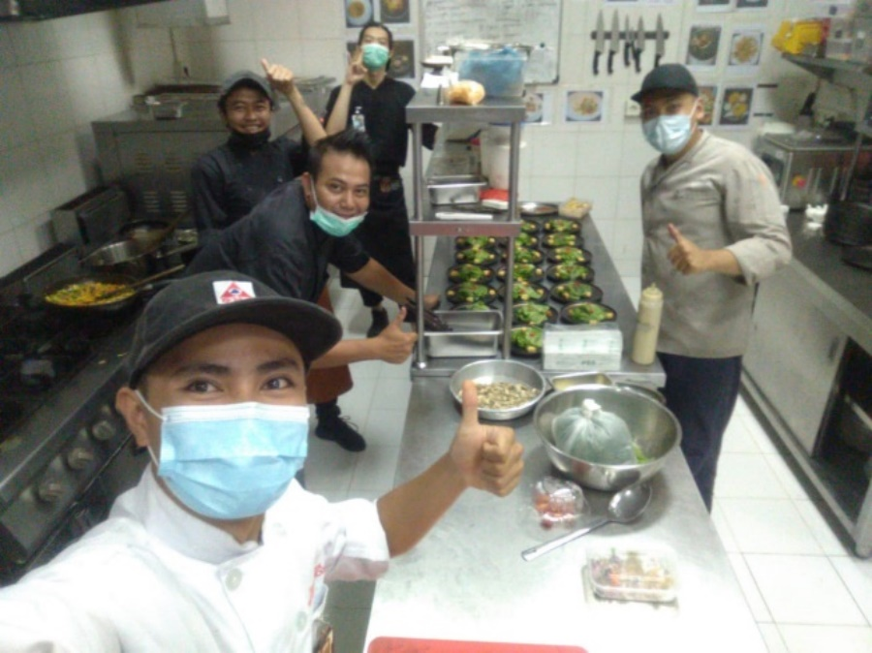
5.1 Pianoza Crew
Picture 19. Photo with crew for birthday set menu event

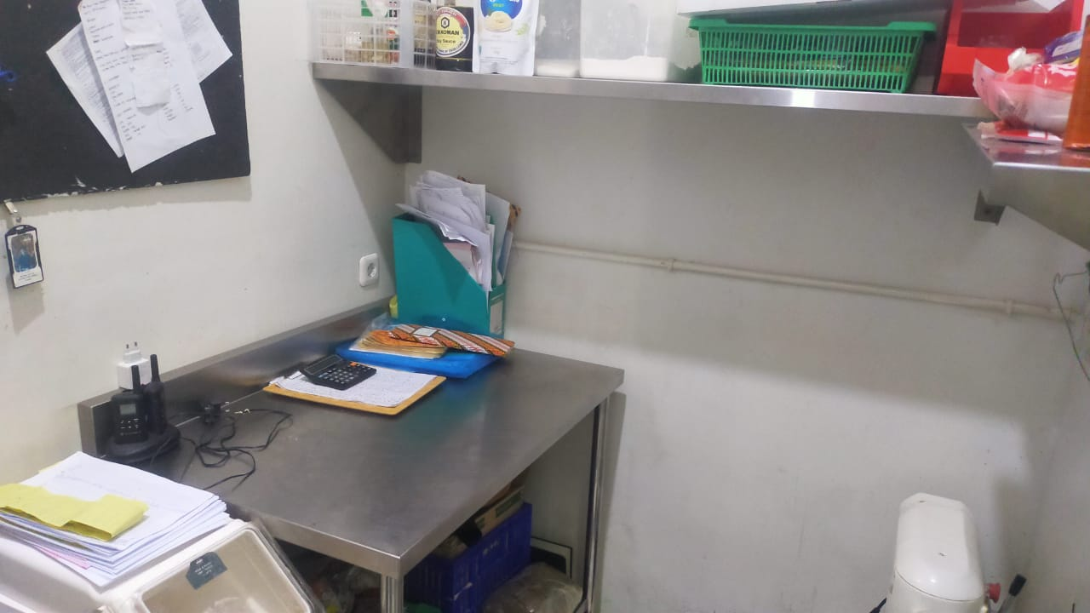
5.2 Dry Storage
Picture 20. Dry Storage

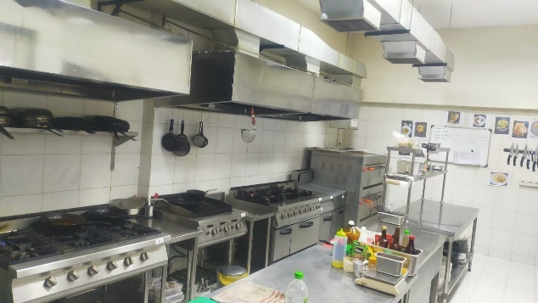
5.3 Kitchen Area
Picture 21. Kitchen Area

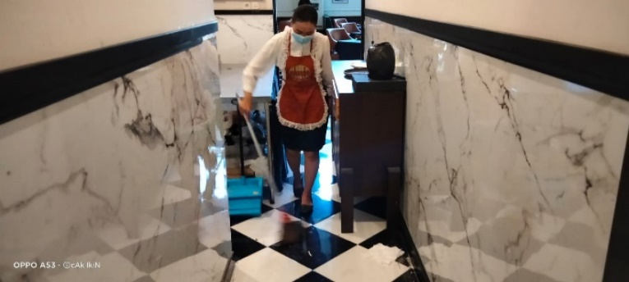
5.4 Service area
Picture 22. Service Area

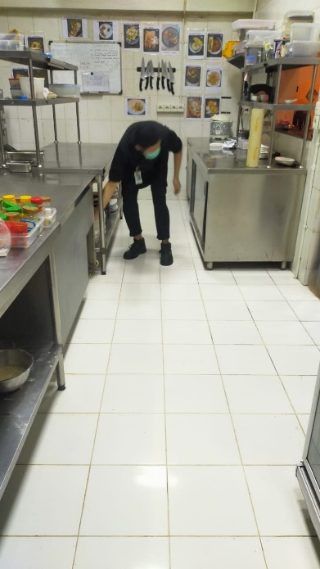
5.5 Plating Area
Picture 23. Plating Area
5.6 PPKM Menu
Picture 24. PPKM Menu

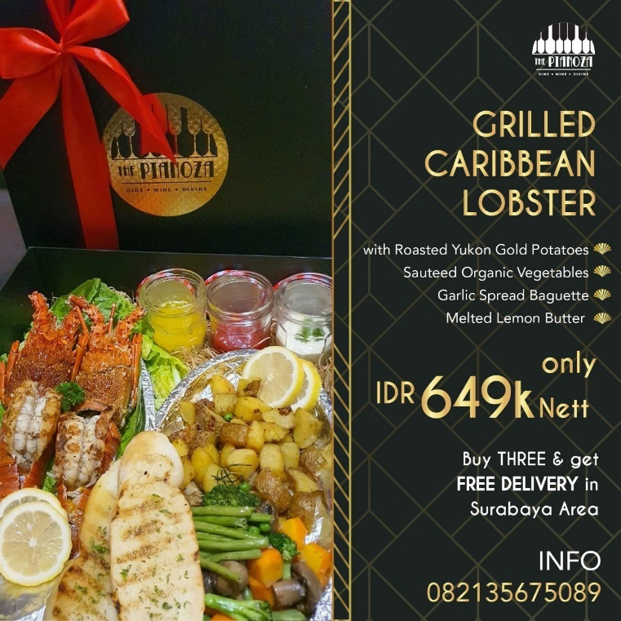
5.7 Hampers Menu
Picture 25. Hamper Menu

Picture 26. Hampers Menu 2
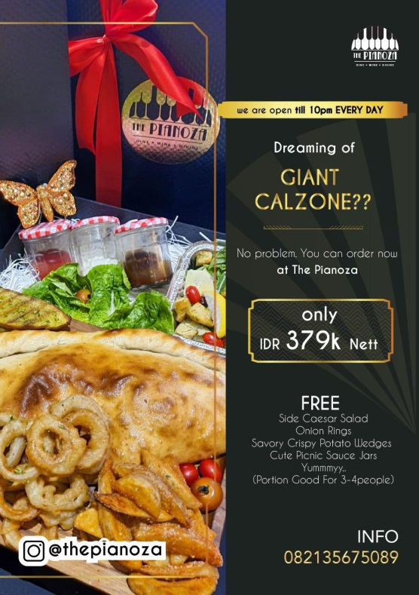
Picture 27. Hamper menu 3

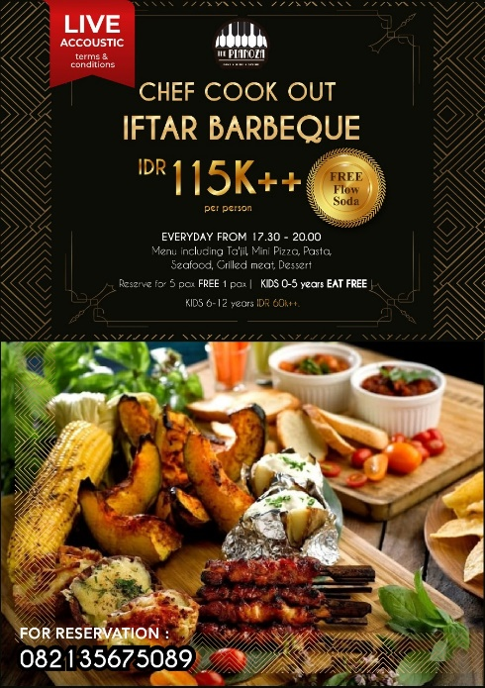
5.8 Iftar Buffet Menu
Picture 28. Iftar Buffet Menu

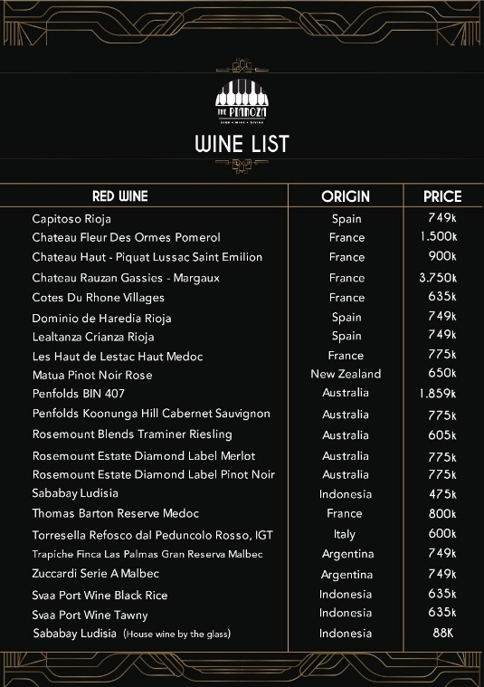
5.9 Wine Menu
Picture 29. Red Wine Menu

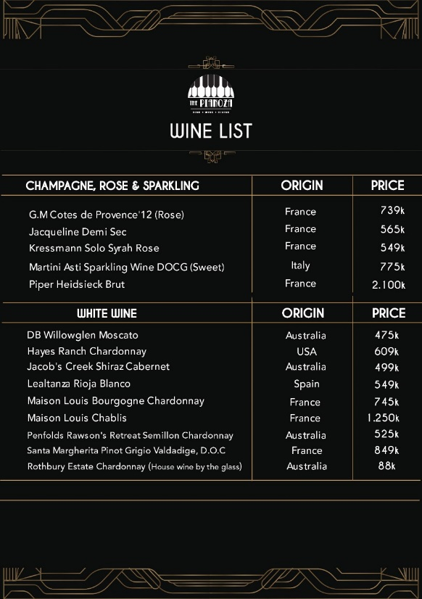
Picture 30. White Wine Menu
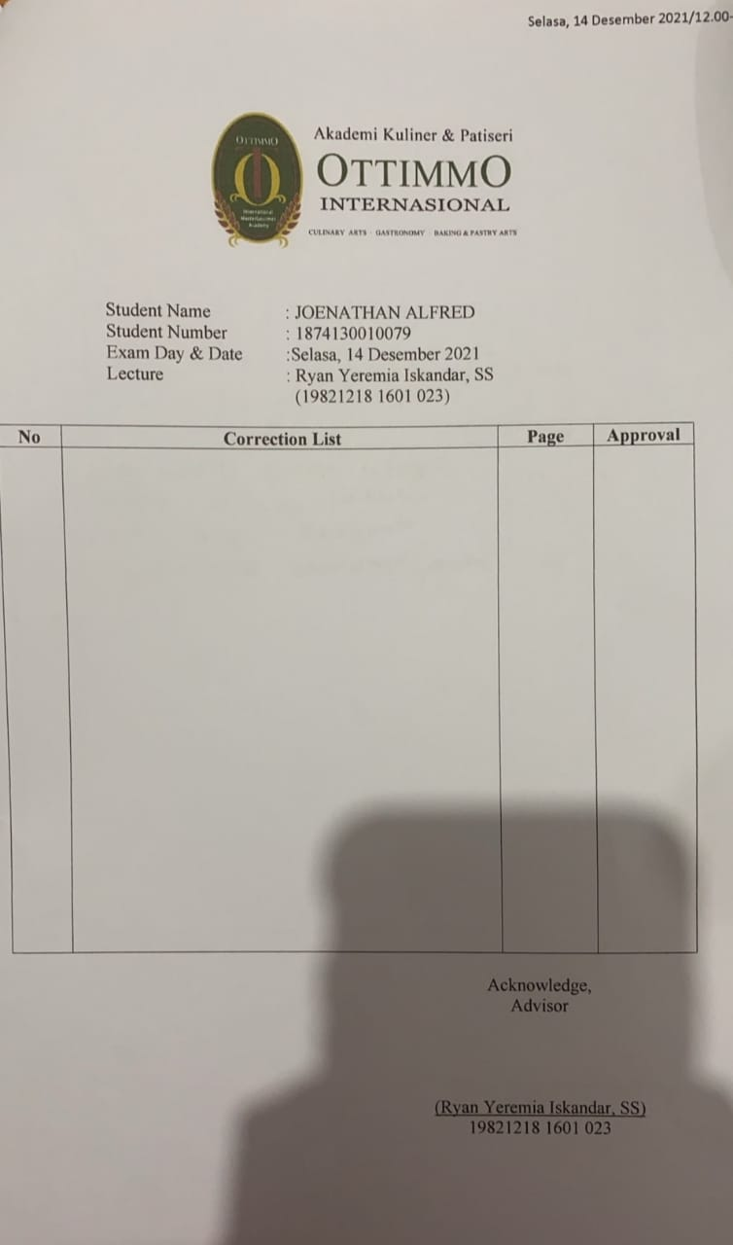
5.10 Revise Form Advisor
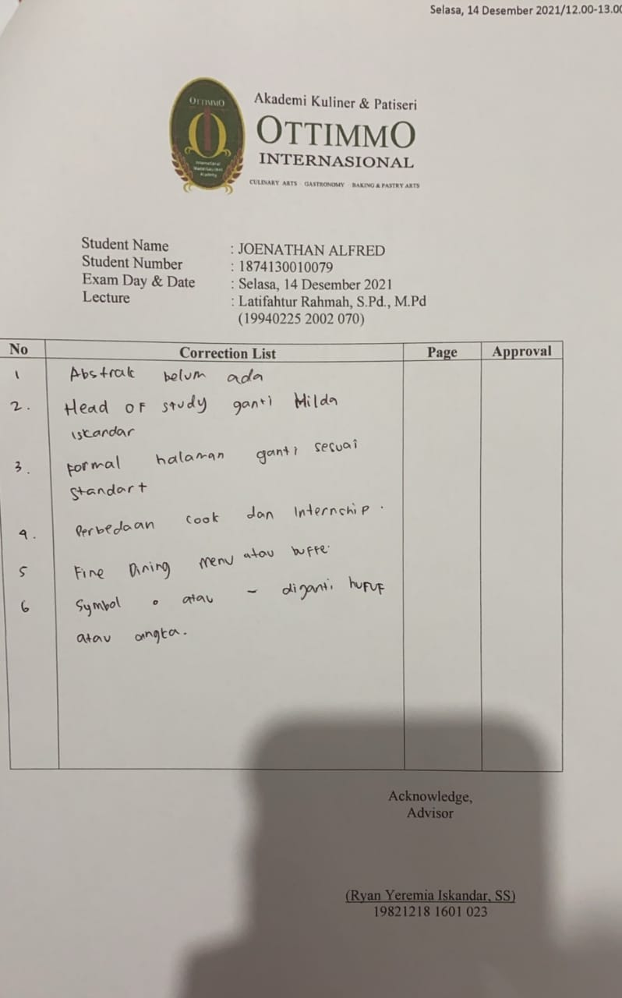
5.11 Revise Form Examiner 1
5.12 Revise Form Examiner 2
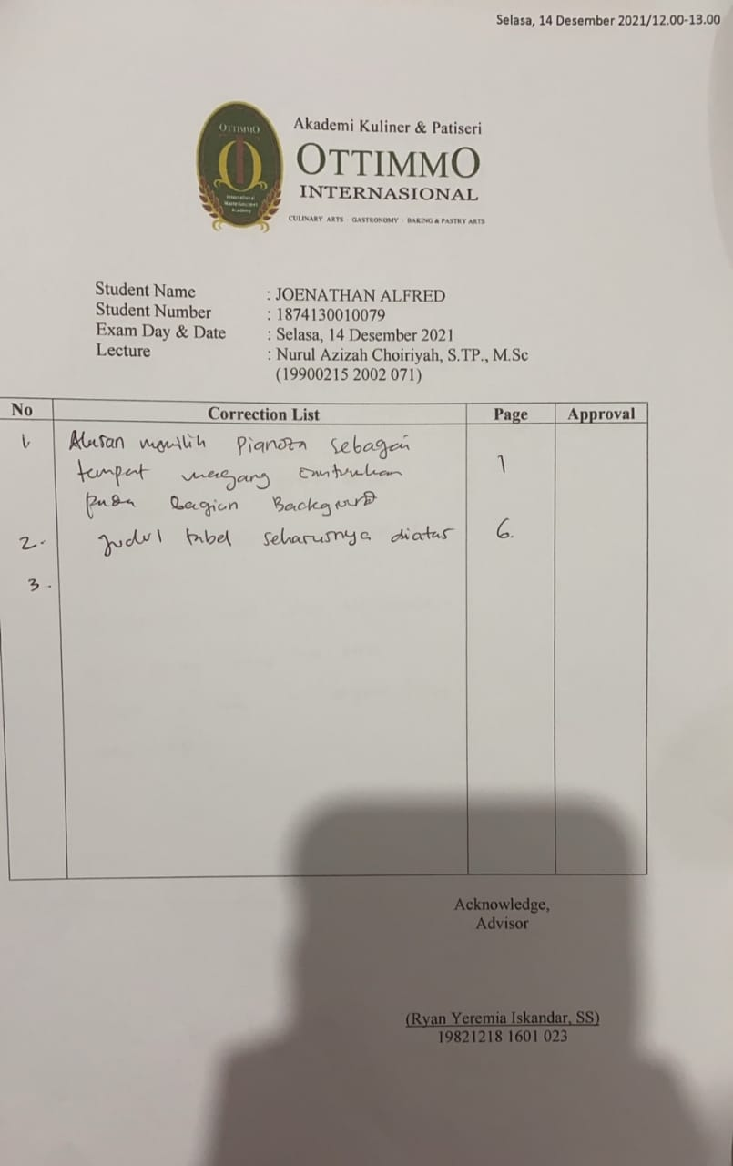
5.13 Internship Certificate
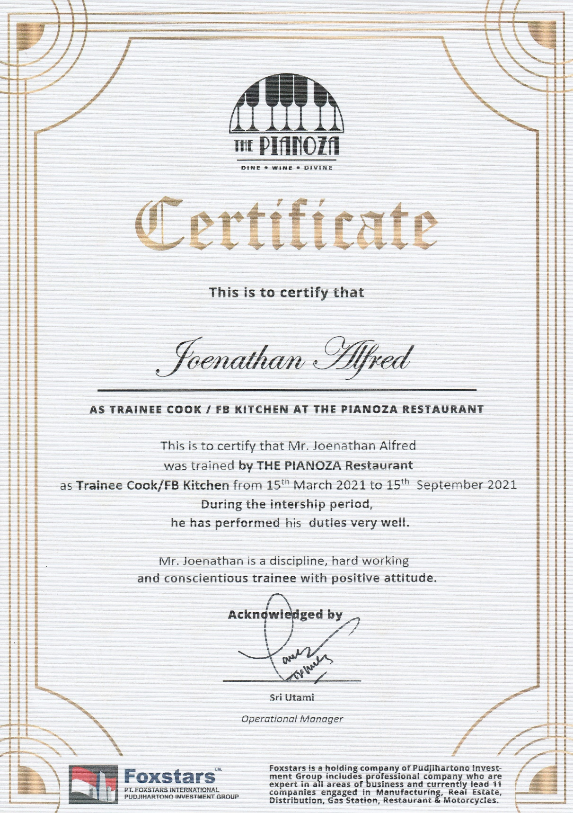

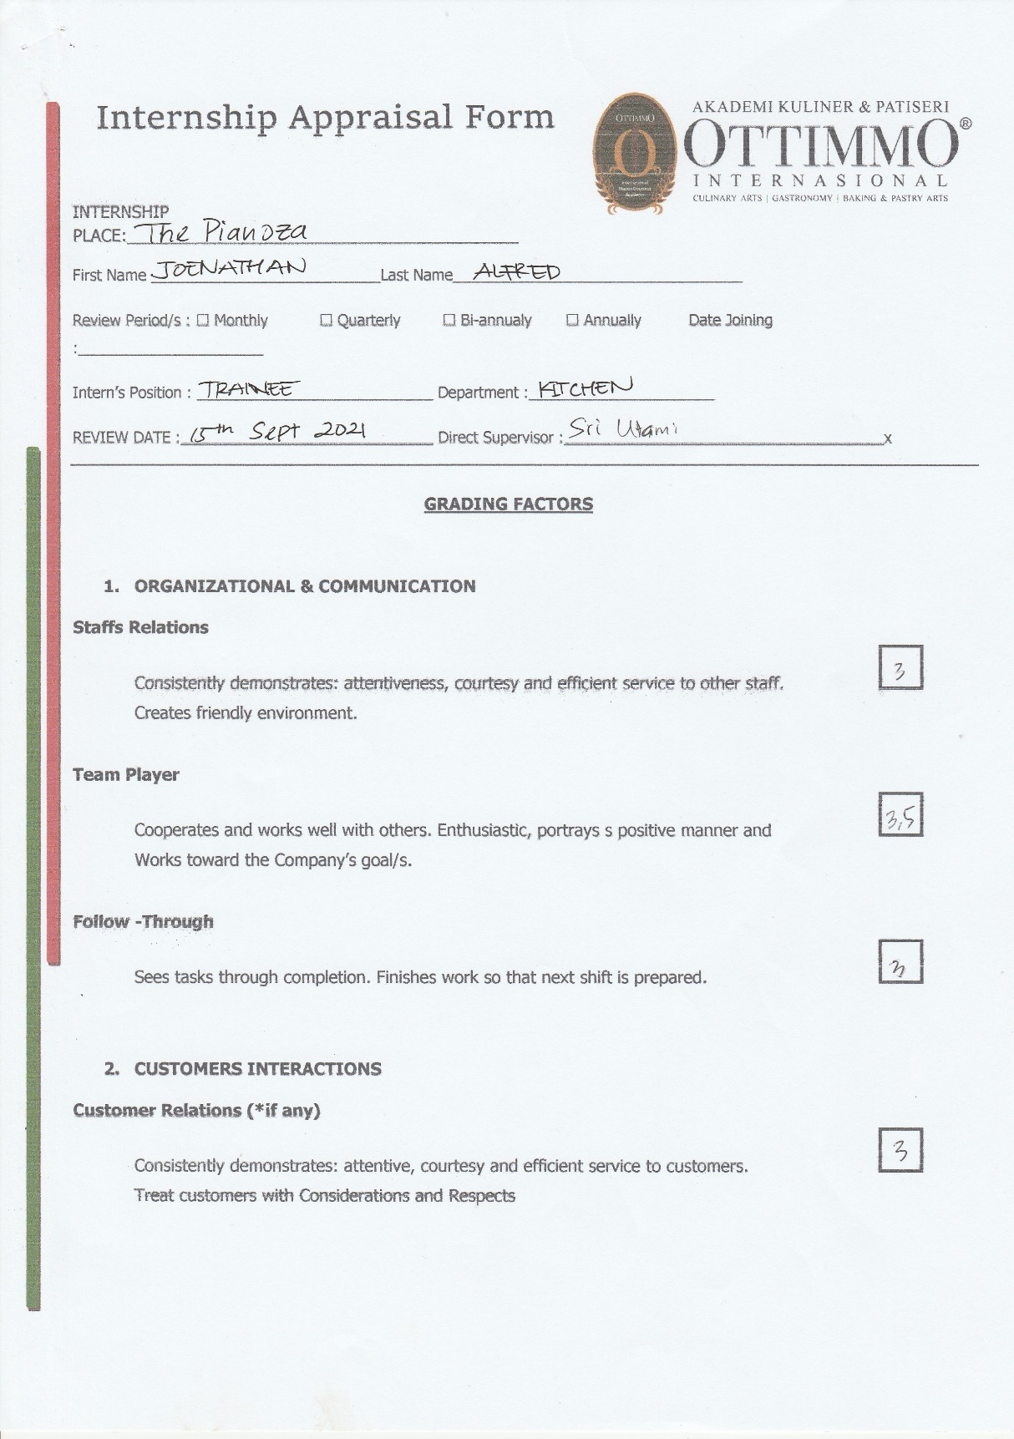
5.14 Internship Appraisal Form
