BILIOGRAPHY

Lombok Plaza Hotel Website, 2015 Lombok Plaza
https://www.lombokplazahotel.co.id/
Lombok Plaza Hotel Website, 2015 Suite Room
https://www.lombokplazahotel.co.id/
Lombok Plaza Hotel Website, 2015 Meeting Room
https://www.lombokplazahotel.co.id/
Lombok Plaza Hotel Website, 2015 Restaurant
https://www.lombokplazahotel.co.id/
Lanny Rustan, 27 Agustus 2020, 30 Resep Jajan Pasar Ala Master Kue Tradisional, Gramedia Pustaka Utama

APPENDIX

Appendix 1. Trainee Schedule
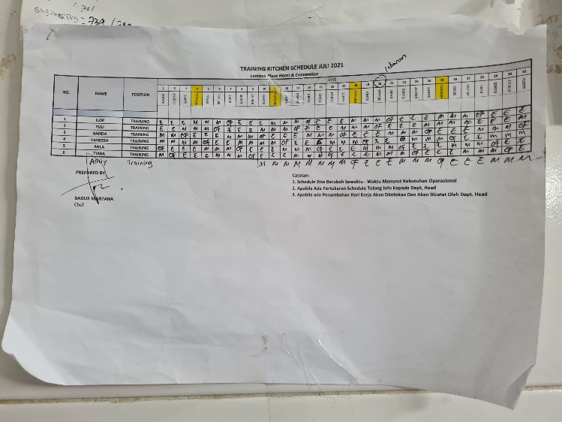
Picture 25. Schedule
Appendix 2. Team Pastry Lombok Plaza
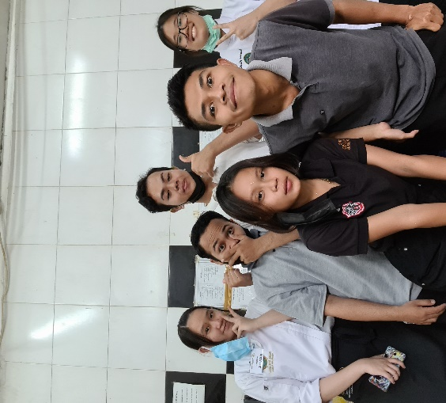
Picture 26. Team pastry
Appendix 3. Hotel Logo
Picture 27. Logo

Revise Form
