CHAPTER II
GENERAL DESCIPTION OF COMPANY
Lombok Plaza Hotel & Convention is a 3 star hotel located in the area Cakranegara, Mataram. The hotel is located in the central business and commercial district of Mataram. With its strategic location, Lombok Plaza Hotel & Convention have easy access to a variety of entertainment and activities, Lombok Plaza Hotel & convention is an ideal accommodation choice.
This hotel consists of 142 rooms with Superior, Deluxe, Cabanas, plaza suite & Presidential suite.
The Plaza Suite and the Presidential Suite. With the following information:
1. Superior number (107) rooms
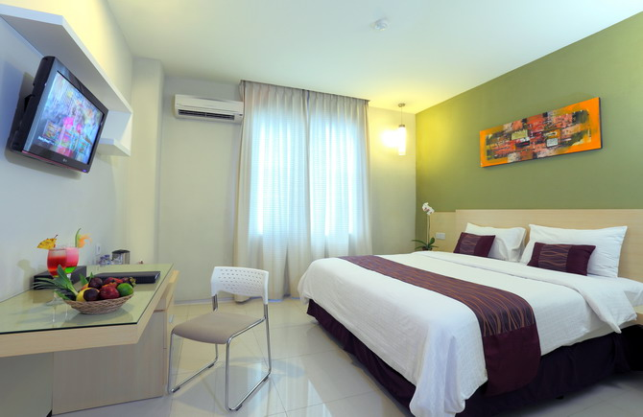Picture 1.
2. Deluxe number of (4) rooms
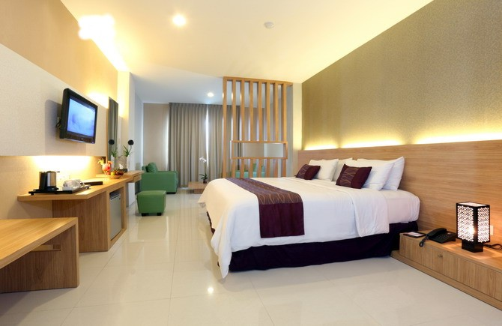Picture 2.

3. Cabanas (18) rooms
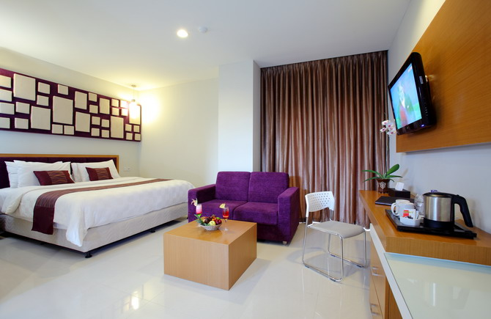Picture 3.
4. CABANAS Suites (6) rooms
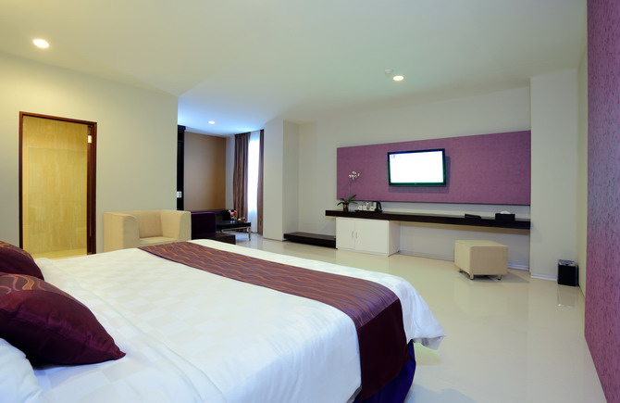Picture 4.
5. The Plaza Suite (3) rooms
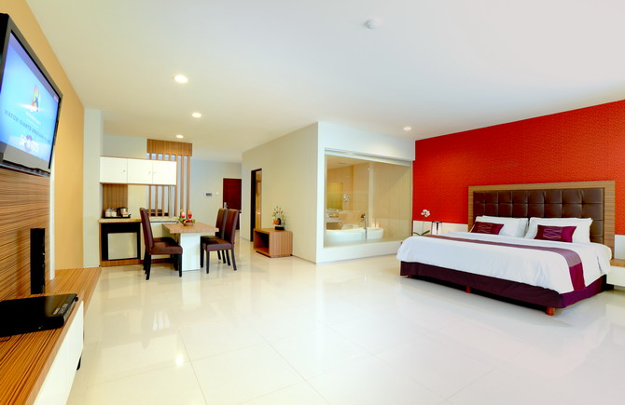Picture 5.

6. The Presidential Suite 4 rooms
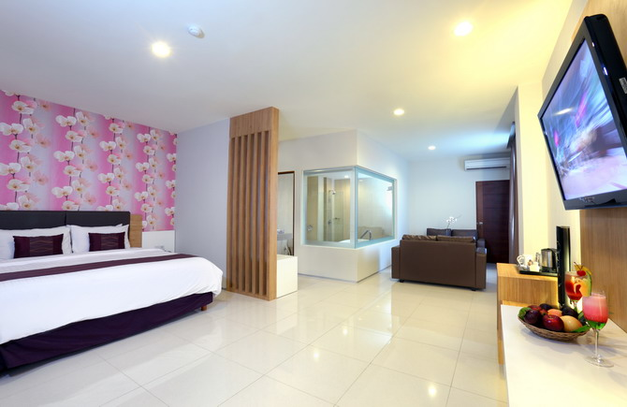Picture 6.
The Hotel has a variety of facilities and service including Restaurant, Lobby lounge, Family karaoke, SPA, Poll, Business canter, 24-hour in-room dinning, Laundry, Parking area, and Broadband internet access. This Hotel has 10 meeting rooms of business and private events in Mataram.
- History of company
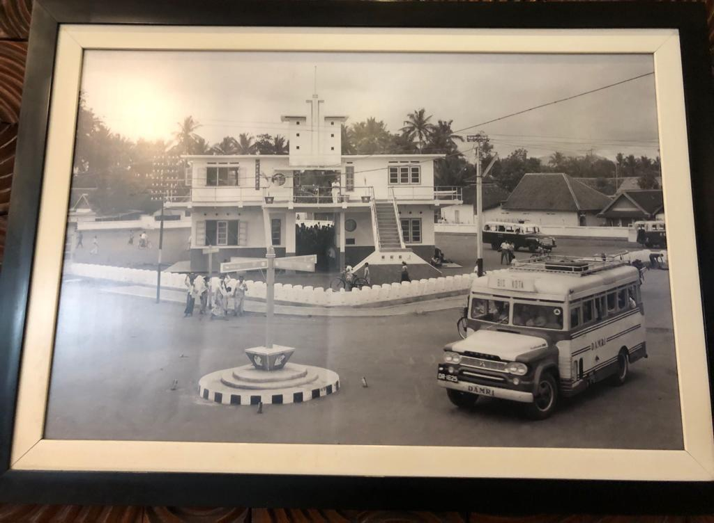 Picture 7.
Lombok Plaza Hotel is located in the city of Mataram, Jl. Pejanggik No.8, Mataram, was founded by PT. Sinar Mas Cakra Buana as a city a hotel with a soft opening on 27 April 2011. Before becoming a hotel in 1939 it was one of the terminals in Cakra Negara (Picture 7), and after that in 1990 it turned into a plaza (KFC).
Lombok Plaza Hotel & Convention is a new luxury that has emerged in the middle of the city, with a modern and elegant hotel design. This hotel is located right in the area urban areas, this hotel offers several types of clean and comfortable rooms such as Superior, Deluxe,
The Plaza Suite and the Presidential Suite. Please choose according to your taste. In addition, this hotel is also equipped with various facilities, such as a comfortable meeting place with modern decorations, a wedding venue and theatre. There is also a shuttle bus available if you want to go around the city of Mataram to visit Senggigi Beach which is a famous tourist spot among domestic and foreign tourists.

- Vision, Mission and Company Objectives
Mission
Hotel Lombok Plaza's mission is to place hospitality services at the highest level to meet the demands and expectations of existing guests so that our hotel has zero complaints. Our goal is to make Lombok plaza a hotel for meetings, business success, wedding ceremonies, fun gatherings and gala ceremonies.
Vision
The ideology of our vision is to continue to apply and set the highest standards of service quality and in that way justify and uphold the reputation that we have among the guests, partners, competitors and the wider community. We use and constantly introduce environmentally friendly technologies and processes in order to remain in balance with nature and also meet the needs of contemporary society.
Strategy
Our strategy is based on:
1. Partnership with guests
Guest satisfaction is the most important thing for us and we try with our quality of services to exceed their expectations. Our goal is to make every guest feel like at home and that for this reason he chooses Lombok plaza hotel again for his accommodation facility. We provide services at the highest level that will meet the needs and expectations of guests and will recognize their requirements through open communication, satisfaction monitoring and analysis of compliments and complaints.
2. Employees
Accepting new knowledge and technologies is a condition for progress including quality training and education.
Because of that our strategy is based on the education and training of all employees and constant communication between all departments of the hotel. We support teamwork, personal responsibility and initiative of each employee.

- Organizational Structure And Main Task
Executive Chef

Sous Chef

Chef De Pertie Pastry
Chef De Pertie Butcher

Chef De Pertie
Kitchen

Demi Chef Cold
Commis 1

Trainee
Commis 2

Trainee
Cook Helper/ Steward

Table.1
Main Taks
1. Executive Chef
Duties and responsibilities:
a. Supervise and check the needs and materials needed kitchen needed.
b. Control and supervise the quality of food ingredients.
c. Supervise food production before serving to guests.
d. Maintain food quality standards.
e. Evaluate the work of the kitchen staff.
f. Develop a work program.
g. Maintain occupational health and safety in the kitchen.
h. Maintain food coast standards.

2. Sauce chef/Assistant chief cook
a. Assist the executive chef in organizing and supervising all kitchen tasks, especially in the procurement process and food processing
b. Replaces the Executive Chef position if he is absent or holiday.
c. Supervise treatment, use of available food commodities in the kitchen, in order to facilitate the work of the kitchen team itself
d. Checking completeness, accuracy of mice in place and layout the presentation of the food according to the standard of the food itself.
e. Researching restaurant orders requested by guests brought by F&B Product and function order and pass it on to the chef de party
f. Prepare sales product reports sold today, yesterday and previously
g. Supervise the management of food hygiene (free of germs), sanitation
Work environment.
h. Setting up the buffet table and food display
i. Handling, asking guest complaints about the quality of the food
j. Assisting the smooth implementation of physical inventory
3. Chef De Partie
Cold kitchen is one part of the kitchen that is responsible for responsible for the manufacture and processing of Appetizers, making salads and dressings.
Chef De Partie Duties:
a. Supervise the smooth day-to-day work of the cold kitchen section
b. Give daily tasks to each cook under him
c. Supervise kitchen operations for each shift
d. Resolve all problems that arise when operational
e. Provide operational briefing every day
f. In charge of preparing all kinds of appetizers (appetizer)
g. Arrange cold food served on the buffet.
h. Make buffet table decorations made of butter, ice cubes, vegetable & fruit carvings.
i. Making sandwiches, canapés & savories
j. Making salads & sauces and cold dressings (dressings)

4. Chef De Partie Butcher
Butcher is a responsible part of the kitchen in foodstuffs such as poultry, fish meat and other marine products.
Chef De Partie Butcher Duties:
a. Prepare food ingredients such as poultry, meat, fish that have been cooked cleaned and cut
b. Cutting the bones of stock base ingredients for a sexy need
c. Cut meat, poultry, fish, into portions like fillets steak, sirloin steak, darned and others.
d. Cleaning food ingredients such as poultry, meat, fish and produce other seas.
e. Maintain the cleanliness of the food to be processed
f. Maintain hygiene and sanitation where food stock is placed
5. Chef De Partie Pastry (CPD Pastry)
Also known as station chef or line cook. He is responsible for certain areas of the kitchen in this case dealing with pastry.
Duties of Chef De Partie Pastry (CDP pastry)
a. Make the type of cake served for dessert
b. Processing fruits for dessert
c. Make a sweet sauce served with cake
d. Making ice cream & shorbet and dishes made from ice cream base & shorbet
e. Arrange cakes for buffet
f. Make decorations for buffet tables such as snow houses, decorations of brown sugar, and others.

6. Chief Steward
Chief Steward is the position of someone who takes care of kitchen utensils and a restaurant in a hotel. As a worker who strives cleanliness of the work area environment, so as to avoid interference health for guests and hotel employees.
Chief Steward Duties:
a. Responsible for the cleanliness of all kitchen areas, including floors, walls, glass walls and so on
b. Doing light work / without a lot of responsibility assigned by the head/head of the section, for example cleaning vegetables, potatoes, onions and so on.
c. Looking for and or sending food / food ingredients to other parts of the kitchen, such as getting a restaurant / kitchen grill that is outside the main kitchen (main kitchen)
d. Collect and send dirty laundry to the laundry section then receive clean laundry for the kitchen such as towels, napkins cookware, apron, other cleaning cloth.
e. Responsible for the work done by his subordinates
f. Organize and assist subordinates to maintain and cleaning the utensils used by the restaurant.

