INTERNSHIP REPORT
LOMBOK PLAZA HOTEL MATARAM

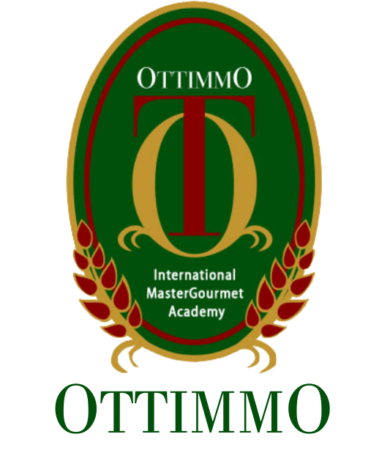

By:
VANESSA CAKRA
1874130010028

STUDY PROGRAM OF CULINARY ART
OTTIMMO INTERNATIONAL
MASTER GOURMET ACADEMY SURABAYA
2021

INTERNSHIP REPORT
LOMBOK PLAZA HOTEL

Arranged by:
VANESSA CAKRA (1874130010028)
Done the internship period from April, 7th 2021 at LOMBOK PLAZA HOTEL

Approved by:

Supervisor, Examiner I, Examiner II,

Hilda Tjahjani Iskandar, Irra Chrisyanti Dewi, Gilbert Yanuar Hadiwirawan, SE, AK, CA S.PD.M.S.M A.MD.Par
NIP. 196910292002072 NIP.197812011702028 NIP.199001011701041

Knowing,
Director of OTTIMMO Head of Study Program Culinary art, International MasterGourmet OTTIMMO International Academy, Mastergourmet Academy,

Zaldy Iskandar, BSc. Hilda Tjahjani Iskandar, SE, AK, CA NIP.197310251201001 NIP. 196910292002072

APPROVAL BY
Title : LOMBOK PLAZA HOTEL MATARAM
Company Name : LOMBOK PLAZA HOTEL
Company Address : Jl. Pejanggik No.8, Cakranegara Bar., Kec. Cakranegara, Kota Mataram, Nusa Tenggara Barat. 83231
No. Telp. / Fax. : (0370) 643999
Which is carried out by students of Culinary Art study program OTTIMMO internasional MasterGourmet Academy Surabaya
Name : Vanessa Cakra
Student No : 1874130010028
Has been tested and declared successful.

Approve, Mataram, November 24 ^{th} 2021 Advisor, Supervisor

Hilda Tjahjani Iskandar, SE, AK, CA Bagus Martana
NIP. 196910292002072 Executive Chef

Acknowledged by,
Director of OTTIMMO Internasional MasterGourmet Academy Surabaya

Zaldy Iskandar, BSc. NIP.197310251201001

ACKNOWLEGEMENT
First, I would like to thank my JESUS Christ for the blessings to complete this intership, so that I can prepare this internship report with the goal is to be able to complete the internship report assignment.
This internship report explains the various activities that I do in this internship that I did this 6 months, in Lombok plaza hotel. This internship report discusses the process of my internship at the Lombok Plaza Hotel.
During this process of completing this report, I received so much guidance and support. By this, I would like to express my gratitute to the names below:
- My parents who have support and provided me to achive good eduction.
- Ms . Hilda Tjahjani Iskandar, SE, AK, CA as my intership mentor who guide me.
- Ms . Hilda Tjahjani Iskandar, SE, AK, CA as the head of study program at Ottimmo Internasional.
- My friend who have assisted me by giving guidance and suggestion.

Mataram,November 24th 2021

Vanessa Cakra

PLAGIARISM STSTEMENT

I certify that this assignment/report is my own work, based on my personal study and/or research and that I have acknowledged all material and sources used in its preparation, whether they be books, articles, reports, lecture notes, and any other kind of document, electronic or personal communication. I also certify that this assignment/ report has not previously been submitted for assessment in any other unit, except where specific permission has been granted from all unit coordinator involved, or at any other time in this unit, and that I have not copied in part or whole or otherwise plagiarised the work of other students and/ or persons.
On this statement, I am ready to bear the risk/any sanctions imposed to me in accordance with applicable regulations, if in the future there is a breach of scientific ethics, or you have a claim against the authenticity of my work.

November, 24th 2021

Vanessa Cakra

TABLE OF CONTENTS
APPROVAL ADVISOR AND EXAMINER ……………………………………i
APPROVAL INTERSHIP PLACEMENT……………………………………..ii
ACKNOWLEGMENT………………………………………………………….iii
PLAGIARISM STSTEMENT………………………………………………….iv
TABLE OF CONTENT………………………………………………………….v
LIST OF PICTURE……………………………………………………………...vi
LIST OF TABLE ……………………………………………………………….vii
EXECUTIVE SUMMARY ……………………………………………………viii
CHAPTER I INTRODUCTION ………………………………………………..1
A. Background of study …………………………………………………...1
B. Industrial training objectives ……………………………………..…….1
C. The benefits of industrial training ………………………………………1
CHAPTER II General Description of Company ………………………………3
A. History of company……………………………………………………..5
B. Vision, mission, and company objectives………………………………6
C. Organizational structure and main task …………………………………7
CHAPTER III Industrial Training Activities …………………………………11
A. Place of assignment …………………………………………………...11
B. Activities performed…………………………………………………..11
3.1 Product of Internship …………………………………………………11
C. Job description based on workmanship………………………………..17
D. Problem faced and how to solve them ………………………………..25
CHAPTER IV Conclusion ……………………………………………………..26
A. Conclusion…………………………………………………………….26
B. Suggestion……………………………………………………………..26
BILIOGRAPHY ………………………………………………………………..27
APPENDIX………………………………………………………………….......28
Appendix 1. Trainee Schedule……………………………………………28
Appendix 2. Team Pastry Lombok Plaza…………………………………28
Appendix 3. Hotel Logo …………………………………………………28

LIST OF PICTURE
Picture 1 Superior Rooms…………………………………………………………3
Picture 2 Deluxe Rooms…………………………………………………………..3
Picture 3 Cabanas Rooms……………………………………………………..…..4
Picture 4 Cabanas Suites…………………………………………………………..4
Picture 5 Plaza Suites……………………………………………………………...4
Picture 6 President Suites………………………………………………………….5
Picture 7 Train Station…………………………………………………………….5
Picture 8 Putu Ayu……………………………………………………………….11
Picture 9 Kue Lumpur……………………………………………………………12
Picture10 Wajik…………………………………………………………………..12
Picture 11 Nagasari………………………………………………………………12
Picture 12 Sarang Semut…………………………………………………………13
Picture 13 Risol & Dadar Gulung ……………………………………………….13
Picture 14 Banana Cake…………………………………………………………13
Picture 15 Tape Cake…………………………………………………………….14
Picture 16 Marble Cake…………………………………………………………..14
Picture 17 Donat…………………………………………………………………14
Picture 18 Sweet Bread…………………………………………………………..15
Picture 19 Sweet Bread Set………………………………………………………15
Picture 20 White Bread…………………………………………………………..15
Picture 21 Pudding……………………………………………………………….16
Picture 22 Coffee Break Set……………………………………………………...16
Picture 23 Croissants……………………………………………………………..16
Picture 24 Bubur Mutiara………………………………………………………...17
Picture 25 Schedule………………………………………………………………28
Picture 26 Team Pastry…………………………………………………………..28
Picture 27 Logo ………………………………………………………………….28

LIST OF TABLE
Table 1 Organizational structure…………………………………………………..7
Table 2 Job description………………………………………………………….25

EXECUTIVE SUMMARY
This is the internship report based on the six month long internship program that I hadsuccessfully completed in Lombok Plaza Hotel from April 7th, 2021 to October 7th, 2021 as a requirement of my Diploma III of the Culinary Arts Program at Ottimmo Internasional MasterGourment Academy Surabaya.
Lombok Plaza Hotel & Convention is a 3 star hotel located in the area Cakranegara, Mataram. The hotel is located in the central business and commercial district of Mataram. With its strategic location, Lombok Plaza Hotel & Convention have easy access to a variety of entertainment and activities, Lombok Plaza Hotel & convention is an ideal accommodation choice.
Internship at the Lombok Plaza Hotel for 6 months was a pleasant and unforgettable experience, during author 6 months in the pastry section at the Lombok Plaza hotel I got new techniques in dealing with various problems that arise in hospitality and also in the kitchen.
During internship author get many thing like learning to adapt in the real work environment, and the importance of discipline. The author will explain the activitis intership in the report for more detail.

Keywords: Hotel, Intership, Lombok Plaza Hotel

