APPENDIX

Appendix 1. PACKAGING DESIGN

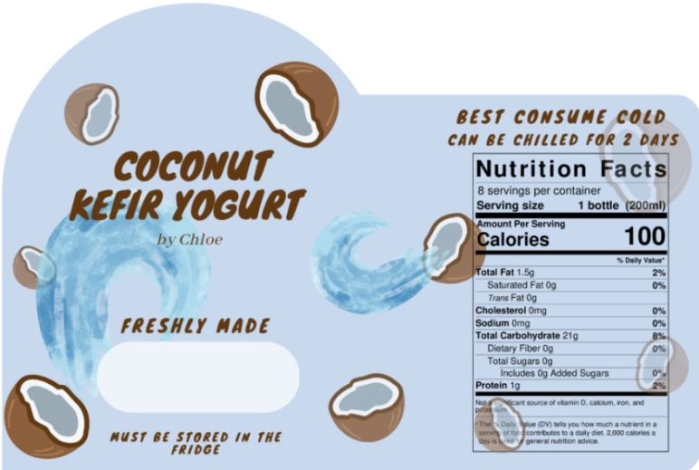
Label of our product

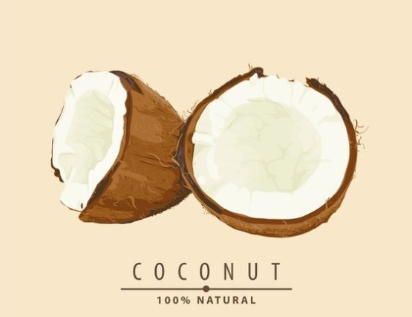
MOOD BOARD
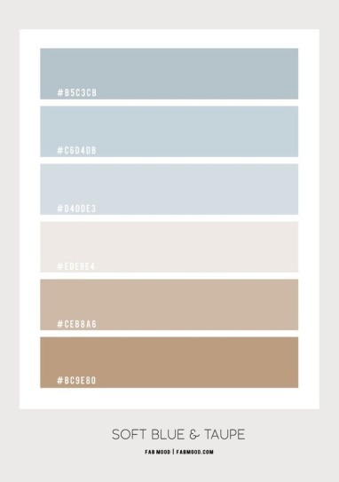

Appendix 2.
SUPPLIER LIST

- Fresh Coconut
From a coconut seller in jl. Martadireja 3, near the Jaya Bengkel, Purwokerto, jawa tengah Indonesia
- Kefir probiotics
Order through online for in purwokerto people didn’t sell kefir probiotic, buy it from Jakarta selatan.
- Packaging bottle
From toko Surya Mulia in jl. Jendral sudirman no.57, purwokerto, jawa tengah Indonesia
- Sticker
From toko advertising in jl. Gatot subroto no 76, purwokerto, jawa tengah Indonesia

Appendix 3. PRODUCT LOGO
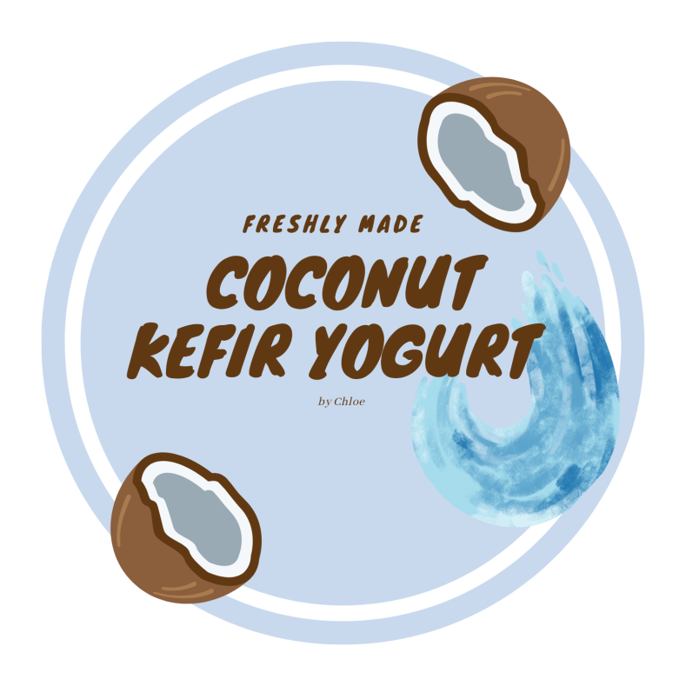

- Unpacked Product
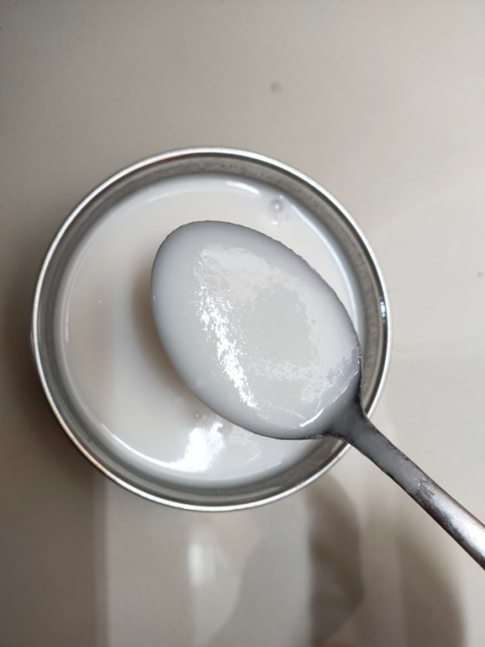

- Packed Product

