CHAPTER 2
INGREDIENTS AND UTENSILS OVERVIEW
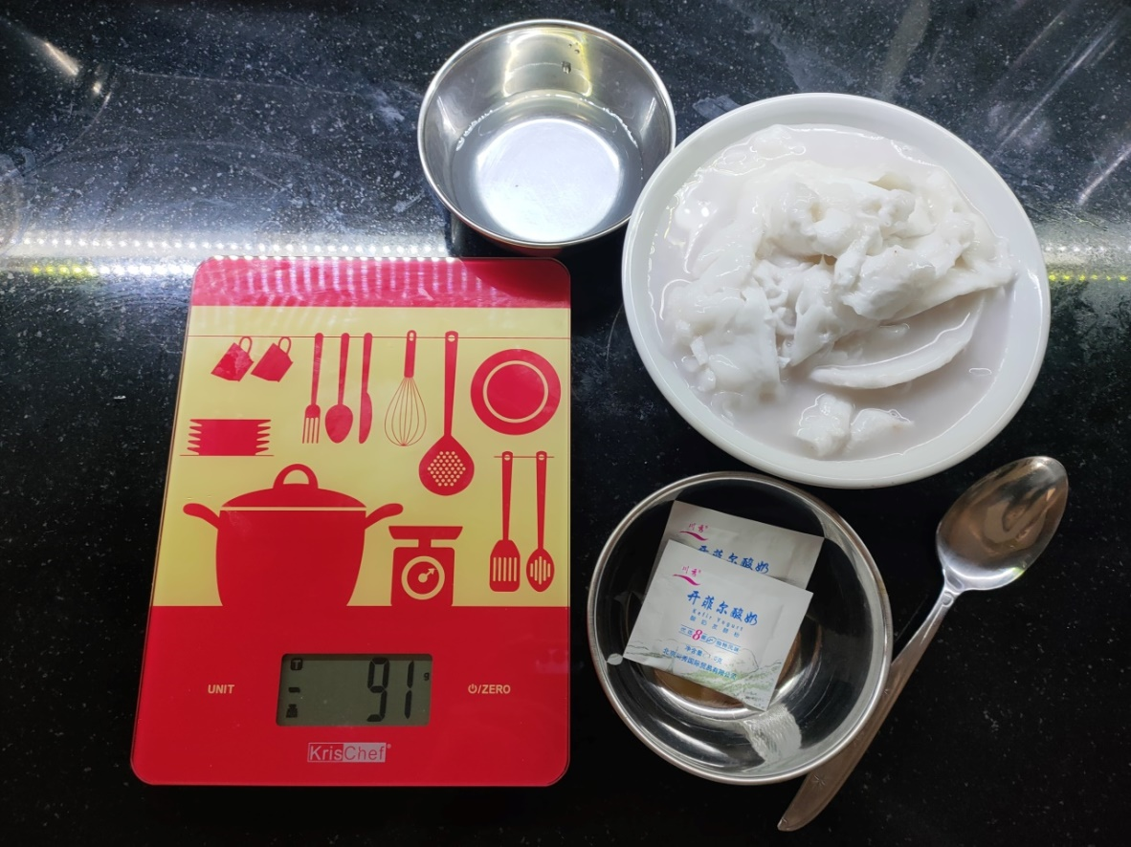
2.1 DESCRIPTION OF THE MATERIAL TO BE USED
- Kefir probiotics
For fermenting the coconut using kefir yogurt probiotics
- Young coconut
The main ingredients for the coconut kefit yogurt
- Coconut water
Mix in the coconut meat while blending with a mixer

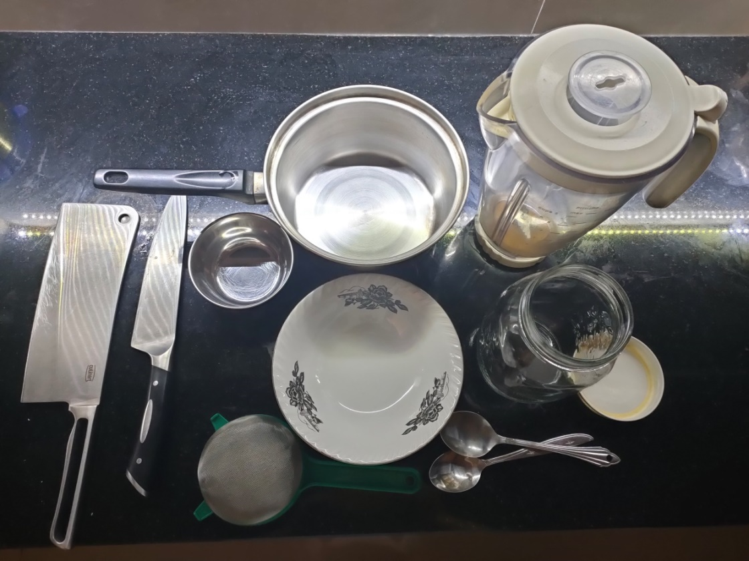
2.2 THE TOOLS USED DURING THE PROCESSING
- Pan
Use to cook the coconut meat and water in a warm water bath.

- Clean and steril spatula
for stirring in the pan

- Glass jar for the fermentation process
that has been boil or submerged in hot water for around 5-10 minutes and dried with a clean towel

- Digital scale
To scale every ingredients

- A chinese wok
For opening up the coconut hard shells

- Tissue / clean towel
For cleaning purpose

- Stove
Used to cook the coconut and sterilize the glass jars

- Spoons
Clean spoons for taking out the coconut meat and pick up the ingredients for scaling

- Kitchen Knife
Use to chop & open up the coconut shells

