RESEARCH AND DEVELOPMENT FINAL PROJECT
COCONUT KEFIR
(using coconut meat with kefir starter)

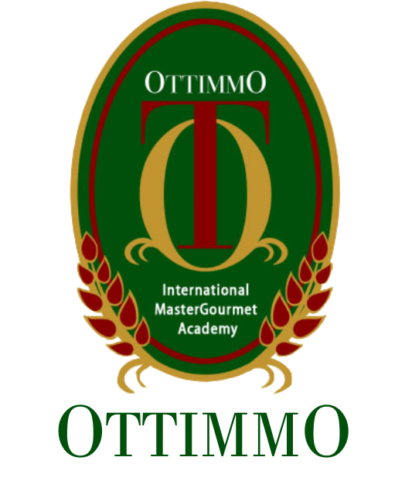
By
Josephine Edberta B
1974130010057

STUDY PROGRAM OF CULINARY ART
OTTIMMO INTERNATIONAL MASTERGOURMET ACADEMY
SURABAYA
2021

