CHAPTER 2
INGREDIENTS AND UTENSILS OVERVIEW

2.1 DESCRIPTION OF THE MATERIAL TO BE USED
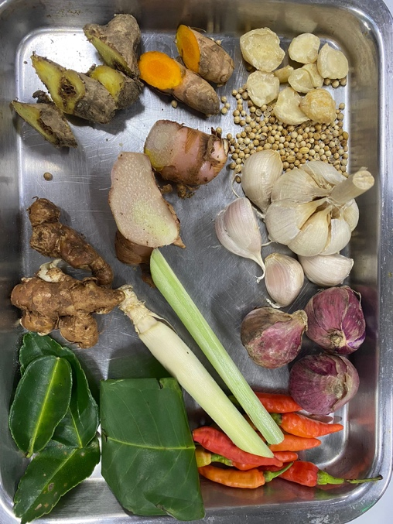
Picture 1. Base Genep Ingredients
1. Candlenut
Candlenut is a must of the base genep ingredients because candlenut can give the spices nuttiness.
2. Coriander
Coriander is a must of the base genep ingredients because it has a unique smells.
3. Garlic
Shallot is one of the ingredients to make base genep.
4. Shallot
Shallot is one of the ingredients to make base genep.
5. Bird’s Eye Chilli
Bird’s Eye Chilli is a must ingredients to make Base Genep.
6. Indonesian Bay Leaf
Indonesian Bay Leaf is an ingredients to make base genep to make it more aromatic.
7. Lemongrass
Lemongrass is an ingredients to make base genep to make it more aromatic.
8. Galangal
Galangal is an ingredients to make base genep.
9. Turmeric
Turmeric is an ingredients to make base genep.
10. Ginger
Ginger is an ingredients to make base genep.
11. Aromatic Ginger
Aromatic Ginger is an ingredients to make base genep.
12. Kaffir Lime Leaf
Kaffir Lime Leaf is an ingredients to make base genep to make it more aromatic.
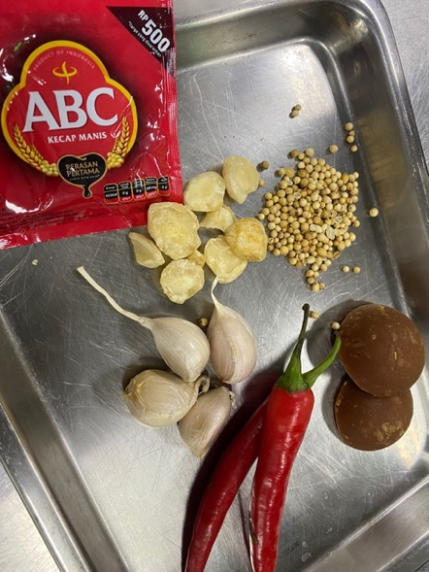
Picture 2. Signature Sauce Ingredients
1. Coriander
Coriander is an ingredients to make signature sauce because it has a unique smell.
2. Brown Sugar
Brown Sugar is an ingredients to make signature sauce to make this sauce sweet.
3. Sweet Soy Sauce
Sweet Soy Sauce is an ingredients to make signature sauce.
4. Candlenut
Candlenut is an ingredients to make signature sauce to give the nuttiness taste.
5. Garlic
Garlic is an ingredients to make signature sauce.
6. Red Chillies
Red Chillies is an ingredients to make the signature sauce has a hint of spicy in it.
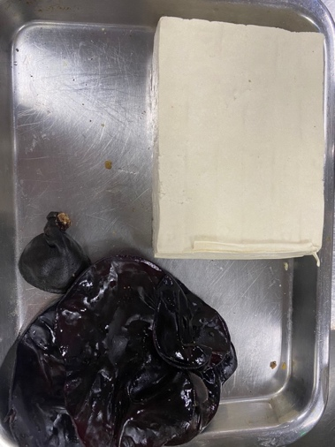
Picture 3. Vegan Gyoza Filling

1. Indonesian White Tofu
Indonesian White Tofu is the main ingredients to make The vegan gyoza filling.
2. Black Wood Ear
Black Wood Ear is the main ingredients to make the vegan gyoza filling.
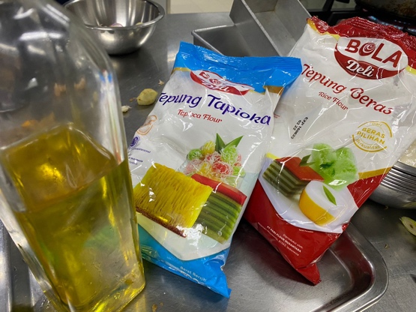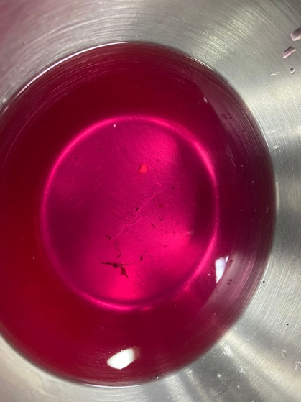
Picture 4. Gluten Free Wrappers Picture 5. Strained peeled dragonfruit water
1. Vegetable Oil
Vegetable Oil is an ingredients to make Gluten Free Dumping Wrappers.
2. Tapioca Flour
Tapioca Flour is an ingredients to make Gluten Free Dumpling Wrappers.
3. Rice Flour
Rice Flour is an ingredients to make Gluten Free Dumpling Wrappers.
4. Strained Peeled Dragonfruit Water.
Strained Peeled Dragonfruit Water is an ingredients to make Gluten Free Dumpling Wrappers.

2.2 THE TOOLS USED DURING THE PROCESSING
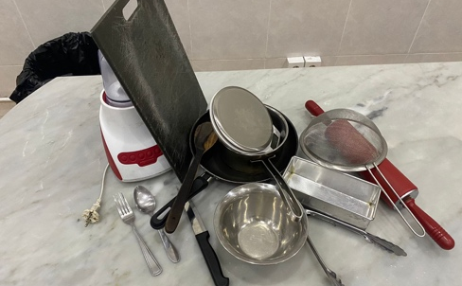
Picture 6. The Tools Used During The Processing
1. Blender
Blender used to make the Base Genep and Signature dipping sauce.
2. Cutting board
Cutting board used to cut all the ingredients.
3. Pan
Pan used to sauteing the base genep and for frying the gyoza.
4. Wooden Spatula
Wooden Spatula used to stirred the base genep.
5. Sauce Pan
Sauce Pan used to reduced the dipping sauce.
6. Digital Scale
Digital Scale used to put the ingredients.
7. Knife
Knife used to peel all the ingredients.
8. Strainer
Strainer used to strain the juice from the dragonfruit skin juice.

9. Rolling pin
Rolling pin used to roll the dumpling dough.
10. Spoon
Spoon used to mix the Vegan Sate Lilit Filling.
11. Fork
Fork used to mashed the white tofu.
12. Stove
Stove used to cook the dish.

