APPENDIX

- DESIGN PACKAGING
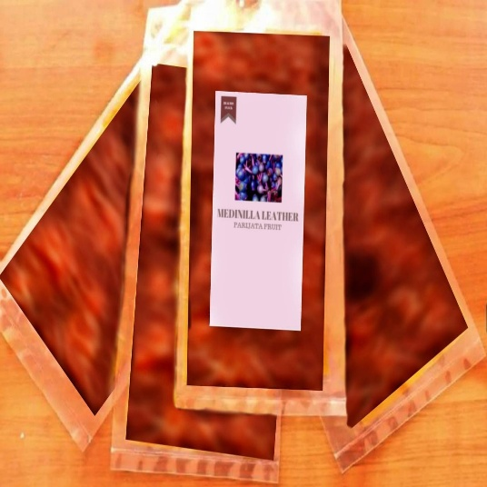

Picture 30. Design Packaging

Picture 23. Design Packaging (Personal Documentastion, 2021)

- SUPPLIER LIST

- Parijoto
The Parijoto that we bought as our signature ingredients from PT. Toko Elena
https://www.tokoelena.com/jual-buah-parijoto-kota-surabaya/.
- Honey
The honey that we bought from PT.Ridho Sribumi Sejahtera.
https://www.indotrading.com/ridhosribumisejahtera.
- Aqua
The Mineral Water that we bought from PT. Distributor Air Minuma
Aqua Surabaya.
https://www.facebook.com/pages/category/Community/Distributor-Air-Minuma-Aqua-Surabaya-553134158069704/.
- Lemon
The lemon that we bought from Taman Puspa Raya Market that is located at International Village 1 Block C2 No. 21,Blok F, Sambikerep, Lontar, Kota Surabaya, Jawa Timur 60219.
- Salt
The Salt that we bought from PT.Ridho Sribumi Sejahtera.
https://www.indotrading.com/ridhosribumisejahtera
- Stevia Sugar
The Stevia Sugar that we bought from PT. CV. SUMBER JAYA MAKMUR.
http://distributor-sembako-murah-surabaya.blogspot.com/2018/06/blog-post.html
- Plastic Pack
The Plastic Pack that we use is from Pelangi Minu Market that is located at Ruko Taman Gapura Blok F No. 19 – 20, Jl. Sentra Taman Gapura, Sambikerep, Lontar, Kota Surabaya, Jawa Timur 60217.

- LOGO PICTURES, PRODUCT
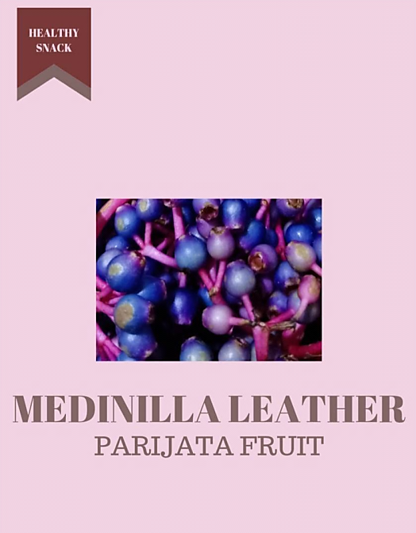
(BEFORE AND AFTER PACKAGING)

Picture 24. Logo Picture (Personal documentation, 2021)

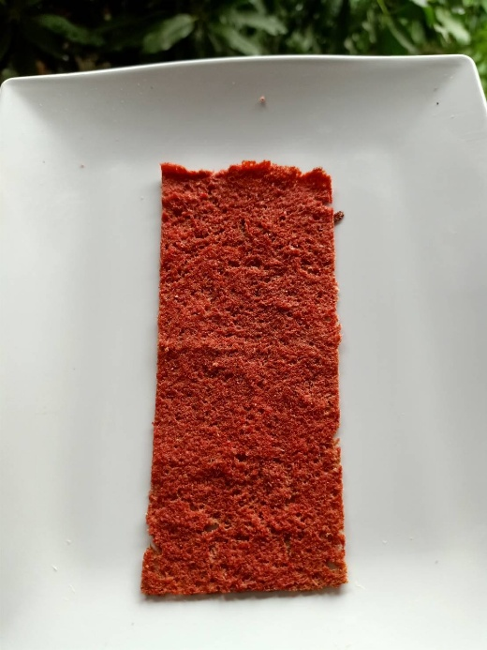

Picture 25. Product before Packaging (Personal documentation, 2021)

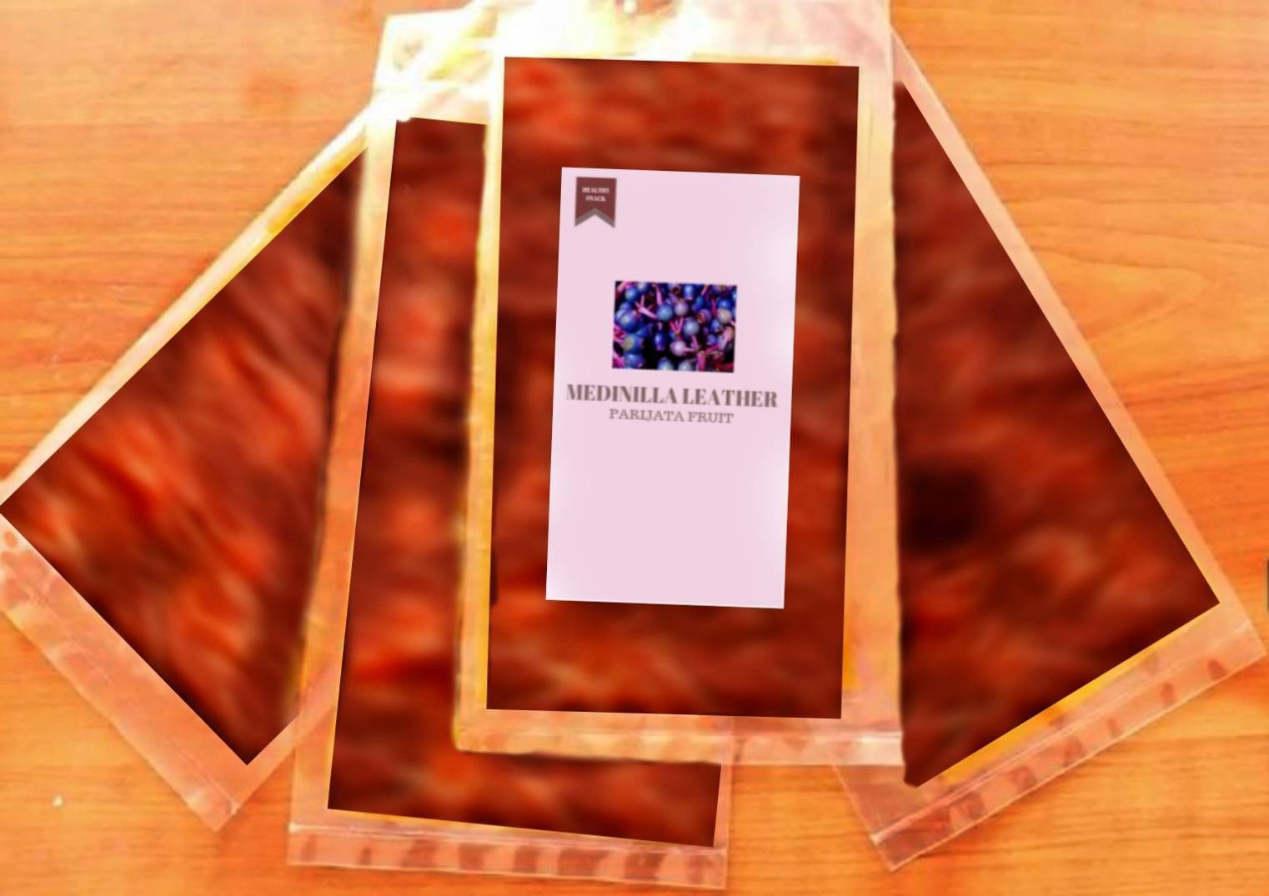

Picture 26. Product after Packaging (Personal documentation, 2021)

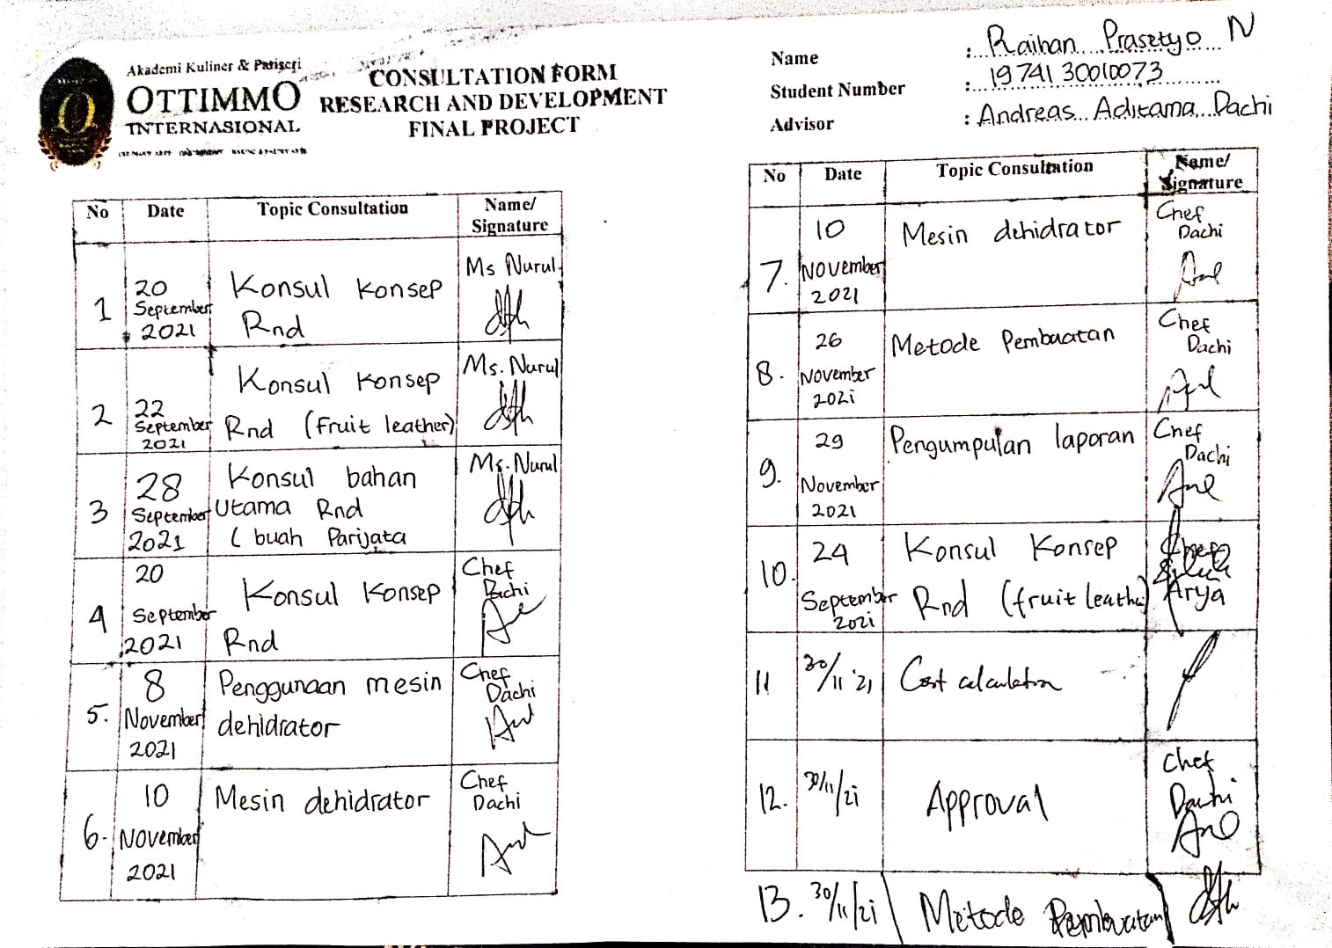
D. CONSULTATION FORM

Picture 27. Consultation form (Personal documentation, 2021)

