CHAPTER II
INGREDIENTS AND UTENSILS OVERVIEW

- Description of The Material to be Used
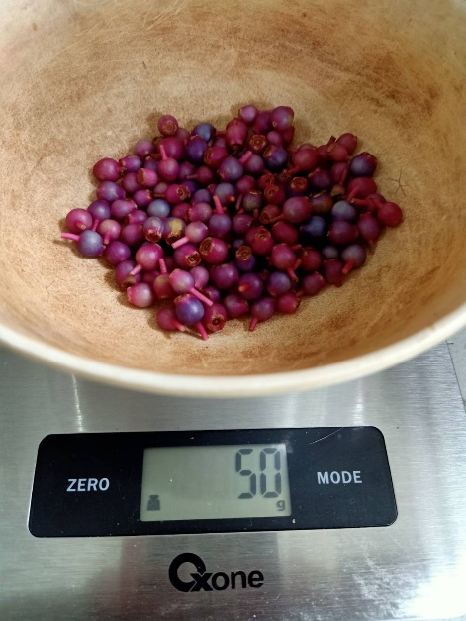

Picture 1. Main Ingredients of Product (Personal documentation, 2021)

The author used this ingredients to make Medinilla leather Snacks :
- Parijoto fruit (Separated from twigs), used as the main ingredients of Parijata Healthy Snacks.

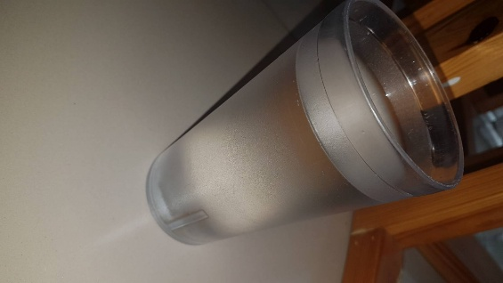

(Personal documentation, 2021)
Picture 2. Mineral Water
- Mineral water, used as liquid for making product.

Picture 3. Stevia Sugar (Personal documentation, 2021)
- Stevia sugar, used to natural sweetness for product.

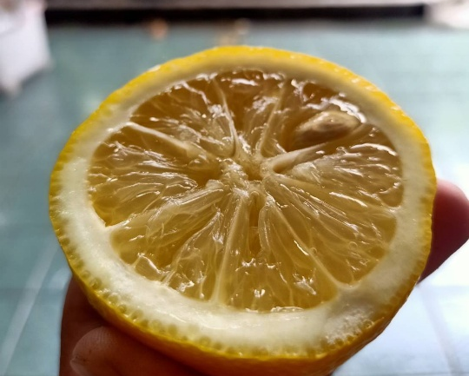

Picture 4. Lemon (Personal documentation, 2021)
- Lemon, used to create odor and sour flavor.

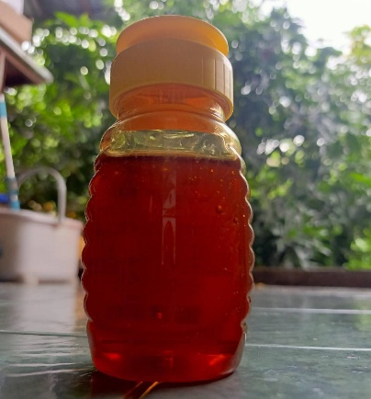

Picture 5. Honey (Personal documentation, 2021)
- Honey, used to give natural sweetness of the product.

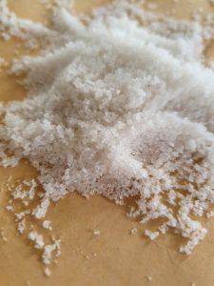

Picture 6. Salt (Personal documentation, 2021)
- Salt, used to balancing flavor the sweeetness of the product.

  - The Tools Used During The Processing
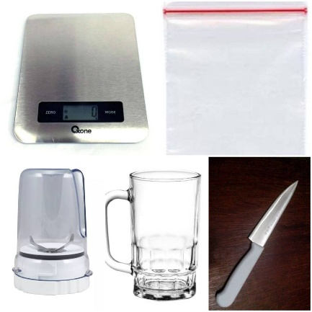

E.
A.

D.
B.

C.

Picture 7. Tools for making Parijata Healthy Snacks (Personal documentation, 2021)
The author used this tool to make Parijata Healthy Candy :
- Scales, used calculate and measure the weight of the material.
- Mini Blender, used to blend and making parijoto juice.
- Glass, used as place for water before poured into blender.
- Knife, used to slice lemon, and slice final product.
- Plastic Clip, used as place for fermentation parijoto juice.
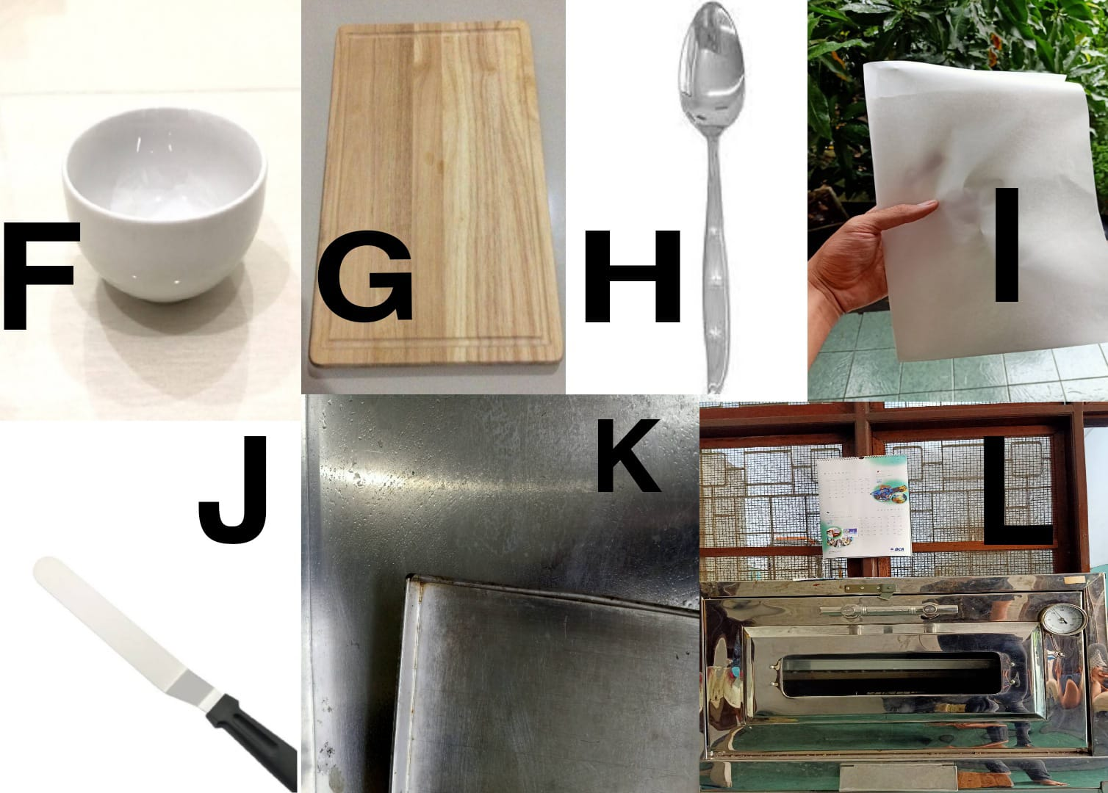
Picture 8. Tools for making Parijata Healthy Snacks (Personal documentation, 2021)
- Bowl, used as place for mixing juice and rice flour.
- Spoon, used for stir juice and mix ingredients.
- Cutting board, used as place for slice lemon.
- Cake spatula, used for flatten product.
- Parchment paper, used as base place to container for product.
- Tray, used as place for product when baking process.
- Oven, used to baking product.
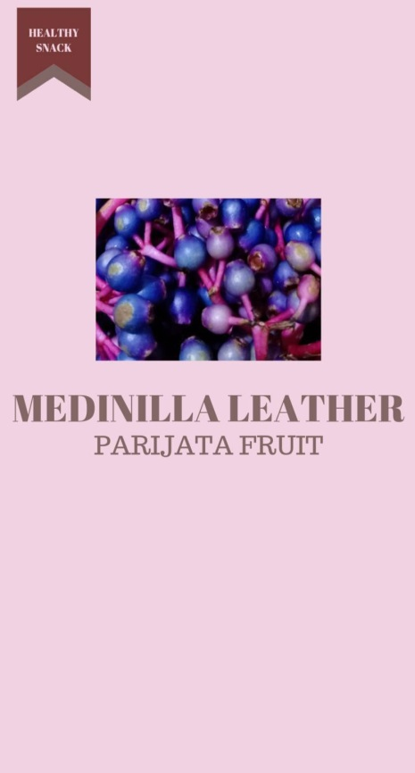

Picture 9. Sticker Logo (Personal documentation, 2021)
- Sticker logo, used as detail profile product

