RESEARCH AND DEVELOPMENT FINAL PROJECT

MEDINILLA LEATHER
(PARIJATA HEALTHY SNACKS)

Arranged by:
RAIHAN PRASETYO NUGROHO
( 1974130010073 )

STUDY OF CULINARY ART OTTIMO INTERNATIONAL
MASTERGOURMET

SURABAYA
2021
STUDY PROGRAM OF CULINARY ART
OTTIMMO INTERNATIONAL MASTER GOURMET ACADEMY
SURABAYA
2020

APPROVAL I

MEDINILLA LEATHER
(PARIJATA HEALTHY SNACK)

Research and Development Report by:
RAIHAN PRASETYO NUGROHO
( 1974130010073 )

This report is ready to presented :

Advisor,
Date: December 30th 2021

Andreas Aditama Dachi, S.E., A.Md.Par
NIP . 1982 1218 1601 023

(Hilda Tjahjani Iskandar, SE, AK, CA,MM)
NIP. 1969 1029 2002 072
APPROVAL 2
MEDINILLA LEATHER
(PARIJATA HEALTY SNACK)

Research and development report by:

RAIHAN PRASETYO NUGROHO
( 1974130010073 )

This report is already presented and
pass the exam on
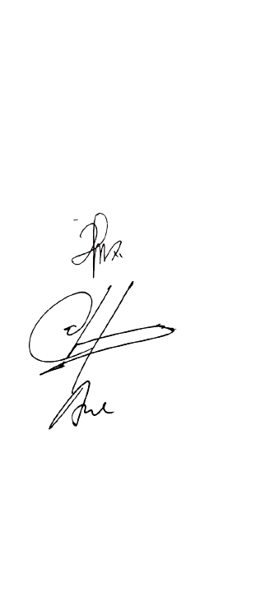

Examiners

Examiner 1 : Anugerah Danny Priyanto, S.TP., M.P., M.Sc.

Examiner 2 : Latifahtur Rahmah, S.Pd.,M.Pd.

Examiner 3 : Andreas Aditama Dachi, S.E., A.Md.Par

APPROVAL 3
RESEARCH AND DEVELOPMENT PROJECT

Name : Raihan Prasetyo Nugroho
Place, Date of Birth : Malang, 4 October 2001
N.I.M : 1974130010073
Study Program : D3 Seni Kuliner
T I T LE : PARIJATA HEALTHY SNACKS
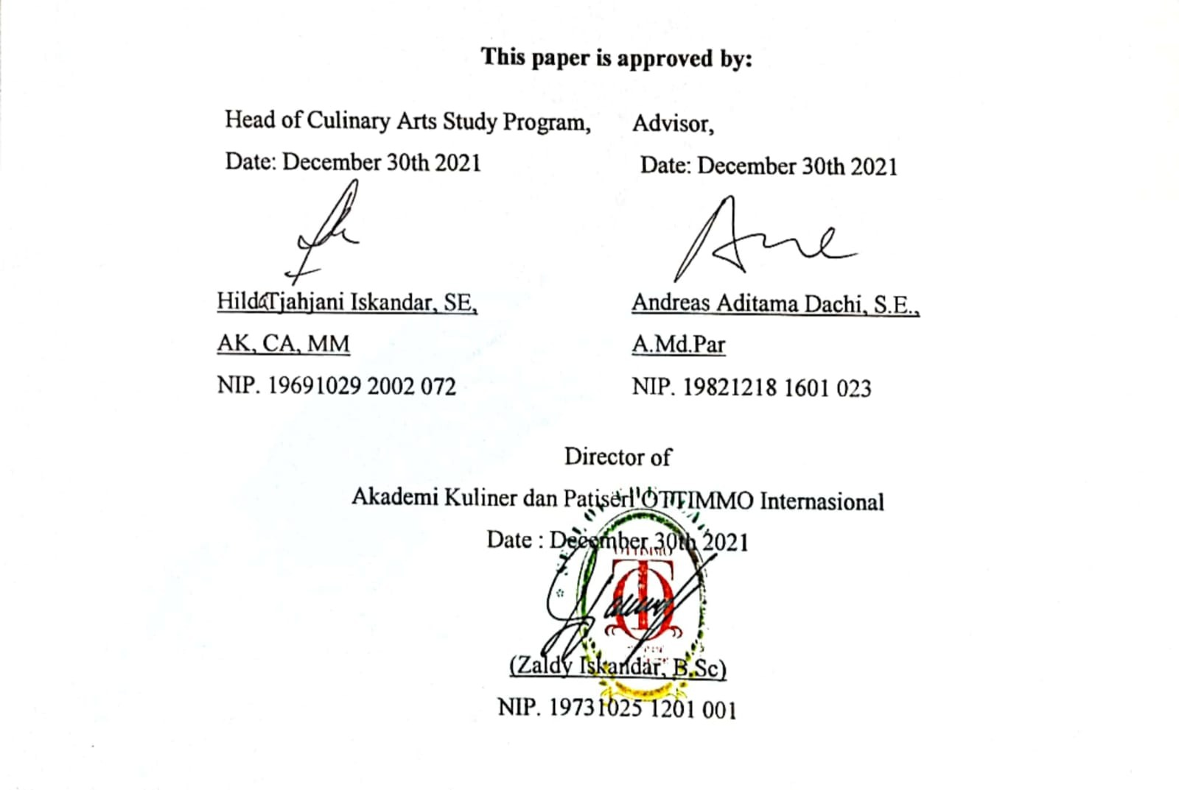

PLAGIARISM STATEMENT
I certify that this assignment/report is my own work, based on my personal study and/or research and that I have acknowledged all material and source sused in its preparation, whether they’re books, articles, reports, lecture notes, and any other kind of document, electronic or personal communication. I also certify that this assignment/report has not previously been submitted forassessment in any other unit, except where specific permission has been granted from all unit coordinators involved, or at any other time in this unit, and that I have not copied in part or whole or otherwise plagiarised the work of other students and/or persons.
On this statement, I am ready to bear the risk/ any sanctions imposed to me in accordance with applicable regulations, if in the futture there is a breach of scientific ethics, or you have claim against the authenticity of of my work

Surabaya, December 30 2021

RAIHAN PRASETYO NUGROHO

PREFACE
First of all, the author would like to thank God Almighty for His blessings & guidance to complete this Final Project RnD entiled "PARIJATA HEALTHY SNACKS" Report to fulfill one of the requirements in completing D3 education at the Culinary and Pastry Art Program of Ottimmo International Master Gourmet Academy.The author has traveled a long journey in the context of completing the writing of this Final Project. Therefore, with full humility, on this occasion, the author should thanks:
- To Zaldy Iskandar as a Chef. Thank you given me permission to conduct
experiments in developing author products.
- To Irra C.Dewi as supervisor lecture. Which gives the author the marketing knowledge
of the writer in completing the research.
- To my parents, Bapak and Ibuk who always gave love and support to the author.
- To my partner, RR. Nabiilah Elaine who always gives encouragement, motivation and
affection while doing research and accompanying me.
- To Andreas Aditama Dachi as Advisor. thank you for guiding me during research and
Development.
- To all chefs and teaching lecturers of OTTIMMO INTERNASIONAL SURABAYA.
Thank you for allowing the author to do research and help the author during my research.

The author recognizes that this report is out of the expectations due to lack of capacity & knowledge, therefore the author is willing to accept all critism and suggestions from all parties. In conclusion, the author hopes that this report is useful for the author as well as the readers.

Surabaya, December 30th 2021

RAIHAN PRASETYO NUGROHO

TABLE OF CONTENT

APPROVAL ..…....................................................................................... ii
PLAGIARISM STATEMENT ………………..………………………. iv
PREFACE ................................................................................................ v
TABLE OF CONTENT......................….................................................. vii
EXECUTIVE SUMMARY................….................................................. vii
LIST OF PICTURES …...........…................................................. ix
LIST OF TABLE …............…................................................................. xi
CHAPTER I INTRODUCTION …......................................................... 1
  - Background Study ............................................................................. 1
  - The Objectives Study.......................................................................... 3
  - The Benefits Study……….................................................................. 3
CHAPTER II INGREDIENTS AND UTENSILS OVERVIEW …... 4
- Description of the Material to be Used.............................................. 4
- The Tools Used During the Processing.............................................. 7
CHAPTER III NEW PRODUCT PROCESSING SEQUENCE ….... 10
- The Processing Product by Using Picture.......................................... 10
- Complete Recipe Attached................................................................. 15
CHAPTER IV NEW PRODUCT OVERVIEW .................................. 18
- The Nutrition (Ingredients)................................................................ 18
CHAPTER V BUSINESS PLAN …................................................... 20
- General Description .......................................................................... 20
- Business Scope ................................................................................. 21
- Stakeholder ....................................................................................... 23
- SWOT Analysis ............................................................................... 25
- Marketing Aspect ............................................................................. 26
- Finacial Aspect ................................................................................. 28
- Technical Aspect .............................................................................. 32
- Legal Aspect .................................................................................. 33
CHAPTER VI CONCLUSION …............................................................. 37
- Conclusion ...................................................................................... 37
- Suggestion ...................................................................................... 37
BILIOGRAPHY ................................................................................... 39
APPENDIX….......................................................................................... 40
EXECUTIVE SUMMARY

Medinilla Leather is a fruit leather product made from parijata fruit. This idea arose when I consulted with lecturer Ottimmo International. Seeing Indonesia's great opportunity for this product, therefore I immediately explored a lot about fruit leather and fruit parijata. When consuming Medinilla Leather, it will taste sour, sweet and it has a soft texture. This product belongs to the healthy food group.

Medinilla Leather will be packaged in eco plastic. The weight of each product is 5 grams and is sold at a price of Rp. 38,000. In the future this product will be developed gradually. This product can be found in supermarkets and social media

LIST OF PICTURES

Picture 1. Main ingredients of product……................................................ 4
Picture 2. Mineral Water............................................................................. 4
Picture 3. Stevia Sugar................................................................................ 5
Picture 4. Lemon......................................................................................... 5
Picture 5. Honey.......................................................................................... 6
Picture 6. Salt.............................................................................................. 6
Picture 7. Tools for making parijata healthy snacks................................... 7
Picture 8. Tools for making parijata healthy snacks................................... 8
Picture 9. Sticker logo.................................................................................. 9
Picture 1. Parijoto fruit in bowl .................................................................. 10
Picture 11. Parijoto fruit and water in bowl.................................................. 10
Picture 12. Parijoto juice in plastic clip........................................................ 11
Picture 13. Three flavor ingredients above parijoto juice............................ 11
Picture 14. Rice flour in Spoon.................................................................... 12
Picture 15. Preheat oven process.................................................................. 12
Picture 16. Mixed parijata on parchment paper............................................ 13
Picture 17. Product in Plate.......................................................................... 13
Picture 18. Packaged products...................................................................... 14
Picture 19. Recipe attached.......................................................................... 15
Picture 20. Recipe attached......................................................................... .16
Picture 21. Nutrition fast of parijata healthy snacks................................... 18
Picture 22. Stakeholder................................................................................ 23
Picture 23. Design packaging…………………………………………….. 40
Picture 24. Logo picture………………………………………………….. 42
Picture 25. Product before packaging……………………………………. 42
Picture 26. Product after packaging……………………………………… 43
Picture 27. Consultation form……………………………………………. 44

LIST OF TABLE
Table 1. Ingredients Nutrition...................................................................................19
Table 2. Consumer Characteristic.............................................................................26
Table 3. People Segmentation..................................................................................26
Table 4. Variable Cost..............................................................................................28
Table 5. Startup Cost................................................................................................29
Table 6. Overhead Cost............................................................................................29
Table 7. Total Cost...................................................................................................30

