APPENDIX
Appendix 1. PACKAGING DESAIN
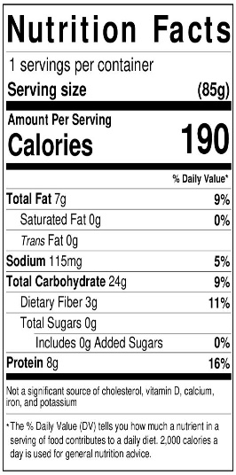
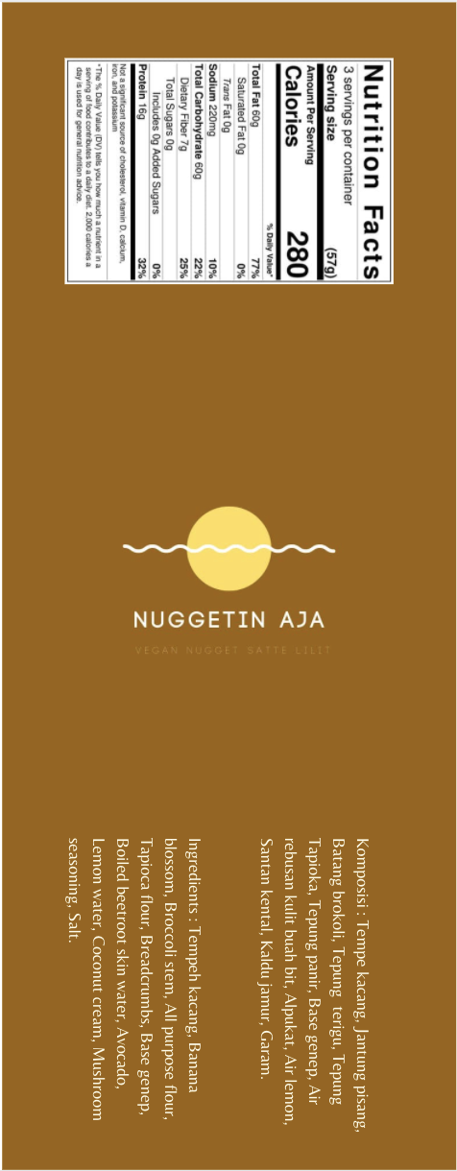
Picture. Label

Appendix 2. SUPPLIER LIST
- Tempe kacang
The tempe kacang is form Pasar Mergan, located at Jl. Raya Langsep, Bareng, Kec. Klojen, Kota Malang, Jawa Timur 65146.
- Banana blossom
The shallot is from Tiara Sayur, located at Jl. Raya Sambikerep No.1,
Lontar, Kec. Sambikerep, Kota SBY, Jawa Timur 6021, Indonesia.
- Broccoli
The chilli is from Tiara Sayur, located at Jl. Raya Sambikerep No.1,
Lontar, Kec. Sambikerep, Kota SBY, Jawa Timur 6021, Indonesia.
- Vegetable Oil
The vegetable is from Tobaku, located at Jalan Raya Dukuh Kupang No.57A,
Dukuh Pakis, Kota Surabaya, Jawa Timur 60225, Indonesia.
- Salt
The salt is from Tobaku, located at Jalan Raya Dukuh Kupang No.57A,
Dukuh Pakis, Kota Surabaya, Jawa Timur 60225, Indonesia.
- Mushroom seasoning
The sugar is from Tobaku, located at Jalan Raya Dukuh Kupang No.57A,
Dukuh Pakis, Kota Surabaya, Jawa Timur 60225, Indonesia
- Ginger
The ginger is from Tiara Sayur, located at Jl. Raya Sambikerep No.1,
Lontar, Kec. Sambikerep, Kota SBY, Jawa Timur 6021, Indonesia.
- Turmeric
The turmeric is from Tiara Sayur, located at Jl. Raya Sambikerep No.1,
Lontar, Kec. Sambikerep, Kota SBY, Jawa Timur 6021, Indonesia.
- Aromatic Ginger
The aromatic ginger is from Tiara Sayur, located at Jl. Raya Sambikerep No.1,
Lontar, Kec. Sambikerep, Kota SBY, Jawa Timur 6021, Indonesia.
- Coriander
The coriander is from Tiara Sayur, located at Jl. Raya Sambikerep No.1,
Lontar, Kec. Sambikerep, Kota SBY, Jawa Timur 6021, Indonesia.

- Candle nut
The candle nut is from Tiara Sayur, located at Jl. Raya Sambikerep No.1,
Lontar, Kec. Sambikerep, Kota SBY, Jawa Timur 6021, Indonesia.
- Kaffir lime leaf
The kaffir lime leaf is from Tiara Sayur, located at Jl. Raya Sambikerep No.1,
Lontar, Kec. Sambikerep, Kota SBY, Jawa Timur 6021, Indonesia.
- Lemongrass
The lemongrass is from Tiara Sayur, located at Jl. Raya Sambikerep No.1,
Lontar, Kec. Sambikerep, Kota SBY, Jawa Timur 6021, Indonesia.
- Shallot
The shallot is from Tiara Sayur, located at Jl. Raya Sambikerep No.1,
Lontar, Kec. Sambikerep, Kota SBY, Jawa Timur 6021, Indonesia.
- Garlic
The garlic is from Tiara Sayur, located at Jl. Raya Sambikerep No.1,
Lontar, Kec. Sambikerep, Kota SBY, Jawa Timur 6021, Indonesia.
- Red Chilli
The red chilli is from Tiara Sayur, located at Jl. Raya Sambikerep No.1,
Lontar, Kec. Sambikerep, Kota SBY, Jawa Timur 6021, Indonesia.
- All purpose flour
The all purpose flour is from Tobaku, located at Jalan Raya Dukuh Kupang
No.57A, Dukuh Pakis, Kota Surabaya, Jawa Timur 60225, Indonesia.

- Tapioca flour
The tapioca flour is from Tobaku, located at Jalan Raya Dukuh Kupang
No.57A, Dukuh Pakis, Kota Surabaya, Jawa Timur 60225, Indonesia.
- Bread crumb
The bread crumb is from Tobaku, located at Jalan Raya Dukuh Kupang No.57A, Dukuh Pakis, Kota Surabaya, Jawa Timur 60225, Indonesia.
- Avocado
The avocado is from Superindo, located at Jalan Telaga Utama D1 No.31-32, Jeruk, Kec. Lakarsantri, Kota SBY, Jawa Timur 60213

Appendix 3. PRODUCT LOGO
- Logo
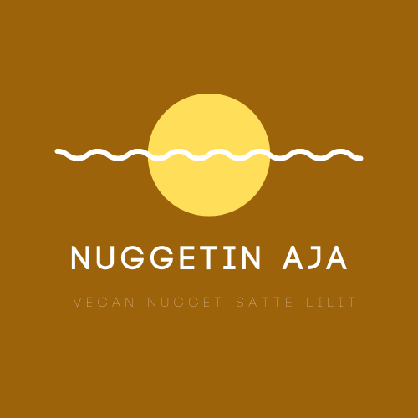
Picture . Logo

- Unpacked Product
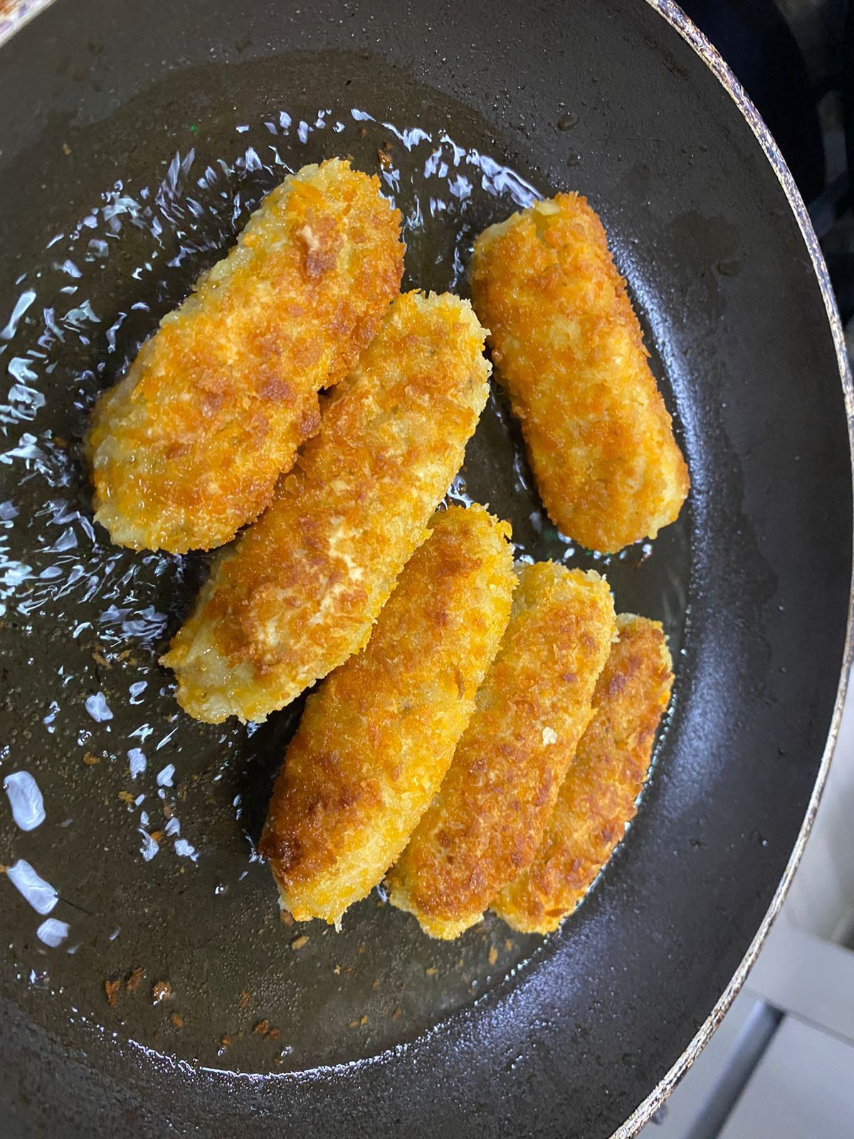
Picture. Unpacked Product

- Packed Product
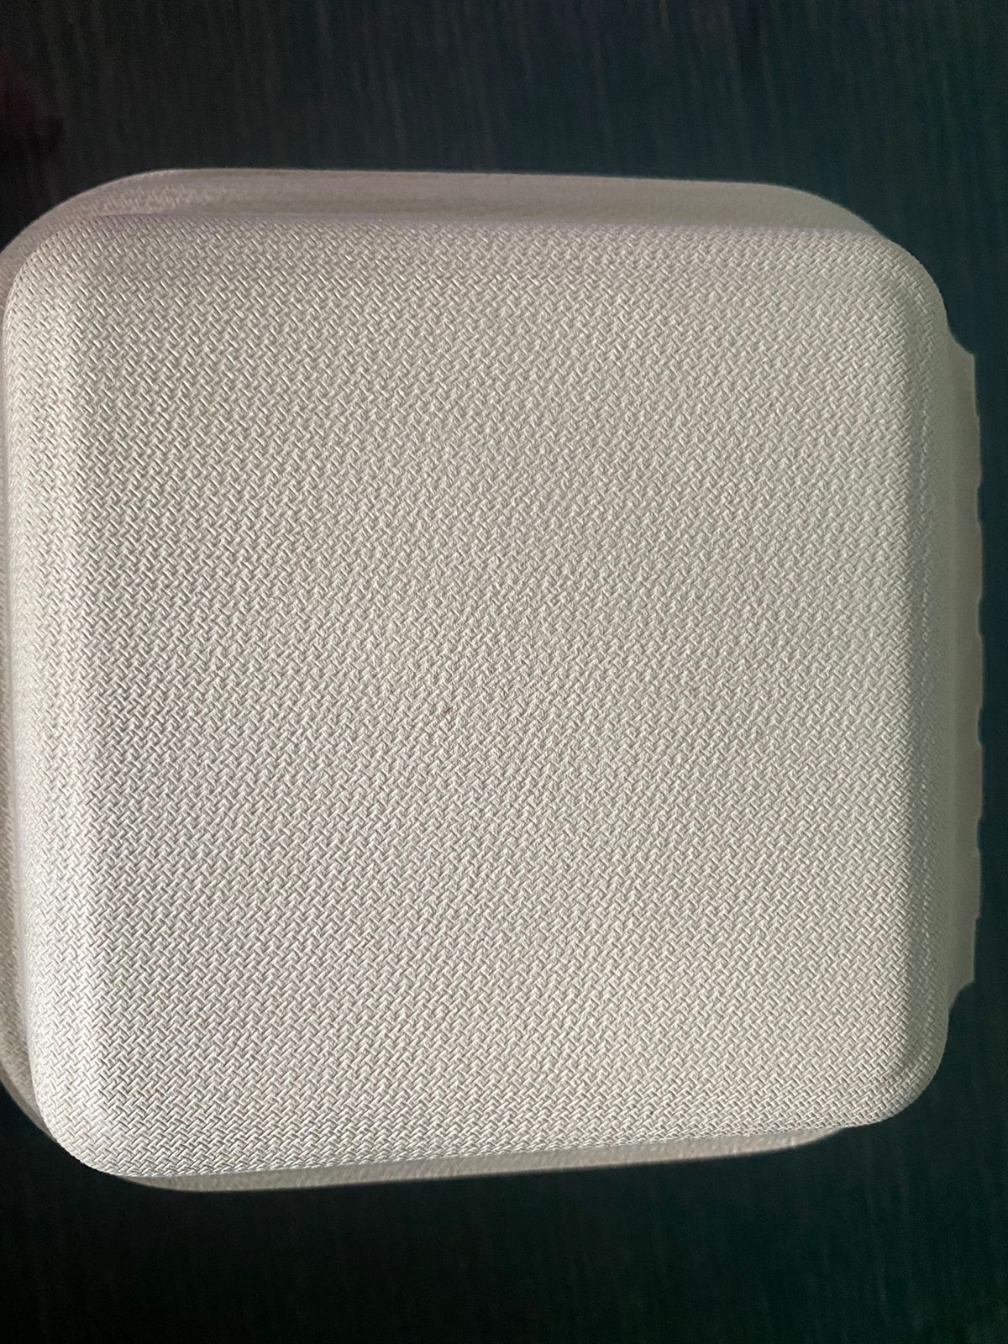
Picture. Packed Product

