CHAPTER 2
INGREDIENTS AND UTENSILS OVERVIEW

2.1 DESCRIPTION OF THE MATERIAL TO BE USED
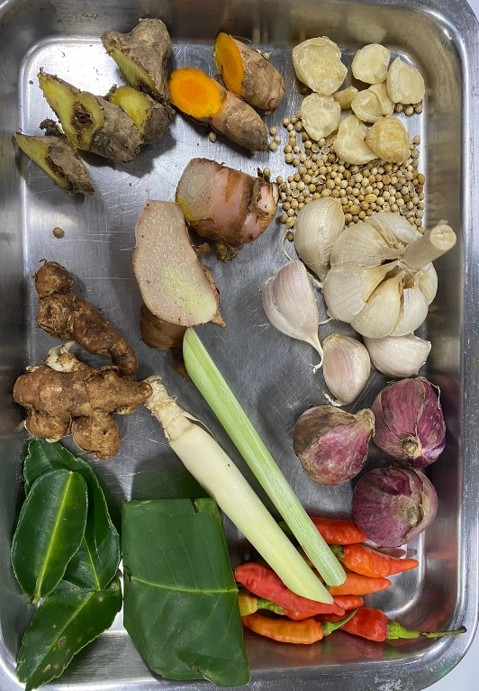
Picture 1. Personnal documentation

1. Candlenut
Candlenut is a must of the base genep ingredients because candlenut can give the spices nuttiness.
2. Coriander
Coriander is a must of the base genep ingredients because it has a unique smells.
3. Garlic
Garlic is one of the ingredients to make base genep.
4. Shallot
Shallot is one of the ingredients to make base genep.

5. Bird’s Eye Chilli
Bird’s Eye Chilli is a must ingredients to make Base Genep.
6. Indonesian Bay Leaf
Indonesian Bay Leaf is an ingredients to make base genep to make it more aromatic.
7. Lemongrass
Lemongrass is an ingredients to make base genep to make it more aromatic.
8. Galangal
Galangal is an ingredients to make base genep.
9. Turmeric
Turmeric is an ingredients to make base genep.
10. Ginger
Ginger is an ingredients to make base genep.
11. Aromatic Ginger
Aromatic Ginger is an ingredients to make base genep.
12. Kaffir Lime Leaf
Kaffir Lime Leaf is an ingredients to make base genep to make it more aromatic.

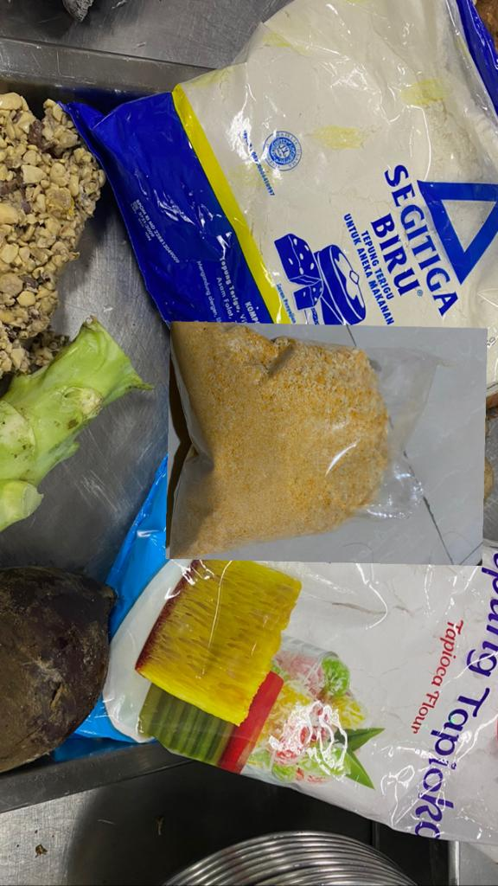
Picture 2. Personnal documentation
1. All purpose flour
All purpose flour is the ingredient to make the nugget
2. Tapioca flour
Tapioca flour is the ingredient to make the nugget
3. Breadcrumb
Breadcrumb is the ingredient to coat the nugget
4. Tempe kacang
Tempe kacang is the main ingredient
5. Broccoli stem
Broccoli stem is the ingredient to make nugget
6. water
water is the ingredient to the nugget mixture not to stiff
7. vegetable oil
Vegetable oil is the ingredients to fry the nugget
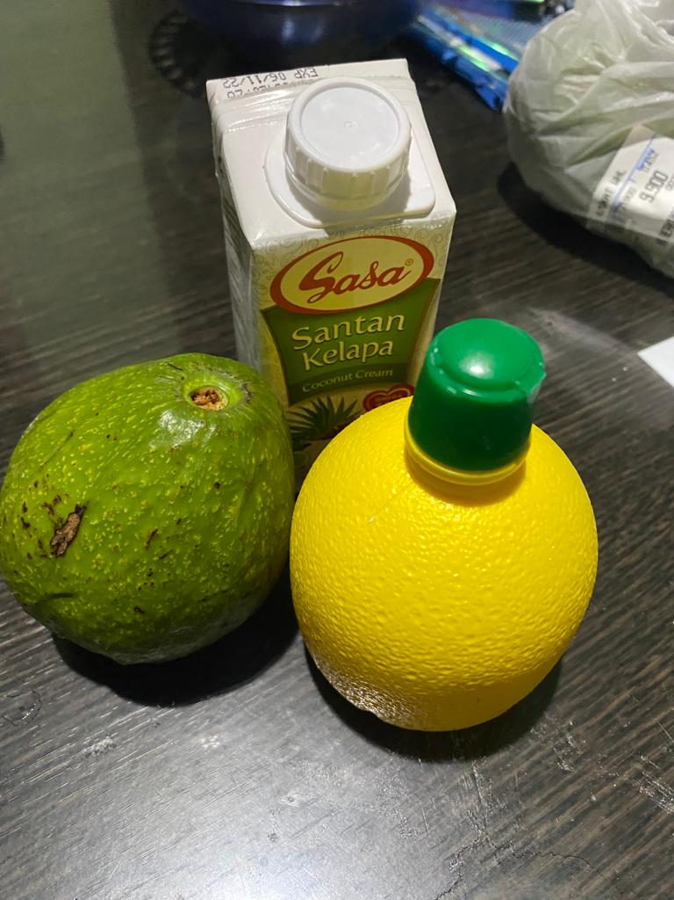
Picture 3. Personnal documentation
1. Avocado
Avocado is the ingredient to make sauce
2. Coconut cream
Coconut cream is the ingredient to make sauce
3. Lemon
Lemon is the ingredient to make sauce

2.2 THE TOOLS USED DURING THE PROCESSING
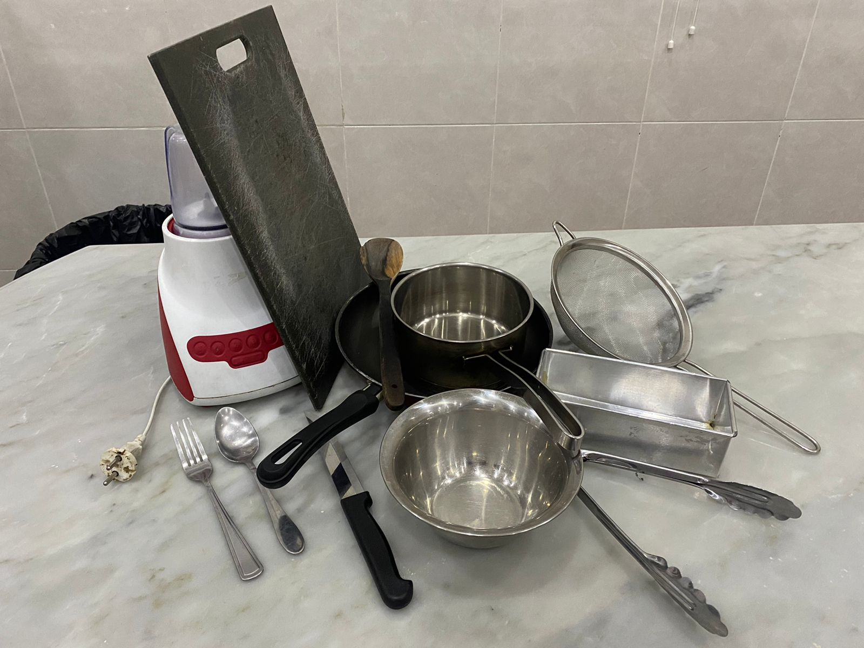
Picture 4. Personnal documentation
1. Stove
Stove used to cook the nugget.
2. Pan
Pan used to fry and cook the base genep.
3. tongs
tongs used to fry.
4. Digital Scale
Digital scale used to measure the amount of the ingredients.
5. Bowl
Bowl used to put the ingredients.
6. Steamer
Steamer used to steam the tempe kacang.
7. Knife
Knife used to cut the ingredients.
8. Spatula
Spatula used to stir and mix all ingredients in the pan.
9. Strainer
Strainer used to strain the fry mandai from the oil.
10. Baking tray
Baking tray used to steam the nugget dough.
11. Tissue
Tissue used to absorb the excess oil.
13. Stove
Stove used to cook the nugget.

