RESEARCH AND DEVELOPMENT FINAL PROJECT
VEGAN BASE GENEP NUGGET
(TEMPE KACANG, BEETROOT, BROCCOLI, BANANA BLOSSOM)
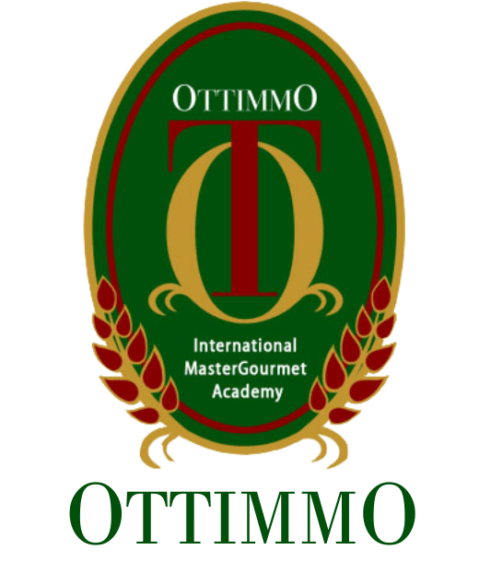
By
David Adde Krisna
1974130010025

STUDY OF CULINARY ART
OTTIMMO INTERNATIONAL MASTERGOURMET ACADEMY
SURABAYA
2021

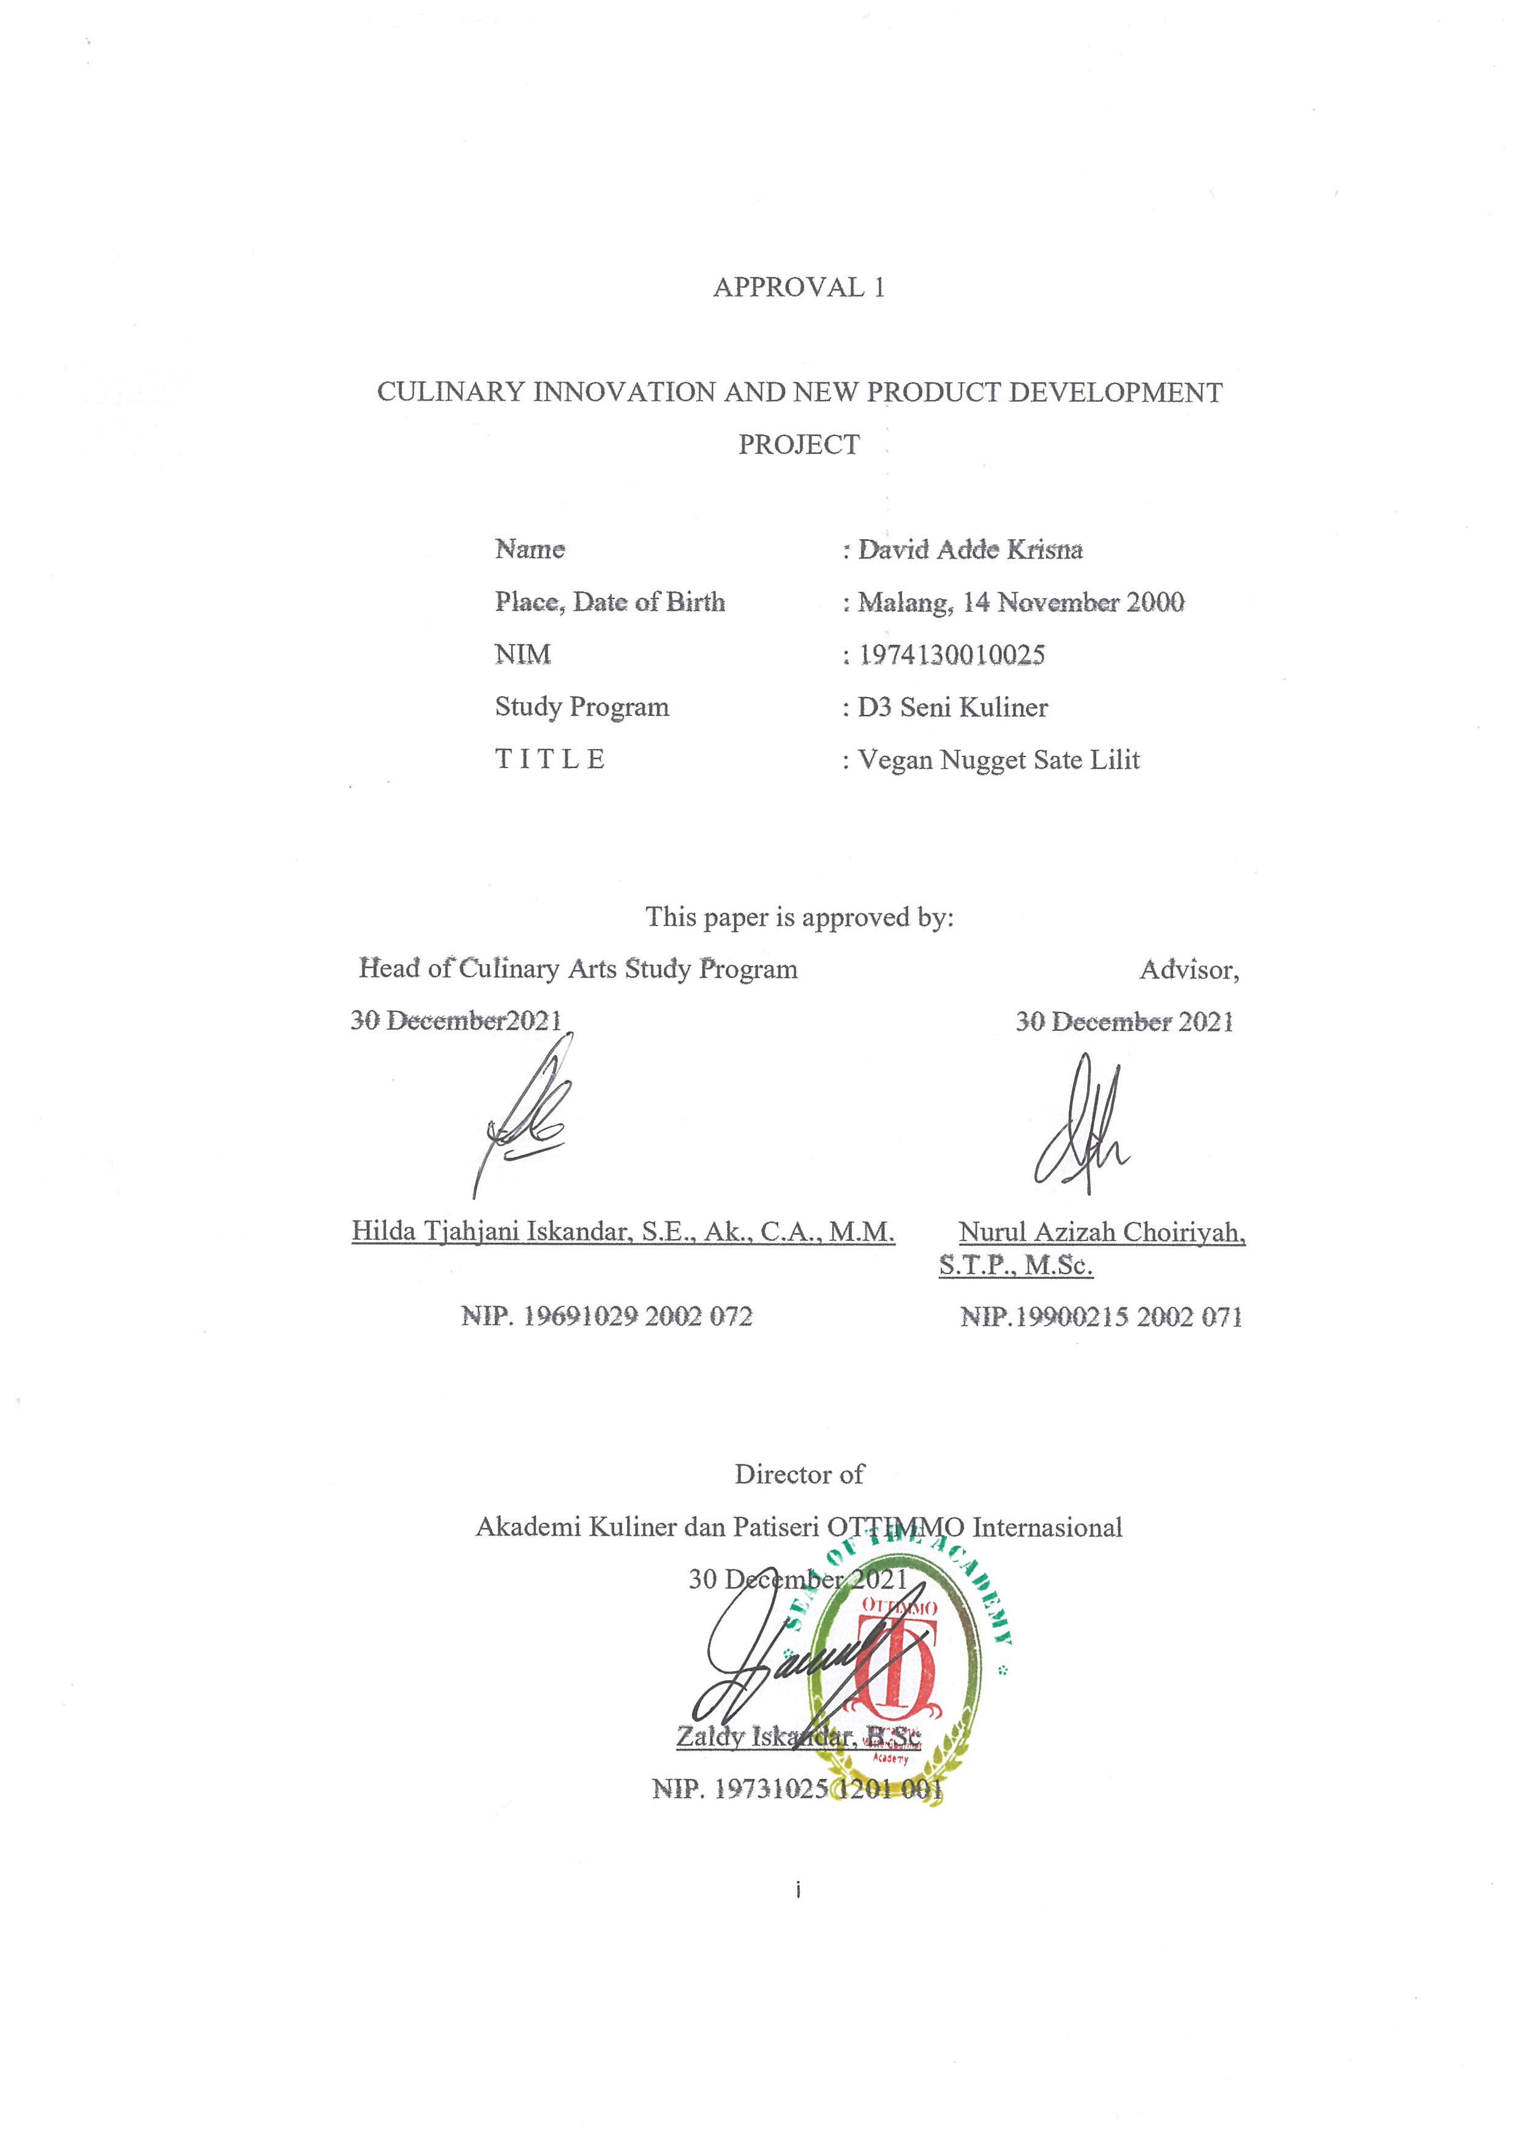
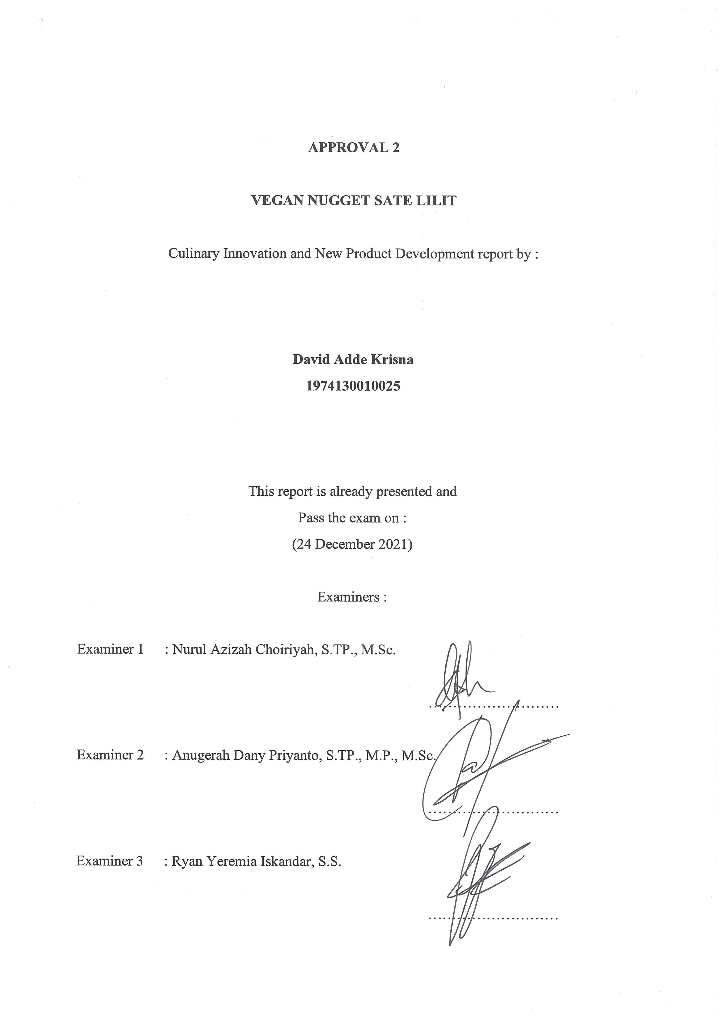

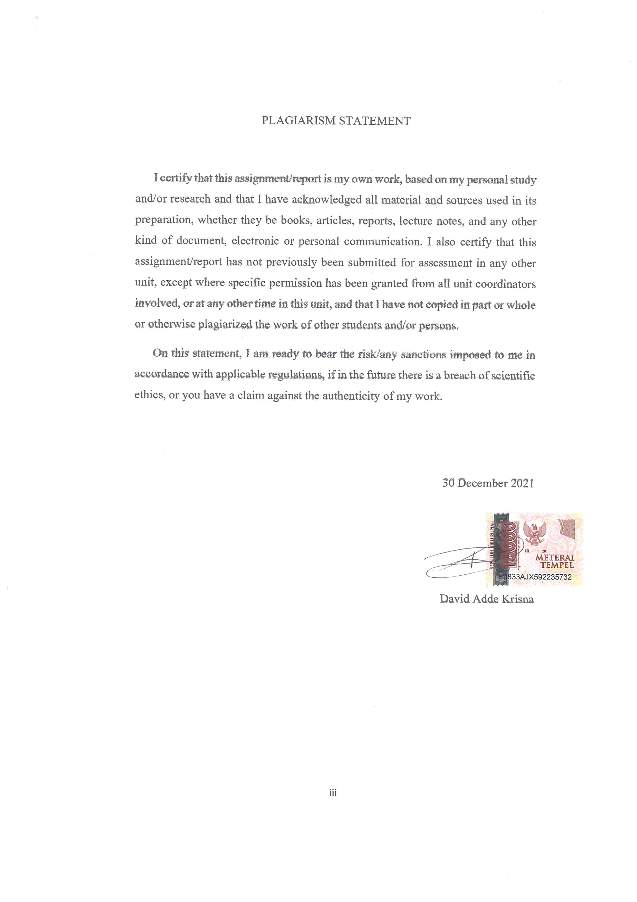
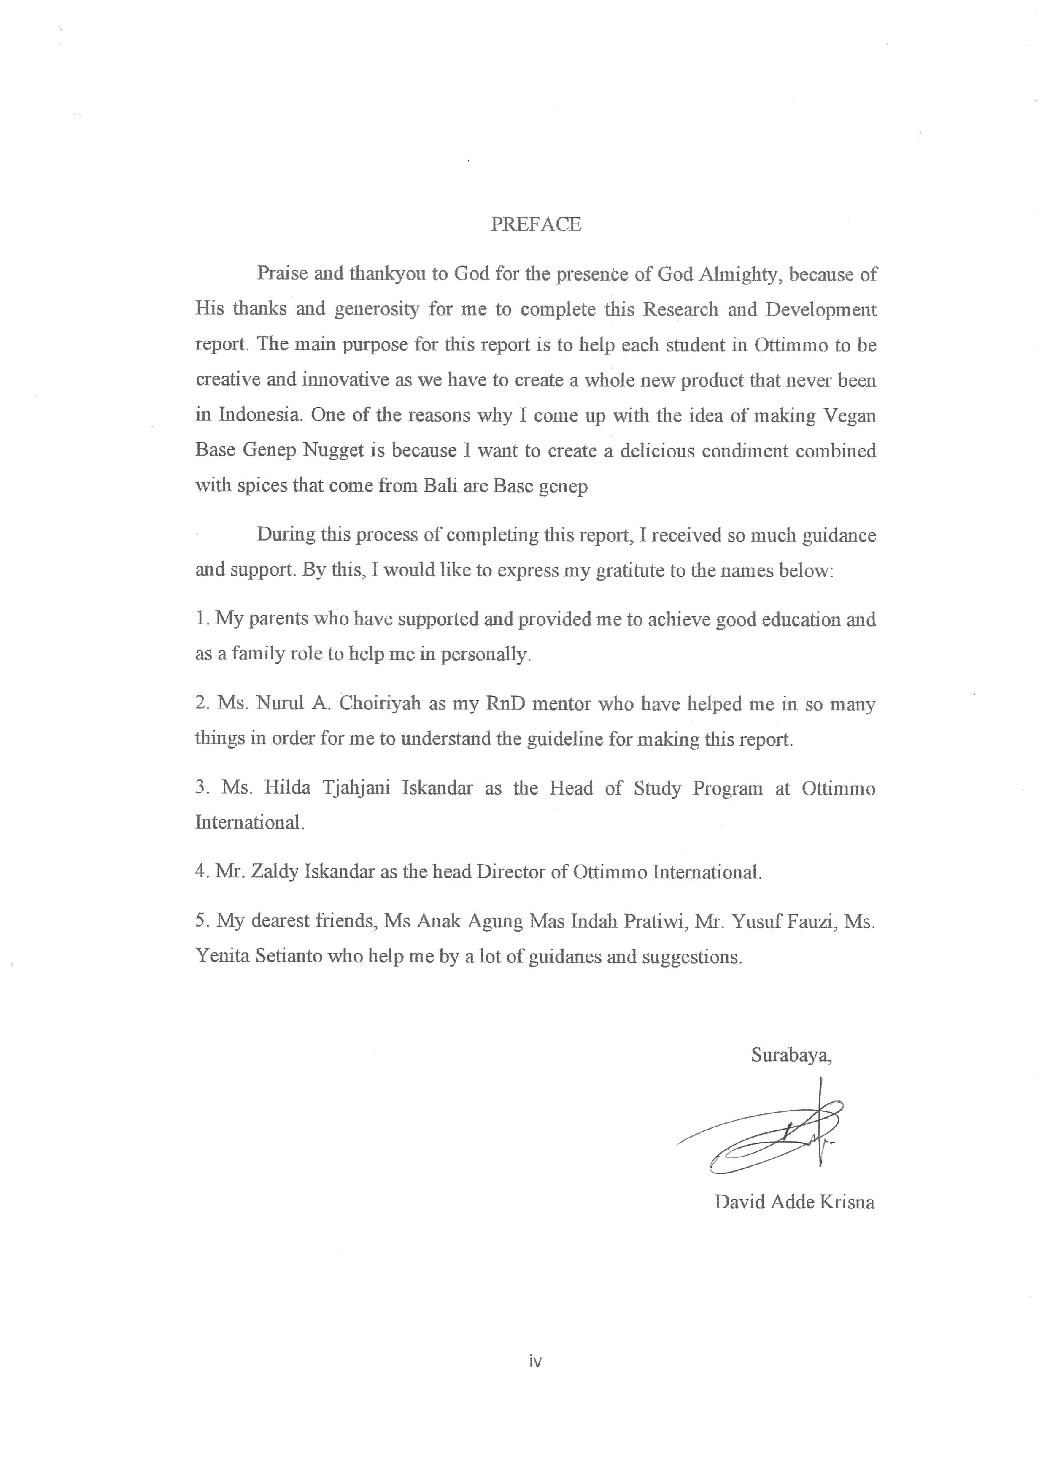
TABEL OF CONTENT
HARD COVER 0
TITLE PAGE 0
APPROVAL 1 i
APPROVAL 2 ii
PLAGIARISM STATEMENT iii
PREFACE iv
TABLE OF CONTENTS v
LIST OF TABLE vii
LIST OF FIGURES viii
EXECUTIVE SUMMARY ix
CHAPTER 1 INTRODUCTION 1
  - Background of The Study 1
  - The Objectives of The Study 2
  - The Benefits of The Study 2
CHAPTER 2 INGREDIENTS AND UTENSILS OVERVIEW 3
  - Description of The Material to be Used 3
2.2 The Tools Used During The Processing 7
CHAPTER 3 NEW PRODUCT PROCESSING SEQUENCE 9
3.1 The Processing Product Using Picture 9
3.2 Complete Recipe Attached 17
CHAPTER 4 NEW PRODUCT OVERVIEW 24
4.1 The Facts of Nutrition 24
CHAPTER 5 BUSINESS PLAN 28
5.1 General Description of Company 28
5.2 Identification of Investment Opportunities 28
5.3 Stakeholder 29
5.4 SWOT Analysis 30
5.5 Marketing Aspect 31
5.5.1 Customer Characteristic 31
5.5.2 Market Segmentation 32
5.5.3 Marketing Strategies 33
5.6 Financial Aspect 34
5.6.1 Variable Cost 34
5.6.2 Fixed Cost 36
5.6.3 Overhead Cost 37
5.6.4 Cost of Production 37
5.6.5 Break Even Point 37
5.7 Technical Aspect 38
5.8 Legal Aspect 38
CHAPTER 6 CONCLUSION 40
6.1 Conclusion 40
6.2 Suggestion 40
BIBLIOGRAPHY 41
APPENDIX 42
Appendix 1. Packaging Design 42
Appendix 2. Supplier List 42
Appendix 3. Product Logo 47

LIST OF TABLES

Table 1. Nutrition Fact 25
Table 2. Variable Cost 34
Table 3. Fixed Cost 36
Table 4. Overhead Cost 37
Table 5. Cost of Production 37

LIST OF PICTURES

Picture 1. The Material to be Used 3
Picture 2. The Material to be Used 5
Picture 3. The Material to be Used 6
Picture 4. The Tools Used During The Processing 7
Picture 5. Peeled and Washed Base Genep Ingredients 9
Picture 6. Blend all the base genep ingredients 10
Picture 7. Blend all the base genep ingredients 10
Picture 8. Heated Oil 10
Picture 9. Sauteing the base genep 11
Picture 10. Putting all the aromatic leav 11
Picture 11. Steam the tempeh kacang 12
Picture 12. Mashed tempe kacang 13
Picture 13. Uncooked nugget 13
Picture 14. Half cooked nugget 14
Picture 15. Cooked nugget 15
Picture 16. Cooked nugget 15
Picture 17. Coat nugget 15
Picture 18. Fried nugget 16
Picture 19. Avocado sauce 16

EXECUTIVE SUMMARY
Vegan Base Genep Nugget is a sambal that we combine with special Balinese herbs and spices. I come up with this idea looking at how most of Indonesian people usually eat sate lilit with rice and used as the main course, i made this dish from main course to snacks because I want it to be unique and healthy. This dish for people who are a vegan person and also for people who wants to do weightloss(diet).
We use mashed Tempe bungkil and we mixed it with base genep, banana blossom, broccoli stem, and also seasoning. After we mixed all the ingredients(include all the flour we use) we steamed it and then we deep fry it.
Vegan Base Genep Nugget will be serve in a beige rectangle box and the sauce will be serve in a plastic cup. The nugget contains 6 pieces in a box and will be sold at IDR31.000. Vegan Base Genep Nugget will be sold with a pre-order system on social media such as Instagram.

Key word: Vegan Base Genep Nugget, Tempe Bungkil, Base Genep, Balinese.

