CHAPTER II
GENERAL DESCRIPTION OF COMPANY

2.1. History Of Marriott Bonvoy

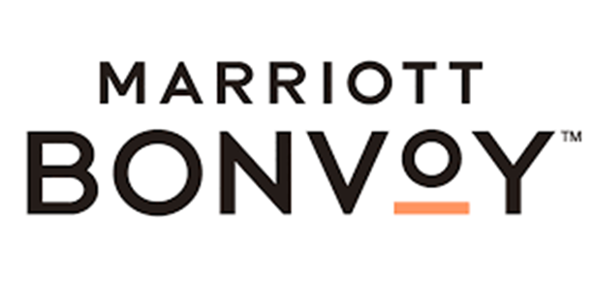
Picture 1. Marriott BONVOY Logo

Marriot's origins date back to 1927 when J. Willard Marriott and his partner, Alice, opened a 9-seater root beer shop in Washington DC, called the Hot Shoppe, where spicy foods like tamales, chili peppers, and tacos were served during the winter. In 1929, Hot Shoppe officially became a limited liability company (PT), Hot Shoppes, Inc., in the State of Delaware. With rapid growth, Hot Shoppes went public in 1953, and then in 1957, marriott opened its first hotel, the Twin Bridges Marriot in Arlington, Virginia. The Marriott Bridge Lock in Arlington, Virginia is Marriott International's longest-running hotel, and celebrated its 50th anniversary in 2009. Their son and current Chairman and Chief Executive Officer, JW (Bill) Marriott, Jr. has led the company to spectacular growth worldwide. Today, Marriott International has approximately 3,400 lodging properties located in the United States and 67 other countries and territories. Edwin D. Fuller is the current President and Managing Director of Marriott International Lodging for Marriott International. Marriott International was formed in 1992 when Marriott Corporation was split into two companies, Marriott International and host Marriott Corporation.
Marriot International was formed in 1992 when Marriott Corporation was split into two companies, Marriott International and host Marriott Corporation. Marriott International and Host Marriott Corporation in 2002 Marriott International began a major restructuring by separating much of Senior Community Services Living (which is now part of Sunrise Senior Living) and Marriott Distribution Services, resulting in April 1995, Marriott International acquiring 49% of the Ritz-Carlton Hotel Company LLC. Marriott International does not believe that it can increase sales and profit margins at the Ritz, a chain of problems with a large number of properties losing money or even barely breaking. The initial investment cost of Marriott was estimated at about $200 million in cash and debt. The following year, Marriott secured $331 million to take over the Atlanta Ritz-Carlton and buy shares owned by William Johnson, a real estate developer who had purchased the Boston Ritz-Carlton in 1983 and expanded his ownership of the Ritz over the next twenty years. The Ritz began its expansion into the lucrative timeshare market among other new initiatives that were made financially possible with the Marriott pocket, which also lent its own expertise in certain areas. There are other benefits to the Ritz-Carlton flowing from a relationship with Marriott, such as the gains from the parent company's booking system and purchasing power. The partnership was solidified in 1998 when Marriott increased its stake in the Ritz-Carlton to 99 percent. In 1999 revenues from 35 hotels operating worldwide totaled approximately US$1.4 billion.
Marriott International owned Ramada International Hotels & Resorts until it was sold on September 15, 2004 Cendant. It is the first hotel chain to serve completely trans fat-free food at all of its properties in North America. In 2005, Marriott International and Marriott Vacation Club International were two of the 53 bodies that contributed a maximum of $250,000 to President George W. Bush's second inauguration. On July 19, 2006, Marriott announced that all lodging establishments they operate in the United States and Canada will be smoke-free with a focus on hotel ownership and management. Changes were completed in 2003. Marriott International, Inc. is a leading company in the world of hospitality. This legacy can be traced to a small root beer shop that was opened in Washington, DC in 1927 by J. Willard Marriott and Alice S.. He currently owns more than 7000 properties in 135 countries. The company is headquartered in Bethesda, Md., and has approx. employees in late 2009. It is recognized by FORTUNE as one of the best companies to work for, and by Newsweek as one of America's greenest large companies. In fiscal 2009, Marriott International reported sales from operating operations of nearly $11 billion.

2.1.1. History of Four Points by Sheraton Manado
Four Points by Sheraton Manado is a 4-star hotel on Jalan Pierre Tendean, Sario, Manado City, North Sulawesi which is the Boulevard on Business (BOB) area. This hotel is located above the biggest mall in Manado City, namely Manado Town Square (Mantos). Four Points by Sheraton Manado is one of the properties of Marriott International Inc. is the largest hotel company in the world with more than 6700 properties in more than 130 countries with 30 brands. Four Points by Sheraton Manado is a property owned by PT. Gerbang Nusa Perkasa.
Four Points by Sheraton Manado is the only Marriott property in North Sulawesi. Four Points by Sheraton Manado was first opened on March 18, 2017 and has 10 room types with a total of 257 rooms including 40 suites and 1 presidential suite, 5 food and beverages outlets (Eatery All-Day-Dining, Wrapped Lounge, Tao Yuan Chinese Restaurant , Scorta Pool Bar, and In-Room-Dining), 6 meeting rooms, 1 function room, 1 grand ballroom, fitness center, and swimming pool overlooking Bunaken, Manado Tua, Siladen, Nain, and Mentehage Island.

2.2. Description
Four Points By Sheraton Manado is a company engaged in services that provides housing as a place to stay. Four Points by sheraton is a 4-star hotel in Manado, Indonesia that offers a variety of services, one of which is food. The food already uses typical food from several regions in Indonesia, Chinese, Western and European.

2.2.1. Logo
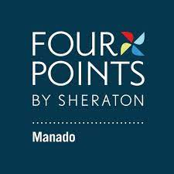
Picture 2. Four Points by Sheraton Manado Logo

2.2.2. Location
Jalan Pierre Tendean Boulevard, Kec. Sario, Kota Manado. Sulawesi Utara 95111.
Call : +624318803999
Web : www.marriot.com

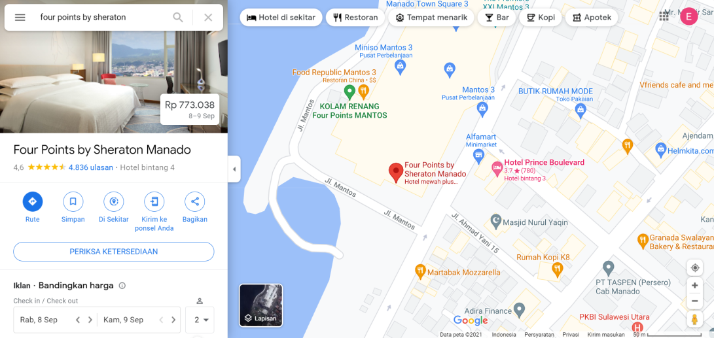
Picture 3. Four Points by Sheraton Manado Hotel Location

2.2.3. Features of Four Points by Sheraton Manado Hotel
Four points always guarantee customer satisfaction. Every guest who comes to eat at this hotel does not leave feeling full but they are satisfied with the service and get new experiences, including the food served. Therefore, it is also important to pay attention to all aspects within the hotel such as the quality of food, atmosphere, views, cleanliness to the music we play at dinner.

    - Vision and Mission
- Vision
Marriott Bonvoy has a vision to be the number 1 company or a leader in the field of lodging or hospitality in the world. Marriott has achieved their vision. And to maintain it, Marriott Bonvoy has a core value that is the foundation of the company.
- Put People First “Take care of associates and they will take care of the customers.”
- Pursue Excellence “Our dedication to the customer shows in everything we do”
- Embrace Change “Innovation has always been part of the Marriott story.”
- Act With Integrity “How we do business is as important as the business we do.”
- Serve Our World “Marriott strives to be a force for good

- Mission
Meet the needs of each individual so that it exceeds consumer expectations by taking into account the interests of all parties, both from the owner, guests/consumers, and employees.

    - Restaurant and Kitchen Picture

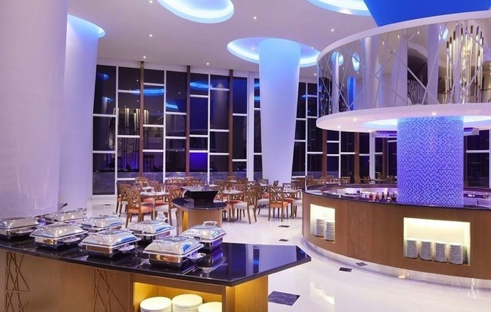
Picture 4. Guest Breakfast Room ( Indoor II )

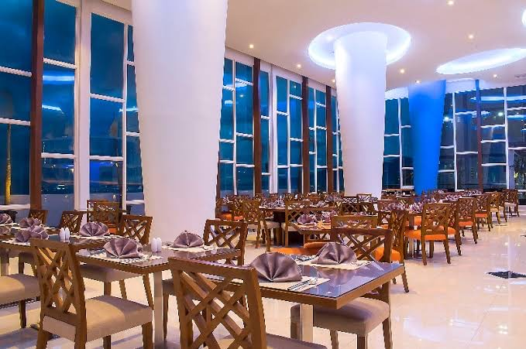
Picture 5. Guest Breakfast Room ( Indoor II )

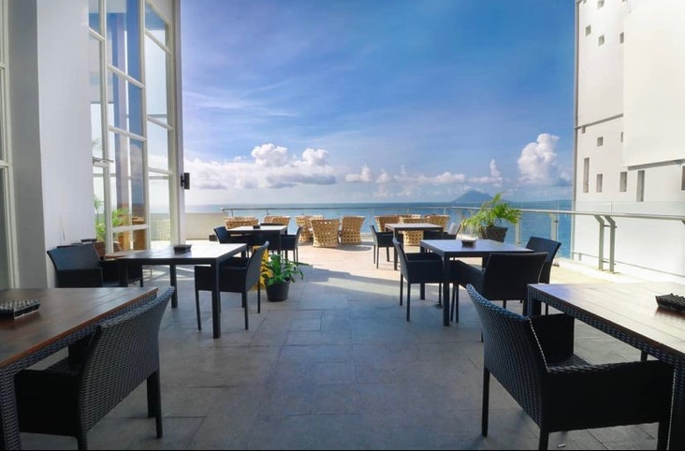
Picture 6.Guest Breakfast Room ( Outdoor )

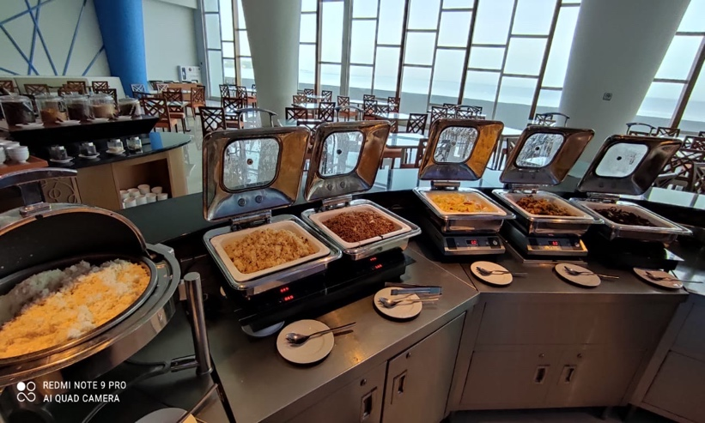
Picture 7. Buffet Station ( Main Course )

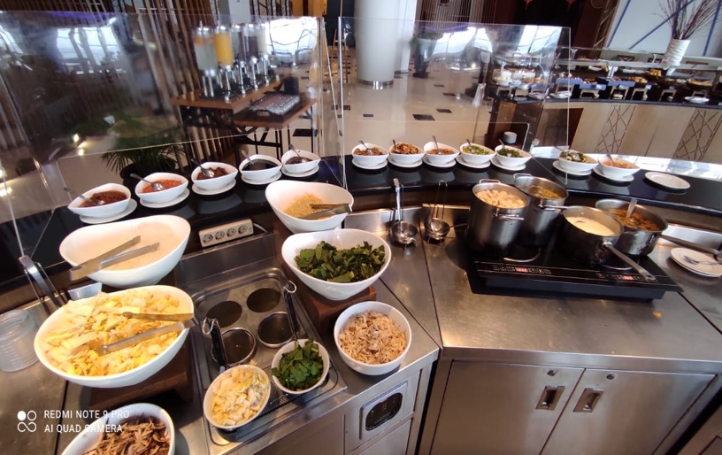
Picture 8. Buffet Station ( Noodles & Porridge )

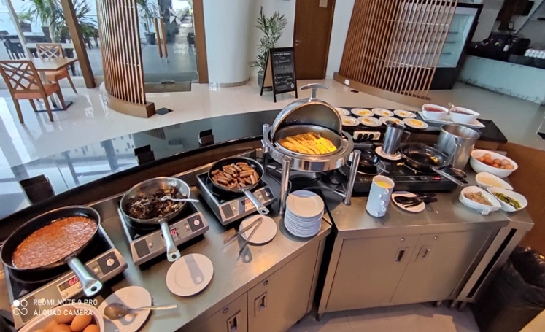
Picture 9. Buffet Station ( American Breakfast )

Picture 10. Buffet Station ( Waffle & Pancake )

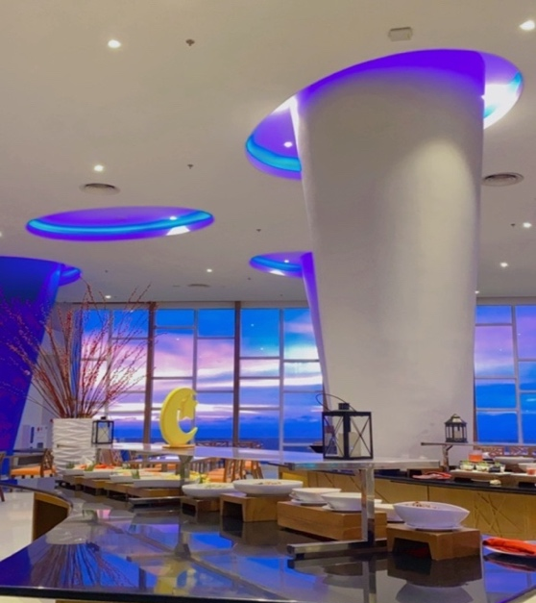
Picture 11. Fresh Fruit & Salad Station

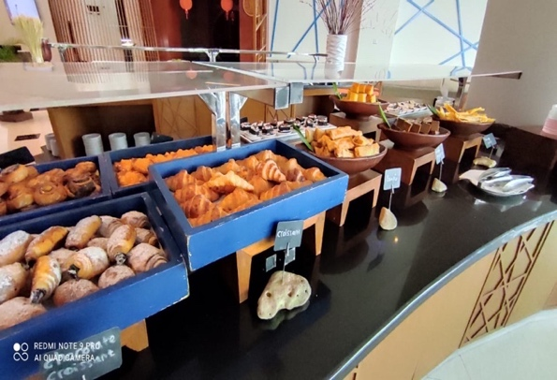
Picture 12. Buffet Station ( Pastry I )
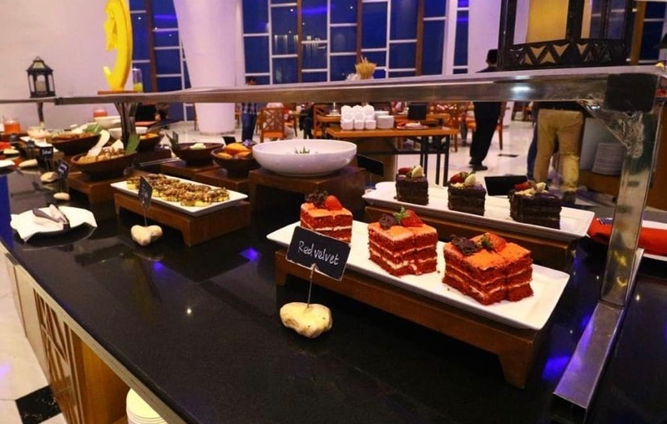
Picture 13. Buffet Station ( Pastry II )

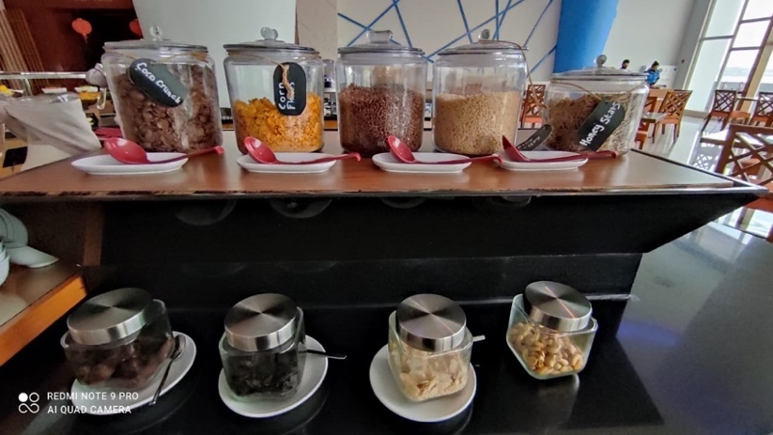
Picture 14. Buffet Station ( Cereal )

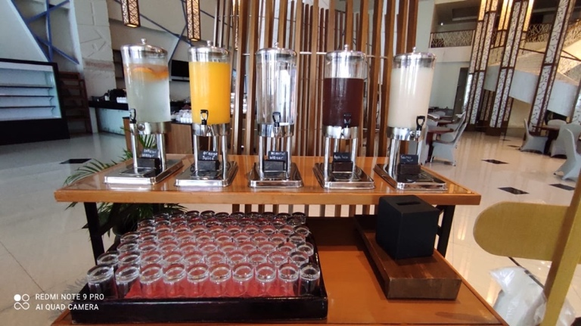
Picture 15. Drink Holder

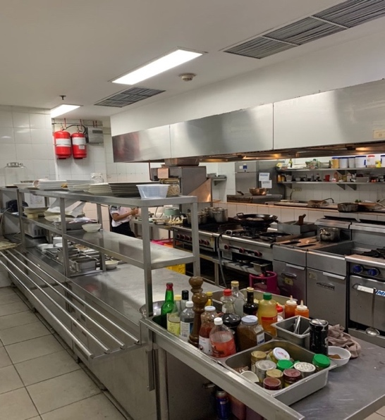
Picture 16. Main Kitchen ( I )

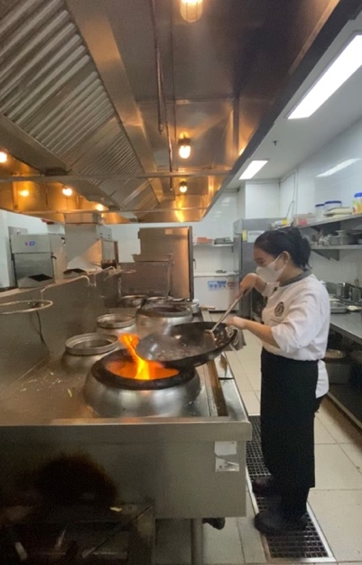
Picture 17. Main Kitchen ( II )

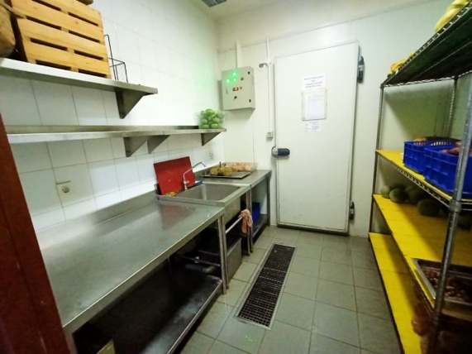
Picture 18. Cold Kitchen
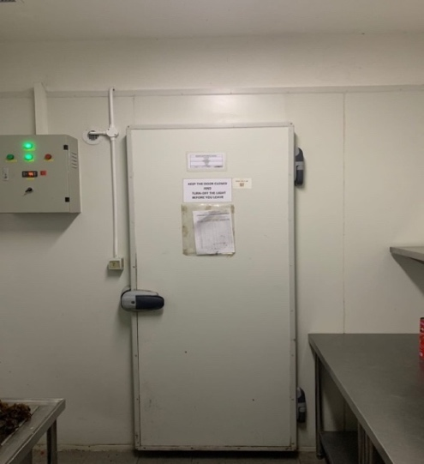
Picture 19. Main Kitchen Chiller

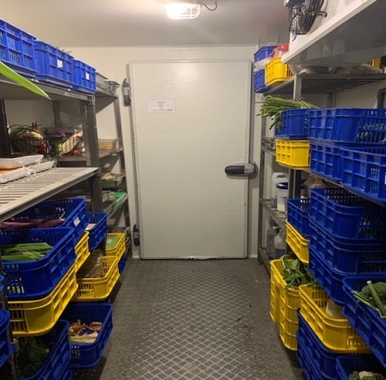
Picture 20. Vegetable chiller

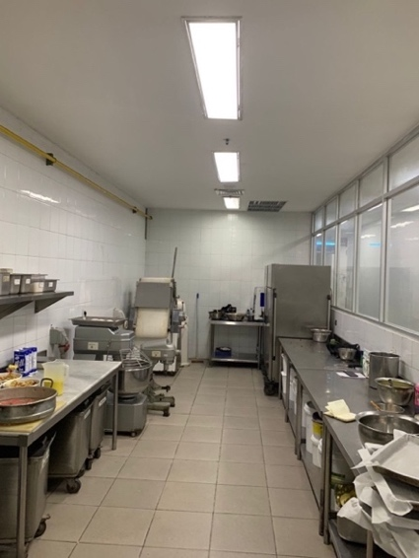
Picture 21. Baking & Pastry ( I )
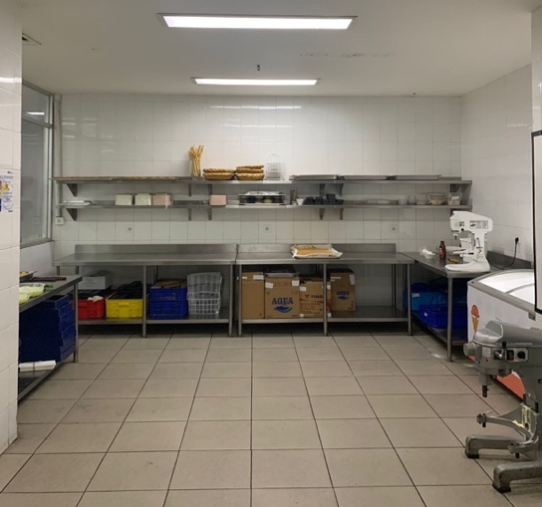
Picture 22. Baking & Pastry ( II )

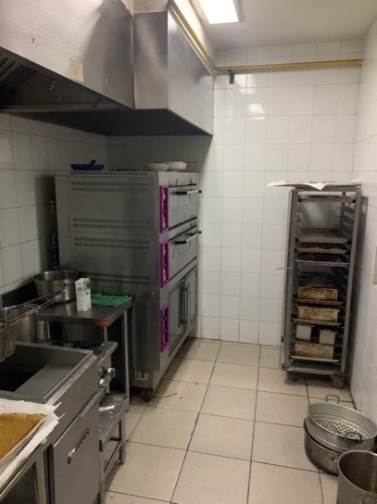
Picture 23. Baking & Pastry ( III )

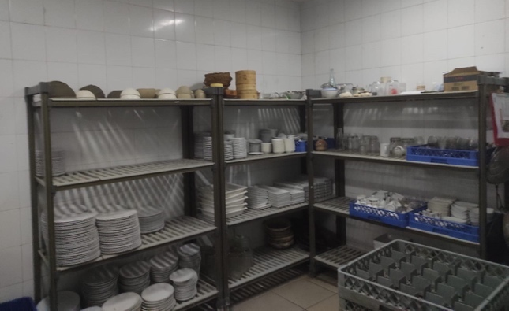
Picture 24. Steward ( I )

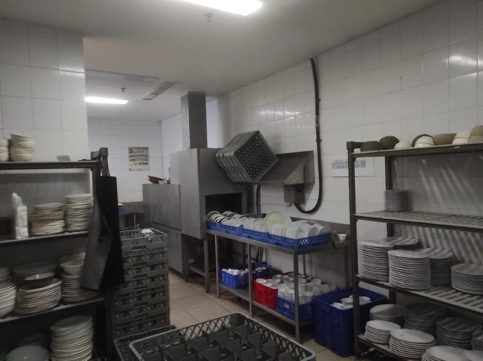
Picture 25. Steward ( II )

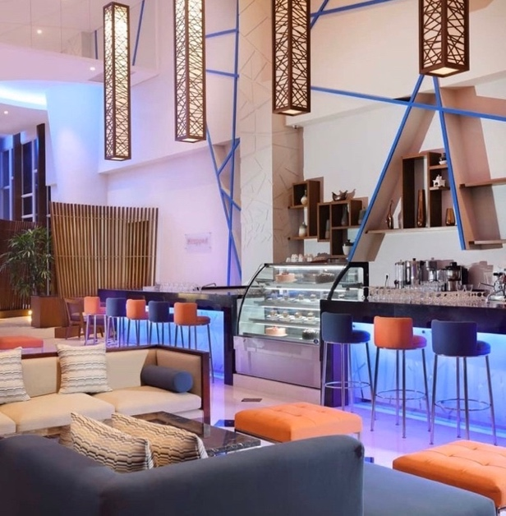
Picture 26. Lobby Bar

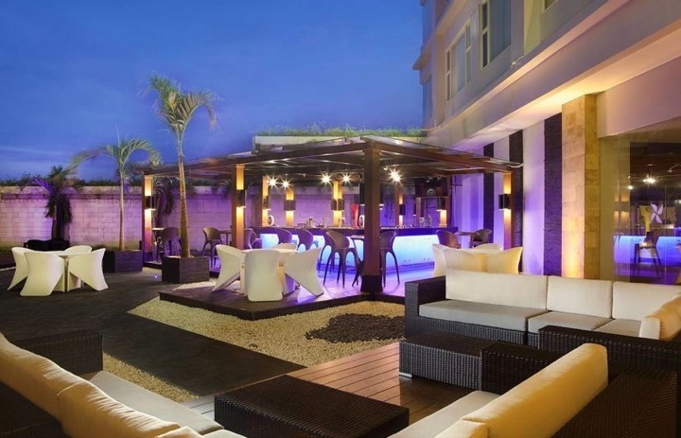
Picture 27. Scorta Pool Bar
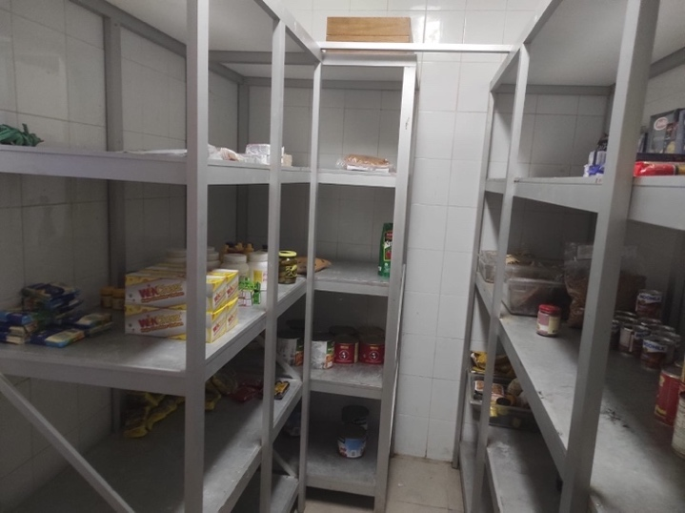
Picture 28. Store ( I )

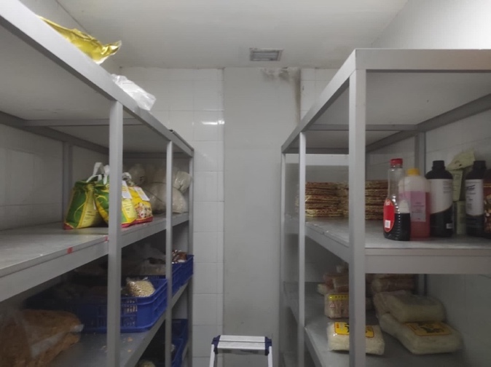
Picture 29. Store ( II )

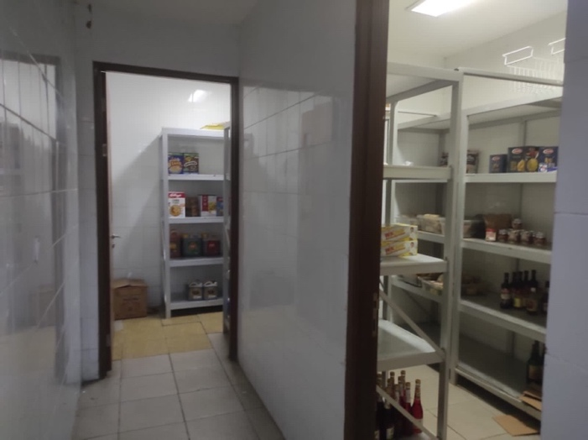
Picture 30. Store ( III )
  - Organization Structure and Main Task

2.3.1. Structure
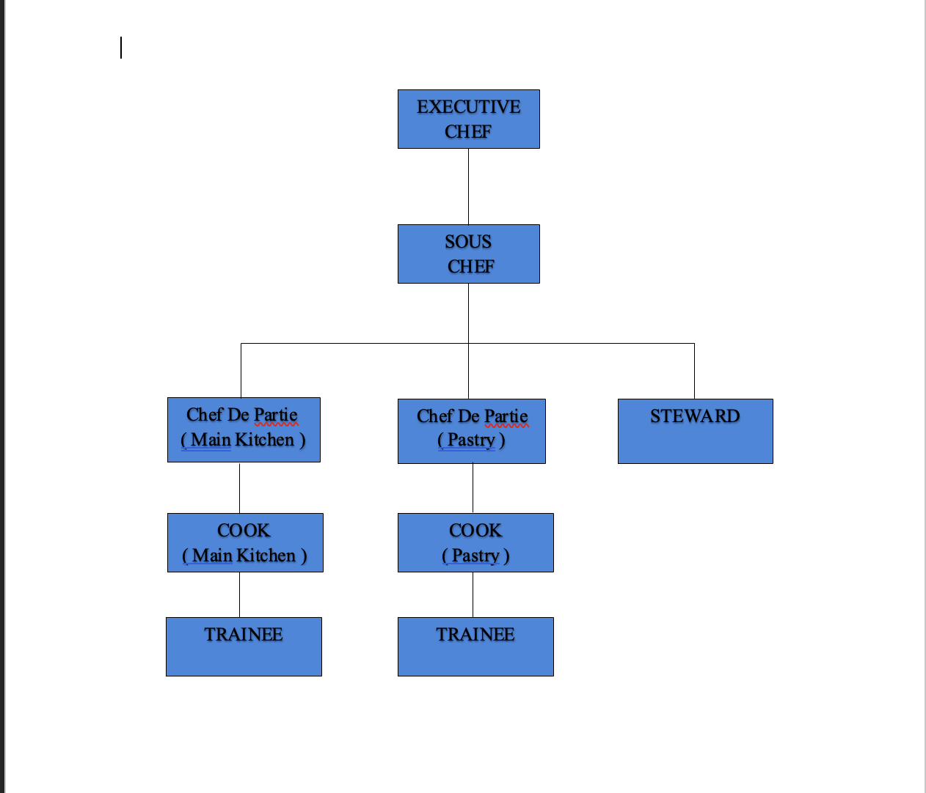
Picture 31. Organization Structure

2.3.2. Main Task
- Executive Chef
- Supervise treatment, use of food commodities available in the kitchen to facilitate the work of the kitchen team itself.
- Checking the completeness, accuracy of the mise in place and the arrangement of food presentation according to the standard of the food itself.
- Researching restaurant orders requested by guests brought by F&B service to F&B product and function orders, and forwarding them to the chef de partie.
- Perform menu totaly or total food sold according to menu items so that it can provide an overview of preferred preparation.
- Prepare sales product reports sold for today, yesterday and before.
- Supervise the smoothness, accuracy of service for food orders which are then handed over to guests by Food and beverage service.
- Supervise the management of food hygiene (free of germs), sanitation of the work environment. Arrange Buffet Table and Food Display.
- Handling, addressing guest complaints on food quality.
- Assisting the smooth implementation of the physical inventory.
- Checking completeness. Stipulation, the procurement of Store Requisition for ordering goods and or for cross checking with the store man regarding the procurement of goods.
- Prepare Repair and Maintenance Orders to maintain all kitchen tools and equipment that require repairs.
- Supervise the use of clean equipment for hygiene (sanitation) and hygiene (germ-free) factors in carrying out kitchen duties.
- Handling issues that require immediate handling, reporting to Chef issues that require special handling.
- Supervise personal discipline by providing accurate attendance without manipulation in the employee attendance list.
- Checking Personal Hygiene or the neatness of employees in carrying out their respective jobs.
- Assess the work performance of direct subordinates, approve the results of the assessment carried out by direct subordinates.
- Sous Chef
- Responsibility for compiling the schedule and replacing the Chef position if he is not present or on holidays ( day off )
- Chef De Partie ( pastry )
- Responsible for overseeing the smooth operation of the pastry section.
- Organize and divide tasks and work among subordinates
- And participate directly in preparing meals.
- Chef De Partie ( main kitchen )
- Responsible for overseeing the smooth operation of the main kitchen section.
- Organize and divide tasks and work among subordinates
- And participate directly in preparing meals.
- Stewards
- Responsible for cleaning the equipment used in the kitchen
- Cook
- Responsible for the part that has been given
- Trainee
- Responsible for helping each commission according to the schedule that has been distributed

