BAB II

BUSINESS PLAN

2.1 Market Potential
2.1.1 Company Form
Our product form is a daily food business, So we choose to open our food cart in district foods in Sampit; Why? The reason’s because many people go to the district food.
Figure 1. Core Value
CORE VALUE
Kedai Yako
TRUST

Make people trust our product
INTEGRITY

We Work Honestly with each other
RESPECT

We will treat our people fairly
INOVATION

Support continuous growth & improvement
VISION
MISION
VALUE

Vision
Become a food cart that interests many people, and can provide best service to customers
Mission
Get an impression that exceeds customer expectations
Value
We respect and care for our customers by offering the highest in quality products and service

2.1.2 Segmentation
Yako shop collects data segmentation on the number of purchases, people's favorite menus, and their satisfaction. From the data, Yako can determine the number of products and materials that must be prepared for sale.
2.1.3 Targeting
Yako shop's target market is determined by adjusting the price and the place we provide, most of the customers we target are middle to lower class. We also target young children to adults with families, because our place is not only comfortable to hang out but also comfortable to eat with family.
2.1.3 Positioning
One of the services we provide is that you can place orders from afar for the normal menu or additional side dishes on the grilled rice menu.

2.2 Location
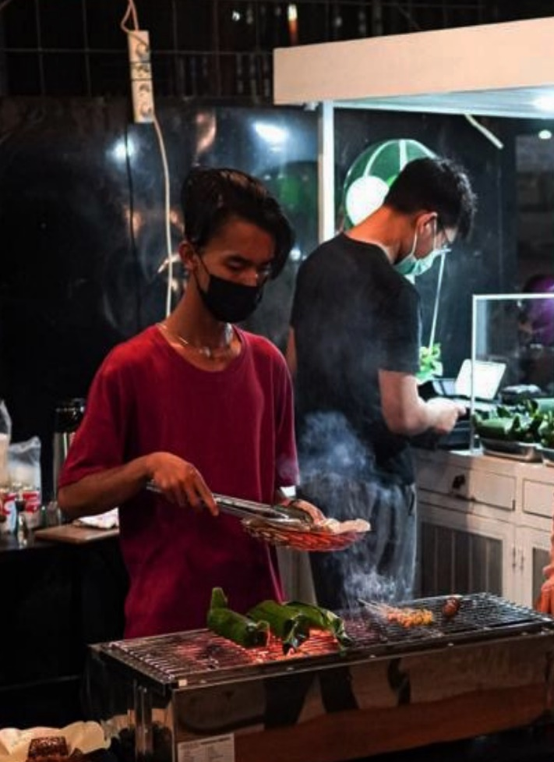
Kedai Yako located on Kapten Mulyono Street, No. 83/01. For the food preparation kitchen, its located at my house, which is quite close to the sales location.
Figure 2. Cooking Process
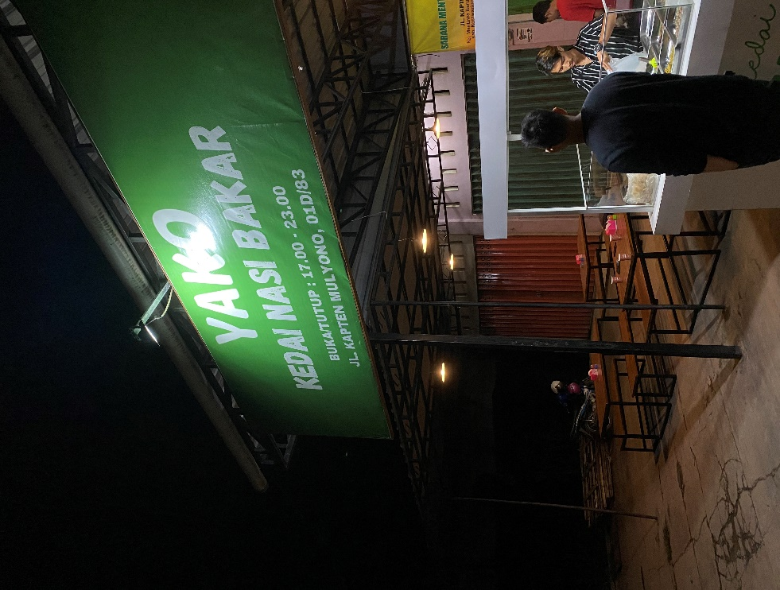
Figure 3. Kedai Yako
Figure 4. Kedai Yako
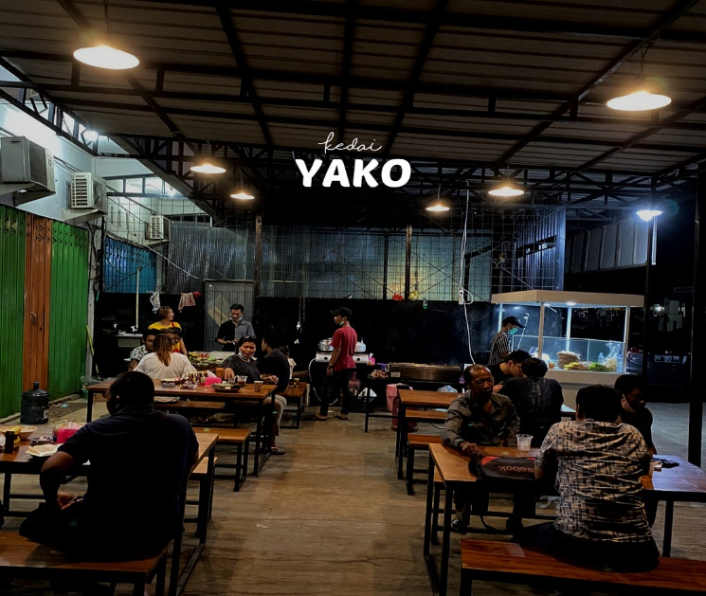

2.3 Product & Price
2.3.1 Roasted Rice
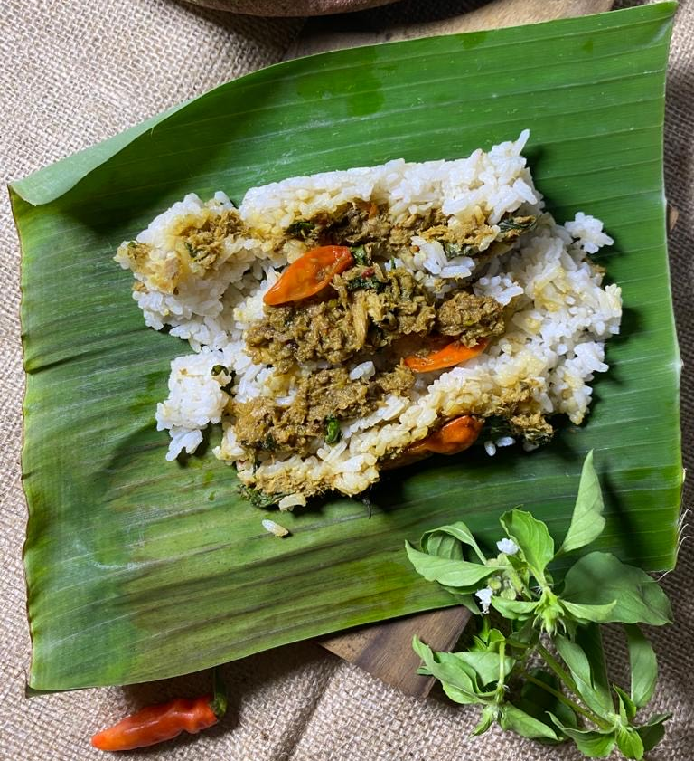
There are 2 type of grilled rice served by the yako shop, namely tuna grilled rice and chicken grilled rice
Figure 5. Nasi Bakar

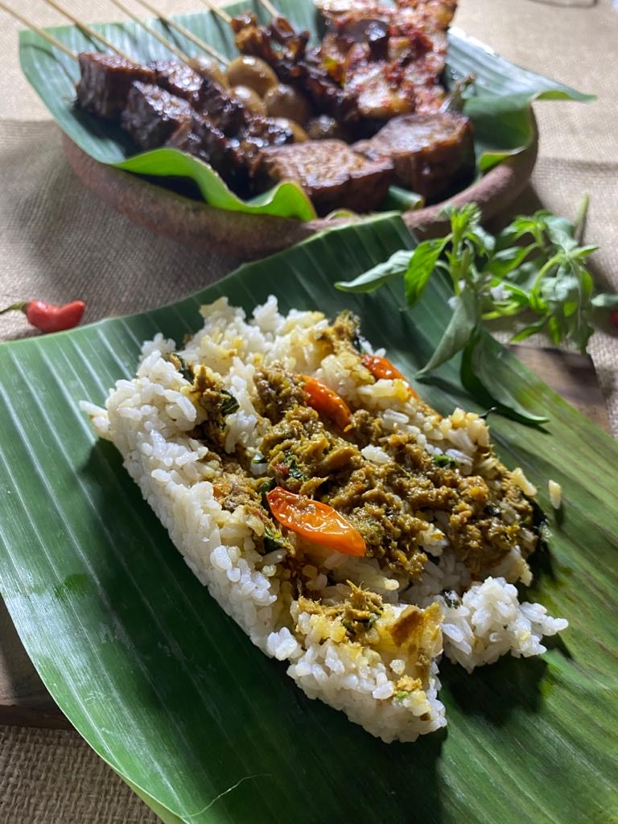
Figure 6. Nasi Bakar

2.3.2 Satay Menus
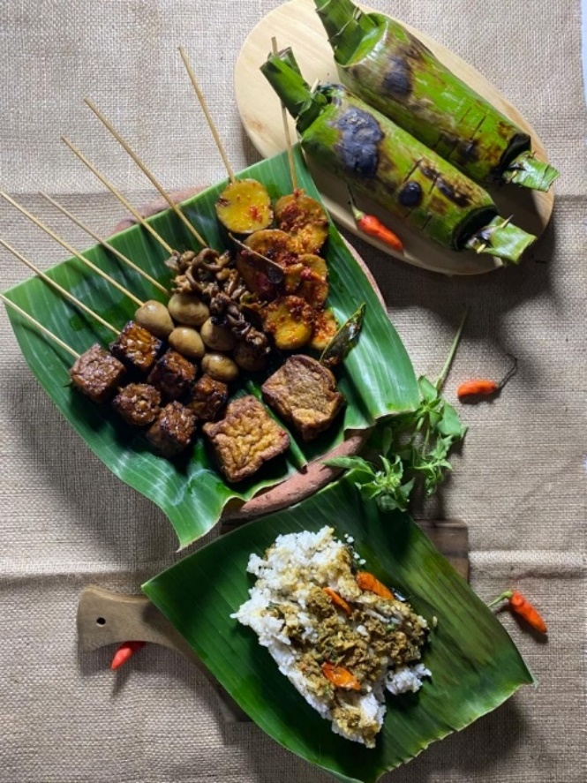
For the satay menu and side dishes there are chicken wings, intestines, gravel, tofu, tempeh, pentol, quail eggs, liver.
Figure 7. Nasi Bakar

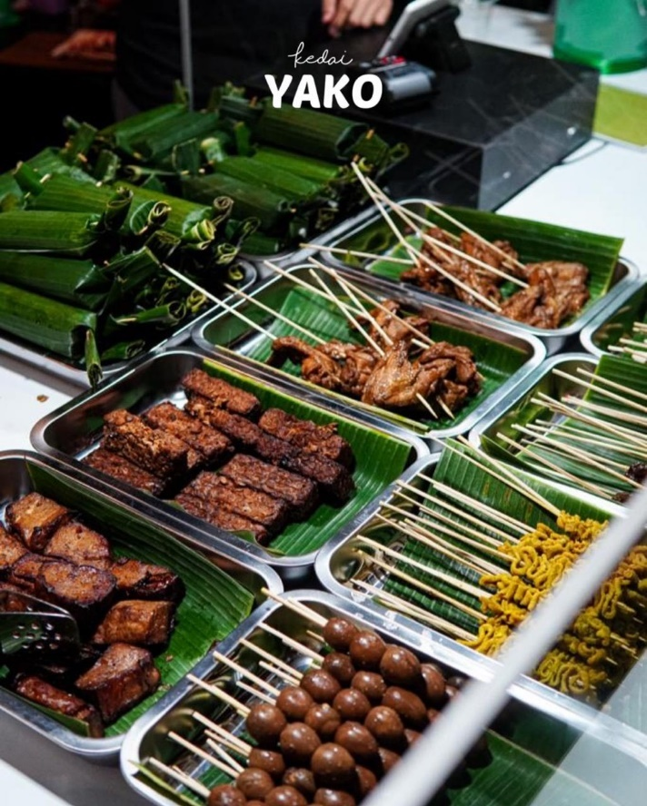
Figure 8. Yako Satay

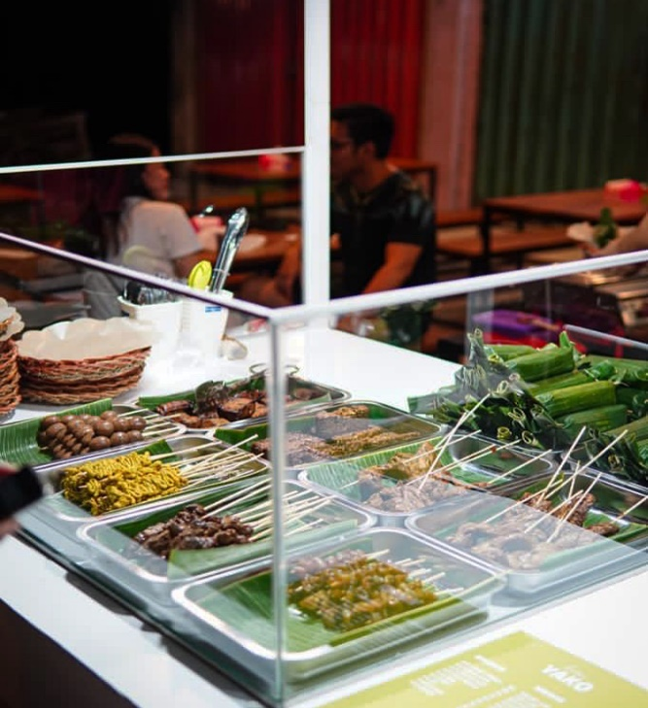
Figure 9. Yako Satay

2.3.3 Drinks
Beverage variants, namely iced tea, milk coffee, ginger wedang milk, ginger wedang, etc

2.4 Sales Projection
for selling grilled rice per day we prepare 25 packs of grilled rice per day as well as side dishes and drinks, where per day we can get sales approaching maximum capacity and sometimes exceeding.

2.5 Marketing Strategies
2.5.1 Promotion
Yako shop does a buy 2 get 1 promotion for the grilled rice menu and promotes our location and place to make it easier for people to find.
2.5.2 Marketing
2.5.2.1 Social Media
Social media is a good tool to promote the food, location, and place of a business, yako shop has been doing promotions on social media so that it can achieve sales targets every day.

2.6 SWOT analysis
2.6.1 Strength
Food we serve includes daily food that can be enjoyed by various people, and has an affordable price for the surrounding community
    - Weakness
It's a new brand, so there are still many people who don't know about Yako, and it has several competitors around
    - Opportunity
Because Kedai Yako is a new brand, an interesting promotion is needed to attract customers
    - Threat
There are many competitors who have been selling for a long time in the surrounding area

