BIBLIOGRAPHY

Depkes RI. 2004. Higiene Sanitasi Makanan dan Minuman.
Jakarta: Ditjen PPM dan PL. Accessed on July 14th 2021
Keputusan Menteri Kesehatan Republik Indonesia Nomor 1098/ MENKES/ SK/ VII. Persyaratan Higiene Sanitasi Rumah Makan dan Restoran. Jakarta.
Acessed on July 14th 2021
Marriot. 2020. Westin Hotels and Resorts. Family Friendly Hotel.
Available: https://westin.marriot.com/wellness/play-family. Acessed on June 25th 2021.
Marriot. 2020. The Westin Pakuwon Indah Surabaya.
Available: https://westin.marriot.com/about. Acessed on June 25th 2021.
Marriot. 2020. Westin Hotels and Resorts. Hotel Meeting Space.
Available: https://westin.marriot.com/meetings. Acessed on June 25th 2021.
Marriot. 2020. Westin Hotels and Resorts. What to Expect in The Age of COVID-19
Available: https://whattoexpect.marriot.com/subwi. Acessed on July 2th 2021.

APPENDIX

Magnolia Hot Kitchen Area
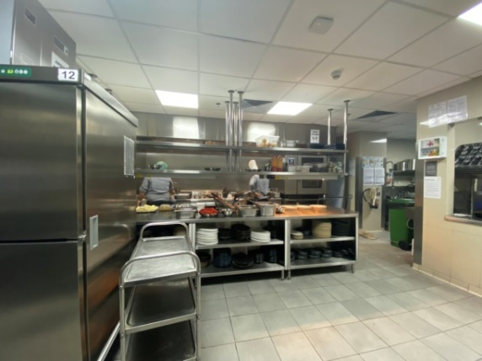
Figure 91. Hot Kitchen Area
Source: Personal Documentation, 2021

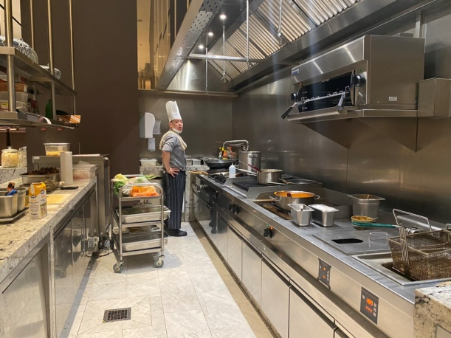
Figure 92. Hot Open Kitchen
Source: Personal Documentation, 2021

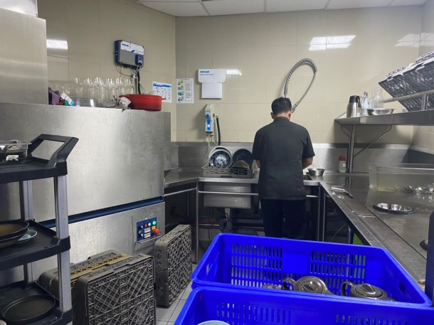
Figure 93. Steward Area
Source: Personal Documentation, 2021

Magnolia Cold Kitchen

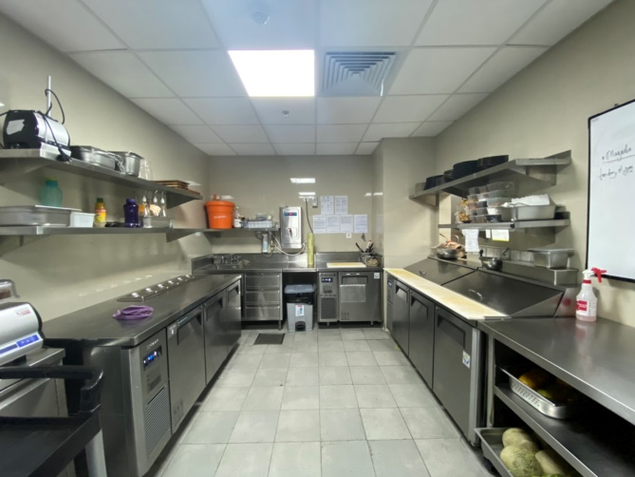
Figure 94. Cold Kitchen Area
Source: Personal Documentation, 2021

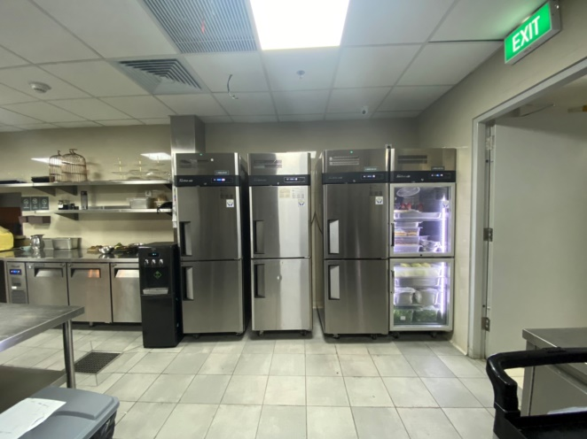
Figure 95. Cold Kitchen Chiller Area
Source: Personal Documentation, 2021

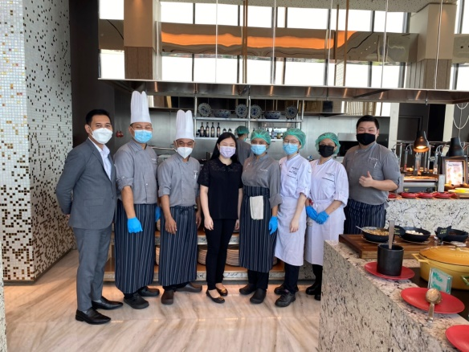
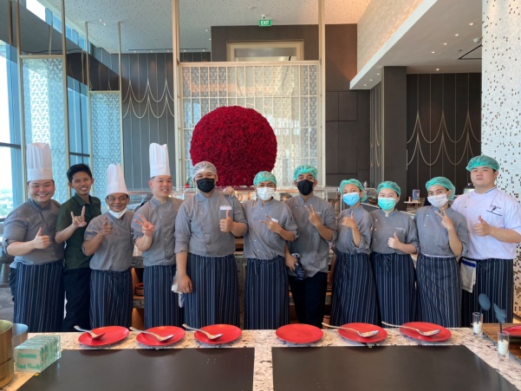
Magnolia Kitchen Team
Figure 97. Magnolia Team1
Source: Personal Documentation, 2021

Figure 96. Magnolia Team 2
Source: Personal Documentation, 2021

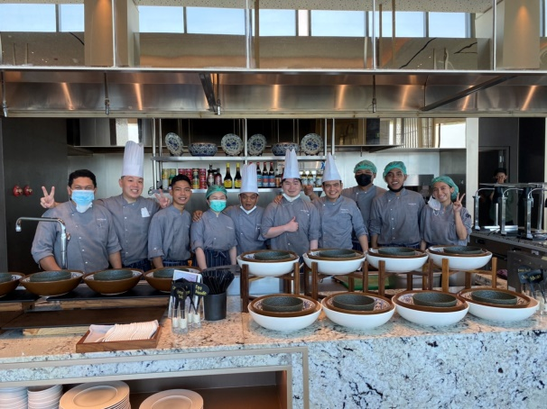
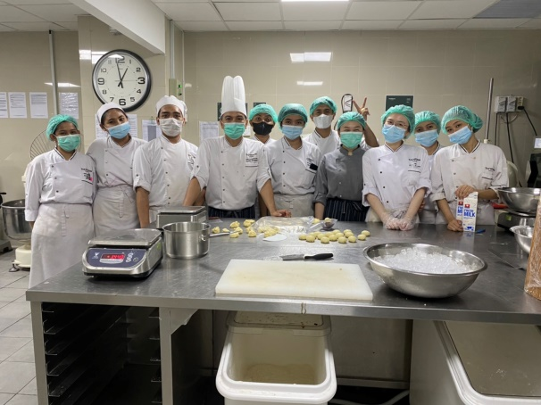
Figure 99. Magnolia Team 3
Source: Personal Documentation, 2021

Figure 98. The Westin Pastry Team
Source: Personal Documentation, 2021

