CHAPTER II
GENERAL DESCRIPTION OF COMPANY

History of The Company
Western Hotel
In 1930, Severt W. Thurston and Frank Dupar of Seattle, Washington met unexpectedly during breakfast at the coffee shop of the Commercial Hotel in Yakima, Washington. The competing hotel owners decided to form a management company to handle all their properties, and help deal with the crippling effects of the ongoing Great Depression. The men invited Peter and Adolph Schmidt, who operated five hotels in the Puget Sound area, to join them, and together they established Western Hotels. The chain consisted of 17 properties – 16 in Washington and one in Boise, Idaho.
Western Hotels expanded to Vancouver, British Columbia and Portland, Oregon in 1931, to Alaska in 1939, and then to California in 1941, assuming management of the Sir Francis Drake Hotel the day after Pearl Harbor was bombed. By the early 1950s, Western also had properties in Montana and Utah.
Western Hotels executive Edward Carlson convinced Victor "Trader Vic" Bergeron to open his first franchised Trader Vic's location in the chain's Benjamin Franklin Hotel in Seattle in 1949. Originally a small bar named The Outrigger, it was expanded into a full restaurant in 1954 and renamed Trader Vic's in 1960. Due to the restaurant's success, Bergeron worked with Western Hotels to open Trader Vic's locations in a number of its hotels.
Western expanded to Hawaii in 1956, with the acquisition of the Hawaiian Village Hotel from Henry J. Kaiser.
Early management developed each property individually. After more than two decades of rapid growth, many of its properties were merged into a single corporate structure in 1958, focusing on bringing the hotels together under a common chain identity. Also in 1958, Western Hotels assumed management of three hotels in Guatemala, its first properties outside the US and Canada. Western opened its first hotel in Mexico in 1961. In March of that same year, they opened the first hotel to be both constructed and owned by the chain, The Bayshore Inn in Vancouver.
Edward Carlson became President of the chain in 1960 and is credited with bringing the Century 21 Exposition to Seattle in 1962. Carlson's own napkin sketch of a tower with a revolving restaurant on top, inspired by his visit to the Stuttgart TV Tower, was the origin of the Space Needle. The chain managed the restaurant atop the Space Needle from its opening until 1982. Western Hotels also managed a floating hotel aboard the ocean liner QSMV Dominion Monarch, docked in Seattle harbor during the fair.

Western International Hotels
The company was renamed Western International Hotels in January 1963, to reflect its growth outside the US. That same year, the company went public. From November 1, 1965 to 1970, Western International had an agreement with Hotel Corporation of America (today known as Sonesta), under which all 72 hotels of the two chains were jointly marketed as HCA and Western Hotels. From 1968 to 1973, Western International had a similar joint marketing agreement with UK-based Trust House Hotels. In 1970, Western International was acquired by UAL Corporation, with Edward Carlson becoming president and CEO of UAL, Inc and United Airlines. Western International bought New York's iconic Plaza Hotel in 1975 for $25 million.

Westin Hotels
On January 5, 1981, the company changed its name again to Westin Hotels (a contraction of the words Western International). The chain's flagship Washington Plaza Hotel in Seattle was the first property to be rebranded, becoming The Westin Hotel on September 1, 1981. That same year, Westin opened a new corporate headquarters directly across the street in the Westin Building, which shared a parking garage with the hotel.
In 1987, UAL Chairman Richard Ferris announced a plan to reorganize UAL as Allegis Corporation, a travel conglomerate based around United Airlines, Hertz Rent a Car, Hilton Hotels, and Westin and linked by Apollo. This strategy failed, however, and Allegis sold Westin in 1988 to the Japanese Aoki Corporation for $1.35 billion. Aoki immediately sold the Plaza Hotel to Donald Trump for $390 million.
In 1994, Aoki agreed to sell Westin to real estate investment firm Starwood Capital Group (parent of Starwood) and Goldman Sachs at an enormous loss, for $561 million, but by the time the sale closed in May 1995, the buyers had negotiated the price down to $537 million. In 1998, Starwood assumed full ownership of the company.
Westin was the first hotel chain to introduce guest credit cards (in 1946), 24-hour room service (1969), and personal voice mail in each room (1991).

21st Century
In the early 21st century, Westin focused on global expansion. Since 2005, the number of hotels grew from 120 locations in 24 countries to over 192 locations in 37 countries as of 2013.
Westin markets certain amenities available in its properties to the public under the brand name Heavenly. In 2005, Westin became the first hotel company to gain a national retail store presence when Nordstrom started carrying the Heavenly Bed line in more than 60 stores.
Westin refreshed its partnership with United Airlines in 2008. United began offering pillows and blankets from Westin's Heavenly Bed line on select United premium service routes between New York City and California, as well as Westin decorations and scents in some Red Carpet Club lounges. This program ceased following United's merger with Continental Airlines. Beginning in 2013, Delta Air Lines began an extensive partnership with Westin and Starwood, which included adding Westin Heavenly In-flight Bedding to all Delta One seats on international flight as well as transcontinental flights.
In 2016, Marriott International acquired Starwood, becoming the world's largest hotel company.

Vision, Mission and Company Objectives

Vision
“ To be the best hotels, leading the market, and creating extraordinary experiences through personalized and authentic services.”

Mission
    - Owner / Company
We continuously drive revenue, take care of our assets to consistently grow our profits for our stakeholders.
    - Associates
We inspire and empower our associates through our strong culture to motivate them to reach their best.
    - Guests
We are authentic, energetic and approachable to create extraordinary experiences that exceeds guests’ expectations.
    - Community
We actively support local communities, through partnerships to shape a better life for others.

Core Values
The core values of The Westin Surabaya are :
      - Personal
We innately understand each guest is unique. We customize care and attention to create an intimate and distrinctive experience.
      - Instinctive
We meet guests’ needs proactively, not just teactively. We inspire associates to tap into their intuition to anticipate guests’ every desire.
      - Renewal
We offer guests countless opportunities maintain their well-being while restoring a sense of control so that they leave feeling better then when they arrived.

Six Pillars of The Westin
The Westin is starting a new well-being initiatives called The Westin Well-Being Movement and being offered not only to hotel guests but also the employees worldwide. All of the related programs and partnerships through it will be based on what the brand is calling its “Six Pillars” that consist of Feel Well, Work Well, Move Well, Eat Well, Sleep Well, and Play Well.

- Feel Well
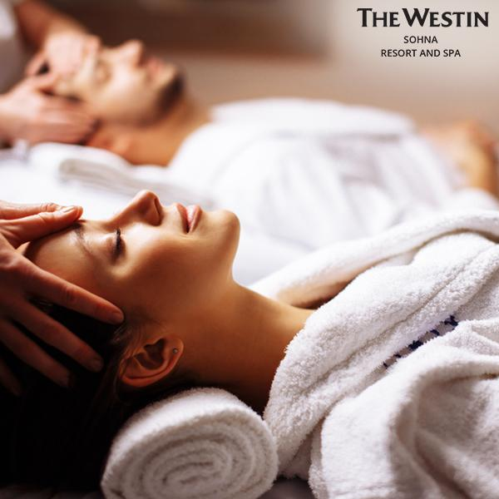
Figure 1. Feel Well by The Westin
Source: The Westin, 2018
In times like this, self-care becomes increasingly important. In the meantime, this means keeping up our spirits and hopes. Therefore, The Westin with its Well-Being program offers several series to pamper ourselves such as : Heavenly® Bath, Heavenly® Spa, In-Room Spa, and Sensory Welcome.
- Work Well
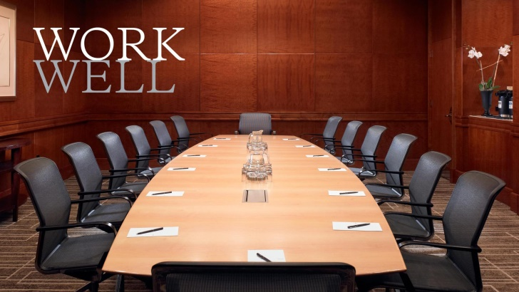
Figure 2. Work Well by The Westin
Source: The Westin, 2018
Change up your office view, and Work Well! We believe that working well sometimes means stepping outside of the office, and that inspiration can come from unexpected places. This package is for those working or learning remotely who want to get away, while still maintaining productivity. The Westin offered their Meeting Room that you can use for working with your company with different atmosphere.
- Move Well
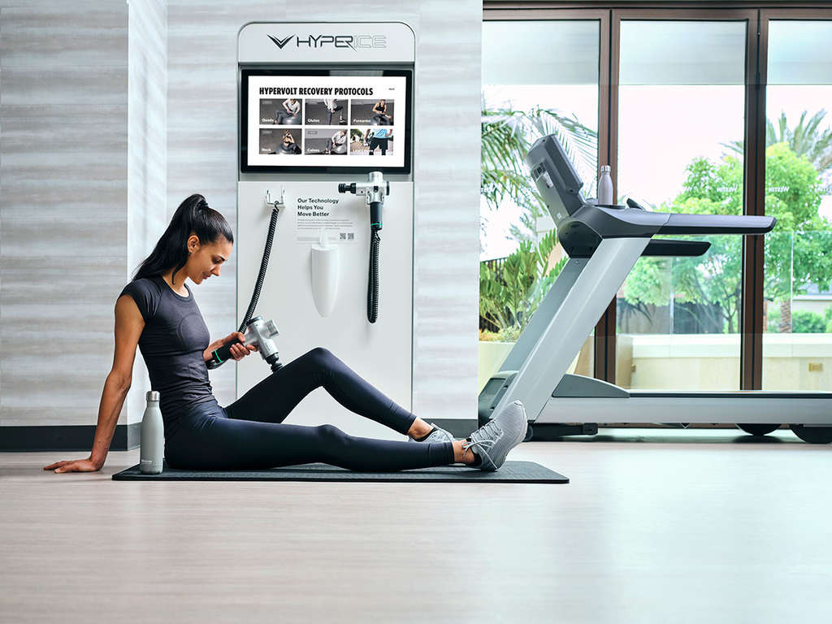
Figure 3. Move Well by The Westin
Source: The Westin, 2018
The Westin is here to help you chase your personal best and find your best selves. At Westin, you can do it all get your workout in, take in beautiful surroundings, and unwind with a restful stay. The Westin provides you with their WestinWorkout® Fitness Studio, Westinworkout® Rooms, Gear Lending, TRX Session, and RunWestin™. You can also do exercises and take some classes such as accompanied by experienced instructors from The Westin.
- Eat Well
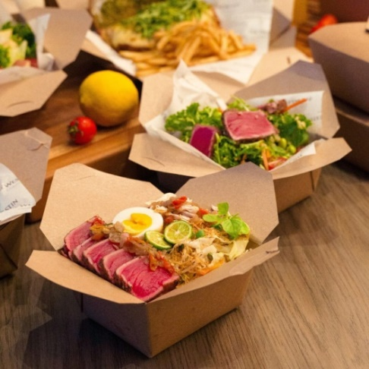
Figure 4. Eat Well by The Westin
Source: The Westin, 2018
Rise above the rigors of travel and keep up with your healthy eating habits while on the road. Explore all the ways you can eat well at Westin with programs like our Westin Eat Well Menu , a menu packed with thoughtful options that keep you fueled and focused on feeling your best. As for some of the menu variations that Westin offers are : Eat Well Menu, Eat Well Menu for Kids, Westin Fresh by The Juicery, Crafted at Westin, and Jing Tea.
- Sleep Well
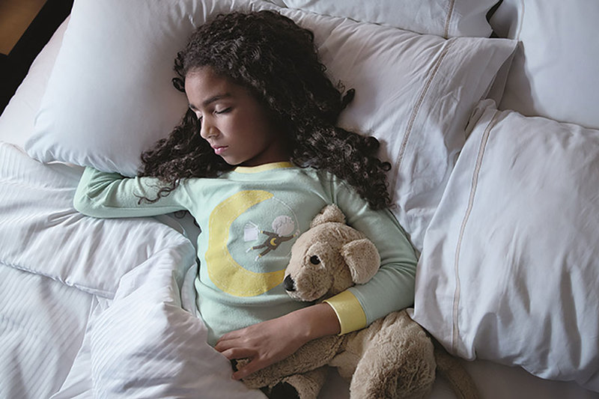
Figure 5. Sleep Well by The Westin
Source: The Westin, 2018
We know that restorative sleep is essential to your well-being, which is why we’ve created signature programs to support a restful night. Our signature Heavenly® Bed and Lavender Balm have been thoughtfully crafted to ensure you rise refreshed.
- Play Well
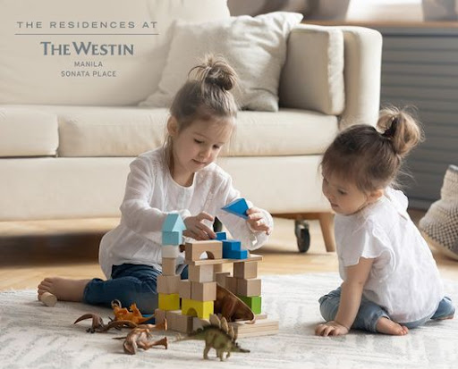
Figure 6. Play Well by The Westin
Source: The Westin, 2018
We believe that all our guests should leave feeling better than when they arrived – and kids are no exception. Our Westin Family programs were designed to ignite wonder and spark curiosity, and our Westin Family Kids Clubs provide imaginative spaces for kids to play. Discover all that Westin Family has to offer, then gear up for a vacation filled with adventure.

Description of The Company

Location

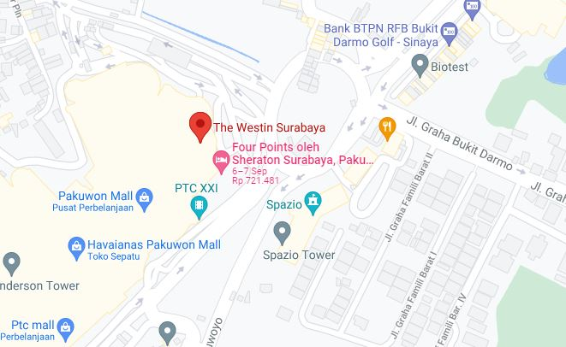
Figure 7. The Westin Surabaya Map Location
Source: The Westin, 2018

The Westin Surabaya
Address : Pakuwon Mall, Jl. Puncak Indah Lontar No. 2,
Wiyung, Surabaya, Jawa Timur, 60216.
Telp/ Fax : +62 31 29710000 / +62 31 99149999
Website : www.westinsurabaya.com
GPS Long : 112.676146
GPS Lat : - 7.289127

The Westin Surabaya Overview and Facilities

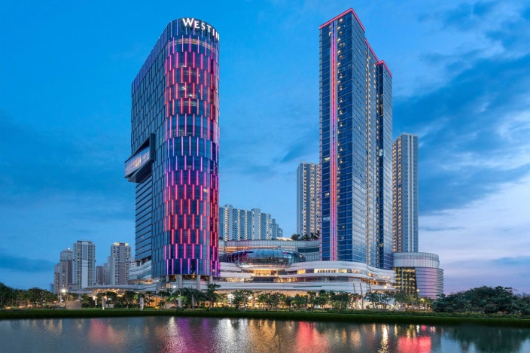
Figure 8. The Westin Surabaya Tower
Source: The Westin, 2020

Live a 5-star experience in Surabaya, Indonesia, that nurtures your well-being with upscale facilities and exceptional service at The Westin Surabaya. Explore West Surabaya's high-end neighborhoods, experience night golf at Pakuwon Golf & Family Club and shop at the adjoining Pakuwon Mall, one of the largest in Indonesia. Your sensory-filled journey begins in one of the city's highest lobbies, set against the breathtaking backdrop of the Surabaya skyline. Treat yourself to cocktails at the Sky Lounge and savor nutritious meals at Magnolia Restaurant, both overlooking the city from the Sky Lobby. Maintain your workout in our hotel's 24-hour WestinWORKOUT® Fitness Studio, take a dip in our three outdoor swimming pools, including a dedicated Kids Pool, and host unforgettable events in one of Surabaya's largest ballrooms. Rest in a well-appointed, 5-star room complete with signature Westin amenities like in-room dining, free Wi-Fi and a White Tea Aloe Bath & Body Set. Explore Indonesia from The Westin Surabaya.

    - The Welcome Lobby

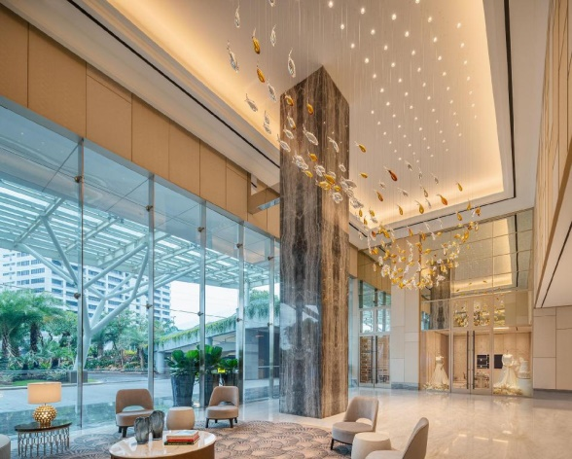
Figure 9. The Westin Welcome Lobby
Source: The Westin, 2020
The visitors who will stay at the westin surabaya will be warmly welcomed by The Westin team when they arrive at the welcome lobby. With a very elegant interior design makes visitors feel amazed by the beauty and comfort of our hotel. In this welcome lobby there is also a westin wedding room where The Westin can help you to realize your dream wedding.

    - The Main Lobby

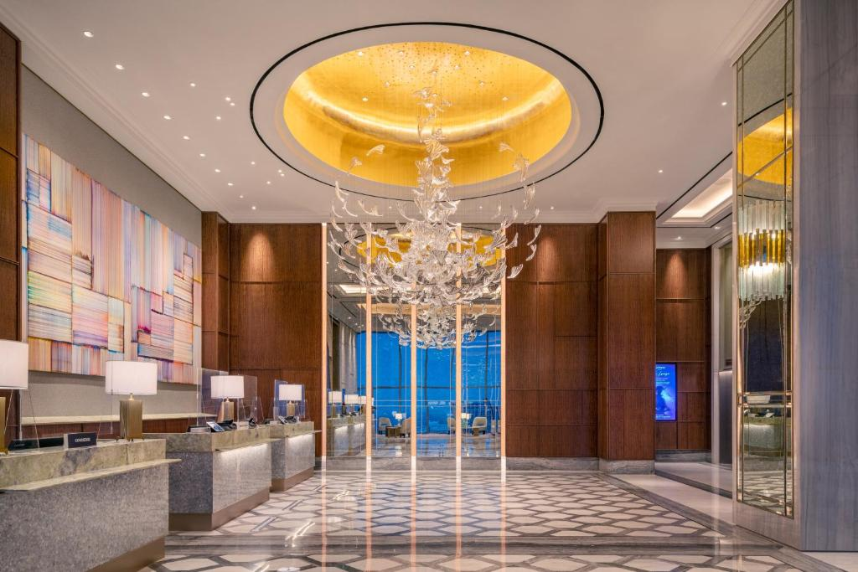
Figure 10. The Westin Main Lobby
Source: The Westin, 2020
The Westin Surabaya's main lobby is located on the L floor where from there visitors will be pampered with a beautiful view of the city and of course The Westin's luxurious and elegant interior design. In the main lobby, visitors will be greeted warmly and friendly by the staff of The Westin Surabaya. The visitors will be directed to the receptionist and will get extraordinary service.

    - Swimming Pool

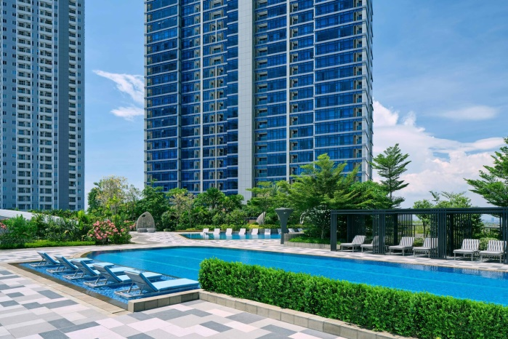
Figure 11. The Westin Swimming Pool
Source: The Westin, 2020
A swimming pool surrounded by tall buildings, The Westin Surabaya Level 6 outdoor swimming pool provides 3 kinds of pools, namely Lap Pool which is very suitable for swimming with laps, Lagoon, and also Kids Pool which is very suitable for children.

    - Fitness Center

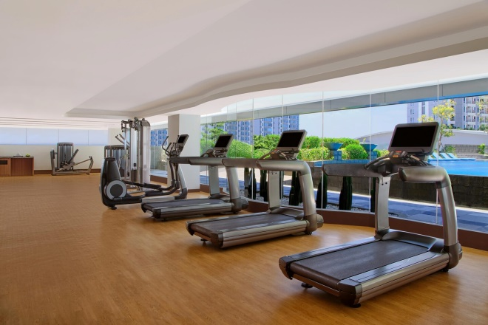
Figure 12. The Westin Fitness Center
Source: The Westin, 2020

Maintaining a workout routine can be tough when you’re traveling. That’s why we’ve partnered with TRX® to provide functional training equipment in WestinWORKOUT™ Fitness Studios around the globe, allowing you the flexibility to fully customize your workout according to your individual fitness goals.

    - Meeting Room

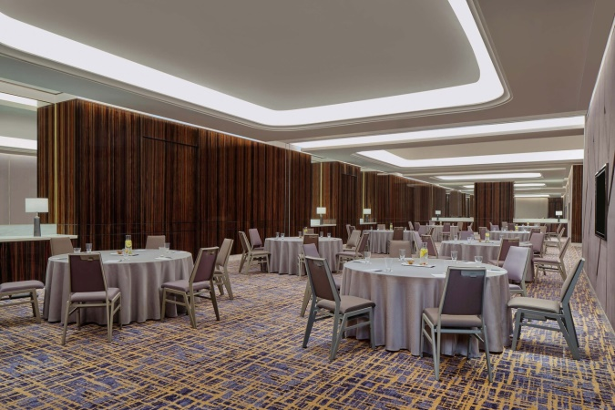
Figure 13. The Westin Meeting Room
Source: The Westin, 2020
At Westin Hotels, everything we do is designed to inspire well-being and enhance productivity. Meetings are no exception. Our entire range of wellness offerings empower your team to make the most of every meeting. You’ll find focus-enhancing foods on our new Eat Well Menu catered to fuel your team, Bright Breaks such as mid-morning stretches that lead to brighter ideas and so much more. Because when you Eat Well, Move Well and maintain balance, you empower your team to be their best selves.

    - Grand Ballroom

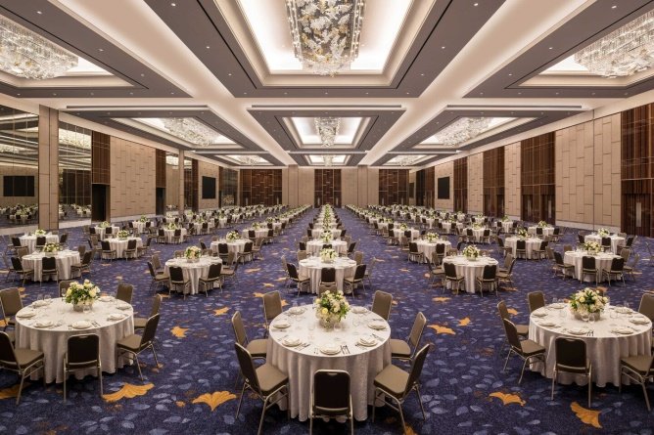
Figure 14. The Westin Grand Ballroom
Source: The Westin, 2020
Our Grand Ballroom is perfect for a grand prestigious occasion. The state-of-the-art, 9,300 square meters Grand Ballroom and Convention Center. The Westin Grand Ballroom stands to be the ultimate venue in the city – and the largest one yet - to host all kinds of events, amidst excellent and impeccable service.
    - Sky Lounge Restaurant

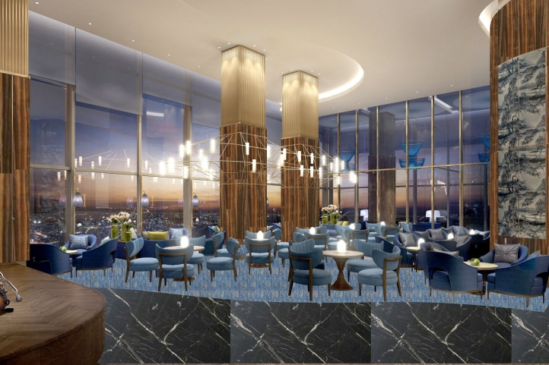
Figure 15. The Westin Sky Lounge
Source: The Westin, 2020
Located on Level L, Sky Lounge is perfect for savoring an extensive list of classic cocktails created by the most talented mixologists, as well as rare single-malt whiskeys accompanied by gourmet bar bites with a beautiful Surabaya skyline view.

    - Magnolia Restaurant

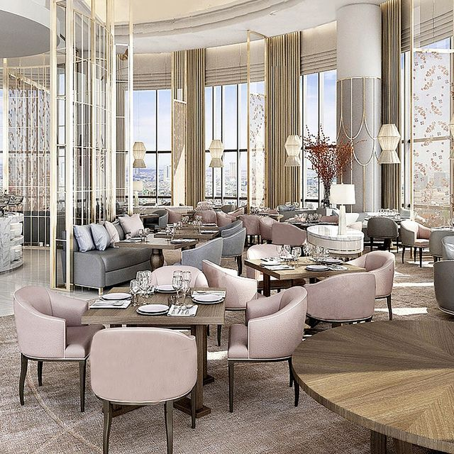
Figure 16. Magnolia Restaurant by The Westin
Source: The Westin, 2020
Located on the sky level, indulge in casual all-day restaurant dining at Magnolia Restaurant, where we highlight diverse flavors from around the globe in a warm and welcoming atmosphere.

    - Club Lounge

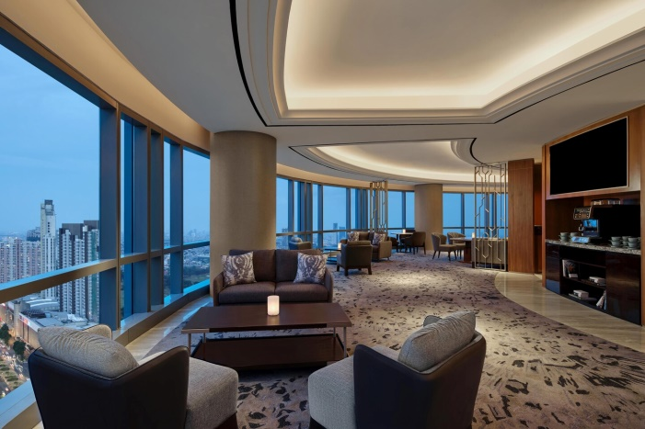
Figure 17. Club Lounge by The Westin
Source: The Westin, 2020
Guests staying in our club level rooms and suites can join us in our Westin Executive Club Lounge, which serves complimentary breakfast, snacks, and happy hour with stunning views of Surabaya.

Accommodation

  - Westin Deluxe King

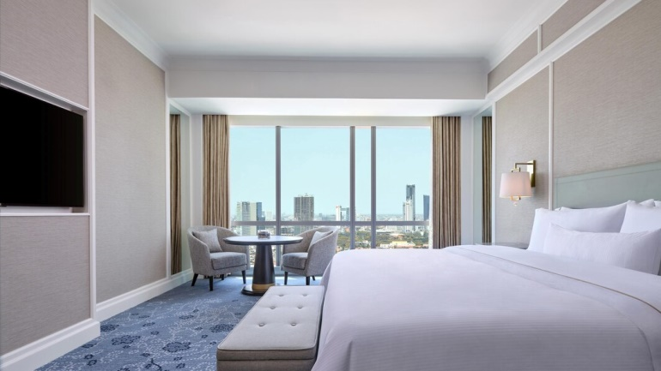
Figure 18. Westin Deluxe King
Source: The Westin, 2020
Room Features :
    - 38 sqm / 409 sqft,
    - Non smoking room.
    - Air-conditioned
Accesible Room Features :
    - This room type offers mobility accessible rooms
    - This room type offers accessible rooms with roll in showers
    - This room type does not offer hearing accessible rooms

  - Westin Deluxe Double

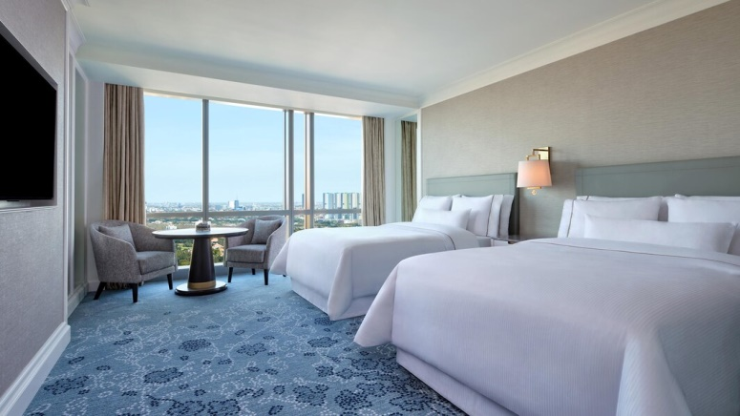
Figure 19. Westin Deluxe Double
Source: The Westin, 2020
Room Features :
    - 38 sqm / 409 sqft,
    - Non smoking room.
    - Air-conditioned
Accesible Room Features :
    - This room type offers mobility accessible rooms
    - This room type offers accessible rooms with roll in showers
    - This room type does not offer hearing accessible rooms

  - Westin Club King

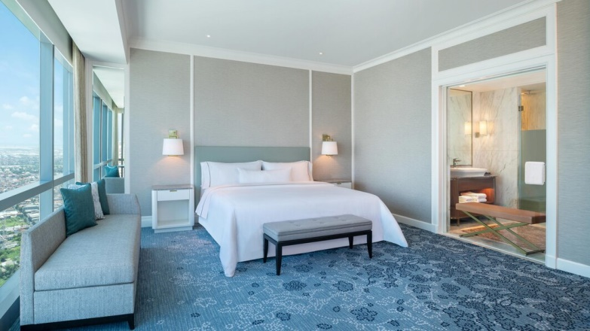
Figure 20. Westin Club King
Source: The Westin, 2020
Room Features :
    - 38 sqm / 409 sqft,
    - Non smoking room.
    - Air-conditioned
    - This room features Club Lounge access
    - Connecting room are available (for some rooms)
Accesible Room Features :
- This room type offers mobility accessible rooms
- This room type offers accessible rooms with roll in showers
- This room type does not offer hearing accessible rooms

  - Westin Club Double

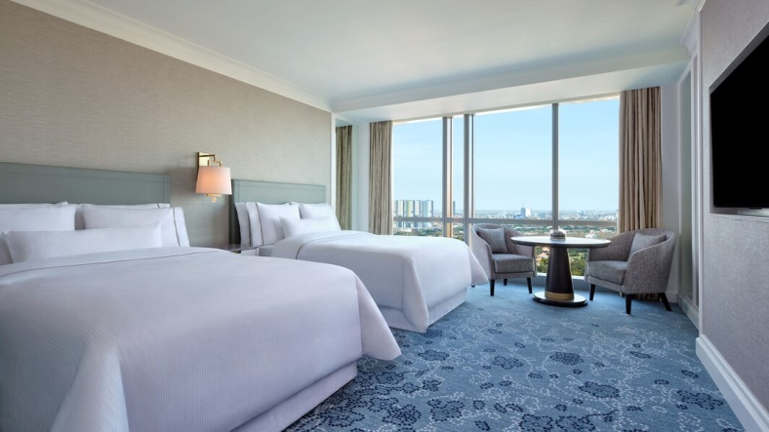
Figure 21. Westin Club Double
Source: The Westin, 2020
Room Features :
    - 38 sqm / 409 sqft,
    - Non smoking room.
    - Air-conditioned
    - This room features Club Lounge access
Accesible Room Features :
- This room type offers mobility accessible rooms
- This room type offers accessible rooms with roll in showers
- This room type does not offer hearing accessible rooms

  - Westin Executive Suite

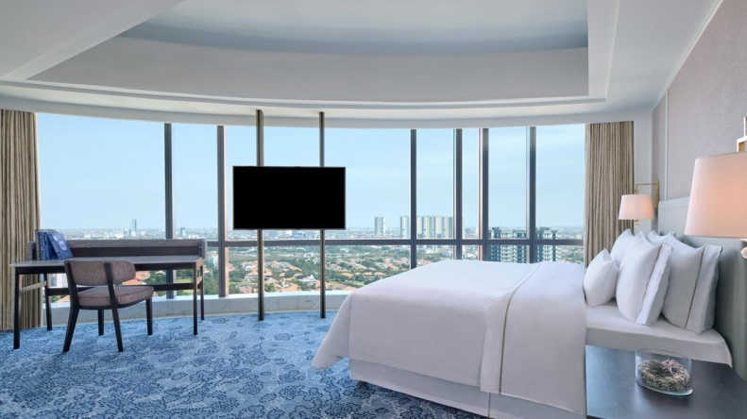
Figure 22. Westin Executive Suite
Source: The Westin, 2020
Room Features :
- 78 sqm / 839 sqft,
- Non smoking room.
- Air-conditioned
- This room features Club Lounge access
- Connecting room are available (for some rooms)
- Living / sitting area
Accesible Room Features :
    - This room type offers mobility accessible rooms
    - This room type offers accessible rooms with roll in showers
    - This room type does not offer hearing accessible rooms

  - Westin Grand Suite

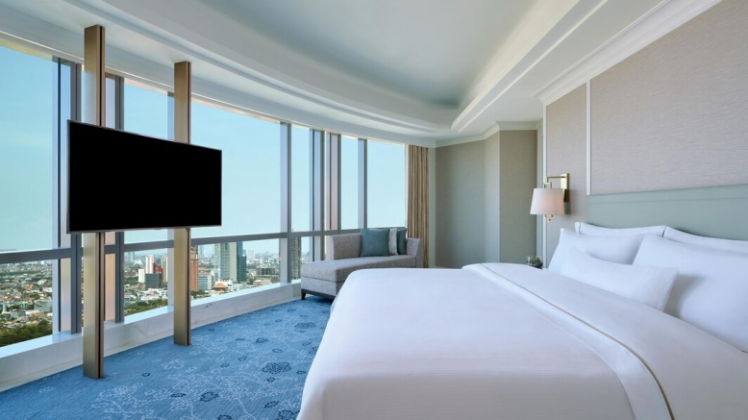
Figure 23. Westin Grand Suite
Source: The Westin, 2020
Room Features :
- 97 sqm / 1044 sqft,
- Non smoking room.
- Air-conditioned
- This room features Club Lounge access
- Connecting room are available (for some rooms)
- Living / sitting area
Accesible Room Features :
- This room type offers mobility accessible rooms
- This room type offers accessible rooms with roll in showers
- This room type does not offer hearing accessible rooms

Standard Operating Procedures During Pandemic
Westin is a place where you don't just get up, you rise. And now, more than ever, we want you to rise with confidence. As part of Marriott International's family of brands, we have implemented a multi-pronged approach to meet the health and safety requirements of our "Commitment to Clean" standards.
Here are some of the key changes you can expect from your stay at Westin. For a restorative and fulfilling stay, we want to provide you with all the details regarding changes to our services, amenities and facilities during this time. Find your balance. Your Westin team is here to help you be your best.
- For The Staff of The Westin
In a pandemic like this, The Westin is very strict about maintaining health protocols. All staff from The Westin are required to use gloves and masks that we are in. When there are signs of someone being sick, they are required to rest at home and can return to work if they feel fit and bring a swab result letter that shows negative. For workplaces such as kitchens and other offices, disinfectant is periodically sprayed to maintain the safety of the working staff.

- Shared Responsibility
Providing a safer environment for our guests and associates is a top priority. Achieving this is a shared responsibility. Please join us in our efforts to enhance the safety of our public spaces by complying with local regulations, practicing social distancing (staying at least 6 feet or 2 meters from other guests and hotel associates), and wearing face coverings whenever you're in public areas of the hotel. We appreciate your support and understanding.

- Social Distancing Measures and Contactless Experiences
Signage throughout our hotels to remind guests to maintain social distancing, occupancy limits and seating capacities reductions in our restaurants in compliance with local and state mandates, and partitions installed at front desks and food and beverage service lines.

- Enhanced Cleaning Protocol and Housekeeping Service at this Hotel
Kindly be informed that every guest room is thoroughly cleaned and disinfected, every room keys also cleaned and disinfected prior to your arrival. In keeping with Marriott's Commitment to Clean, we have made several enhancements to our cleaning practices throughout our property and in guest rooms.
Enhanced Public Space Cleaning: We have increased the frequency of cleaning and disinfection, particularly in areas with high traffic including restrooms, elevators, and escalators as well as provided more hand sanitizing stations.
Personal Protective Equipment (PPE): Associates will wear PPE (e.g., face masks, gloves, etc.) based on the activities they are performing and based on direction by the local authorities. It is mandatory to all of our guests to wear their face mask.
Electrostatic Spraying: We're utilizing enhanced technologies, including electrostatic sprayers with hospital-grade disinfectants, to support our already rigorous cleanliness protocols in rooms, meeting venues, restaurants and public areas.
Room Amenities: Personal Guest Sanitizing Kit are available for every arriving guest as well as upon request.
Every guest room is thoroughly cleaned and disinfected prior to your arrival. We will provide housekeeping cleaning services on the daily basis and while you are away from the room. If you'd like to have additional cleanliness request, simply let our team know.

- Property Amenities and Service
Fitness Center: Open from 6.00 a.m. to 7.00 p.m. access with guest key card. Required to wear face mask at all times.

Pool: Open, from 6 a.m. until 7 p.m. Please note that furniture and sunbeds has been arranged to maintain social distancing protocols.

Room Service: Available at 24 hours/day.

Business Center: Open 24 hours.

- Food and Beverage Offerings
Magnolia: Open from 06.00 a.m. until 10.00 p.m.
Sky Lounge: Open from 11.00 a.m. until 11.30 p.m.
Room Service: Available 24 hours/day with limited menu offering from 11.00 p.m. until 6.00 a.m.
Our restaurants team abides by state and local guidelines, including the use of face masks and gloves. Seating capacity also reduced to maintain social distancing. Buffet breakfast is served from 06.00 a.m. until 11.00 a.m. and equipped with partitions, service lines to maintain physical distancing and hand gloves to avoid direct contact in food cutleries. Hand sanitizer stations also available in every corner of the restaurants. In Room Dining service available following local authorities protocols wearing face mask, and hand glove.

Organizational Structure and Main
Demi Chef
Dikky Ickhsan
Casual/Daily Worker
Ayu
Commis
David Richardo
Trainee
Tjioe Felicia
Bagus Triandono
Chef de Partie
Ridho Makarim
Sous Chef
Sahrul Anwar
Chief Steward
Mojaipar
Hygiene Manager
Winarno
Chef de Cuisine
John F. Tarigan
Chef de Partie
Twedi Martatna
Executive Chef
Nurtriantoro
General Manager
Alamsyah Jo
Hotel Manager
    - Complex General Manager
- Overseeing daily business operations.
- Developing and implementing growth strategies.
- Training low-level managers and staff.
- Creating and managing budgets.
- Improving revenue.
- Hiring employees.
- Evaluating performance and productivity.
- Analyzing accounting and financial data.
- Researching and identifying growth opportunities.
- Generating reports and giving presentations.

    - Complex Hotel Manager
- Supervising day-to-day operations
- Defining growth strategies and plans and setting targets
- Coordinating the activities of the various departments, monitoring efficiency and quality of services and compliance with standards
- Organizing, controlling and supervising the work of the hotel staff
- Managing the hotel’s budget and finances with the aim of achieving efficiency and cost-effectiveness
- Monitoring hotel budget and accounts and verifying results achieved
- Implementing sales and marketing strategies and rates policies
- Coordinating communications and marketing
- Participating in the staff selection process
- Maintaining relations with suppliers and managing purchasing
- Looking after administrative matters and ensuring compliance with all relevant regulations
- Responding to customer complaints in a timely manner

    - Complex Director of Culinary / Executive Chef
- Ensuring promptness, freshness, and quality of dishes.
- Coordinating cooks' tasks.
- Implementing hygiene policies
- Designing new recipes, planning menus, and selecting plate presentations.
- Reviewing staffing levels to meet service, operational, and financial objectives.
- Hiring and training kitchen staff, such as cooks, food preparation workers, and dishwashers.
- Performing administrative tasks, taking stock of food and equipment supplies, and doing purchase orders.
- Setting and monitoring performance standards for staff.
- Obtaining feedback on food and service quality, and handling customer problems and complaints.

    - Chef de Cuisine / Head Chef
- Controlling and directing the food preparation process
- Approving and polishing dishes before they reach the customer
- Managing and working closely with other Chefs of all levels
- Creating menu items, recipes and developing dishes ensuring variety and quality
- Determining food inventory needs, stocking and ordering
- Ultimately responsible for ensuring the kitchen meets all regulations including sanitary and food safety guidelines
- Being responsible for health and safety
- Being responsible for food hygiene practices

    - Sous Chef
- Develop new menu options based on seasonal changes and customer demand.
- Assist with the preparation and planning of meal designs.
- Ensure that kitchen activities operate in a timely manner.
- Resolve customer problems and concerns personally.
- Monitor and record inventory, and if necessary, order new supplies.
- Provide support to junior kitchen employees with various tasks including line cooking, food preparation, and dish plating.
- Recruit and train new kitchen employees to meet restaurant and kitchen standards.
- Create schedules for kitchen employees and evaluate their performance.
- Adhere to and implement sanitation regulations and safety regulations.
- Manage the kitchen team in the executive chef's absence.

    - Chef de Partie
- Preparing specific food items and meal components at your station.
- Following directions provided by the head chef.
- Collaborating with the rest of the culinary team to ensure high-quality food and service.
- Keeping your area of the kitchen safe and sanitary.
- Stocktaking and ordering supplies for your station.
- Improving your food preparation methods based on feedback.
- Assisting in other areas of the kitchen when required.

    - Demi Chef
- Relays orders to his station cooks and ensures each menu item his station is responsible for is prepared on time.
- Oversees all preparation, cooking and presentation for plates.
- Required to assist with cooking, preparation and plating when station chefs are absent.
- Ensures that all health and food safety standards are practiced.
- Helps troubleshoot any kitchen issues that may arise.

    - Commis
- Assisting in the food preparation process
- Cooking and preparing elements of high quality dishes
- Preparing vegetables, meats and fish
- Assisting other Chefs
- Helping with deliveries and restocking
- Assisting with stock rotationCleaning stations
- Contributing to maintaining kitchen and food safety standards.

    - Casual / Daily Worker
- Enthusiasm to learn. Diligent and interested in his work.
- Follow and remember the instructions of superiors.
- Assisting with cooking activities in the kitchen; follow instructions and remember procedures and standard recipes.
- Maintain the cleanliness of trolleys, utensils and machines in the kitchen.
- Work according to the duties and directions of the Chef de partie/ Sous chef/ Chef.
- Comply with all the standards in the operational manual.
- Maintain cleanliness and tidiness of food ingredients in refrigerators.
- Carry out other reasonable obligations and responsibilities.

    - Trainee
- Assists in the preparation of several parts of a major meal
- Prepares breakfasts on an independent basis
- Directs subordinates, and/or other helpers in dishing foods, preparing portions, serving, and
- Cleaning work areas and utensils, and personally participates in such tasks when required.
- Performs other related work as required.
- Prepares his mise-en-place for next day.
- Assists with another station as assigned by the Chef de Partie.
- Collects store items as required from the main kitchen.
- Cleans and maintains kitchen equipment and reports any repair or maintenance needed

Hygiene and Sanitation of The Company
Hygiene and sanitation within the scope of the kitchen are the basic determinants of the quality of the products produced. Therefore, the cleanliness of the kitchen must be considered very well. Cleanliness is also an important factor for the health of personnel and the environment. Therefore the kitchen depatment must be responsible for cleanliness in the kitchen area and the health of the products produced. The scope of hygiene and sanitation in the kitchen area includes: personal hygiene, hygiene and equipment sanitation, food hygiene and sanitation, and workplace hygiene and sanitation.
    - Personal Hygiene
Personal hygiene is how a person's or workers' efforts in maintaining their own health and hygiene so as not to cause contamination of processed food. To be able to carry out their work properly and appropriately without contaminating the food products they process, kitchen workers must pay attention to several things regarding hygiene and sanitation for themselves as follows:
- A worker must wear clean and decent clothes. Clothing that is generally long sleeved.
- Do not use watches, earrings, necklaces, rings, and other small objects that are easily broken or lost.
- Wear clothes of the right size, where the buttons of the shirt must be attached properly so that they do not break, fall, and mix in the food being processed.
- Using uniforms that have been provided by the hotel with existing standards.
- Use a hair cover to protect against possible hair fall or dandruff onto the food being processed. The use of a hair cover can also help absorb sweat on the forehead so that sweat does not fall on the food.
- Maintain the cleanliness of hand nails, by regularly cutting nails to keep them clean and tidy. In addition, it is not allowed to paint nails
- Maintain oral and dental hygiene.
- Do not smoke while processing food.
- If you cough, don't expose it to food.
- If this is tasting food, don't use your hands but use an utensil like a clean spoon.
- Wash hands before and after handling food.

    - Equipment Hygiene and Sanitation
In the selection of equipment to be used in food processing, consideration must be given to the materials used and the ease of cleaning. Usually the equipment used in food processing is a material that does not react with food ingredients. In addition to paying attention to the type of material used for kitchen utensils, the placement of
Kitchen utensils and equipment also need to be considered properly. Kitchen utensils and equipment are very easily contaminated. Factors that can cause pollution come from
from humans, insects and rodents, expired food, and garbage. To maintain cleanliness in kitchen utensils, several criteria must be met, such as:
- Wash the equipment thoroughly with high temperature water in order to eradicate the bacteria present.
- Using a knife and cutting board according to the standard color that has been determined.
- Using equipment that is not easy to rust so as not to endanger health.
- Conditions where equipment is stored must be free from insects, rats, and other nuisance animals.
- All kitchen utensils such as knives, peelers, and so on must be soaked in water that has been mixed with a sanitary solution and replaced every 2 hours.
- Clean the chiller and freezer regularly.

    - Food Hygiene and Sanitation
Hygiene and sanitation of the food products produced must be considered so as not to cause contamination of the food served to guests. Food served to guests must be really clean, healthy, free from various kinds of contamination such as viruses, bacteria, and other germs, and do not let guests experience food and beverage poisoning. To anticipate these incidents, there are several efforts that can be made to maintain hygiene and sanitation in food, such as:
      - Wash hands before and after processing a food.
      - Use hand gloves to maintain food hygiene.
      - Know the standards of safe and correct food storage.
      - Pay attention to the level of ripeness of food that is safe for consumption.
      - Pay attention to the condition of goods such as damaged cans or food that has expired.
      - If you want to store food, make sure to close it tightly.
      - Do not store cooked food at the same time as raw food.
      - Using the FiFo (first in, first out) system to avoid accumulation of goods.
      - Keep the chiller and freezer at standart temperature. With using this HACCP form, the temperature of chiller and freezer will be stable and safe.
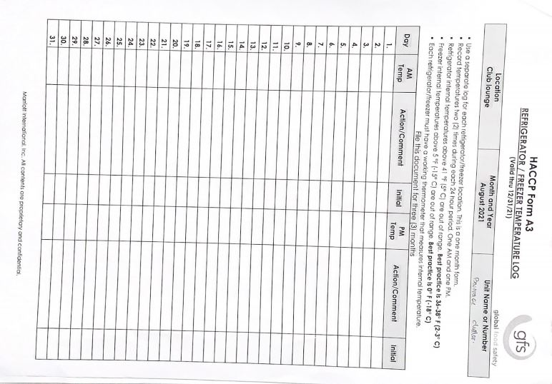
Figure 24. HACCP Form A-3
Source: Personal Documentation, 2021
- Check whether consumers have allergies to a food in order to avoid unwanted things.
- Always check the food and beverages before serve. This HACCP form is really useful to make sure that every dishes have been tested before.
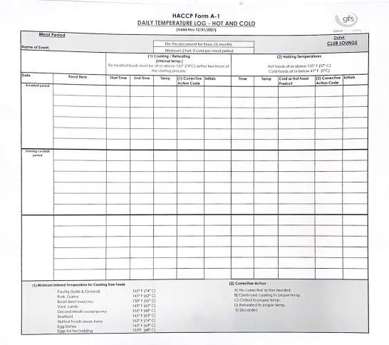
Figure 25. HACCP Form A-1
Source: Personal Documentation, 2021

    - Workplace Hygiene and Sanitation
All kitchen workers must always keep the kitchen area clean. To create and maintain a clean kitchen, it is necessary to pay attention to the following things:
      - Keeping the floor clean to keep it dry and clean
      - Clean the floor using a liquid that can clean as well as lift the oil on the floor.
      - Dispose of garbage in the place provided.
      - Clean the kitchen ceiling to avoid dust that can fall on food.
      - Using a smoker (hood) so as not to interfere with activities in the kitchen.
      - Sewer lines must be closed using iron bars and cleaned daily to avoid bad smells.
      - Carry out general cleaning on a regular basis.

