CHAPTER III INTERNSHIP ACTIVITIES

  - Place of Assignment
During the internship period, the author was placed in breakfast team, prepare cake for Executive Lounge, make and prepare dessert for Uppercut and help the staff who in charge Deli Shop.

Job Description and Activities Performed
    - Job Description
Job description is a guide from the company to employees in carrying out the duties. There are the author’s job descriptions during 6 months of internship:
- Breakfast
Table 1. Breakfast Job Description

Time | Activities
06.00 – 10.30 | Takes care of breakfast at Pavilion
10.30 – 10.45 | Closing breakfast
10.45 – 12.00 | Prepare for breakfast tomorrow
12.00 – 13.00 | Break time
13.00 – 14.40 | Make breakfast product
14.40 – 14.55 | Briefing with chef and staff
15.00 | Go back home

- Executive Lounge
Table 2. Executive Lounge Job Description

Time | Activities
13.00 – 14.00 | Prepare and decorating the cake

14.00 – 16.30 | Help to make pastry products
17.00 – 17.30 | Go to EL and set up
17.40 – 18.40 | Break time
18.45 – 19.30 | Prepare cake for tomorrow
19.30 | Closing EL
19.45 – 21.00 | Prepare cake for tomorrow
21.00 – 21.55 | Make porridge
22.00 | Go back home

- Uppercut
Table 3. Uppercut Job Description

Time | Activities
12.00 – 12.30 | Check order from Uppercut
12.30 – 17.00 | Make enough dessert supplies
17. 15 | Deliver orders for Uppercut
17.30 – 18.30 | Break time
18.30 -20.55 | Help to make pastry products
21.00 | Go back home

- Deli
Table 4. Deli Job Description

Time | Activities
08.00 – 08.20 | Set up Deli
08.30 – 12.30 | Make Deli products with deli staff
12.40 – 13.40 | Break time
14.00 – 16.55 | Make Deli products
17.00 | Go back home

    - Activities Performed
During 6 months of the Internship Program, the author do a lot of activities. These are the activities explanation:
      - Breakfast
        - 4 people are the breakfast team. 3 people divided in toast section, bread section and ice cream section. One other person becomes runner (team leader).
        - In toast section, make a french toast (plain and cinnamon), pancake and waffle
        - After closing, prepare the condiment, make plain sauce and cinnamon sauce for French toast, make pancake dough, muffin dough
      - Executive Lounge
        - Decorating 8 types cake (each 3-4 slice) and pudding. The item every day must be different
        - Cut the cake and prepare
      - Uppercut
        - Make Uppercut dessert: lemon chewy cookies, cheesecake uppercut, sacher cake and soufflé.
      - Deli
        - Make Deli product and finishing several kinds of cake: matcha gateaux, tiramisu, red velvet cake, opera cake.

Product of Internship
During the internship, the author learns to make cakes such as:
- Lemon Cookies
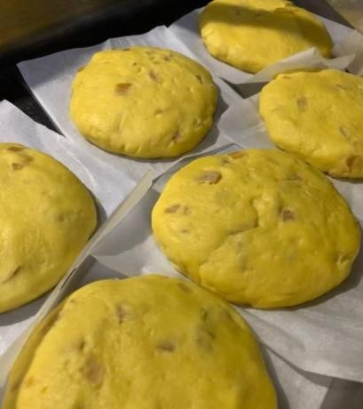
Picture 11. Lemon Cookies (Personal Documentation, 2021)
These lemon cookies are a dessert for the Uppercut. First made, prepare the lemon peel cut into small pieces and then boiled with water and sugar until it looks clear. Make the dough, all the ingredients are mixed with flour, cream cheese, sugar and lemon peel into one bowl. Then weighed 130 grams and then shaped round. Usually the author make the dough just like in the picture, baked by the Uppercut team.

- Cheese cake
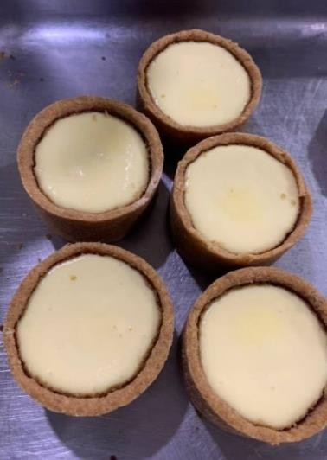
Picture 12. Cheese cake (Personal Documentation, 2021)

This cheese cake is also a dessert for Uppercut. The first thing that is made is the crumble. To make the crumble, mash the biscuits then add melted butter and mix evenly. After that, flattened on a round mold. Make the cream cheese filling in the mixer with sugar until smooth, then add the eggs and mix well. Then pour the cheesecake batter. Usually the author makes it within 1-2 hours.

- Sacher Cake
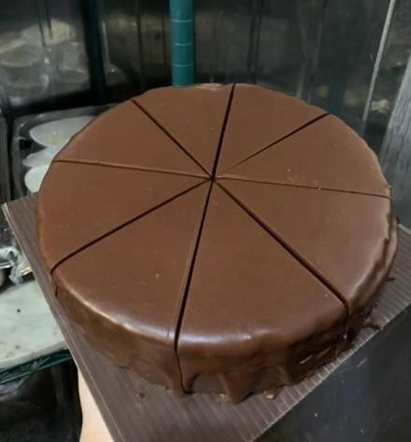
Picture 13. Sacher cake (Personal Documentation, 2021)
Sacher cake is also a dessert for Uppercut. This cake contains a mixture of almond ground with apricot jam and on the outside with a chocolate coating all over the cake. The author helps the staff in making this cake.

- White Roulade
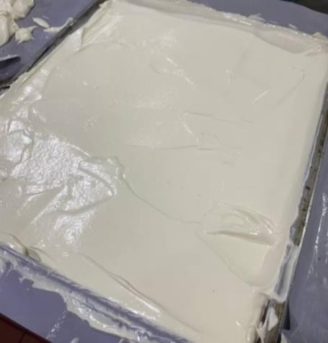
Picture 14. White roulade (Personal Documentation, 2021)
White roulade is a product that is often made because in making sponge cake the basis is roulade, such as opera, tiramisu.

- Red Velvet Cake
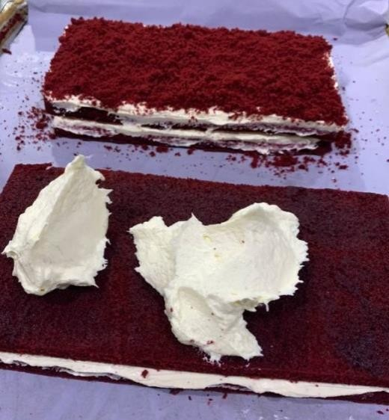
Picture 15. Red Velvet cake (Personal Documentation, 2021)
Red Velvet cake is generally made the same as white roulade. What makes it different is the addition of red flavorings and dyes.

- Chocolate Praline
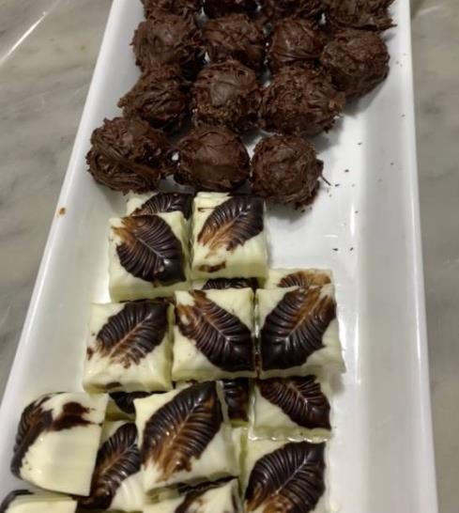
Picture 16. Chocolate praline (Personal Documentation, 2021)
Pralines are made using melted chocolate and then shaped in round or square molds. Chocolate making is usually in the chocolate room.

- Ice Cream
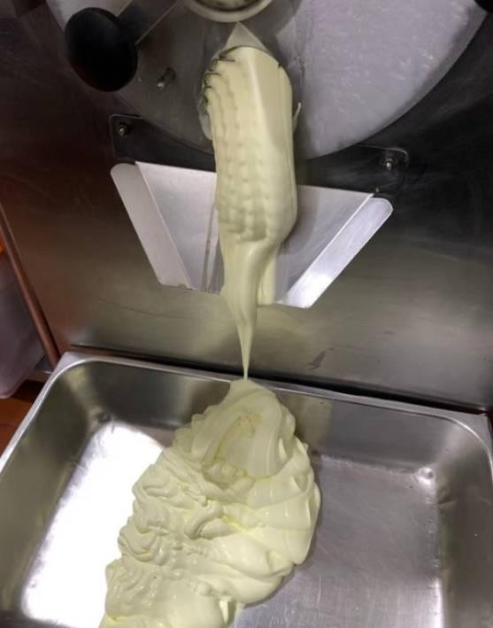
Picture 17. Ice Cream (Personal Documentation, 2021)
In making this ice cream, the author mixes the ingredients, namely milk, sugar and premix and then just puts it into the ice cream machine.

Process until the texture becomes thicker, about 15 minutes. Then, keep in the freezer.

- Chocolate Cupcakes
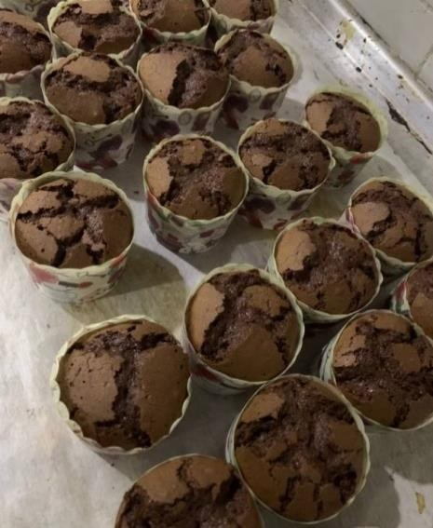
Picture 18. Chocolate Cupcakes (Personal Documentation, 2021)
In making this cupcake, the author prepares all the ingredients, then in the mixer and divided into all cups and then baked until cooked.

- Decorative Cupcakes
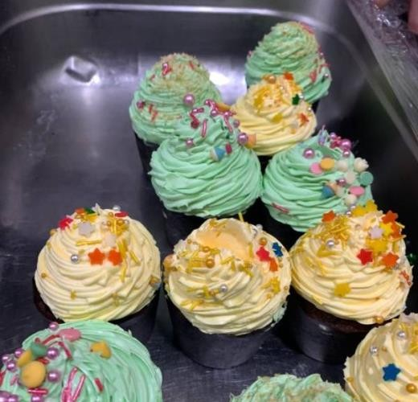
Picture 19. Decorative Cupcakes (Personal Documentation, 2021)
Cupcakes that have been made, decorated with buttercream on top and added sprinkles.

- Opera
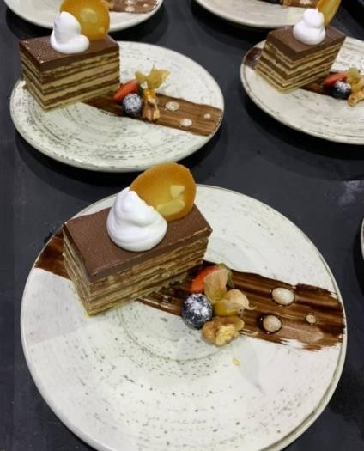
Picture 20. Opera (Personal Documentation, 2021)
In making opera cake usually requires 4 white roulade, cream and chocolate, and made in layers. In the picture, the writer helps the staff in decorating the dessert opera cake using strawberry, blueberry and physalis decorations.

- Broccoli Cookies
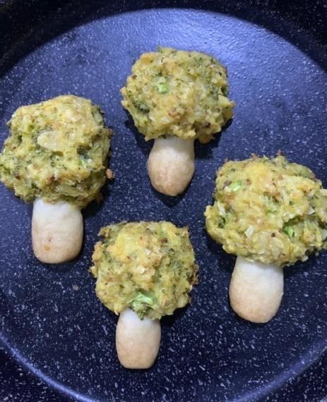
Picture 21. Broccoli Cookies (Personal Documentation, 2021)
Broccoli Cookies are a product made by the author. The shape is made like broccoli. The ingredients to make these cookies are butter, sugar, cake

flour, salt. And then, add the broccoli and form a round shape resembling a leaf.

Problem Faced and How to Solve Them
During the 6 months of internship at pastry kitchen JW Marriott Surabaya, the author faces many problems and has to find a way how to solve the problem. There are the problems and a way how to solve the problem:

- Work Duration
In the first month, still in the process of adapting so sometimes it takes a long time to work and also when working together with other friends there is still miss communication. This makes the author have to quickly understand and learn what to do so that the work can be done without having to waste a lot of time.

- Different Information and Instruction
Usually when working, trainees follow the staff's directions and sometimes when asked about the method, the staff's answers can sometimes be different, so that the writer sometimes has to ask repeatedly.

