CHAPTER II GENERAL DESCRIPTION OF
JW MARRIOTT HOTEL SURABAYA

About JW Marriott Hotel Surabaya

JW Marriott is a company founded by John Willard Marriott. JW Marriott is now recognized as one of the the largest international hotel chain in the world. John Willard Marriott is really making a big effort. He started the business from root beer shop in Washington DC developed through several steps until this hotel became as big as it is now.
JW Marriott Surabaya (formerly The Westin Surabaya) opened in 1996, is a five-star luxury hotel with 25-story building. JW Marriott Surabaya is owned/developed by PT. Ramasari Surya Persada. JW Marriott Surabaya is one of the star hotels Top 5 in Surabaya, located at Downtown Tunjungan Surabaya. As one of the best hotels in the city of Surabaya, JW Marriott Surabaya has a restaurant serves Chinese, Japanese, and International dishes.

Picture 1. Logo of JW Marriott Surabaya (Marriott, 2021)

Location
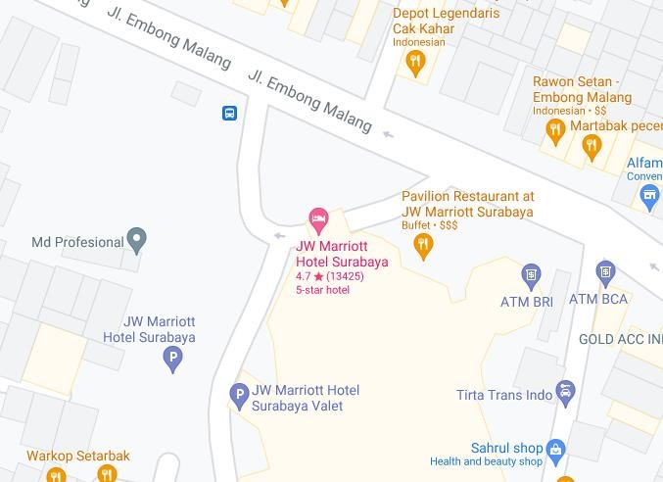

Picture 2. Location of JW Marriott Surabaya ( Marriott, 2021 )

JW Marriott Hotel Surabaya have a strategic location and located in the city center is perfect for entrepreneurs who have business in Surabaya. Located at Jalan Embong Malang no. 85-89, the JW Marriott Hotel consists of a building with twenty-six floors and has special access on the Executive floor on floors 21 and above. The location of the JW Marriott Surabaya Hotel can be reached 40 minutes from Juanda Airport and also 20 minutes from Tanjung Perak port.

Features of JW Marriott Surabaya
    - Lobby Lounge
Lobby Lounge at JW Marriott Hotel Surabaya is a spacious, luxurious and elegant space with superb culinary offerings. Lobby Lounge provides specialty coffee, mocktails, cocktails, wines by the glass and light bites, as well as nightly live music.

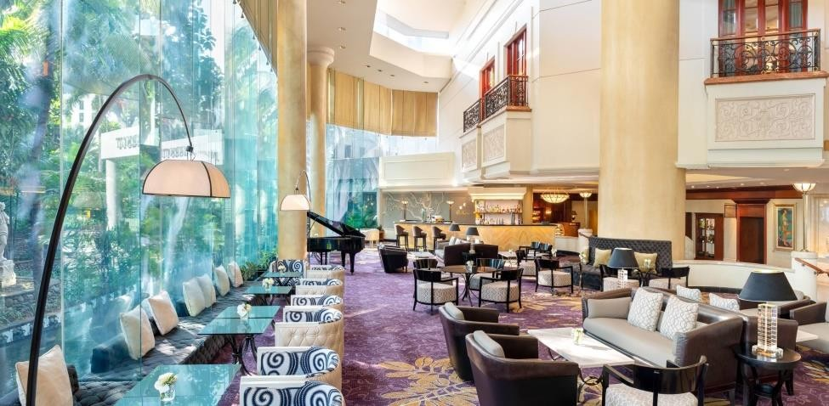
Picture 3. Lobby Lounge ( Marriott, 2021 )

    - Executive Lounge
The Executive Lounge is located on the 21st floor of the JW Marriott Surabaya, with a minimalist concept with a natural color palette and earthy materials. Access to the Executive Lounge is normally reserved for guests staying in Executive rooms and luxury suites. One of the most coveted benefits of Executive Lounge access is the all-day dining offer, which includes a private breakfast, drinks and evening cocktails.
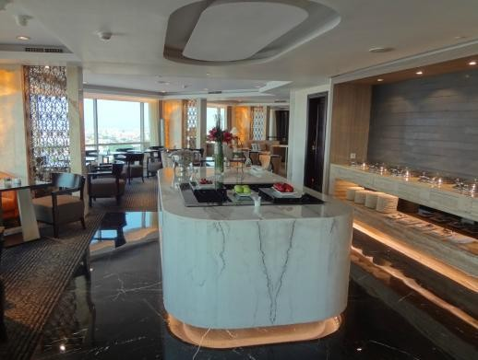
Picture 4. Executive Lounge ( Marriott, 2021 )

    - Deli Shop
Deli shop at JW Marriott is a place to sell pastry & bakery products at JW Marriott Surabaya hotel. This Deli Shop sells various variants, including various types of bread, chocolate pralines, cupcakes, and whole cakes with various delicious shapes and flavors. The products offered at this deli shop are sold at affordable prices and of good quality.
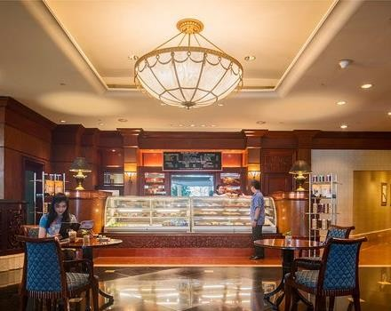
Picture 5. Deli Shop ( Marriott, 2021 )

    - Pavilion Restaurant
Pavilion Restaurant is one of the restaurants located on the ground floor in JW Marriott Surabaya. Open for breakfast, lunch, and dinner, this vibrant restaurant offers both buffet dining and a la carte fare. The combination of minimalist garden and dome elements creates a luxurious impression on the Pavilion Restaurant so that guests who come will feel comfortable when they are at the Pavilion Restaurant.
In addition, the Pavilion Restaurant is also commonly used as a place for birthdays, weddings and other events. Not only that, every weekend Pavilion Restaurant often holds various promos with adopted concepts, such as: Local at friday, Seafood Promotion at saturday, and Sunday Brunch.

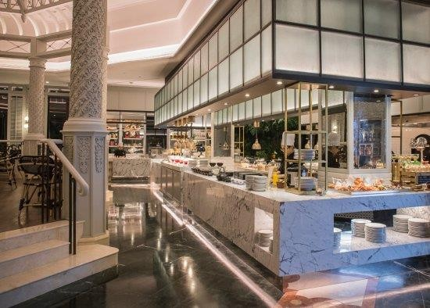
Picture 6. Pavilion Restaurant ( Marriott, 2021 )

    - Imari Japanese Restaurant
Located inside of JW Marriott Surabaya, Imari Restaurant is inspired by the cuisine of Executive Chef Takashi. Imari displays the refined elegance of Japanese culture in every dish, from the restaurant's famous tempura to other classic favourites including sashimi, sushi and teppanyaki. The restaurant offers private dining rooms, each with its own teppanyaki counter. Or dine at the separate sushi, teppanyaki and tempura bars, where watching the chefs prepare these delectable dishes is part of the enjoyment. Imari at JW Marriott Surabaya seamlessly blends traditional-style artwork with modern Japan".
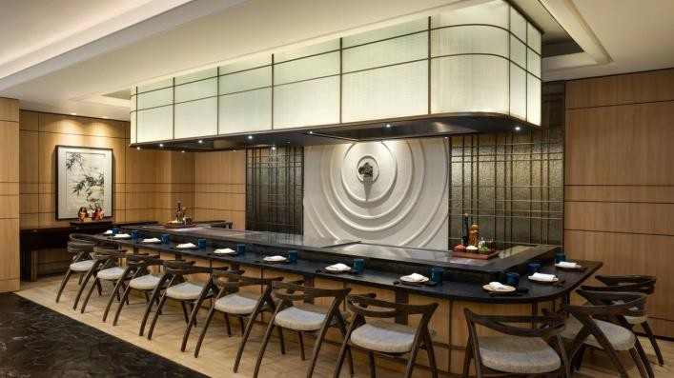
Picture 7. Imari ( Marriott, 2021 )

    - Tang Palace Chinese Restaurant
Tang Palace Chinese Restaurant thrills your palate with authentic Cantonese cuisine and dim sum served in an opulent setting. Accented by antiques from the legendary Tang Dynasty, this exceptional Surabaya restaurant is on the second floor of our hotel.
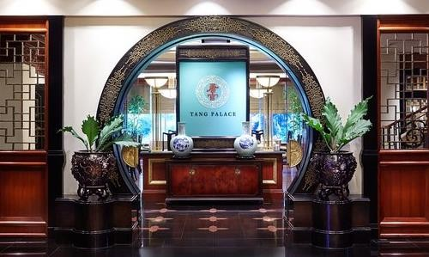
Picture 8. Tang Palace ( Marriott, 2021 )

    - Uppercut Steakhouse
Uppercut Steakhouse translates a sophistication yet relaxing atmosphere into a modern steakhouse. Uppercut’s delightful menu serves a variety of fine quality meats, including dry-aged beef, along with delicious side dishes and non-beef selections, using the freshest ingredients. The bar at Uppercut Steakhouse serves a balanced selection of wine, unique cocktails, and liquor, making it be an all-in-one place where you can have great drinks, shared plates, excellent beef for carnivores as well as vegetarian and non-beef dishes.

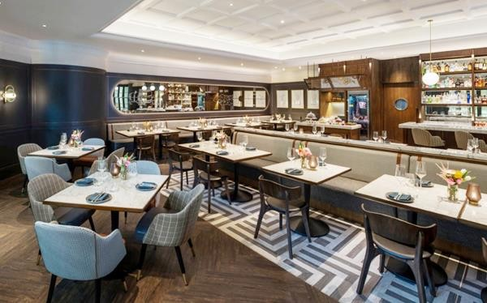
Picture 9. Uppercut ( Marriott, 2021 )

Organizational Structure and Main Task
The pastry kitchen organizational structure in JW Marriott Surabaya is divided into 3, morning shift, afternoon shift and night shift. The pastry staff working in the morning shift and afternoon shift, while the bakery staff usually work at night shift. There is the pastry kitchen organizational structure:

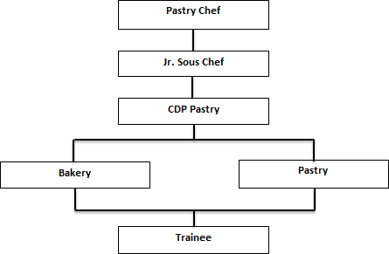

Picture 10. Pastry Kitchen Organizational ( Personal Documentation, 2021 )

- Pastry Chef
  - Creating new recipes and planning menu
  - Ensuring the quality of the cake, bread and dessert
  - Setting and monitoring performance standard for staff
  - Make a weekly work schedule for staff and trainee
- Jr. Sous Chef
  - Pastry chef assistant
  - Helping pastry chef developing new recipes and planning menu
  - Ensuring kitchen runs smoothly
  - Make a purchase order (ingredients)
  - Substitute pastry chef when he is unable to come or day off
- CDP Pastry
  - Managing pastry operations and delegating some work to his/her assistants
  - Overseeing the smooth running of operations in one of the sections that are his/her responsibility
  - Organize and distribute tasks and work to subordinates and participate directly in processing food
  - Responsible to pastry chef
- Bakery
  - Has good qualifications in bread making
  - Responsible for all the products made in the bakery section by several bakers
- Pastry
  - Handling pastry production
  - Maintaining a healthy work atmosphere
  - Make food decorations
  - Make various cake and finishing
  - Make various types of ice cream

- Trainee
  - Assisting pastry staff and bakery staff
  - Who takes care of breakfast at pastry section
  - Who takes care of event like wedding party and birthday party
  - Cleaning area during shift change

