APPENDIX

5.1 Pastry Kitchen
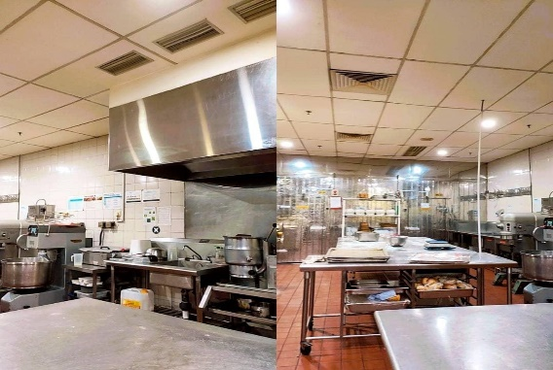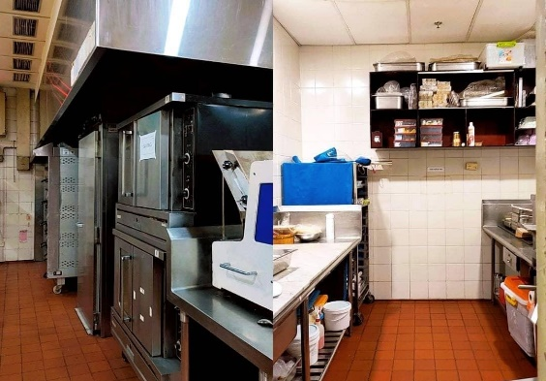
Picture 19. Pastry Kitchen (Personal Documentation, 2021)
5.2 Schedule
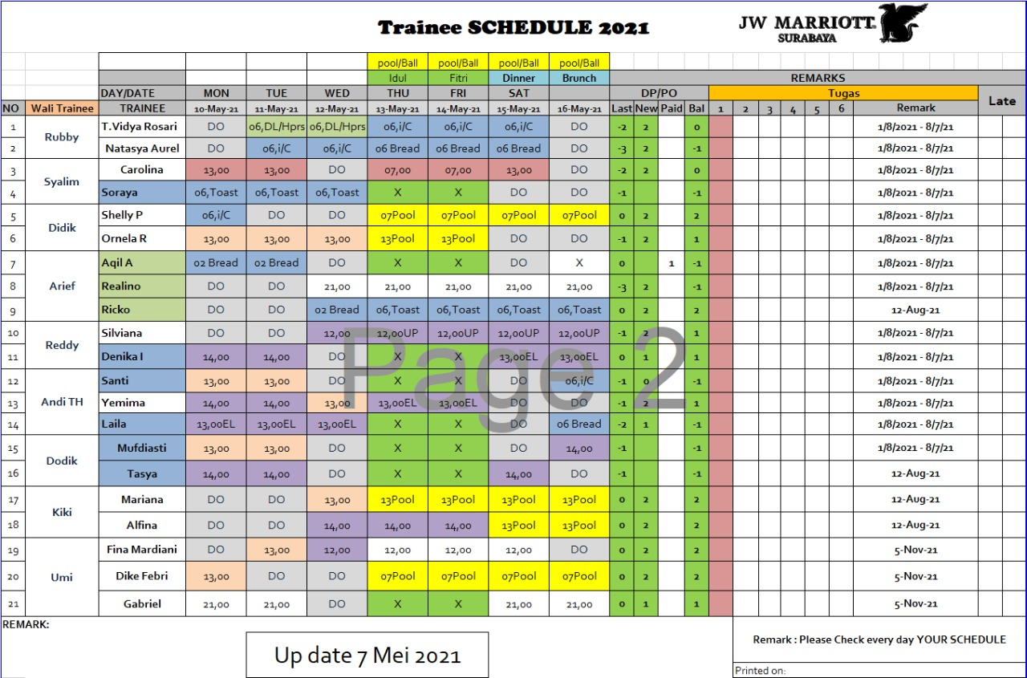
Picture 20. Schedule (Marriott, 2021)

5.3 Banquet Event Order
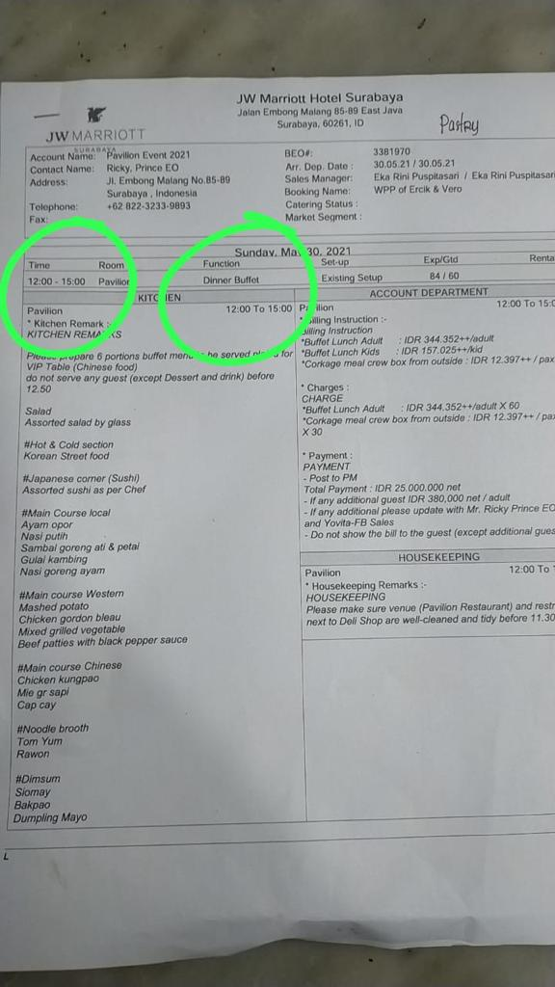
Picture 21. Banquet Event Order (Personal Documentation, 2021)
5.4 Tasting Dessert for Banquet
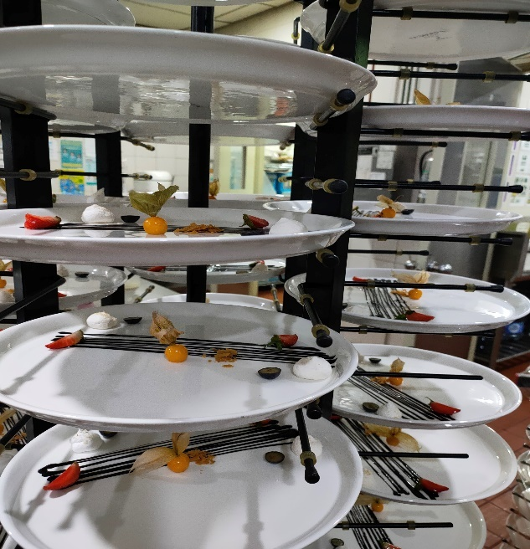
Picture 22. Tasting Dessert for Banquet (Personal Documentation, 2021)

5.5 Pastry Set Up
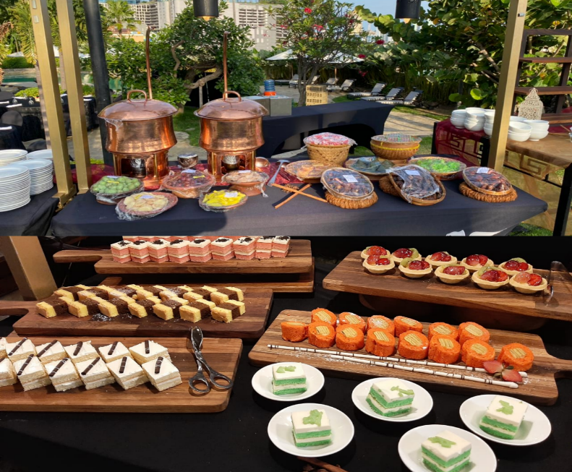
Picture 23. Ramadhan Pastry Set up (Personal Documentation, 2021)

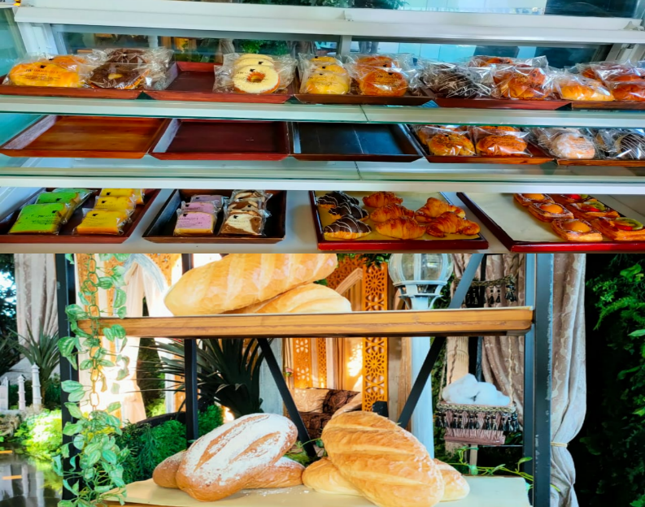
Picture 24. Deli Shop Pastry Set up (Personal Documentation, 2021)

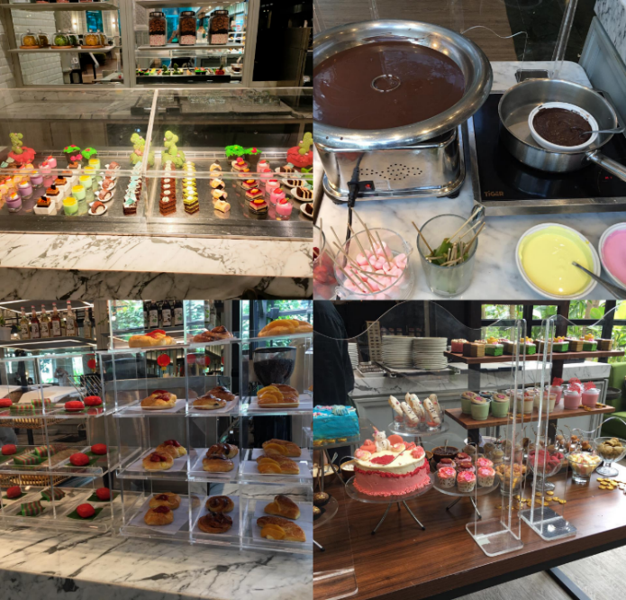
Picture 25. Brunch Pastry Set up (Personal Documentation, 2021)

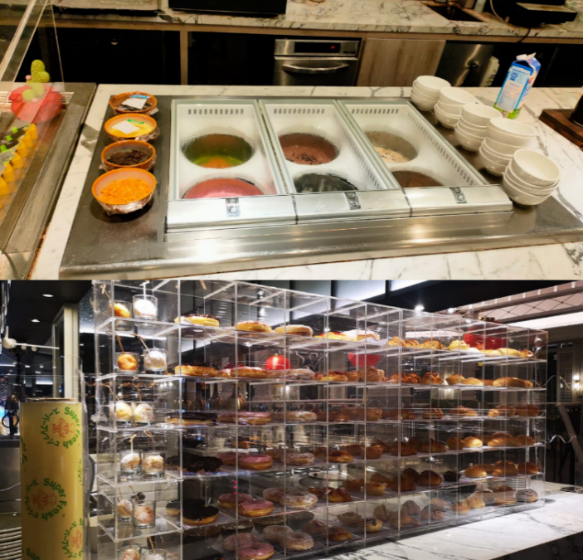
Picture 26. Breakfast Pastry Set up (Personal Documentation, 2021)

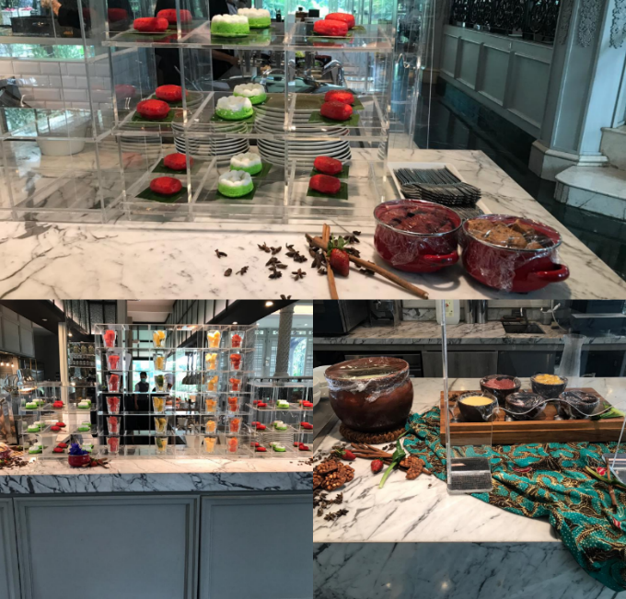
Picture 27. Local Pastry Set up (Personal Documentation, 2021)

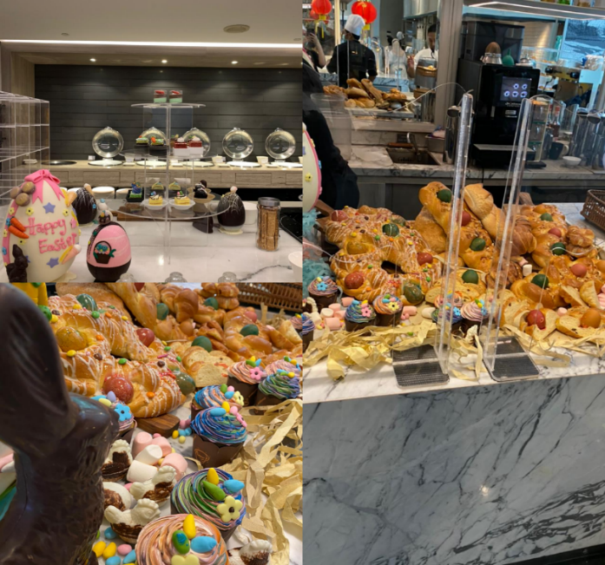
Picture 28. Easter Pastry Set up (Personal Documentation, 2021)
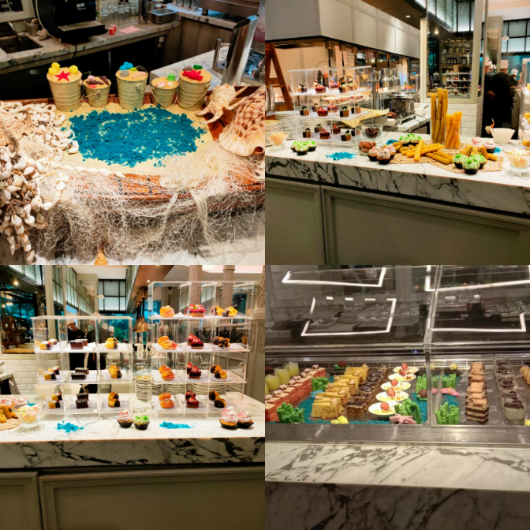
Picture 29. Seafood Pastry Set up (Personal Documentation, 2021)

5.6 Photo with Pastry Team
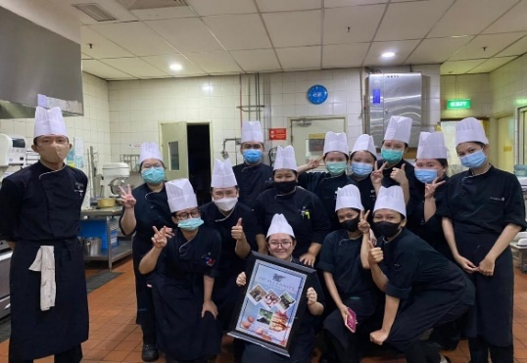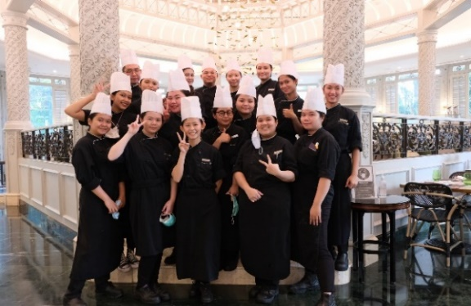
Picture 30. Pastry Team (Personal Documentation, 2021)

REVISE FORM

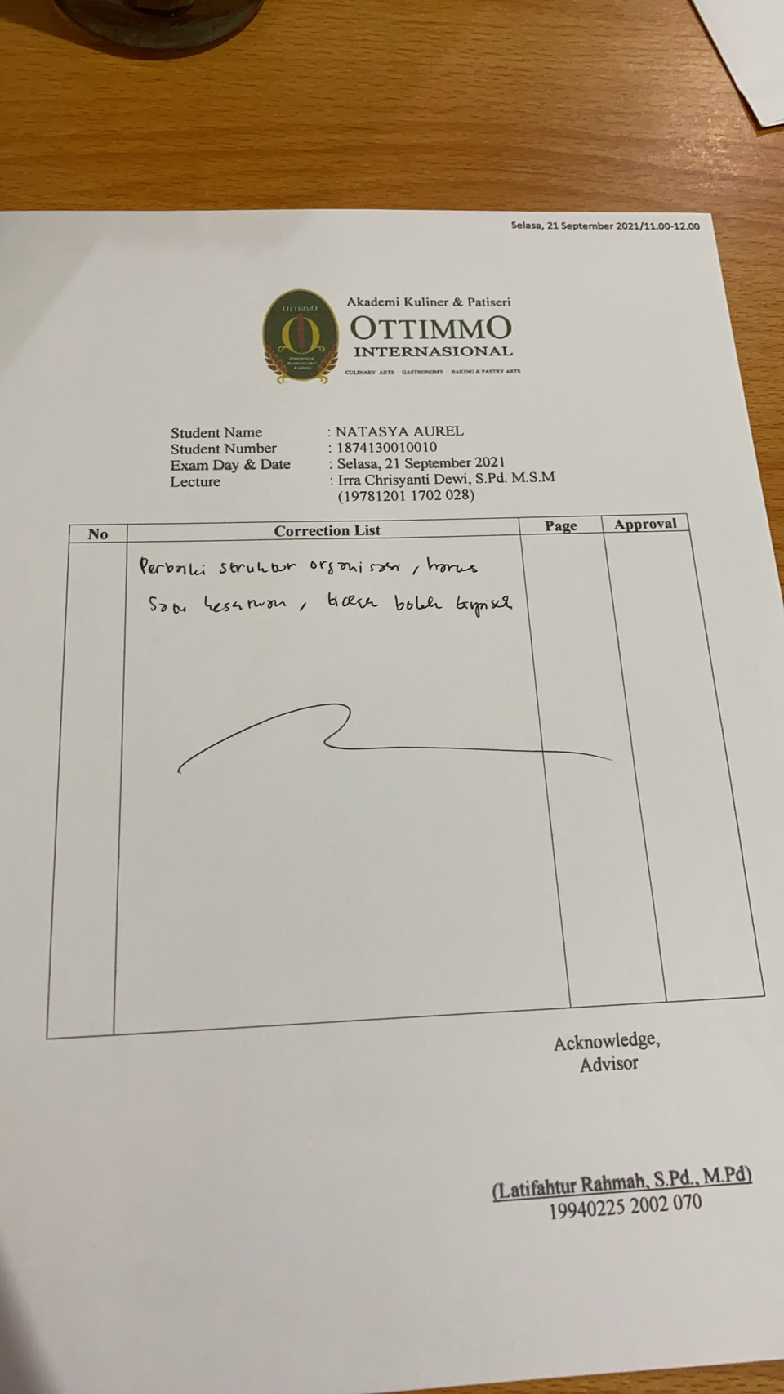

INTENSHIP CERTIFICATE

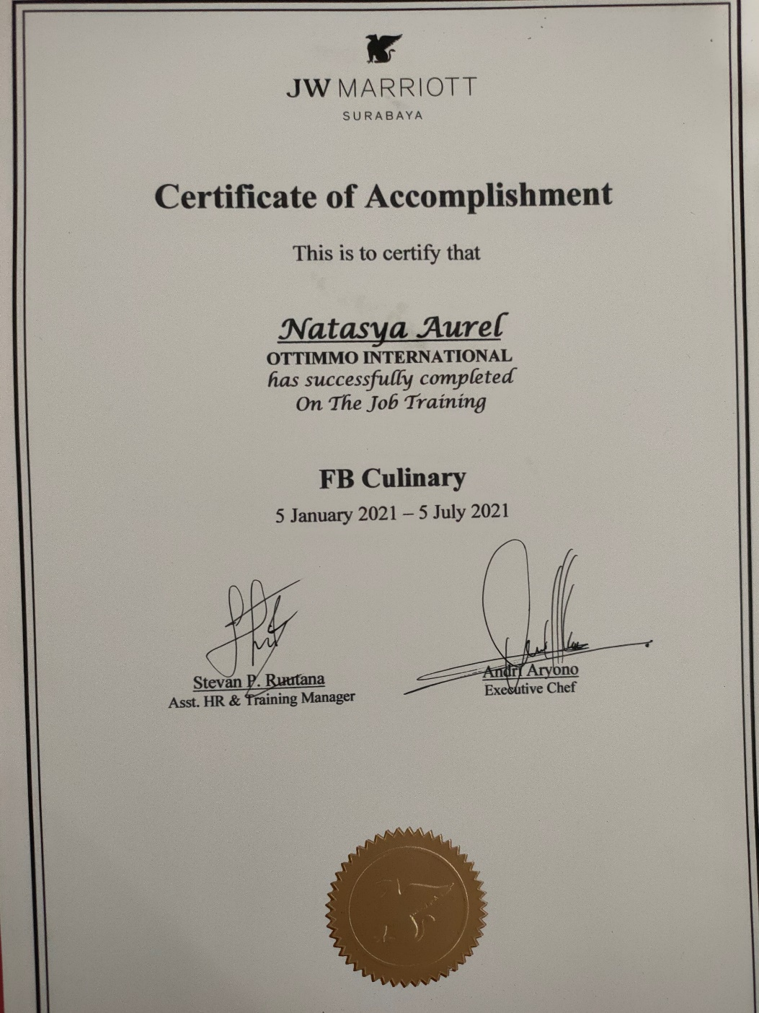

INTERNSHIP APPRAISAL FORM
