CHAPTER II
GENERAL DESCRIPTION OF
JW MARRIOTT HOTEL SURABAYA

2.1 About JW Marriott Hotel Surabaya
JW Marriott is a company founded by John Willard Marriott. JW Marriott is now recognized as one of the the largest international hotel chain in the world. John Willard Marriott is really making a big effort. He started the business from root beer shop in Washington DC developed through several steps until this hotel became as big as it is now.
These steps can be seen as follows:
1927: John Willard Marriott opens a Root Beer shop with 9 seater capacity in Washington DC called: "The Hot Shoppe"
1928: Root Beer is founded and grows into a restaurant Mexican food with the name "Hot Shoppe"
1929: Hot Shoppe, Inc officially launched
1937: The “Hot Shoppe” truck delivers a simple lunch box to the Eastern States, America and England.
1957: The Twin Bridges Motor Hotel Marriott in Arlington Virginia is first hotel built
1967: The Hot Shoppe transforms into the Marriott Corporation
1969: The first Marriott International Hotel opens in Acapulco and California
1975: Marriott opens a hotel in Europe called The Amsterdam Marriott Hotels.
1979: The Marriott Company moves to its new main office in Bethesda Maryland. Marriott's business continues to expand worldwide.
1985: Marriott dies aged 84. J.W. Marriott Jr., in his father's place. Marriott Marquis Hotel opens in New York, Atlanta. The company announced 2 million commitments to develop hotels.
1986: Marriott has acquired The Residence Inn Company. Marriott first opened the Fair Field Inn in Atlanta, Georgia. At the end year, Marriott owns 350 hotels with an estimated 102,000 rooms.
1987: Marriott acquires the Corporate Residence Inn
1993: Marriott is split into two companies, Marriott International and Hosted by Marriott Corporation.
1994: Marriott has acquired the Ritz Carlton Hotel Company, LLC, brand first in the luxury hotel segment.
1997: Marriott International has been awarded the Renaissance Hotel Group. The existence of this award was heard to other countries and Introducing The Town Place Suites and Marriott Executive Apartments at once.
1999: Marriott acquires ExecuStay
2009: Marriott is the world's leading service company with more than 2,300 work units in the United States and 59 units in other regions and other countries. Marriott International has operates many service companies in the field of lodging throughout world, such as:
1. Marriott International Hotel Resorts and Suites in the United States.
2. Renaissance Hotels, Resorts and Suites in the United States.
3. The Ritz Carlton Hotel Company.
4. Resident Inn by Marriott in the United States, Canada and Mexico.
5. Town Plaza Suite by Marriott in 29 states of the United States.
6. Marriott Executive Apartments in the United States.
7. Execustay by Marriott in the United States and Canada.
8. Ramada International Hotels and Resorts in 14 countries and territories in North America.
9. Horizon by Marriott in Orlando, Florida.
10. The Ritz Carlton Club in Aspen, Colorado.
Marriott International has opened 3 hotels in Indonesia; hotel the first is in Jakarta, the second is in Surabaya and the third is in Medan. JW Marriott Surabaya was previously the Westin Hotel Surabaya and has been changed to JW Marriott Hotel. On the 10th June 2002 announced the takeover of The Westin Hotel Surabaya become JW Marriott Surabaya.
JW Marriott Surabaya is owned/developed by PT. Ramasari Surya Persada. The building was designed by Wong & Ouyang Ltd (Building Service), and the interior design itself was created by Bent Severin and Associates. This hotel set their target for the businessman. The location of this hotel is very strategic, located in the city center, Jl. Embong Malang 85-89 which is close to the business center.
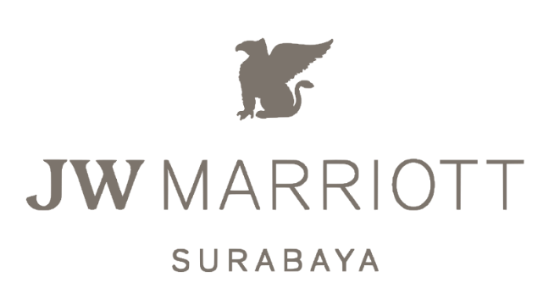
Picture 1. Logo of JW Marriot Surabaya (Marriot,2021)
2.2 Location & Opening Hours
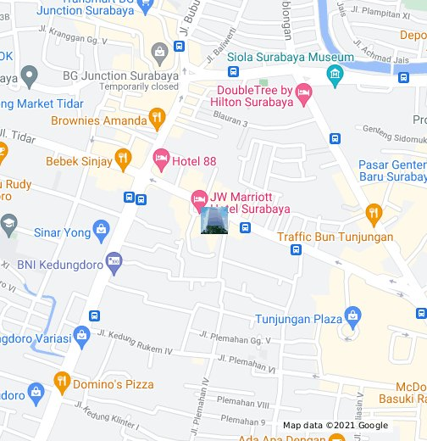
Picture 2. Location of JW Marriott Surabaya ( Marriott, 2021 )
JW Marriott Hotel Surabaya is one of the hotels in Surabaya that has a 5-star hotel standard with a international. JW Marriott Surabaya's strategic location and located in the city center is perfect for entrepreneurs who have business in Surabaya. The JW Marriott Hotel consists of a building with twenty-six floors and has special access on the Executive floor on floors 21 and above.

Address : Jalan Embong Malang no. 85-89 Surabaya 60261
Phone : +62 31 545 8888
Facsimile : +62 31 546 8888
Email : mhrs.subjw.reservations @ marriotthotels.com
Website : www.marriott.com / SUBJW
The location of the JW Marriott Surabaya Hotel can be reached 40 minutes from Juanda Airport and also 20 minutes from Tanjung Perak port.
2.3 Features of JW Marriott Hotel Surabaya
JW Marriott Hotel Surabaya is a five-star luxury hotel with a 25-storey building and 412 rooms featuring exceptional luxury services in Surabaya, located in the Tunjungan City Center of Surabaya. JW Marriott Hotel Surabaya also has a restaurant that serves cuisine from various countries, including: Indonesian, Chinese, Japanese, and International and there are several facilities, including:
- Lobby Lounge
Lobby Lounge at JW Marriott Hotel Surabaya is the perfect rendezvous for friends, family and colleagues, where they can enjoy classic cocktails, exquisite snacks or simply watch the world go by before heading out for the day or retreating for the night. Located next to the grand staircase in the hotel lobby, Lobby Lounge is a spacious, luxurious and elegant space with superb culinary offerings. Savour tasty traditional snacks and light bites, along with select finest coffees and teas, premium wines and spirits, and an array of delicious cocktails, while enjoying live music from Monday to Saturday evening
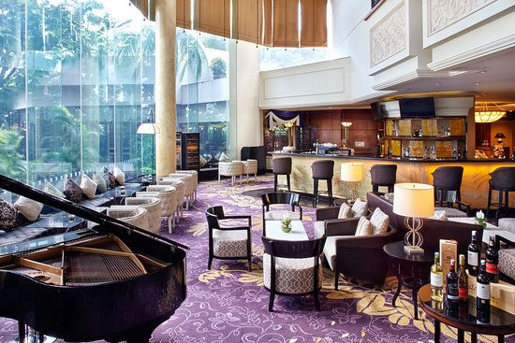
Picture 3. Lobby Lounge ( Marriott, 2021 )
- Deli Shop
Deli shop at JW Marriott is a place to sell pastry & bakery products at JW Marriott Surabaya hotel. This Deli Shop sells various variants, including various types of bread, chocolate pralines, cupcakes, and whole cakes with various delicious shapes and flavors. The products offered at this delishop are sold at affordable prices and of good quality. This Delishop treats guests to freshly baked cakes and sweet treats. This is the perfect place to eat or as a gift to someone else. The deli shop itself operates from 8 am to 9 pm.
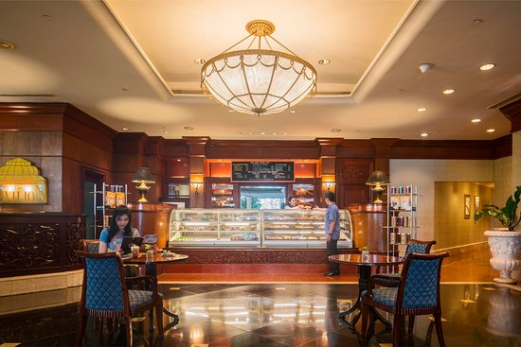
Picture 4. Deli Shop ( Marriott, 2021 )

- Executive Lounge
The Executive Lounge is located on the 21st floor of the JW Marriott Hotel Surabaya, Indonesia with a minimalist concept with a natural color palette and earthy materials. The city views provide the perfect backdrop for informal gatherings, afternoon reading or an early morning cup of coffee. The Executive Lounge is lounge-sized, which can now accommodate up to 74 guests with a dining table and lounge-like seating. A separate area is dedicated to smokers.
One of the most coveted benefits of Executive Lounge access is the all-day dining offer, which includes a private breakfast, drinks and evening cocktails. An update to the lounge creates an inviting dining area where a marble island showcases the day's offerings in a stylish presentation.
Access to the Executive Lounge is normally reserved for guests staying in Executive rooms and luxury suites, but there are now special offers for Deluxe and Studio Room guests. Those staying two nights in a row will enjoy complimentary lounge access and all the benefits that come with it, including complimentary breakfast, tea and cocktails, free Wi-Fi, private check-in/check-out and free ironing service upon check-in -in.
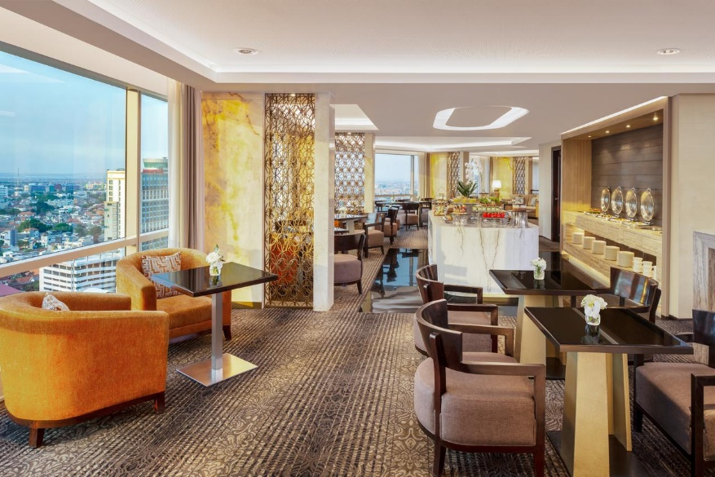
Picture 5. Executive Lounge ( Marriott, 2021 )

- Pavilion Restaurant
Pavilion Restaurant is a great Surabaya drestaurant that will cater to food lovers from local to foreign. Pavilion Restaurant is located on the ground floor of JW Marriott Hotel Surabaya. The combination of minimalist garden and dome elements creates a luxurious impression on the Pavilion Restaurant so that guests who come will feel comfortable when they are at the Pavilion Restaurant.
Pavillion Restaurant serves an international buffet for Breakfast, Lunch and Dinner with a focus on regional cuisine. With a wide selection and a focus on using fresh quality seasonal ingredients, our Executive Chef offers the best food in town. In addition to the Buffet Menu, Pavillion Restaurant also provides a la Carte options for guests.
Pavilion Restaurant itself is often used as a place for weddings, birthdays, engagements, and other events. Not only that, every weekend Pavilion Restaurant often holds various promos with adopted concepts, such as: Local Archipelago, Seafood Promotion, and Brunch.
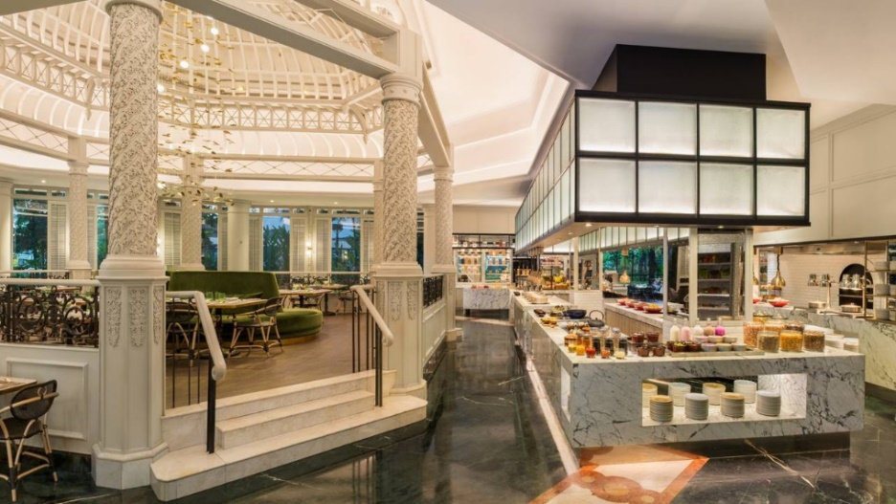
Picture 6. Pavilion Restaurant ( Marriott, 2021 )
- Imari Restaurant
For the finest Japanese cuisine in Surabaya look no further than Imari Japanese Restaurant at JW Marriott Hotel Surabaya. The award-winning restaurant is stylish, designed with a Japanese dining atmosphere and offers a delicious array of authentic Japanese dishes crafted by the highly skilled team of chefs. Imari Japanese Restaurant serves regional comfort food like the wide selection of fresh sushi and sashimi, as well as beef and other seafood dishes. The timeless Japanese restaurant also offers a live teppanyaki programme. Putting the cherry on top of the dining experience at Imari is the restaurant’s premium Japanese sake collection
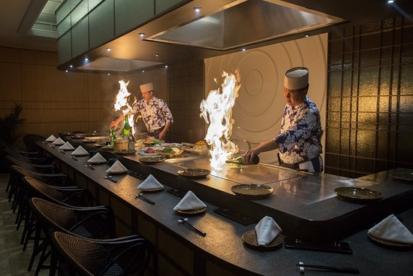
Picture 7. Imari Restaurant ( Marriott, 2021 )

- Tang Palace Restaurant
Tang Palace Chinese Restaurant thrills your palate with authentic Cantonese cuisine and dim sum served in an opulent setting. Accented by antiques from the legendary Tang Dynasty, this exceptional Surabaya restaurant is on the second floor of JW Marriott Hotel Surabaya. At Tang palace itself is served by a Chef who comes directly from China. In addition to the delicious taste of food, Tang Palace also has satisfactory service standards and a beautiful atmosphere, so that when guests visit they are comfortable to dine at Tang Palace Restaurant Surabaya. Tang Palace Restaurant itself is also often used for several events, such as: wedding events, engagement, birthday, etc ….
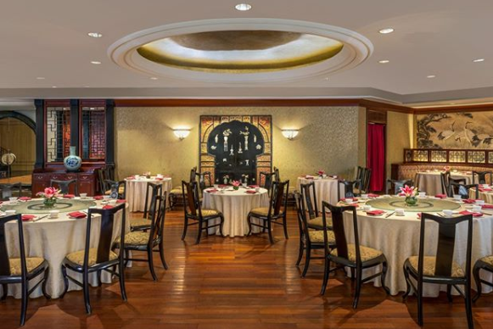
Picture 8. Tang Palace Restaurant ( Marriott, 2021 )
- Uppercut Restaurant
Uppercut Restaurant’s restaurant is on second floor of JW Marriott Hotel Surabaya. Designed with a chic monochromatic brasserie, Uppercut translates sophisticated yet relaxing atmosphere into a modern steakhouse. Its delightful menu serves a variety of premium quality meats, josper grilled dry-age beef and Chef’s specialty desserts using only the finest ingredients. The Bar section provides selection of wines, aging barrel cocktails, and liquor. Uppercut is the all-in-one venue to celebrate moments, have a good times, enjoy excellent beef and great drinks in Surabaya.
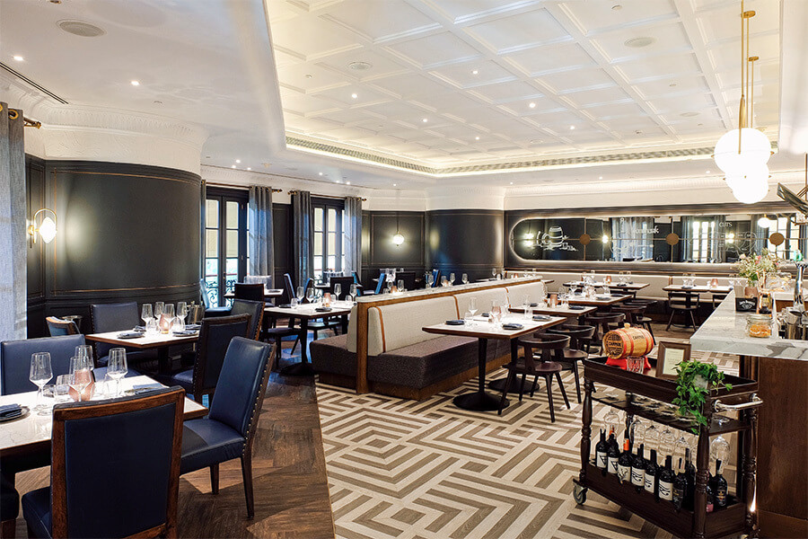
Picture 9. Uppercut Restaurant ( Marriott, 2021 )

2.4 Organizational Structure and Main Task
The organizational structure of the pastry & bakery kitchen at JW Marriott Hotel Surabaya is divided into 3 shifts, namely: morning shift, afternoon shift and night shift. The following is the organizational structure of the JW Marriott Hotel Surabaya pastry & bakery kitchen :

Senior Pastry Chef
Endra Yudha
Junior Sous Chef
Sardji

CDP Pastry
Umi
Demi Chef

Rey
Lim
Andi Astuti

Bakery Team
Pastry Team
Arief
Syahlim

Dino

Kiki

Fandy

Rubby
Dodik
Didik
Lim

Picture 10. Kitchen Organizational Pastry Kitchen ( Personal Documentation, 2021 )
  - Senior Pastry Chef
- Supervise all tasks in pastry kitchen, process of processing pastry & bakery products in accordance with predetermined standards.
- Check and make a list of kitchen supplies.
- Make a weekly work schedule.
- Be creative in creating new menus, as an effort to attract consumers
- Setting and monitoring performance standard for staff

  - Junior Sous Chef
- Senior Pastry Chef’s assistant
- Ensure that the pastry & bakery processing kitchen runs smoothly
- Responsible for the cost of product processing materials and product sales on food cost control.
- Assist senior pastry chefs in carrying out their duties, namely in creating new menus, planning menus and selecting food presentations.

  - CDP Pastry ( Chef de Partie )
- Responsible for activities in the pastry section optimally
- Managing pastry operations and delegating some work to several assistants and is the backbone of pastry.
- Responsible to Pastry Chef

  - Demi Chef
- Conduct experiments to create cake recipes and evaluate the results of their creations.
- Prepare various types of pastry dishes for sale at the pastry shop, breakfast, afternoon tea, dessert for buffet and a la carte, etc ..

  - Bakery Team
- Making bread, process, bake, decorate bakery products neatly and perfectly
- Responsible for all the products he makes in the bakery section and is assisted by several bakers.

  - Pastry Team
- Prepare and cook all dessert products, chocolate, cake and pastry neatly and perfectly.
- Responsible for the processing, production and decorating of cakes and pastry products produced.

