BILIOGRAPHY
Bstrategyhub. 2020. Marriot vision & mission
Available: https://bstrategyhub.com/marriott-vision-mission-core-values-2019-a-complete-analysis/ . Accessed 22nd August 2021
Marriot. 2021. Overview Four Points by Sheraton Surabaya
Available: https://www.marriott.com/hotels/travel/subfp-four-points-surabaya/. Accessed 22nd August 2021

APPENDIX

Hot Kitchen area
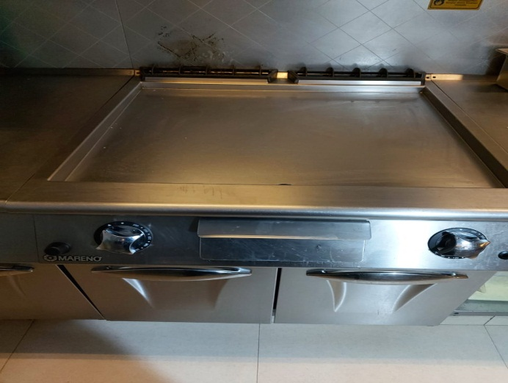
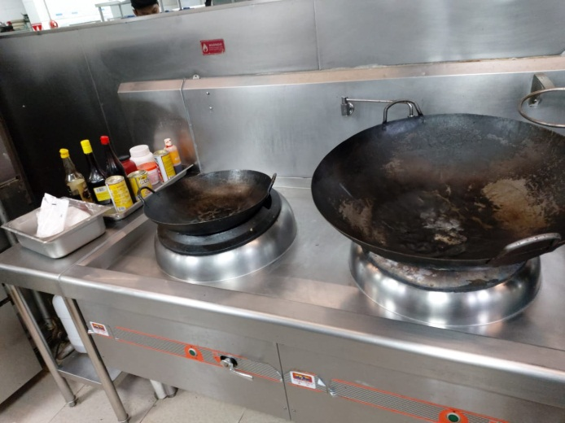

Picture 16. Wok area Picture 17. Flat griddle
(Personal documentation, 2021) (Personal documentation, 2021)
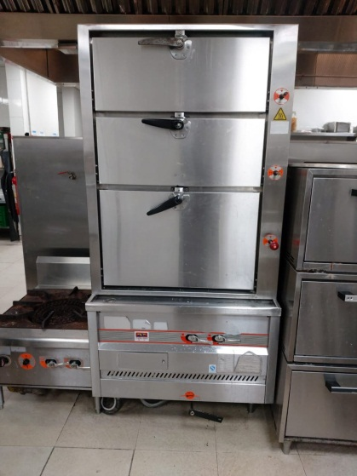
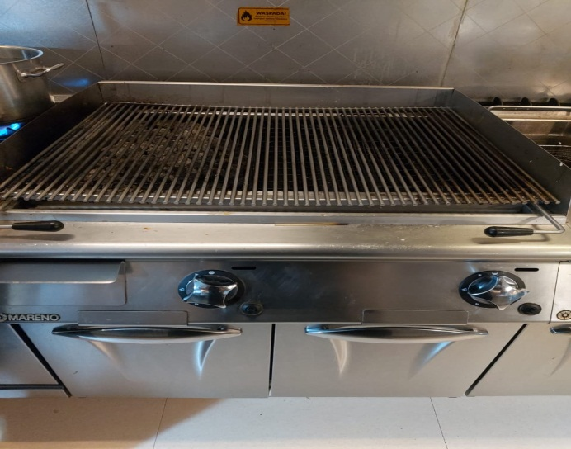

Picture 18. Grill Picture 19. Steam machine (Personal documentation, 2021) (Personal documentation, 2021)

Garde Manger Area
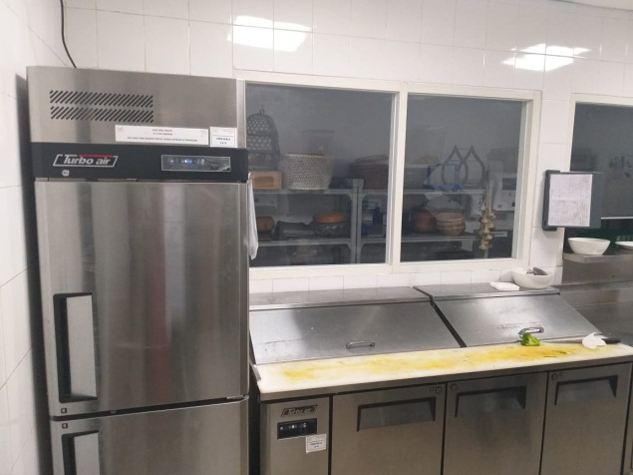
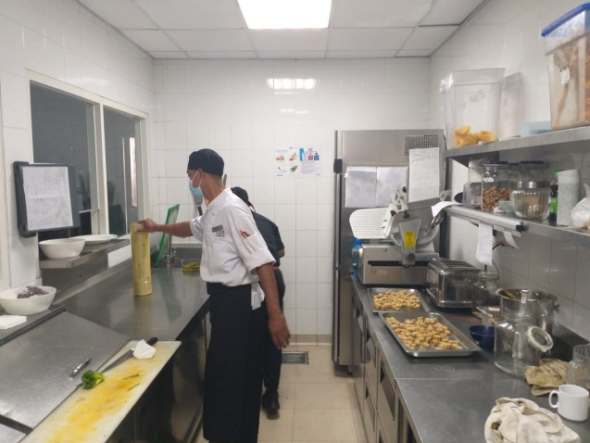

Picture 20. GDM area Picture 21. GDM area (2)
(Personal documentation, 2021) (Personal documentation, 2021)

Pastry Area
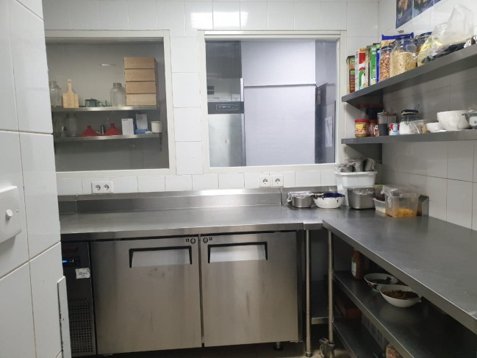
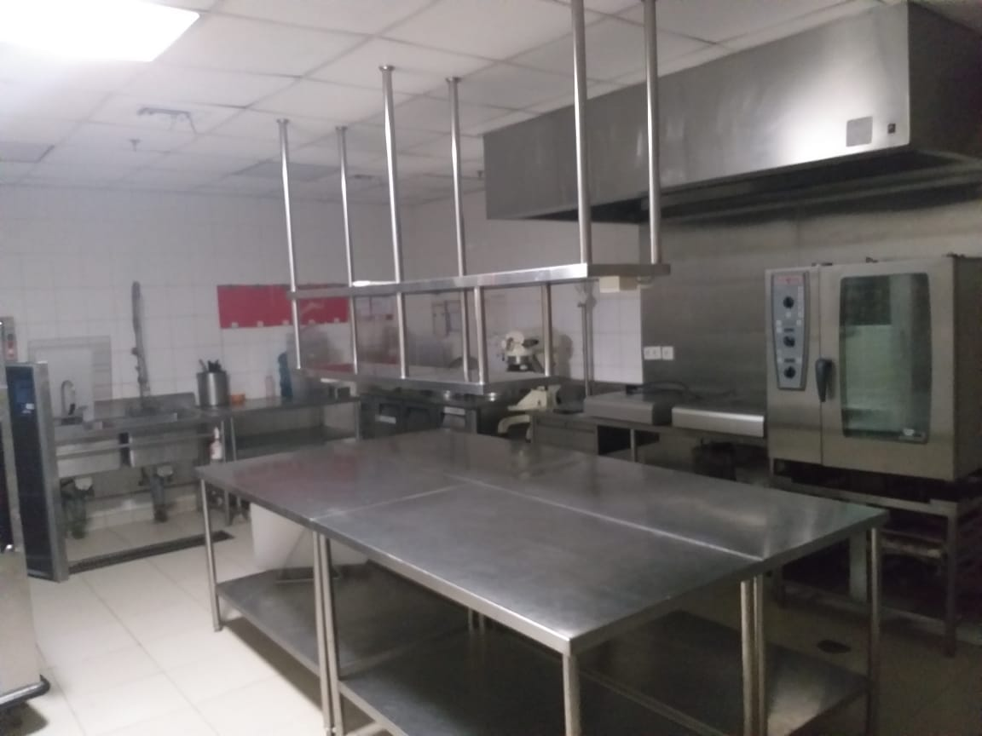

Picture 22. Pastry production area Picture 23. Pastry area
(Personal documentation, 2021) (Personal documentation, 2021)

Schedule
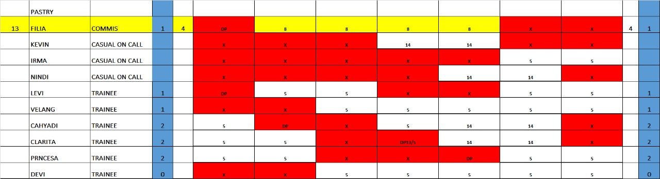

Picture 24. Schedule
(Personal documentation, 2021)

New Menu Tasting
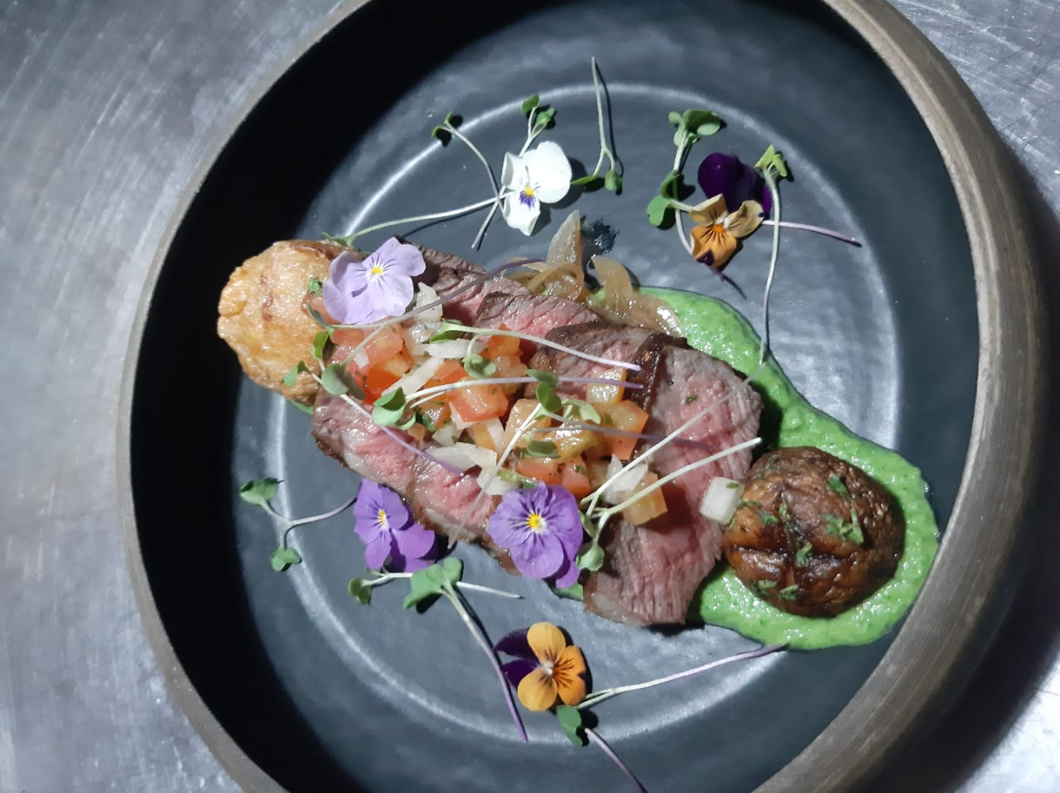

Picture 25. Menu testing
(Personal documentation, 2021)

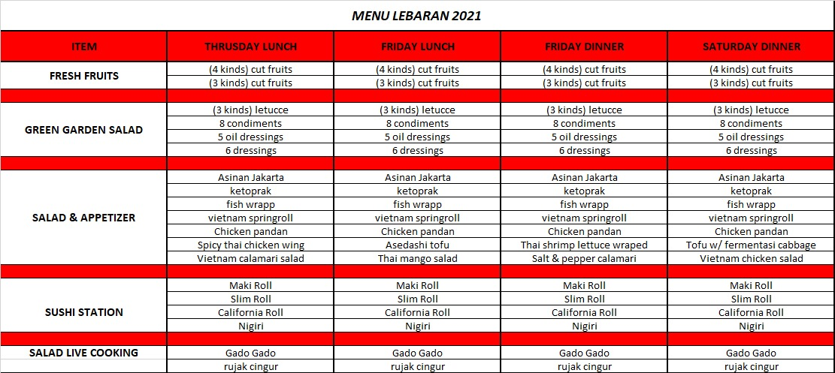
Menu

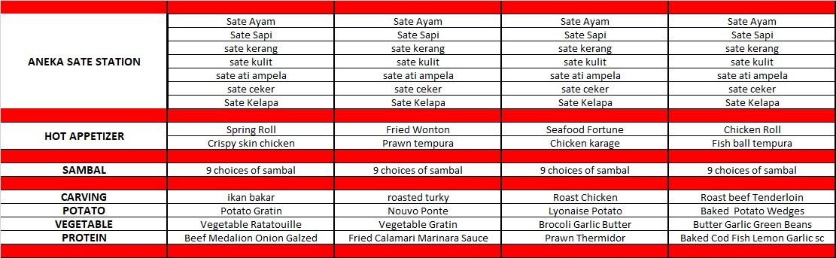

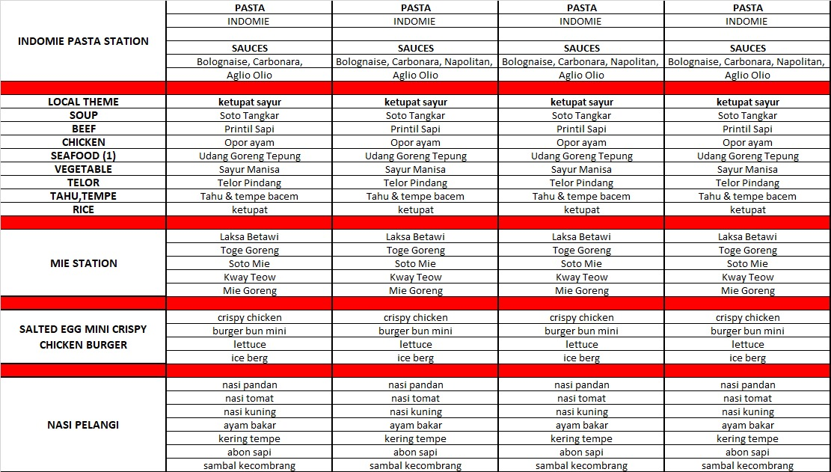

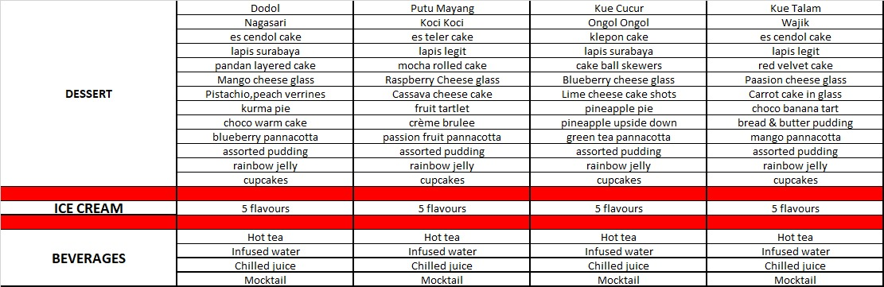

Picture 21. Menu Lebaran 2021
(Personal documentation, 2021)

Photos with team
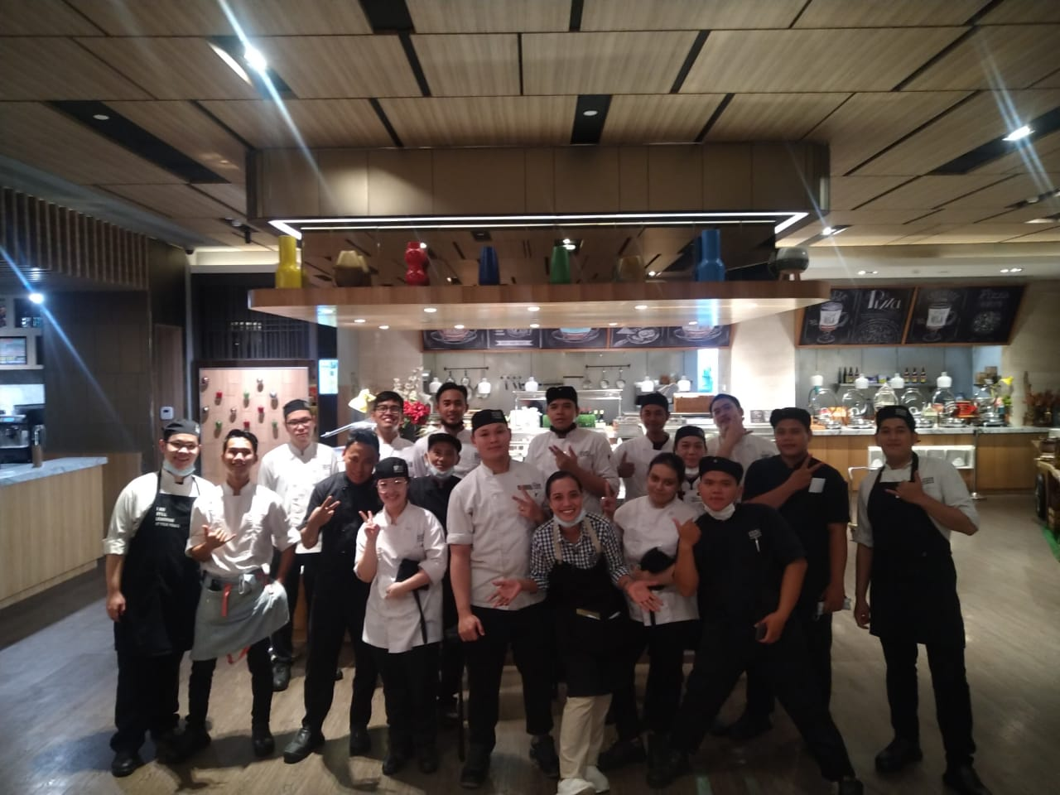

Picture 22. Hot kitchen team
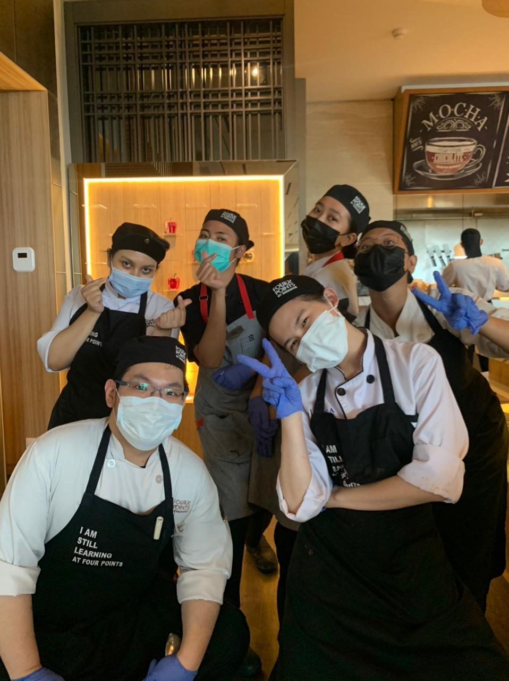
(Personal documentation, 2021)

Picture 21. Pastry team
(Personal documentation, 2021)
