CHAPTER II
GENERAL DESCRIPTION OF COMPANY

  - History of company
First operating in 2016, this hotel was born as one of Marriott Bonvoy hotel brands on Surabaya. Their company objectives are to give experience timeless style with the essentials done right. It also has one of the best brews and travel reinvented. They provide central spot that connected to one of the biggest mall on Surabaya. Inside the hotel we can find convenient workspaces with fast, free Wi-Fi, locally sourced craft beer on tap and a 24-hour gym. Spacious guestrooms designed with simplicity round out your stay.
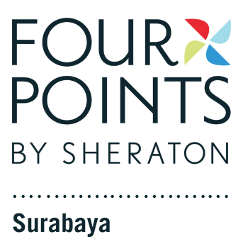

Picture 1. Logo Four Points by
Sheraton Surabaya (Marriot, 2021)

  - Vision, Mission and Company Objectives
Company vision:
- To be the World’s Favorite Travel Company
Company Mission:
- To enhance the lives of our customers by creating and enabling unsurpassed vacation and leisure experience.
- Enhance the lives of the customers
- Creating and enabling unsurpassed vacation and leisure experience
Company objectives:
- Pursuing excellence
The company brand expects the entire employee to exhibit professional excellence.
- Acting with integrity
The company expected the entire employee to execute their duties with the utmost integrity to grow as a trustworthy brand name.
- Putting people first
To create a company culture that had employee well equipped with this skillset to assure all achieve all customer need or desire.
- Embracing change
The company expected all employees not only welcome change but also adjust accordingly to each different culture around the world.
- Serving the World
The company expected all employees to be committed to not only the company but also towards the society and the planet. All employees are expected to give back to society and help make the world more sustainable.

  - Organizational Structure and Main Task

Executive chef

Butcher

Steward Supervision
Chef de cuisine

Chef de partie
(ADD)
Chef de partie
(GDM)
Chef de partie
(Breakfast)
Commis
(Pastry)

Casual
Commis
Commis
Demi chef

Trainee
Casual
Casual
Commis
Trainee
Trainee
Casual

Trainee

Picture 2. Organizational Structure
(Personal Documentation, 2021)

Main Task:
- Executive chef
- Ensuring quality of the dishes.
- Setting and monitoring performance standard for staff.
- Chef de cuisine
- Executive Chef’s assistant.
- Creating new recipes and planning menu.
- Ensuring kitchen runs smoothly.
- Check and make a list of kitchen supply.
- Steward supervision
- Assist in cleaning dishes and tends to customer’s needs.
- Who help solve trouble kitchen equipment having trouble.
- Scrapping food from dirty dishes, pots, pans, plates, flatware and glasses, washing dirty dishes and putting them away
- Chef de partie
- Helping creating new recipes and selecting plate presentation.
- Helping commis when orders are running.
- Responsible for production paper.
- Make a weekly working schedule.
- Butcher
- Check and make list of kitchen supplies.
- Cleaning and portioning all types of meat and fish.
- Cleaning all shrimp, clam, squid and crab.
- Commis
- Who cook when there are orders.
- Check inventory items such as sauce, stock supply, etc.
- Helping prepare mise en place.
- Demi chef
- Who cook when there are orders.
- Who handle banquet event.
- Casual
- Semi contract employee who help in the kitchen.
- Who help commis when there is an order.
- Who help mise en place.
- Trainee
- Assisting commis during mise en place.
- Clearing area during shift change
- Helping commis when there are orders.

