INTERNSHIP REPORT

Four Points by
Sheraton Surabaya

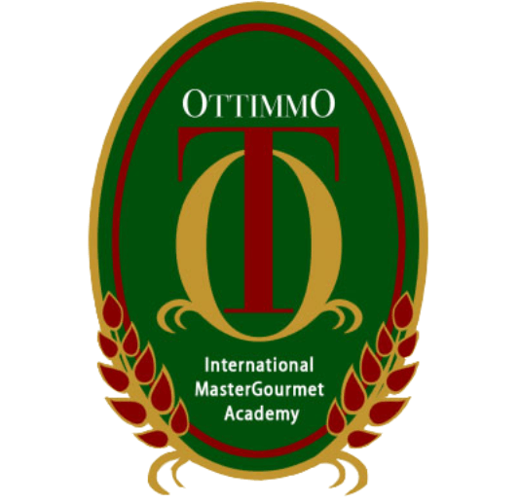

By:
Cahyadi Mardianta
187410030015

STUDY PROGRAM OF CULINARY ART
OTTIMMO INTERNASIONAL MASTERGOURMET ACADEMY
SURABAYA
2021
ADVISOR AND
EXAMINER APPROVAL

Arranged by:
Cahyadi Mardianta
1874130010015
Done Internship program form January 4th 2021 – July 3rd 2021 at Four Points by Sheraton Surabaya
Advisor Examiner I Examiner II

Latifahtur Rahmah, Nurul Azizah Choiriyah, Ryan Yeremia Iskandar,
S.Pd., M.Pd S.TP., M.Sc SS
NIP. 199402252002070 NIP.199002152002071 NIP.198212181601023

Director of OTTIMMO Head of Study Program Culinary Arts
International OTTIMMO International
Mastergourmet Academy, Mastergourmet Academy,

Zaldy Iskandar, B.Sc Hilda Tjahjani Iskandar, S.E, M.M
NIP. 19731025 1201 001 NIP. 196910292002072
INTERNSHIP PLACEMENT APPROVAL
Title : Internship at Four Points by Sheraton Surabaya
Company Name : Four Points by Sheraton Surabaya
Company Address : Jl. Embong Malang No. 25-31, Kedungdoro,Kec. Tegalsari, Kota Surabaya, Jawa Timur 60261
Telephone Number : (031) 5477488
Which is carried out by Students of Culinary Art Ottimmo International Mastergourmet Academy Surabaya
Name : Cahyadi Mardianta
Reg. No : 1874130010015
Has been tested and declared successful.
Approve, Surabaya, July 3 2021
Advisor Supervisor

(Latifahtur Rahmah, S.Pd., M.Kes) (Judi Kristiyanto)
NIP.19940225 2002 070 Chef de cuisine
Acknowledged by,
Director of Ottimmo International Mastergourmet Academy

(Zaldy Iskandar, B.Sc)
NIP. 19731025 1201 001
ACKNOWLEGMENT

By expressing thanks and praise the presence of God Almighty, I’m able to successfully complete this report. The author can complete the writing of internship final report. This report is prepared as one of the requirements to complete Diploma III of Culinary Arts. The internship final report is prepared based on the 6 months of internship in Four Points by Sheraton Surabaya.

In the process of completion of the report, the author has received much guidance and assistance from various parties. To that end, the author expresses their sincere thanks to:

- Mr. Zaldy Iskandar as the Head Director of Ottimmo International.
- Ms. Hilda Tjahjani Iskandar as Head of Study Program at Ottimmo International.
- Ms. Latifahtur Rahmar as Advisor, who has guided, provides guidance and suggestion until the completion of this report.
- Examiner, as the Examiner on the presentation.
- Mr Judi Kristiyanto as Chef de cuisine of Four Points by Sheraton Surabaya.
- The entire staff of Four Points by Sheraton Surabaya.
- All who involved in the making of this internship report.
Finally, the author hope that this report can be useful for everyone

Surabaya, September 3rd 2021

Cahyadi Mardianta

PLAGIARISM STATEMENT

I certify that this assignment/report is my own work, based on my personal study and/or research and that I have acknowledged all material and sources used in its preparation, whether they are books, articles, reports, lecture notes,and any other kind of document, electronic or personal communication. I also certify that this assignment/report has not previously been submitted forassessment in any other unit, except where specific permission has been granted from all unit coordinators involved, or at any other time in this unit, and that I have not copied in part or whole or otherwise plagiarised the work of other students and/or persons.

Surabaya, 3 September 2021

Cahyadi Mardianta
NIM. 1874130010015

TABLE OF CONTENT
INTERNSHIP REPORT ......................... i
ADVISOR AND EXAMINER APPROVAL ……………….. ii
INTERNSHIP PLACEMENT APPROVAL …….................. iii
ACKNOWLEDGEMENT ……………..... iv
PLAGIARISM STATEMENT ......................... v
TABLE OF CONTENT ........................... vi
LIST OF FIGURE ........................... vii
LIST OF TABLE ........................... viii
EXECUTIVE SUMMARY ......................... ix
CHAPTER I INTRODUCTION ........................... 1
  - Background of study ………………… 1
  - Internship Objective ………………… 1
  - The Benefits of Internship ………………… 2
    - Benefits of Internship for Student ……………. 2
    - Benefits of Internship for Ottimmo International Mastergourmet Academy ………. 2
    - Benefits of Internship for Company…………... 2
CHAPTER II GENERAL DESCRIPTION OF COMPANY ……. 3
  - History of Company ………………... 3
  - Vision, Mission and Company Objectives ……………….. 4
  - Organizational Structure and Main task …………………. 5
CHAPTER III INDUSTRIAL TRAINING ACTIVITIES ............ 8
  - Place of Assignment ………………... 8
  - Job Description Based on Workmanship ………………... 9
  - Hygiene and sanitation ………………... 15
  - Problem Faced and How to Solve Them ………………... 17

CHAPTER IV CONCLUSION …....................... 19
4.1 Conclusion ………………... 19
4.2 Suggestion ………………... 19
BILIOGRAPHY ........................... 21
APPENDIX ........................... 22

LIST OF PICTURES
Picture 1. Logo Four Points by Sheraton Surabaya ......................... 3
Picture 2. Organizational structure ......................... 5
Picture 3. Location Four Points ......................... 8
Picture 4. Lime Restaurant ......................... 8
Picture 5. Dining Area ………………. 8
Picture 6. Pempek ………………. 12
Picture 7. Pumpkin soup ………………. 12
Picture 8. Nachos ………………. 13
Picture 9. Vegetable spring roll ………………. 13
Picture 10. BBQ chicken wing ………………. 13
Picture 11. Cendol pannacotta ………………. 14
Picture 12. Red velvet ………………. 14
Picture 13. Crème Brûlée ………………. 15
Picture 14. Guideliness to wash hand ………………. 16
Picture 15. Food safety instruction ………………. 16
Picture 16. Wok area ………………. 21
Picture 17. Flat griddle ………………. 21
Picture 18. Grill ………………. 21
Picture 19. Steam Machine ………………. 21
Picture 20. GDM area ………………. 22
Picture 21. GDM area (2) ………………. 22
Picture 22. Pastry production area ………………. 22
Picture 23. Pastry area ………………. 22
Picture 24. Schedule ………………. 23
Picture 25. Menu testing ………………. 23
Picture 26. Lebaran menu ………………. 25
Picture 27. Hot kitchen team ………………. 25
Picture 28. Pastry team ………………. 25

LIST OF TABLES

Table 1. Job Description (Hot Kitchen) ........................ 9
Table 2. Job Description (Pastry) ........................ 10
Table 3. Product Description ........................ 12

EXECUTIVE SUMMARY

The writer implements the internship program for six months, which begins on January 4th 2021 and end on July 3rd 2021. The writer chooses Four Points by Sheraton Surabaya hotel as his training place. The writer learned a lot in Four Points by Sheraton Surabaya hotel, the hotel allow trainee to learned more than 1 department for trainee report. On that place he got 2 different outlets which is hot kitchen and pastry. The author got opportunity to learn each department for 3 months. The writer learned a lot about cooking methods, time management, introduction and storage of food ingredients, team works, make alternative way and work solutions, quality work, labeling, socializing with customer, be confident. The Internship Program was very great lesson and experience even though it’s only for 6 month. Hopefully in the near future, all the skills and knowledge the write got from Four Points can be a useful and plus points for the writer when he set up his own business.

Keywords: Four Points by Sheraton Surabaya, Internship report

