REFERENCES

Anonymous. 2021. JW Marriott Hotel Surabaya
https://cf.bstatic.com/xdata/images/hotel/max1024x768/224654997.jpg?k=4c7fe7837097f5fde386e362bc44fbbe941da4bf09f7fb6790daf6f91cd3a133&o=&hp=1. Sept 23th, 2021.
Anonymous. 2021. JW Marriott Hotel Surabaya
https://livetheworld.americanexpress.com/wp-content/uploads/2020/12/JW-Marriott-Surabaya_Logo.png.
Sept 23th, 2021.
Anonymous. 2021. JW Marriott Hotel Surabaya
https://maps.app.goo.gl/NUTo8T4rS3Mi17Fg9. Sept 23th, 2021.
Anonymous. 2021. JW Marriott Hotel Surabaya
https://cache.marriott.com/marriottassets/marriott/SUBJW/subjw-guestroom-0070-hor-clsc.jpg?interpolation=progressive-bilinear&downsize=378px:*. Sept 23th, 2021.
Anonymous. 2021. JW Marriott Hotel Surabaya
https://cache.marriott.com/marriottassets/marriott/SUBJW/subjw-guestrooms-0071-hor-clsc.jpg?interpolation=progressive-bilinear&downsize=378px:*. Sept 23th, 2021.
Anonymous. 2021. JW Marriott Hotel Surabaya
https://cache.marriott.com/marriottassets/marriott/SUBJW/subjw-one-bedroom-0193-hor-clsc.jpg?interpolation=progressive-bilinear&downsize=378px:*. Sept 23th, 2021.
Anonymous. 2021. JW Marriott Hotel Surabaya
https://cache.marriott.com/marriottassets/marriott/SUBJW/subjw-chairman-suite-9731-hor-clsc.jpg?interpolation=progressive-bilinear&downsize=378px:*. Sept 23th, 2021.
Anonymous. 2021. JW Marriott Hotel Surabaya
https://cache.marriott.com/marriottassets/marriott/SUBJW/subjw-presidential-0216-hor-clsc.jpg?interpolation=progressive-bilinear&downsize=378px:*. Sept 23th, 2021.
Anonymous. 2021. JW Marriott Hotel Surabaya
https://cache.marriott.com/marriottassets/marriott/SUBJW/subjw-two-bedroom-4344-hor-wide.jpg?interpolation=progressive-bilinear&downsize=1064px:*. Sept 23th, 2021.
Anonymous. 2021. JW Marriott Hotel Surabaya
https://cache.marriott.com/marriottassets/marriott/SUBSI/subsi-fitness-center-8325-hor-clsc.jpg?downsize=1440px:*. Sept 23th, 2021.
Anonymous. 2021. JW Marriott Hotel Surabaya
https://cache.marriott.com/marriottassets/marriott/SI/si-spa-001-hor-feat.jpg?downsize=1440px:*. Sept 23th, 2021.
Anonymous. 2021. JW Marriott Hotel Surabaya Imari Restaurant
https://speisekarte.menu/storage/media/company_images/1993454/conversions/thumbnail.jpg. Sept 23th, 2021.
Anonymous. 2021. JW Marriott Hotel Surabaya Meeting Room
https://cache.marriott.com/marriottassets/marriott/SUBJW/subjwf01.png?downsize=460px:*. Sept 23th, 2021.
Anonymous. 2021. JW Marriott Hotel Surabaya Pavilion Restaurant
https://s3.dealjava.com/content/thumb_small/bd881f641846cf7d283e8471901dea51.jpg. Sept 23th, 2021.
Anonymous. 2021. JW Marriott Hotel Surabaya Tang Palace Restaurant
https://jelajah-indonesia.co.id/wp-content/uploads/2018/11/Tang-Palace-2.jpg. Sept 23th, 2021.
Anonymous. 2021. JW Marriott Hotel Surabaya Steakhouse
https://media-cdn.tripadvisor.com/media/photo-s/19/16/c2/3e/uppercut-steakhouse.jpg. Sept 23th, 2021.

Anonymous. 2021. Kitchen Organization
https://m.facebook.com/story.php?story_fbid=4146891632100943&id=100003404419245. Sept 23th, 2021.
Anonymous. 2021. Standard Temperature
https://www.statefoodsafety.com/Resources/Resources/cooking-times-and-temperatures-poster. Sept 23th, 2021.
APPENDIX

Hot Kitchen
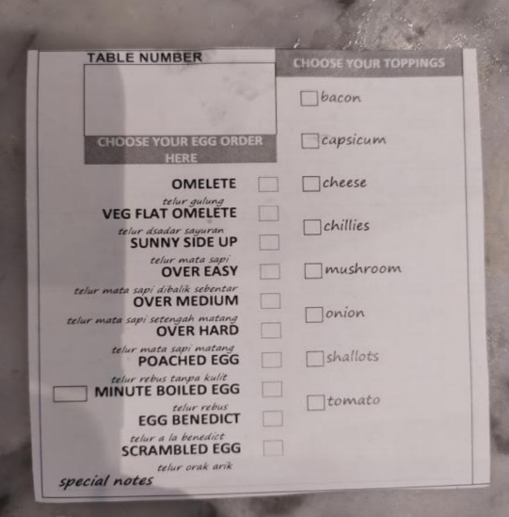

Picture 24. Breakfast Card
(Source : The Author’s Collections)
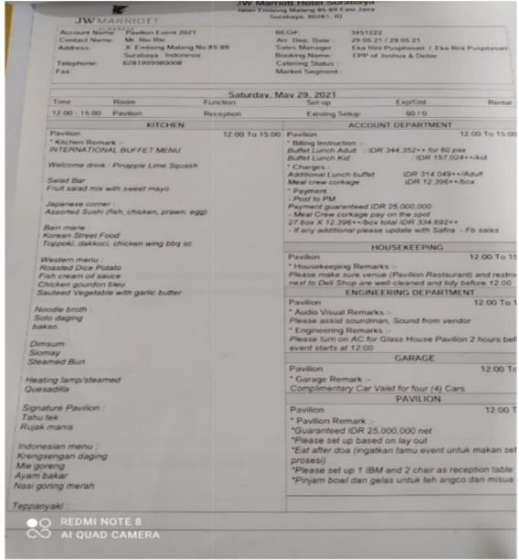

Picture 25. Banquet Event Order
(Source : The Author’s Collections)

Team of JW Marriott
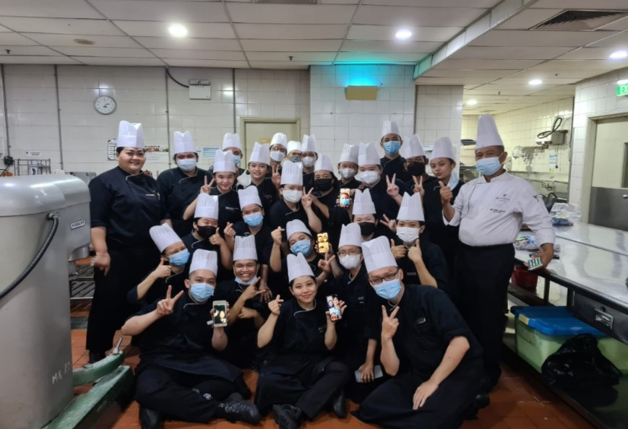

Picture 26. Banquet Team
(Source : The Author’s Collections)

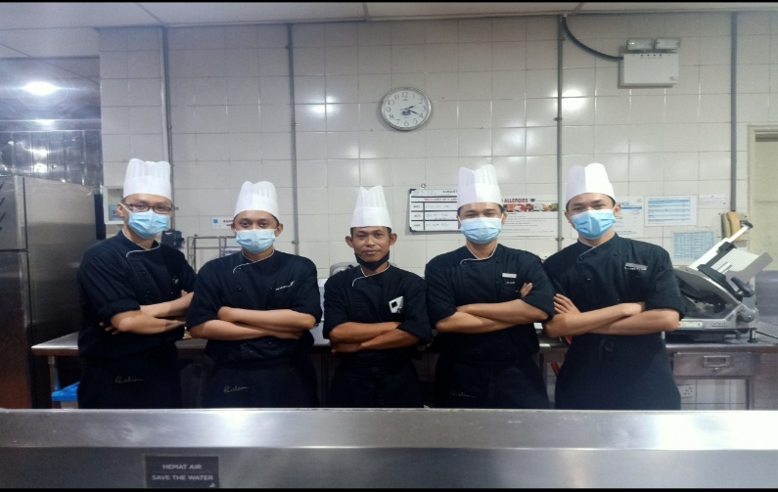

Picture 27. Butcher Team
(Source : The Author’s Collections)

