CHAPTER II
GENERAL DESCRIPTION OF JW MARRIOTT HOTEL SURABAYA

- Overview
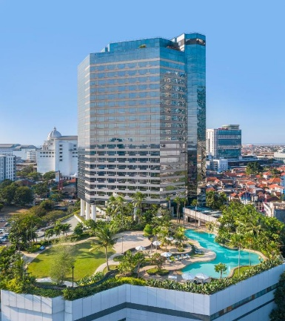

Picture 1. JW Marriott Hotel Surabaya
(Anonymous, 2021)

JW marriott hotel is one of the most famous 5 star hotels in Indonesia, its location close to several tourism place attractions and the night market which is 200 meters west makes it one of the best hotel destinations. So that it is easily known and reached by people. Sheraton Hotel have many Facility, including:
- 407 Guest Room and 23 Apartments
- 24 hour- gym
- 7 Meeting rooms and 1 ballroom
- Health Club Facilites
- Outdoor pool
- Valet parking
- 3 Restaurant and 1 Steakhouse

  - History of JW Marriott Hotel Surabaya

It all began in 1927 whereas the couple named J. Willard Marriott and his wife, Alice, opening up a root beer stand called A&W by quenching people’s thirst during Washington D.C.’s hot, muggy summers. Good food and good service at a fair price became a guiding principle for Hot Shoppes restaurants--and for Marriott International as it grew. In 1927, Newlyweds J. Willard and Alice S. Marriott, along with business partner Hugh Colton, open the first A&W root beer franchise in Washington, D.C. The Marriotts add hot food items to their menu--a first for A&W franchises--and the name "Hot Shoppes" is born. A year later, The Marriotts open two more Hot Shoppes, including the East Coast's first drive-in restaurant.
In 1937 In-flight airline catering debuts when Hot Shoppes begins delivery of boxed lunches to passengers at Hoover Airport, south of Washington, D.C and in 1953 Hot Shoppes, Inc. stock becomes public at $10.25/share and sells out in two hours of trading. The biggest changes for Marriott comes in the year of 1957-1985, Marriott made a historic shift into the hotel business in 1957. The world’s first motor hotel opened in Arlington, Virginia, under the management of J. Willard Marriott’s son, Bill. Over the next 25 years, Marriott became a diverse global enterprise, and Bill Marriott became a visionary CEO whose leadership transformed the hospitality industry and in 1984, the first JW Marriott, named in honor of founder J. Willard Marriott, opens in downtown Washington, D.C. Throughout the years and decades, the Marriott group has expanded globally and has opened various kinds of hotels such as: JW Marriott, Ritz Carlton, Bulgari, and many more.
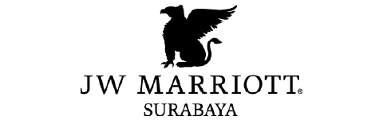

Picture 2. Marriot Surabaya Logo
(Anonymous, 2021)

  - Vision and Mission

Mission
To enhance the lives of our costumers by creating and enabling unsurpassed vacation and Leisure experiences
Vision
- PURPOSE : Open Door to Opportunity
- VALUES : Put People First, Pursue Excellence, Embrace Change, Act with Integrity, Serve our World.
- HOW WE WIN : Marriott Hotels, Marriott Reward, Mobile – Digital, Millennial Mindset.
- SCORECARD : Associate Engagement, Costumer Loyalty, Owner Preference, Shareholder Values.

  - Location of JW Marriott Hotel Surabaya
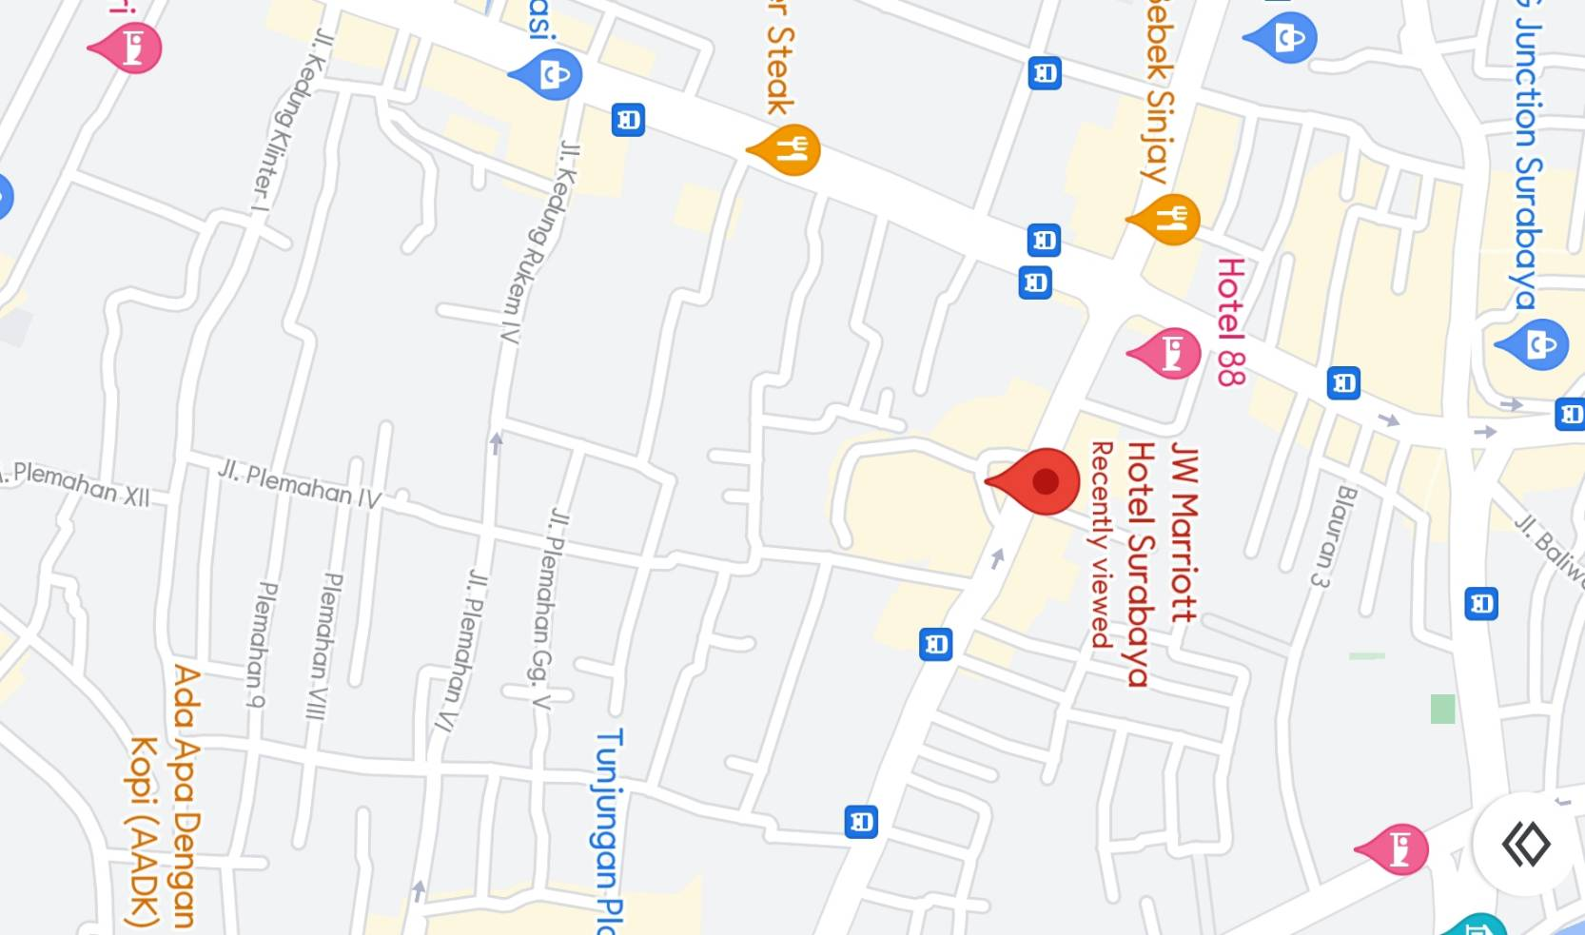

Picture 3. JW Marriott Hotel Surabaya Map
(Anonymous, 2021)

Information :
- Address : Jalan Embong Malang 85-89 Surabaya, East Java, Indonesia
- Phone : (031) 545 8888
- Fax : (031) 546 8888
- Site : https://www.marriott.com
  - Feature in JW Marriott Hotel Surabaya

- Marriott Room
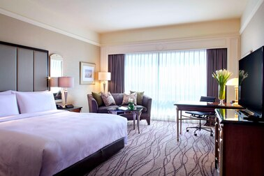
Picture 4. Premium Deluxe Room
(Anonymous, 2021)

The Deluxe Room is decorated with dark wood and features an in-room safe ironing board, 60 TV channels, a spacious working desk with multi- function plugs and complimentary high-speed Wi-Fi access.Which is priced at IDR 1,050,000 for 1 night.

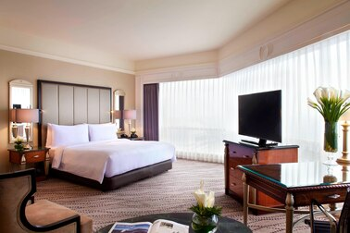
Picture 5. Studio Room
(Anonymous, 2021)
This room has one view corner room. And flat TV with 60 channels, in-room safe, complimentary high-speed Wi-Fi access, and choice for Sweet Sleeper BedTM King Size or Queen Size, guest can feel the comfort of home . Room size 48 m² with city view. Which is priced at IDR 1,140,000 for one night.

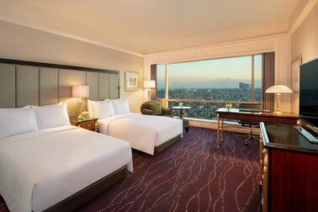
Picture 6. Executive Room
(Anonymous, 2021)

This room has a size of 128m². It has far more facilities such as access to a private room, own dining area, non-alcoholic drinks, high-speed Wi-Fi access, and TV with 60 channels. Priced at IDR 2,340,000 for one night.

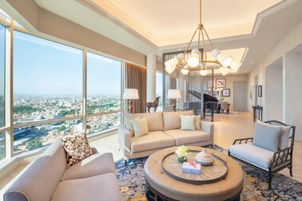
Picture 7. Chairman Suite
(Anonymous, 2021)

This room has a size of 341m2. It has far more facilities such as access to a private room, own dining area, non-alcoholic drinks, high-speed Wifi, television with 60 channels. As well as getting executive access, private check-in and check-out, free drinks in an exclusive mini fridge. Priced at IDR 9,180,000 for one night.

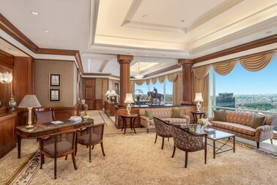
Picture 8. Presidential Suite
(Anonymous, 2021)

This Room has a size of 390m2. Devoted to the visit of the president's country where all access from the rooms above can be enjoyed and get the best view of the hotel.

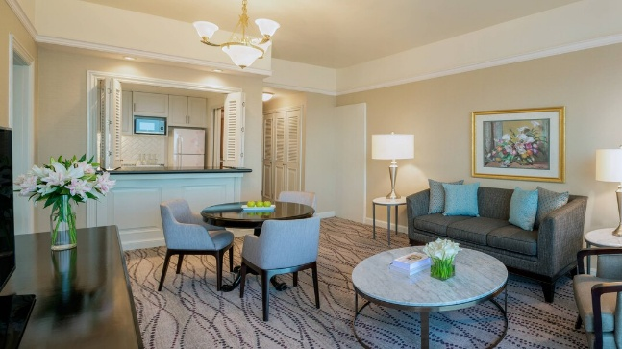
Picture 9. Apartment Room
(Anonymous, 2021)

This room has an apartment size which has a size of 126m², and has several accesses such as a deluxe room and an executive room, a mini kitchen that can be used. And get executive access.

- Marriot Facilities

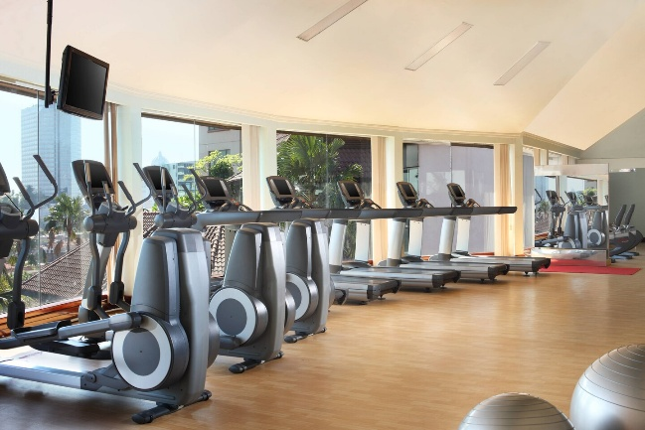
Picture 10. Marriott Fitness
(Anonymous, 2021)

Free entrance for all in-room guest. Sheraton Fitness is also available for the outside guest.
Operational Hours :
- Weekdays 06 : 00 AM to 22 : 00 PM
- Weekends & Public Holidays 06 : 00 AM to 21 : 00 PM

Picture 11. Sheraton Spa
(Anonymous, 2021)

JW Marriott Hotel Surabaya also provides spa facilities that be easily ordered online to create an “appointment”. The serene atmosphere of the room and the friendly greetings of the thet make us comfortable at the beginning. Before the treatment. Treatment can be done in our own room when staying or using one of the existing rooms at the spa location.

- Marriott Dining

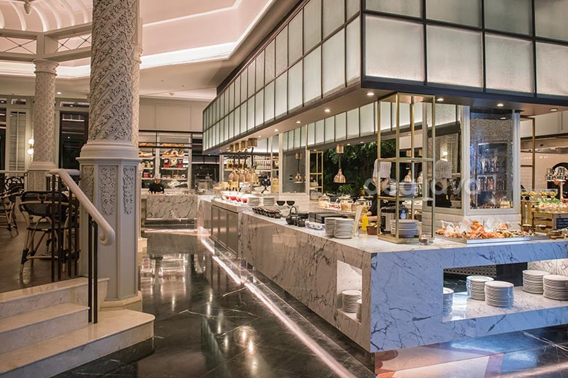
Picture 12. Pavilion Restaurant
(Anonymous, 2021)

Pavilion is both buffet and a la carte dining which offers a wide range variety of foods. We can taste foods from all around the world starting from American, Italian, Japanese, French and many more.

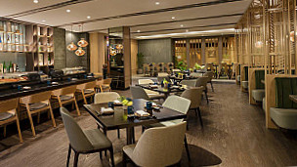

Picture 13. Imari Restaurant
(Anonymous, 2021)

Imari is a Japanese restaurant which features a casually refined ambiance, as well as a sushi bar, teppan-style cooking and fresh grilled seafood and meat.

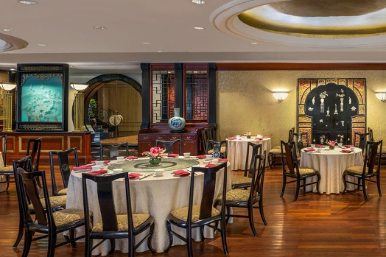

Picture 14. Tang Palace
(Anonymous, 2021)

Tang Palace is a Chinese restaurant which accented by antiques from the legendary Tang Dynasty, a wide variety of Chinese food are served in this restaurant starting from their Cantonese food, dim sums, and many more.

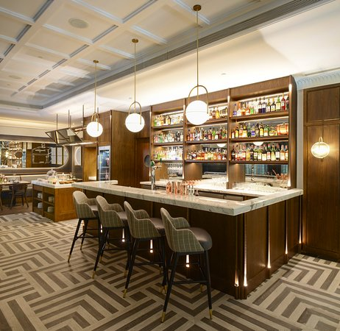
Picture 15. Steakhouse
(Anonymous, 2021)

Tang Palace is a Chinese restaurant which accented by antiques from the legendary Tang Dynasty, a wide variety of Chinese food are served in this restaurant starting from their Cantonese food, dim sums, and many more.

- Marriot Meeting Rooms
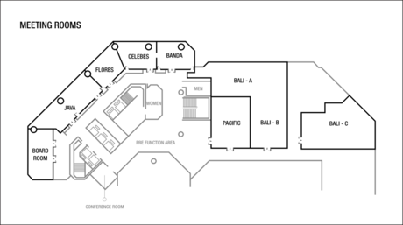

Picture 16. Meeting Room
(Anonymous, 2021)

Our largest indoor space measuring 14 rooms and can caters to 600 guests in different meeting or event. It can be divided into three function rooms for more intimate gatherings.

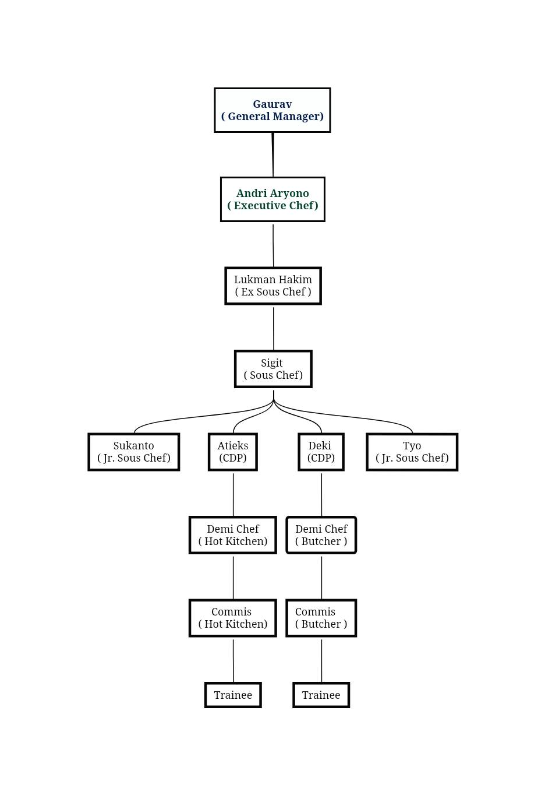
  - Kitchen Organization

Picture 17. Kitchen Organization Structure
(Anonymous, 2021)

  - Feature in Sheraton Surabaya Hotel and Towers

- Executive Chef
- Modifying menus or create new ones that meet quality standards.
- Supervise kitchen staff’s activities
- Estimating food requirements and food / labor costs
- Responsible to the General Manager
- Rectify arising problems or complains
- Perform administrative duties
- Maintain a positive and professional approach with coworkers and customers

- Sous Chef
- Help in the preparation and design of all food and drinks menu
- Ensure that the kitchen operates in a timely way that meets the quality standards
- Fill in for the Executive Chef in planning and directing food preparation when necessary.
- Resourcefully solve any issues that arise and seize control of any problematic situation
- Manage and train kitchen staff, establish working schedule and assess staff’s performance

- Chef de Partie
- Prepare menu in collaboration with colleagues
- Ensure adequacy of supplies at the cooking stations
- Prepare ingredients that should be frequently available
- Follow the guidance of the executive or sous chef and have input in new ways of presentation of dishes
- Enforce strict health and hygiene standard
- Optimizing the cooking process with attention to speed and quality
- Enforce strict health and hygiene standards
- Become a leader who leads and supervise their respective departments

- Demi Chef & Commis
- Support the Chef de Partie or Sous Chef in the daily operation and work
- Work according to the menu specifications by the Chef de Partie
- Keep work area at all times in hygiene conditions according to the rules set by the hotel
- Control food stock and food cost in his section
- Ensure the highest standard and consistent quality in the daily preparation and keep up to date with the new products, recipes and preparation techniques
- Instruct and lead subordinates through their daily requirements in food preparation and actively take part in set up of buffets and special functions

- Cook
- Support Chef de Partie or Demi Chef de Partie in the daily operation and work
- Work according to menu specifications by the Chef de Partie
- Keep work area at all times in hygienic conditions according to the rules set by the hotel
- Control food stock and food cost in your section
- Follow the instructions and recommendations from the immediate Superiors to complete the daily tasks

- Ensure the highest standard and consistent quality in the daily preparation and keep up to date with the new products, recipes and preparation techniques.

  - Hygiene and Sanitation Policy of JW Marriott Hotel Surabaya

As a part of five staff hotel and as a standard, carry the 5 star brand name, JW Marriott Hotel Surabaya and also Pavilion International Restaurant’s kitchen practices international standard of hygiene and sanitation. Standard is an obligation obeyed by everyone inside and outside the kitchen, either interact with customers, superiors, and colleagues, in order to ensure the best service five-star style can be realized.
Before doing the job or after go the toilets hand should be washed, it is mandatory for all staffs and interns. This to make sure contamination bacteria from outside which came in contact with our hands doesn’t transfer to ingredients and foods.

Picture 18. Direction on How to Wash Hands Properly
(Source: The Author’s Collections)
There are rules in cutting board. Cutting boards are also and important aspect, the right cutting board must be used for the right item. For example, white cutting board for ready to eat food, green cutting board for vegetable and fruits, yellow cutting board for poultry products, blue cutting board for seafood products and red cutting board for meat products.
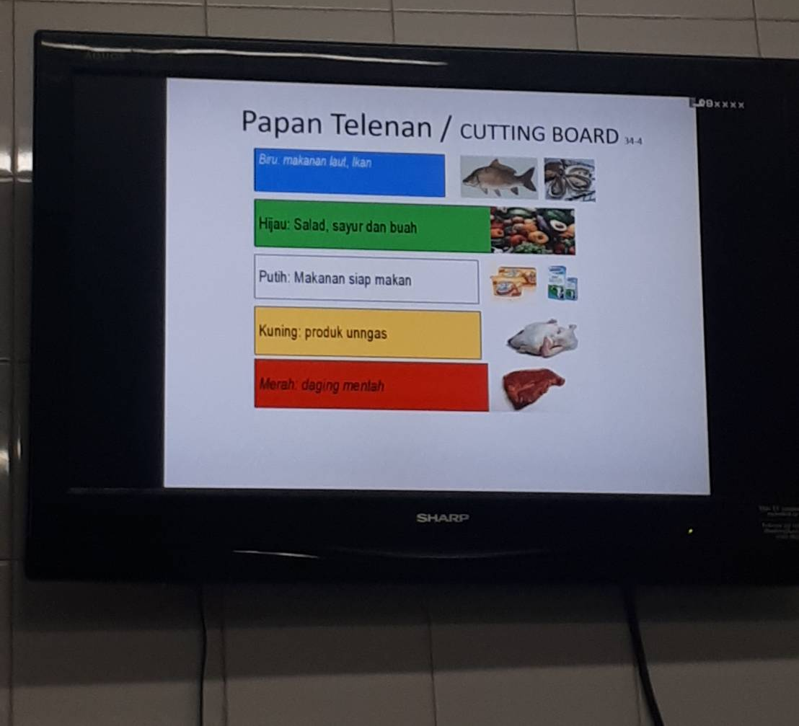
Pict

Picture 19. Standard Coloring Cutting Board
(Source: The Author’s Collections)

This is Standard Operational Procedure (SOP) receipt of goods from suppliers to maintain good quality and condition when received. Frozen food - 18.0 or less. Fresh ingredients 0.5C. All canned food must be in good conditions no dents or leaks.
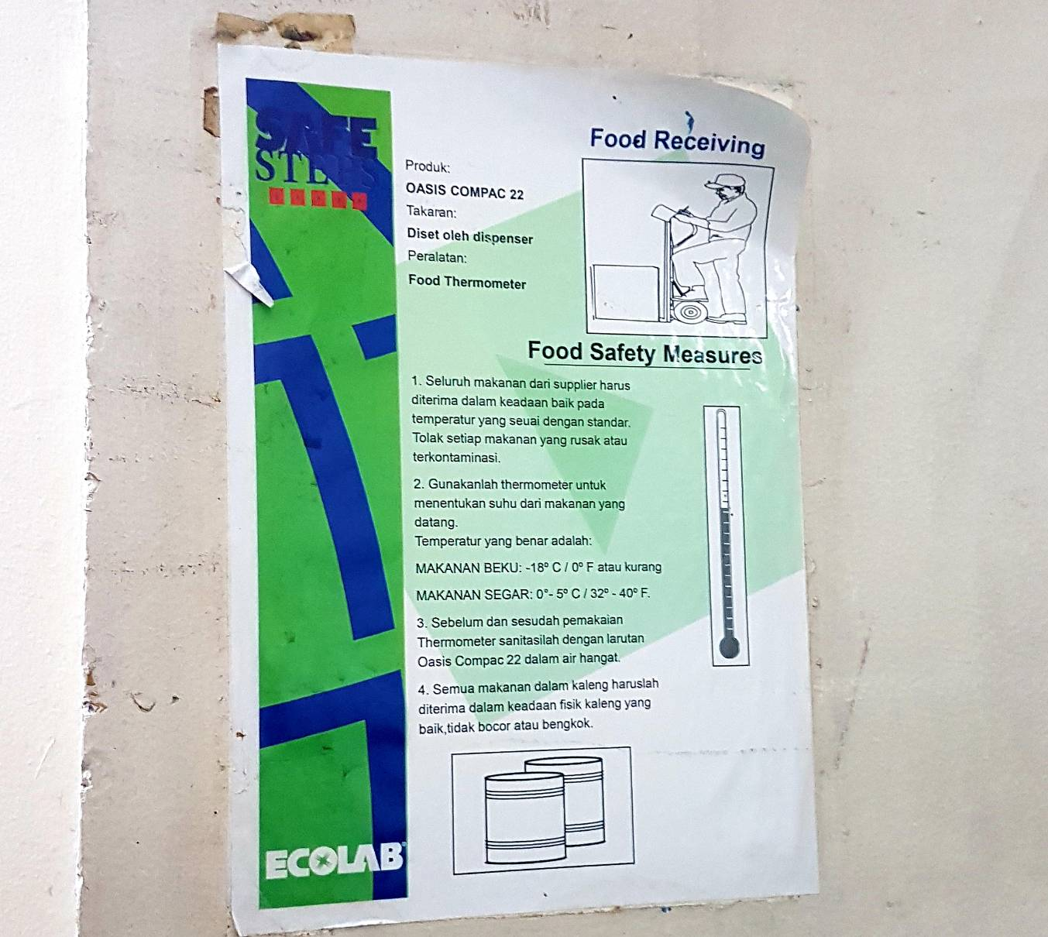

Picture 20. Food Handler’s Guidelines
(Source: The Author’s Collections)

For all staff and interns are required to wear gloves when serving food to guest in the dining area, due to high probability for our hand to touch the food, plate, and serving it to guests. This action is done to prevent further transferring bacteria or contamination from hand to food. Personal grooming is part of hygiene too, such as nail trimming and tidy hair. All staffs and interns with long hairs and/ bangs must be tied up and secure it inside the hat. For the mal staffs and trainee are required to cut hair if it is already long.
Temperature -17.8 C for deep freezer or frozen, 5 C is ideal for chillers, 5 C above below 60 C is the danger zone. Called the danger zone because the development of food microbes can be damaged. 57 C – 100 C is the safe temperature for the storage and processing of foodstuffs.

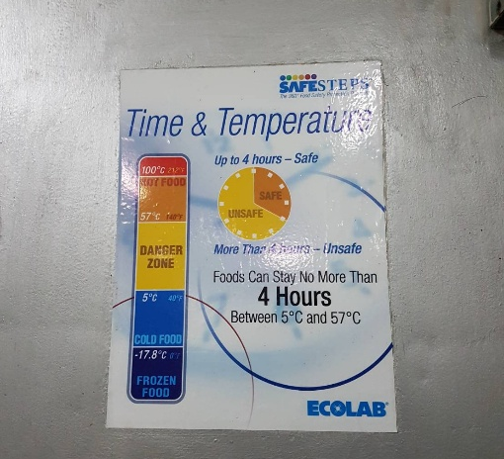

Picture 21. Food Safety Measurements Instruction
(Source: The Author’s Collections)
After every end of buffet operation and set up of the next, all station must be tidied up, cleaned, and sanitized with chemical solution. All ingredients or food that are not used anymore should be disposed or stored properly. All the dirty tools like cutting board, knives, bowls, and spoons must be cleaned and dried properly before using it.
This is standard that indicates the temperature. For example; in white color, the explanation for the temperature of cooking roasted beef must reach a minimum temperature of 55 C should not be less but may be more. The practice should use a thermometer when cooking the puncture the material, if it has reached a standardized temperature means it is safe to consume

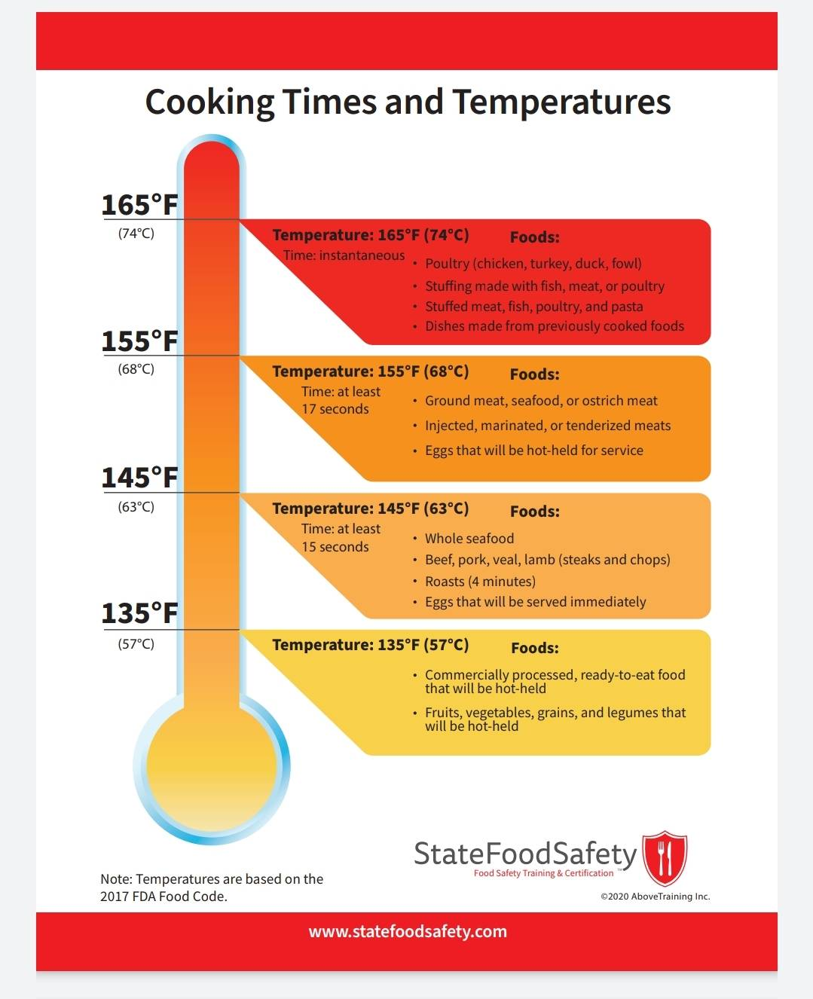

Picture 22. Standard Temperature
(Anonymous, 2021)

If anyone caught any contagious illness they advised to stay home and rest until they feel better. This action is taken to prevent spreading the illness to others and for guest. If they somehow have to go to work despite being sick; for example cough or flu, the advised to wear mouth mask. People with eye infection, will advised to go home, as it can discourage guests about safety and hygiene.

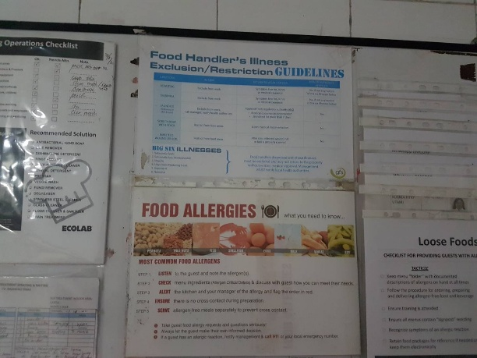

Picture 23. Food Handler’s Illness
(Source: The Author’s Collections)

Tools that require supervision such as cooling machines, ovens, stoves. Every day there will be direct supervision to ensure the use of the tool perfectly, as well as safely, if you find something strange from the operation of the tool, then the engineering will be called to solve the problem, but if the engineering can't solve the problem it will be replaced with a new one. Only with the boss approval.

