JW MARRIOTT HOTEL SURABAYA

INTERNSHIP REPORT

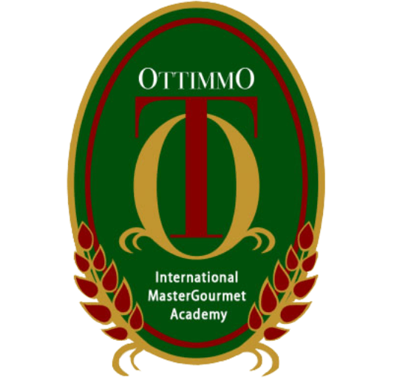

Arranged by:
MOHAMMAD BADRA ANDRA RUM
( 1874130010044 )

STUDY PROGRAM OF CULINARY ART
OTTIMMO INTERNATIONAL MASTER GOURMET ACADEMY
SURABAYA
2021

APPROVAL

Tittle : Internship Report
Company Name : JW Marriot Hotel Surabaya
Address : Jalan Raya Embon Malang No, 85 – 89, Surabaya Tengah, Surabaya
No. Telp./Fax : 0315458888
Which is carried out by Students of Culinary Arts OTTIMMO International MasterGourmet Academy Surabaya

Name : Mohammad Badra Andra RUm
Reg. No : 1874130010044

Has been tested and declared successful.

Approve, Surabaya, July 8th 2021
Advisor Supervisor
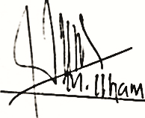

Arya Putra Sudjaja, SE Mohammad Ilham
NIP. 19881018 1701 044 Executive Chef

Knowing,
Director of OTTIMMO Internasional MasterGourmet Academy Surabaya

Zaldy Iskandar, B.Sc
NIP. 19731025 1201 001

INTERNSHIP REPORT
JW MARRIOTT HOTEL SURABAYA

Arranged by :
Mohammad Badra Andra Rum (1874130010044)
Done the internship period from (January 5th, 2021) at
JW Marriott Hotel Surabaya

Approved by :

Advisor, Examiner I, Examiner II,

Latifahtur Rahmah, S.Pd., M.Pd
NIP. 19801017 1703 001
Irra Chrisyanti Dewi, S.Pd. M.S.M
NIP. 19781201 1702 028
Arya Putra Sudjaja, SE
NIP. 19881017 1703 001

Knowing,

Head of Study Program Culinary
art, OTTIMMO International Mastergourmet Academy,

Hilda Tjahjani Iskandar, SE, AK, CA
NIP. 19691029 2002 072

Director of OTTIMMO
Internasional Mastergourmet
Academy,

Zaldy Iskandar, B.Sc
NIP. 19731025 1201 001

ACKNOWLEDGEMENT

Praise and thanks to God Almighty for Almighty for the successful completion of this report. This report is prepared based on industrial training results conducted by the Authors during 6 months in Sheraton Hotel JW Marriott. This report is prepared as one of the requirements to complete the Diploma III of Culinary Arts.
In the process of completion of this report, the Author has received much guidance and assistance from various parties. To that end, the authors express their sincere thanks to:
- Mr Zaldy Iskandar as Director of OTTIMMO Internasional MasterGourmet Academy Surabaya.
- Mr. Arya Putra Sudjaja as Advisor who has guided, provide guidance and suggestions until the completion of this report.
- Mr Dani Suminar Sari who given the place of industrial training implementation.
- Mrs Hilda Tjahjani Iskandar as Head of Culinary Arts Programme.
- Other parties who wish to referred to as parents and colleagues, etc.

Finally, the Authors hope that this report can be useful for us all.

PLAGIARISM STATEMENT

I certify that this assignment/report is my own work, based on my personal study and/or research and that I have acknowledged all material and source used in its preparation, whether they’re books, articles, reports, lecture notes, and any other kind of document, electronic or personal communication. I also certify that this assignment/report has not previously been submitted for assessment in any other unit, except where specific permission has been granted from all unit coordinators involved, or at any other time in this unit, and that I have not copied in part or whole or otherwise plagiarized the work of other students and/or persons.
On this statement, I am ready to bear the risk/ any sanctions imposed to me in accordance with applicable regulations, if in the future there is a breach of scientific ethics, or you have claim against the authenticity of my work.

Surabaya, September 09th 2021

Mohammad Badra Andra Rum

EXECUTIVE SUMMARY
Internship are one of the qualifications to complete the diploma program on Ottimmo International Mastergourmet Academy. The internship program last for 6 months and the author started the internship on the 5th of January 2021 and finished the internship at 5th of July 2021. The author’s internship was at JW Marriott Surabaya.For the past 6 months, the author had gained various kind of knowledge and experiences from the internship at JW Marriott Surabaya. One of the reason why the author had chosen JW Marriott as the place for the internship is because, JW Marriott is one of the best Hotel that can be found in Surabaya. There are various restaurants at JW Marriott Surabaya which are: Pavilion which is the main restaurant, Tang Palace which is the Chinese restaurant, Uppercut which is the fine dining restaurant, and finally Imari which is the Japanese Restaurant. The Pavilion team has given the author many valuable things and lesson which the author is really grateful for all things. The team has always share their experience and knowledge without any hesitation and they are also willing to learn new things from the trainees.This report will be the living proof the author’s experience during the internship program for the past 6 months.
Keywords: JW Marriott Hotel Surabaya, Internship report

TABLE OF CONTENT

APPROVAL ..…....................................................................................... I
ACKNOWLEDGEMENT ...................................................................... III
EXECUTIVE SUMMARY................….................................................. V
TABLE OF CONTENT......................….................................................. VI
LIST OF PICTURES …...........…................................................. VIII
LIST OF TABLE …............…................................................................. IX
CHAPTER I INTRODUCTION …......................................................... 1
  - Background Study ............................................................................. 1
  - The Objectives Study.......................................................................... 2
1.3. The Benefits of Internship…............................................................... 2
CHAPTER II GENERAL DESCRIPTION OF JW MARRIOTT HOTEL SURABAYA...........................................................................…... 3
  - Overview........................................................................................... 3
  - History of JW Marriott Hotel Surabaya............................................... 4
  - Vision and Mission............................................................................ 5
  - Location of JW Marriott Hotel Surabaya…....................................... 6
  - Feature in JW Marriott Hotel Surabaya…......... .............................. 7
  - Kitchen Organization....................................................................... 14
  - Food and Beverage Department Task ............................................. 15
  - Hygiene and Sanitation Policy of JW Marriott Hotel Surabaya.......................................................................................... 16
CHAPTER III INTERNSHIP ACTIVITIES…..................................... 24
  - Place of Assignment …................................................................... 25
  - Activities Performed.......................................................................... 25
  - Job Description ................................................................................ 25

  - Table Activity of Internship.............................................................. 26
  - Problem Faced and How to Solve Them......................................... 27
  - Some Products of All Day Dining Kitchen ....................................... 28
CHAPTER IV CONCLUSION…............................................................ 34
  - Conclusion......................................................................................... 34
  - Suggestion......................................................................................... 35
BIBLIOGRAPHY ................................................................................... 36
APPENDIX….......................................................................................... 39

LIST OF PICTURES

Picture 1. JW Marriott Hotel Surabaya…..................................................... 3
Picture 2. Mariot Surabaya Logo ........................................................... 5
Picture 3. JW Marriott Hotel Surabaya Map .............................................. 6
Picture 4. Premium Deluxe Room……..……............................................... 7
Picture 5. Studio Room................................................................................ 7
Picture 6. Executive Suite............................................................................ 8
Picture 7. Chairman Suite...................................................................... 9
Picture 8. Presidential Suite........................................................................ 9
Picture 9. Apartment Room ....................................................................... 10
Picture 10. Marriott Fitness ...................................................................... 10
Picture 11. Sheraton Spa…......................................................... 11
Picture 12. Pavilion Restaurant.......................................………………. 11
Picture 13. Imari Restaurant...............…….............................................. 12
Picture 14. Tang Palace............................................................................ 12
Picture 15. Steakhouse ............................................................................. 13
Picture 16. Meeting room........................................................................ 13
Picture 17. Kitchen Organization Structure............................................. 14
Picture 18. Direction on How to Wash Hands Properly........................... 18
Picture 19. Standard Coloring Cutting Board......................................... 19
Picture 20. Food Handler’s Guidelines................................................... 20
Picture 21. Food Safety Measurements Instruction ............................... 21
Picture 22. Standard Temperature.......................................................... 22
Picture 23. Food Handler’s Illness......................................................... 23
Picture 24. Breakfast Card................. .................................................... 39
Picture 25. Banquet Event Order............................................................ 39
Picture 26. Banquet Team..................................................................... 40
Picture 27. Butcher Team...................................................................... 40

LIST OF TABLE

Table 1. Table Activity of Internship...................................................... 26
Table 2. Cold Kitchen Menu ..................................................................... 28
Table 3. Soup Menu. ................................................................................. 29
Table 4. Main Course Menu ..................................................................... 30

