APPENDIX

Appendix 1. Karaage Flour Recipe

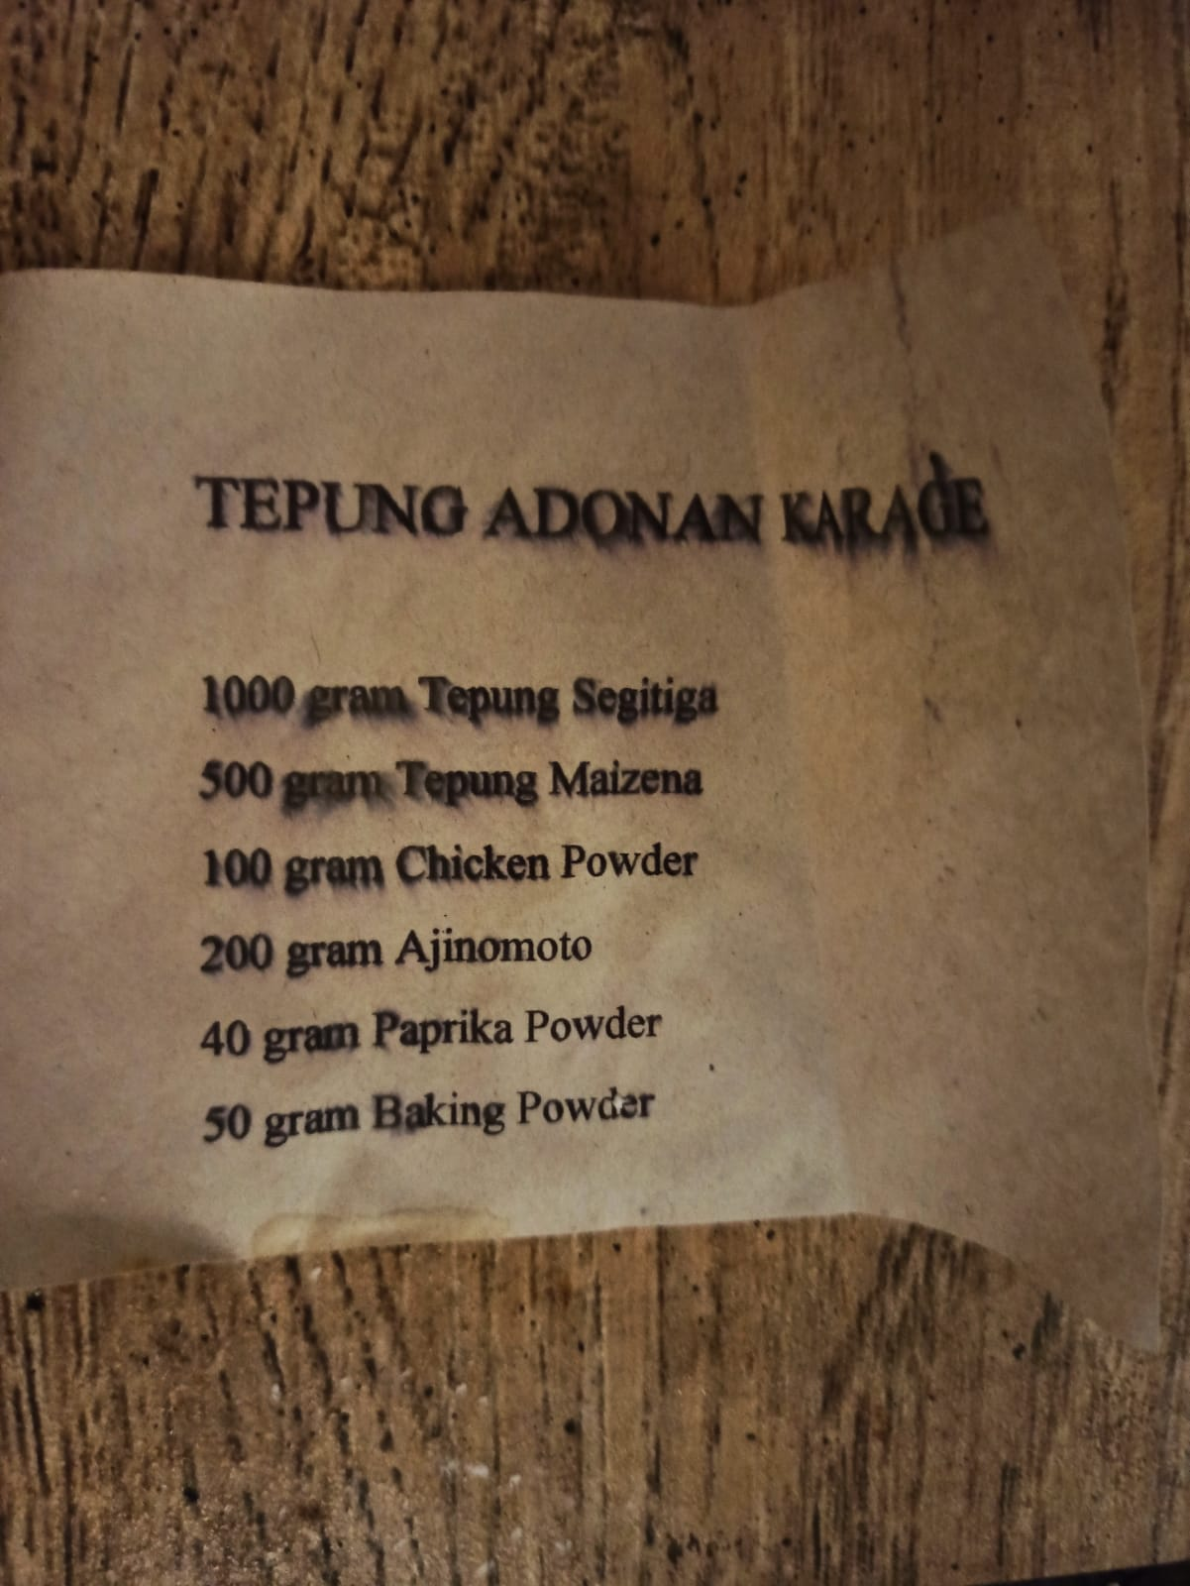

Appendix 2. Mendoan Flour Recipe
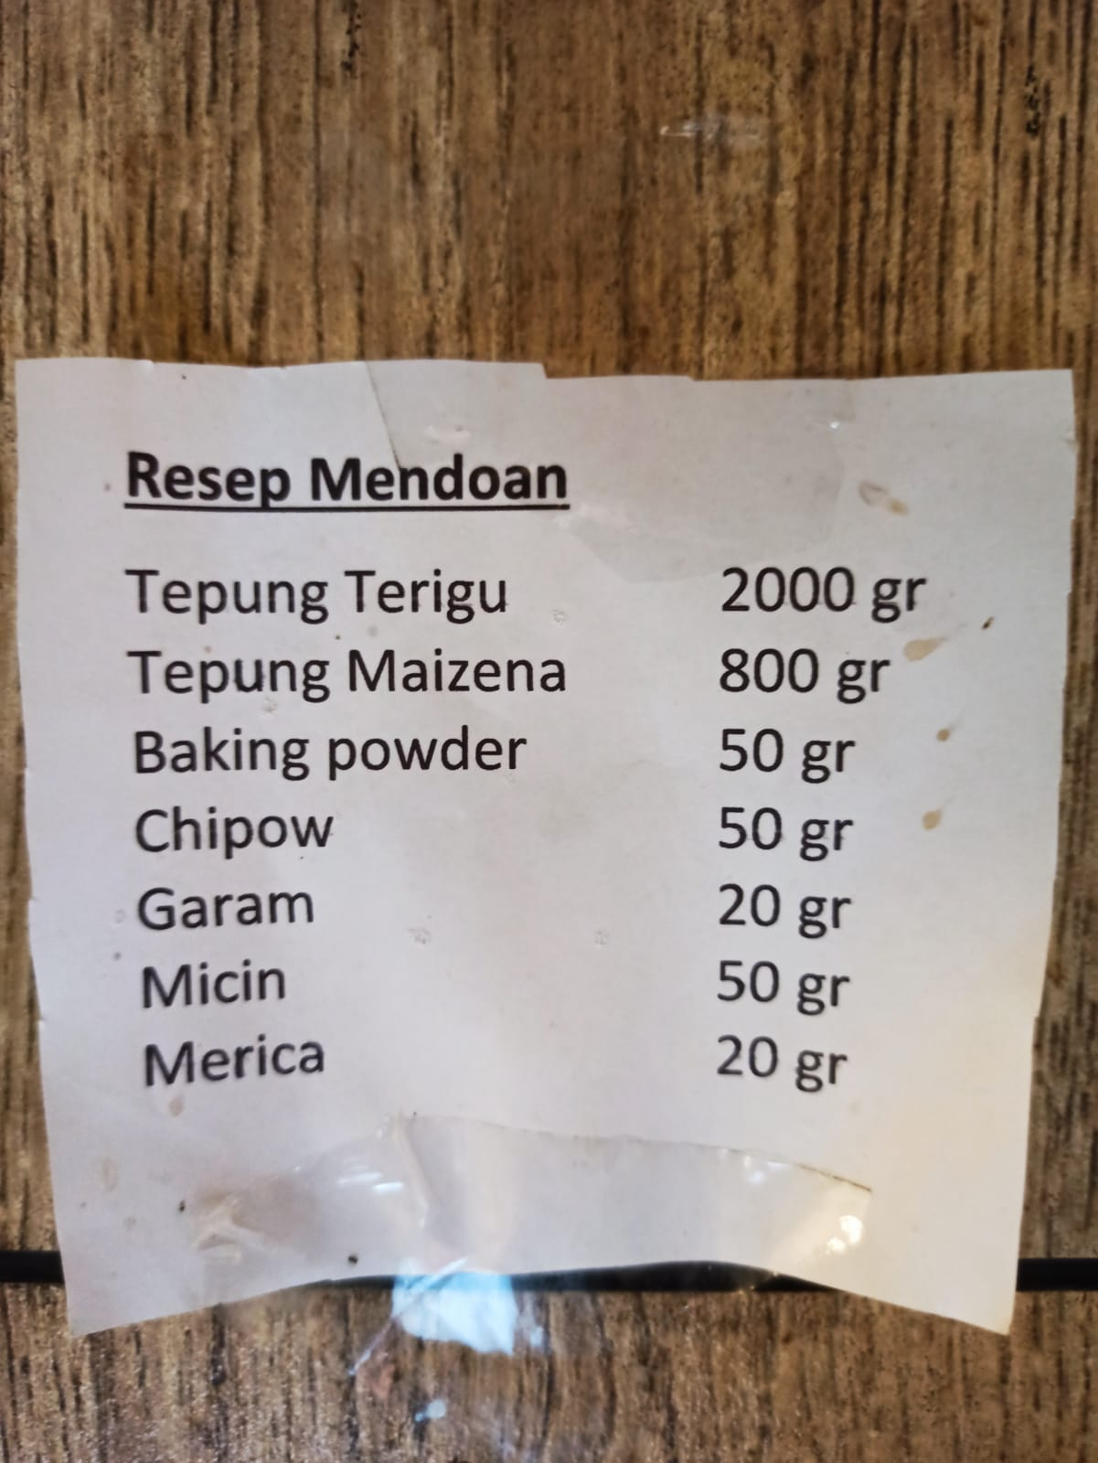

Appendix 3. BBQ Sauce Recipe

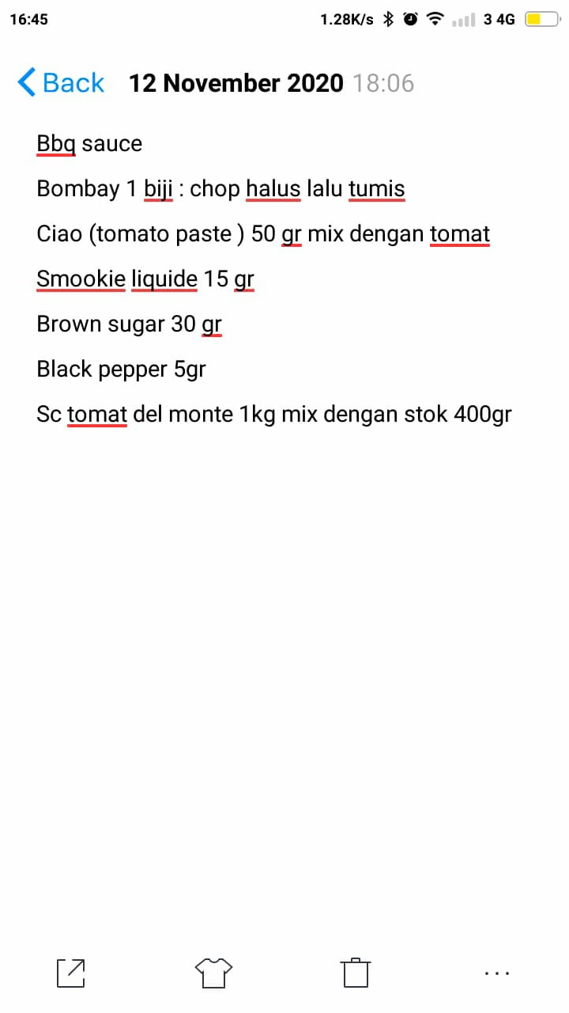

Appendix 4. Kimchi Marinated Recipe

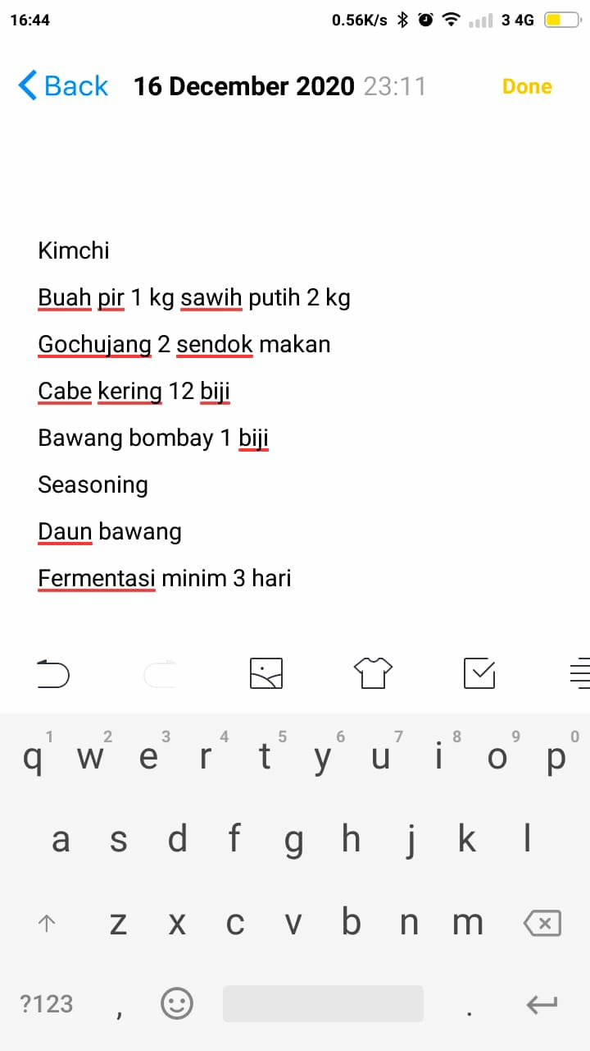

Appendix 5. Latar Ijen Certificate

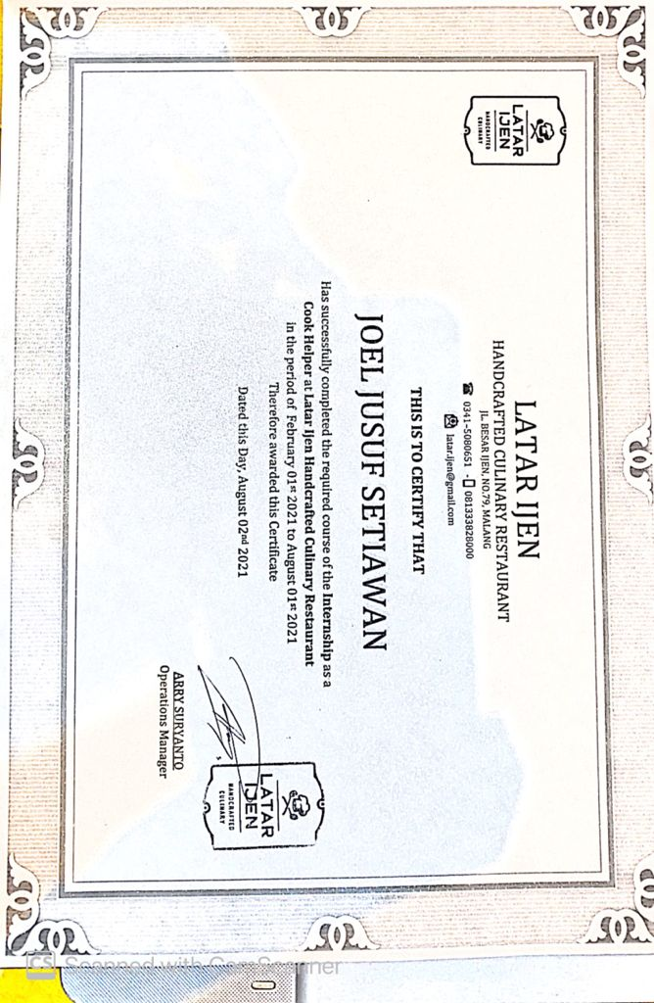

Appendix 6. Internship Appraisal Form

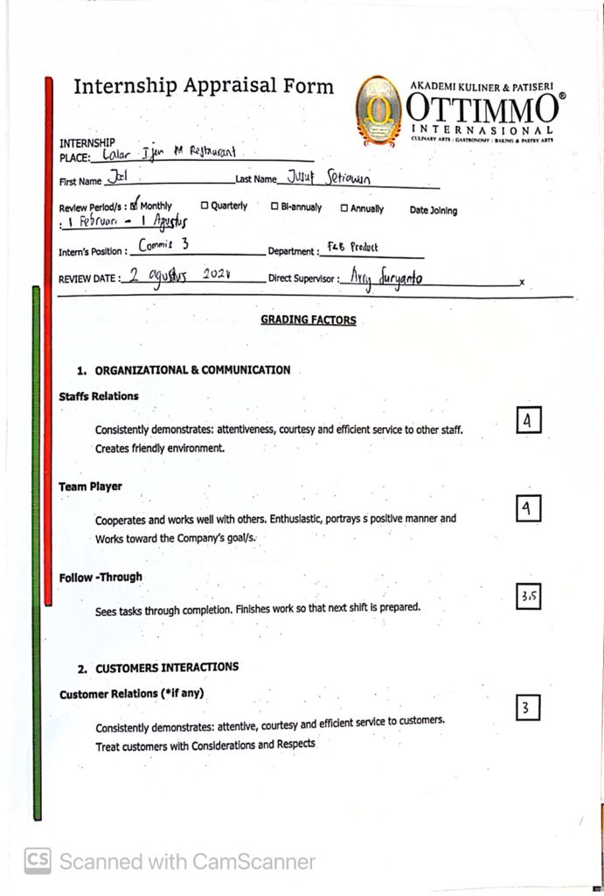

Appendix 7. Internship Appraisal Form
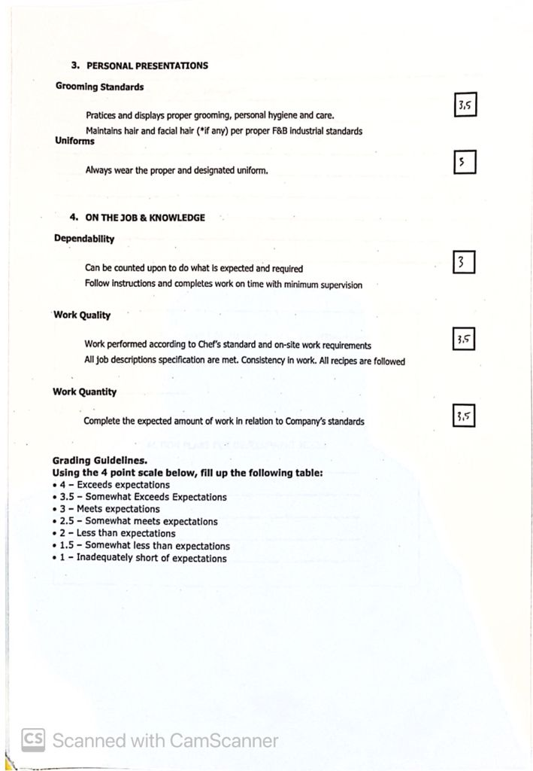

Appendix 8. Internship Appraisal Form

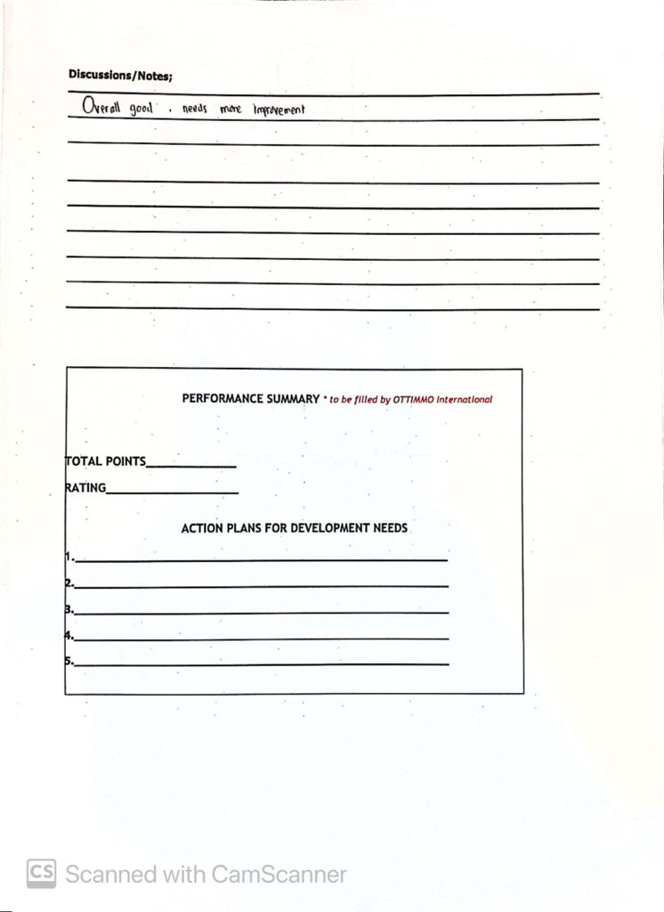

Appendix 9. Internship Appraisal Form

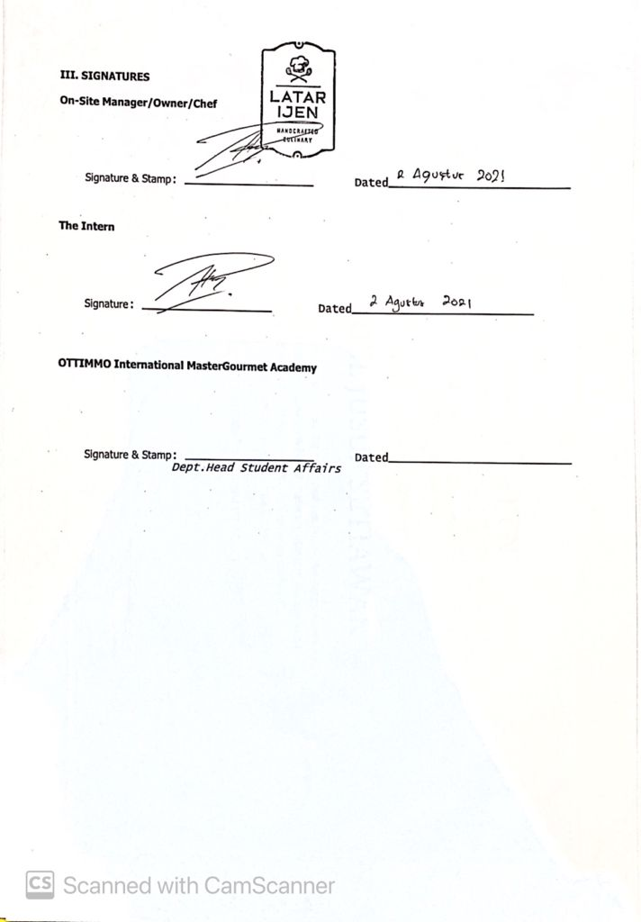

Appendix 10. Approval
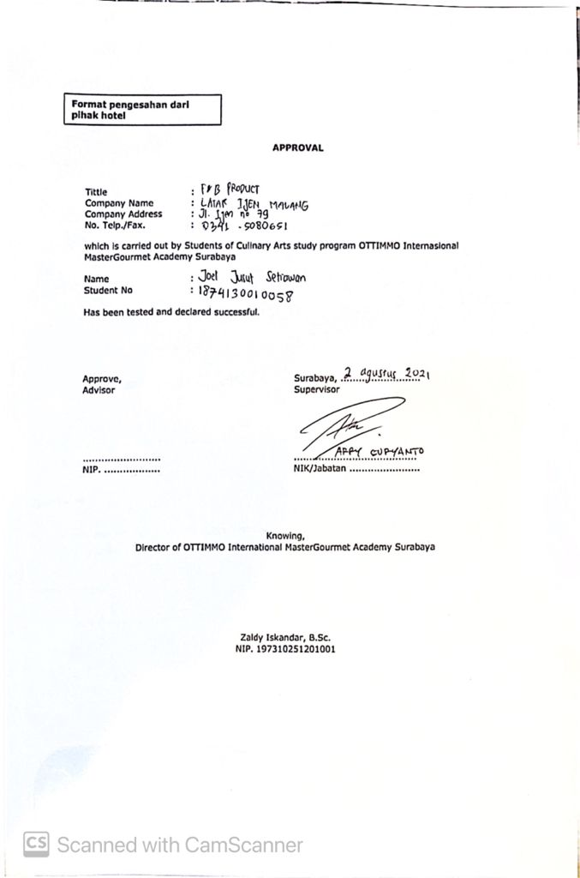

Appendix 11. Secret Garden Latar Ijen

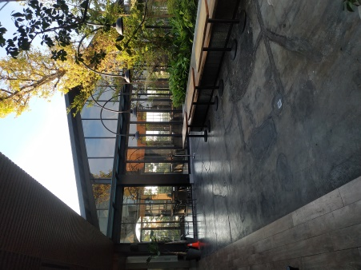

Appendix 12. Latar Ijen Restaurant Interior

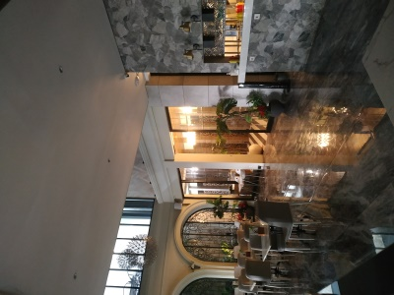

Appendix 13. Latar Ijen Restaurant Interior

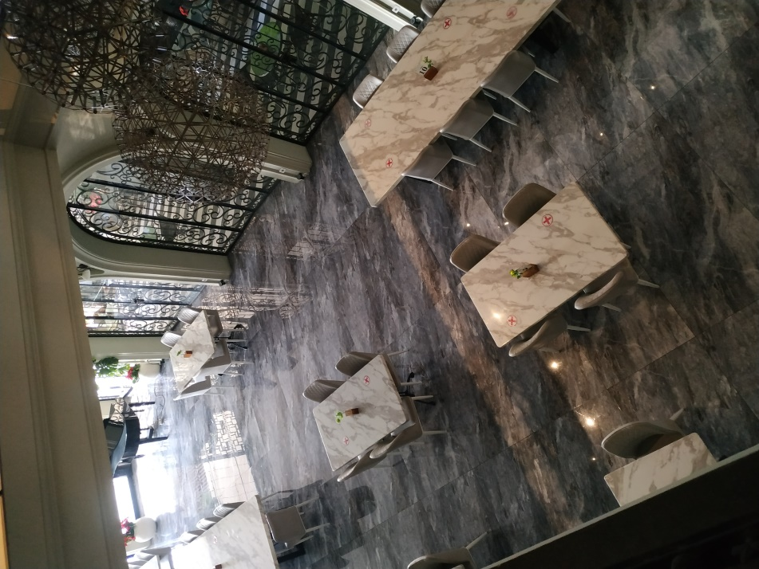

Appendix 14. Layout Kitchen of Latar Ijen Restaurant
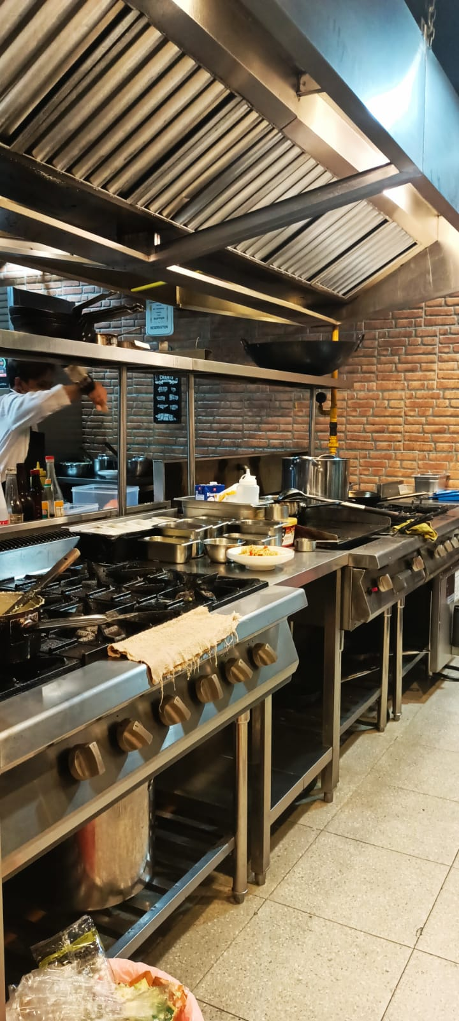

Appendix 15. Layout Kitchen of Latar Ijen Restaurant
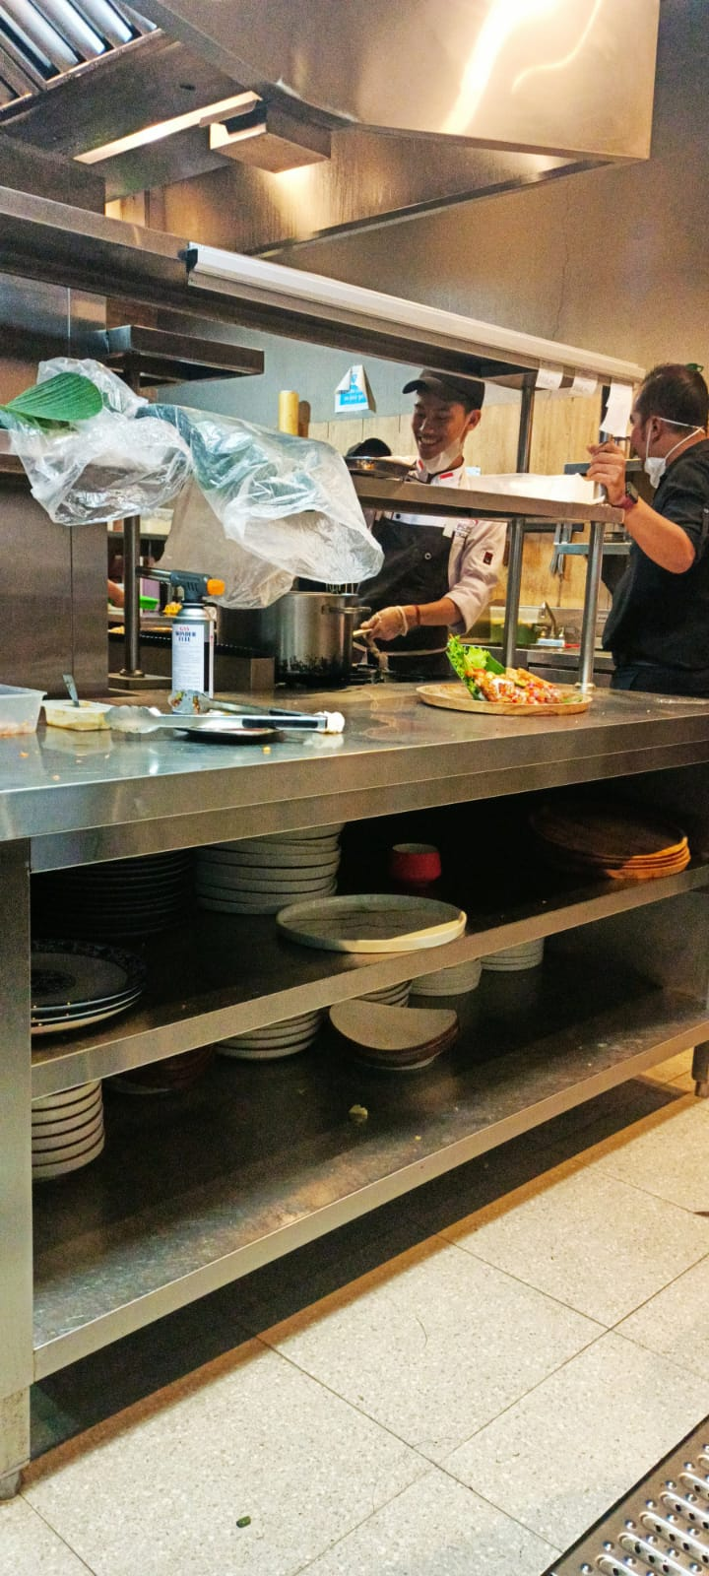

Appendix 16. Layout Kitchen of Latar Ijen Restaurant
