CHAPTER II
GENERAL DESCRIPTION OF COMPANY

  - History of Latar Ijen Restaurant
Latar Ijen was established in December 2019 in Malang. Located in the heritage street of Malang – Jalan Besar Ijen – as a modern Colonial restaurant. The goals is to give the journey of food crafting and best culinary experience in Malang. On the other hand, we hope that Latar Ijen will be the perfect place and to inspire even more.
Latar Ijen provide Nusantara and Western Fusion food with high quality ingredients. We put attention to every little detail of the food we served. Latar Ijen prepared all of the ingredients and processed the food from scratch. That’s the food crafting experience begin. The products made from the qualified local ingredients to a valuable food. Each recipe originally created by our talented Chef and supported by the passionate team.
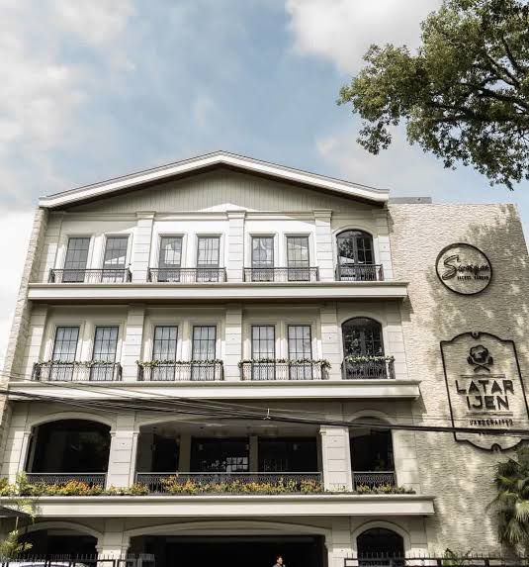
We also keep innovating with the fresh idea for the customer. Besides handcrafted culinary, we also serve signature coffee and beverages in our Secret Garden. The Secret Garden is direct by the Coffee expert Mr Sivaraja. We guarantee the experience you will have here is unforgettable and memorable.
Picture 1. Latar Ijen Restaurant

2.2 Vision of Latar Ijen Restaurant
Become a work unit that is able to increase creativity and innovation and provide the best service.

2.3 Mission of Latar Ijen Restaurant
To provide the best food crafting journey and culinary experience in Malang City and hope that Latar Ijen Restaurant will become the perfect place and inspiring.

2.4 Organization Structure
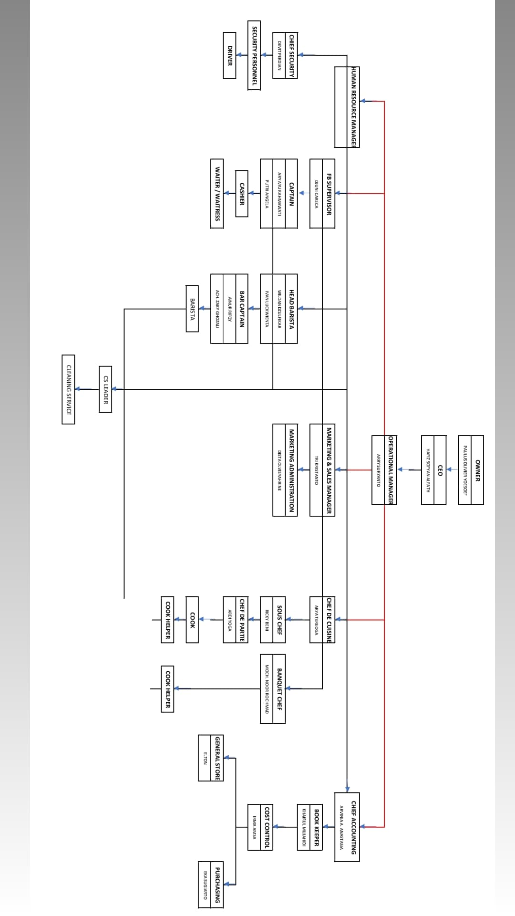
STEWARD
Trainee
Picture 2. Structure Organization of Latar Ijen Restaurant
2.5 Restaurant Location
Latar Ijen Restaurant is located at Jl. Besar Ijen No.79, Oro-oro Dowo, Klojen District, Malang City, East Java 65119. Telephone number 081333828000.

2.6 Description of the Restaurant
Latar Ijen Restaurant is a five-star restaurant that combines luxury and comfort. The following is a list of facilities and services at Latar Ijen Restaurant Malang:
- Hall
Latar Ijen Restaurant has 4 rooms, namely Vishnu, Bima, Shinta and Rama. This place is very suitable to be used as a meeting room, birthdays, wedding or proposal events because it has very adequate equipment. This place can be rented at various prices depending on the number of visitors. This room measures 17m x 8m each room, each room can be filled with 120 people without a table, if you use a table it can be filled with 80 people
- Musholla
For guests who want to worship, Latar Ijen Restaurant provides prayer rooms on the basement floor and on the second floor. This room measures 2.8m x 2.2m, can be used by 4 - 8 people to worship.
- Elevator
For guests, there is no need to worry because the restaurant provides an lift to make it easier for visitors. This room measures 1.75m x 1.75m, this elevator can be used by 4 - 8 people.
- Vehicle Parking
For visitors who bring their own vehicles, they don't need to worry about the safety of their vehicles. The vehicle parking area of ​​Latar Ijen Restaurant is located in the basement area and is guarded by a trained and trusted security team. This room measures 38m x 24m, the parking lot can be filled with approximately 25 - 40 2-wheeled or 4-wheeled vehicles.

2.7 Hygiene & Sanitation Standard
Every day, staff and trainees must wear safety shoes and must wear hats. At the time of the service every staff and trainee are required to use a chef jacket and apron after use must be washed or put in the laundry.
Then after we finished preparing the equipment and closed the restaurant, the staff and trainees were asked to clean individual parts, such as brooms and mops. This restaurant has a steward to clean every tools that we have used.
After the Covid-19 pandemic, staff and trainees were given masks and gloves before working in the kitchen, and hand sanitizer was provided for guests who came to the restaurant. General cleaning at Latar Ijen restaurant is held once a month.

2.8 Department
- Executive Chef
Executive Chefs sit at the top of the kitchen hierarchy, their role is primarily managerial. Executive chefs tend to manage the kitchen across multiple outlets and are usually not directly responsible for cooking.
- Chef De’Cuisine
The Head Chef will typically focus on managerial duties relating to the whole kitchen. For example, they supervise and manage staff, control costs and make purchases, and liaise with the restaurant manager and suppliers to create new menus.
- Sous Chef
The sous chef shares a lot of the same responsibilities as the head chef, however they are much more involved in the day-to-day operations in the kitchen. The sous chef also fills in for the head chef when they are not present.
- Chef De Partie
This role is a vital part of the brigade system, but it’s split into many different roles. There is more than one chef de partie and each one is responsible for a different section of the kitchen. This makes kitchen operations much more productive and helps to coordinate large quantities of meals at busy times.
- Commis Chef
The commis chef works under the chef de partie to learn the ins and outs of a specific station. The junior chef has usually recently completed, or is still partaking in, formal training.
- Dishwasher
This person is responsible for washing anything that was used in the food preparation and cooking process.
- Waiter
Waiters and waitresses work at the front of house and are customer-facing. They serve customers their dishes and anything else they order. If a customer has a problem with their food, it is the role of the waiter or waitress to report this to the kitchen.

