INTERNSHIP FINAL REPORT
CULINARY KITCHEN AT LATAR IJEN RESTAURANT

By: Joel Jusuf Setiawan
NIM. 1874130010058

AKADEMI KULINER DAN PATISERI OTTIMMO INTERNASIONAL SURABAYA PROGRAM STUDI SENI KULINER
2021
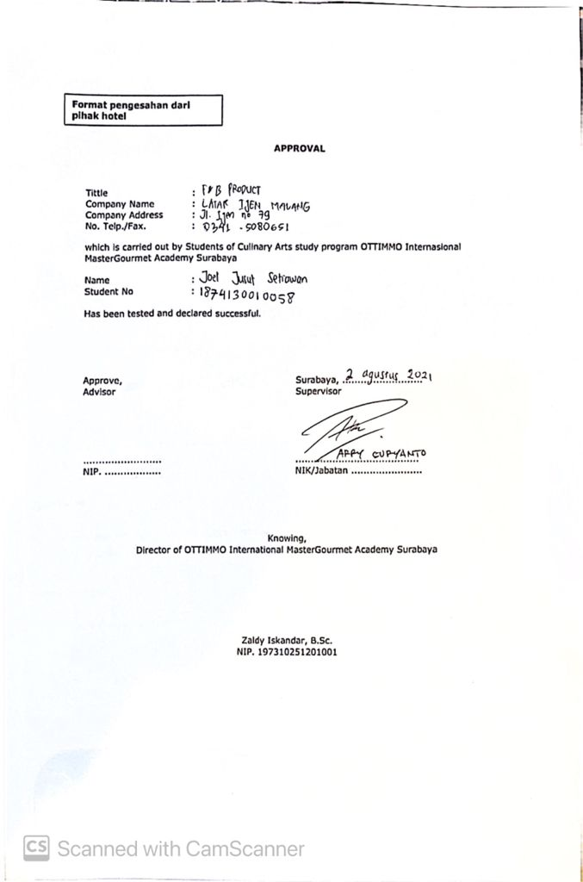

INTERNSHIP REPORTS
CULINARY KITCHEN AT LATAR IJEN RESTAURANT MALANG

Arranged by:
Joel Jusuf Setiawan (1874130010058)
Done the internship period from ( February 1st – August 1st ) at Latar Ijen Restaurant

Approved by:

Supervisor, Examiner I, Examiner II,

Arya Putra Sudjaja, SE Nurul Azizah Choiriyah, S.TP.,M.sc Michael Valent, A.Md. Par

NIP. 198010171703001 NIP. 199002152002071 NIP. 199502192001074

Knowing
Director of OTTIMMO Head of Study Program Culinary
International Mastergourmet Academy, art, OTTIMMO International
Mastergourmet Academy,

Zaldy Iskandar, B.SC. Hilda Tjahjani Iskandar, SE, Ak, CA, MM
NIP. 197310251201001 NIP. 196910292002072
ACKNOWLEDGEMENT

Praise and thanks to God Almighty for the successful completion of this report. This report is prepared based on Internship results conducted by the Authors during 6 months in Latar Ijen Restaurant. This report is prepared as one of the requirements to complete the Diploma III of Culinary Arts. In the process of completion of this report, the Author has received much guidance and assistance from various parties. To that end, the authors express their sincere thanks to:
- Mr. Zaldy Iskandar as Director of Akademi Kuliner dan Patiseri OTTIMMO Internasional Surabaya.
- Mr. Robbie Jie as Head of the Culinary Arts Studies Program.
- Mr. Kukuh Setyawan who has given the place of Internship implementation.
- Mr. Arya Putra as Advisor who has guided, provide guidance and suggestions until the completion of this report.
- Mr. Arry Suryanto as HRD of Latar Ijen Malang Restaurant.
- Ms. Irma as Training Manager of Latar Ijen Malang Restaurant.
- Mr. Arya Tereoga as Head Chef of Latar Ijen Malang Restaurant.
- The entire staff, casual, and trainee of Latar Ijen Malang Restaurant
- My beloved parents for helping me and giving the support until the completion of this report.
Finally, the Authors hope that this report can be useful for us all.

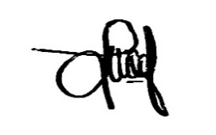
Malang, 27 September 2021

Joel Jusuf Setiawan
PLAGIARISM STATEMENT

I certify that this assignment/report is my own work, based on my personal study or research that I have acknowledged all material and sources used in its preparations, whether they be books, articles, reports, lecture notes and any other of documents, electronics or personal communication. I also certify that this assignment has not previously submitted for assessment in any other unit, except where specific permission has been granted from all unit coordinators involved or at any other time in this unit and that I have not copied in part or whole or otherwise plagiarized the work of other student and/or person.

On this statement, I am ready to bear the risk/any sanctions imposed to me in
accordance with applicable regulations, if in the future there is a breach of scientific
ethics, or you have a claim against the authenticity of my work.

Malang, 27 September 2021
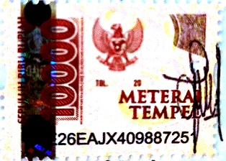

Joel Jusuf Setiawan
TABLE OF CONTENTS

Tittle i
Approval ii
Internship Report iii
Acknowledgment iv
Plagiarsm Statement v
Table of Contents vi
List of Picture viii
List of Table ix
CHAPTER I INTRODUCTION 1
  - Background 1
  - Objectives 1
  - Significance 2
CHAPTER II GENERAL DESCRIPTION OF COMPANY 3
2.1 History of Latar Ijen Restaurant 3
2.2 Vision of Latar Ijen Restaurant 4
2.3 Mission of Latar Ijen Restaurant 4
2.4 Organization Structure 5
2.5 Restaurant Location 6
2.6 Description of the Restaurant 6
2.7 Hygiene and Sanitation Standard 7
2.8 Departement 7
CHAPTER III INTERNSHIP ACTIVITIES 9
3.1 Place of Assignment 9
3.2 Activities Performed 9
3.3 Job Description 10
3.4 Product of Internship 11
3.5 Problem Faced and How to Solve Them 12
CHAPTER IV CONCLUSION 14
4.1 Conclusion 14
4.2 Suggestion 15
BIBLIOGRAPHY 17
APPENDIX 18

LIST OF PICTURE

Picture 1. Latar Ijen Restaurant 3
Picture 2. Structure Organization of Latar Ijen Restaurant 5
Picture 3. Jerk Chicken 11
Picture 4. Salmon Picatta 12

LIST OF TABLE

Table 1. Activities Performed and Job Description 10

