CHAPTER II
INGREDIENTS AND UTENSILS OVERVIEW

2.1 Description of The Materials to be Used

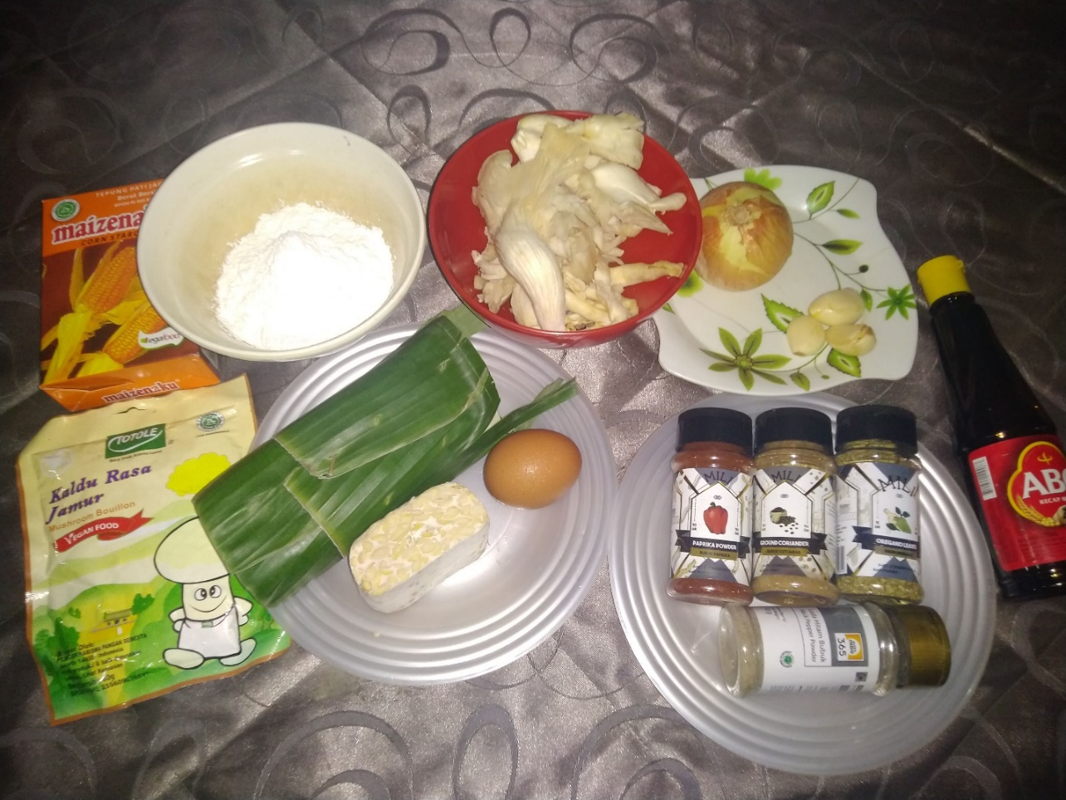
Picture 1. Ingredients of MushBean

The author used these ingredients to make MushBean:
- Oyster Mushroom (you can use other type of mushroom), used as one of the main ingredients of MushBean.
- Soybean Cake, used as on of the main ingredients of MushBean.
- Garlic (Chopped), used to enhance flavor.
- Onion (Chopped), used to add sweet flavor.
- Egg, used as thickening agent.
- Cornstarch, used as thickening agent.
- Powdered Mushroom Broth (Totole*), used to enhance flavor.
- Sweet Soy Sauce, used to add sweet flavor and brown color.
- Salt, used to balancing the sweetness of the product.
- Black Pepper powder, used to enhance flavor.
- Bell pepper powder, used to enhance flavor.
- Oregano Powder, used to enhance flavor.
- Coriander Powder, used to add flavor.
- Sesame Oil, used to enhance flavor.
- Cheddar Cheese, used as supplementary material, to enhance flavor.
- Breadcrumbs., used as supplementary material for texture.
- Salted Butter (you can use oil), used for pan frying the product

2.2 The Tools Used During the Processing

The author used these tools to make Mushbean:
- Stove
- Pan
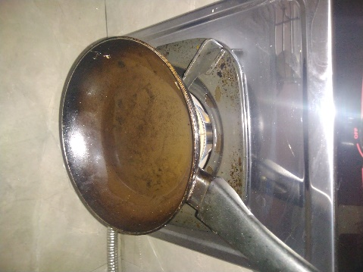
Picture 2. Stove and Pan
- Pestel and Mortar
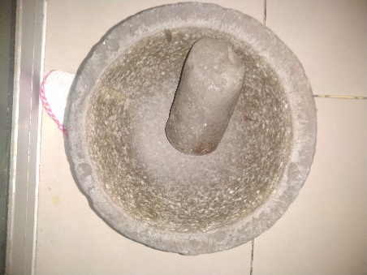
Picture 3. Pestel and mortar
- Pot
- Ring Cutter
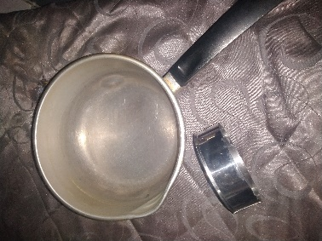
Picture 4. Pot and Ring Cutter
- Spoon
- Knife
- Bowl
- Cutting Board
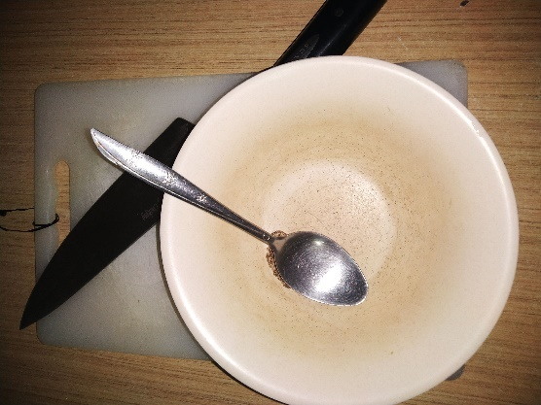
Picture 5. Knife, Cutting board, Spoon and Bowl
- Scales
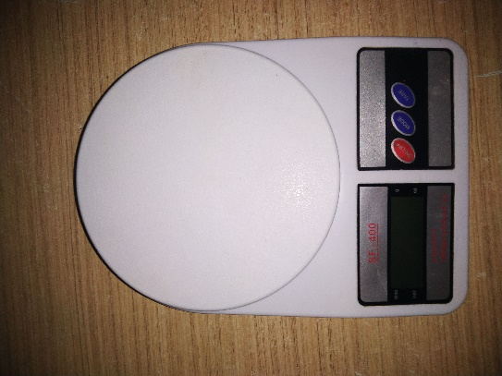
Picture 6. Scales
- Refrigerator
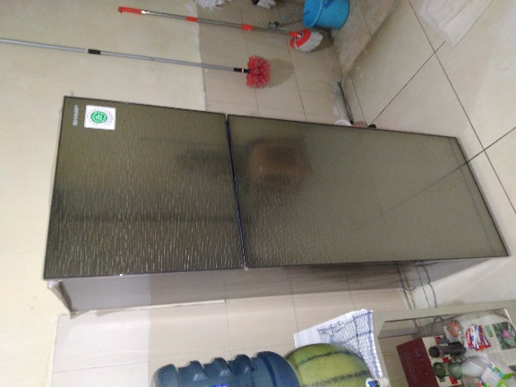
Picture 7. Refrigerator
- Plastic Container
- Aluminum Foil
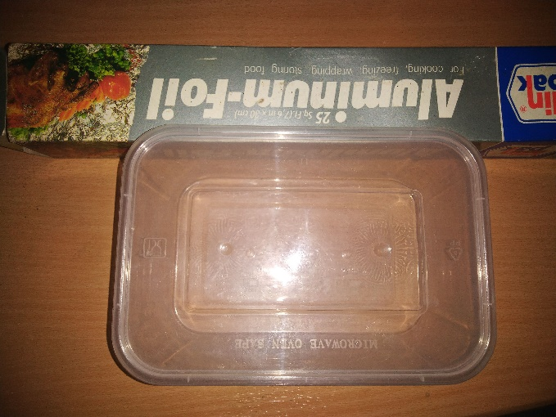
Picture 8. Plastic Container and Aluminum Foil
- Sticker Label
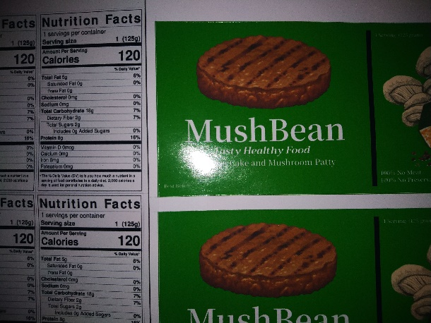
Picture 9. Sticker Label

