APPENDIX

A. DESIGN PACKAGING

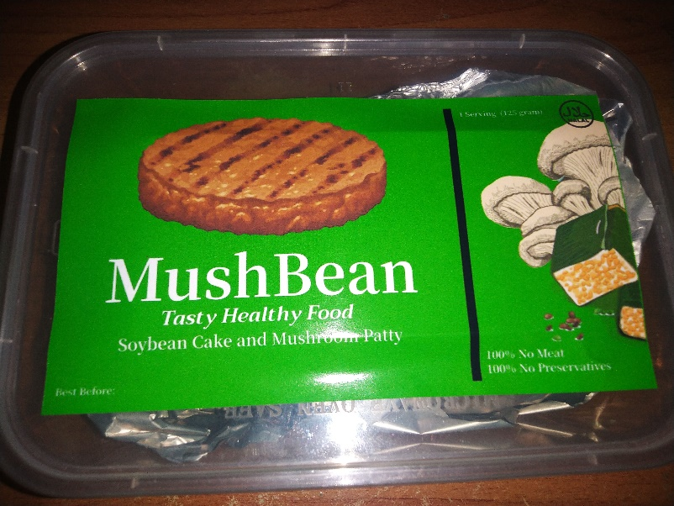
Picture 27. Design Packaging
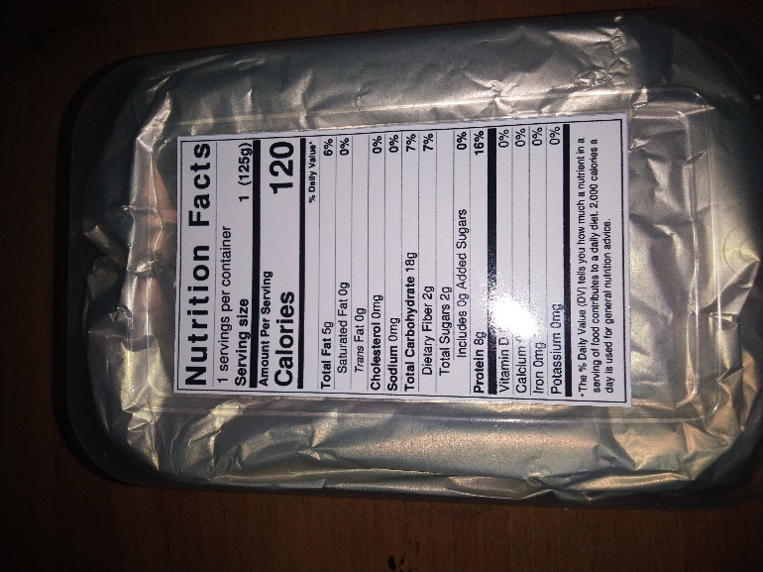

Picture 28. Design packaging

B. SUPPLIER LIST

1. Soybean Cake
Soybean Cake that we use is from Pasar Modern Citra Land, located at Jl. Taman Puspa Raya, Made, Sambikerep, Surabaya, East Java 60217.
2. Oyster Mushroom
Oyster Mushroom that we use is from Pasar Modern Citra Land, located at Jl. Taman Puspa Raya, Made, Sambikerep, Surabaya, East Java 60217.
3. Garlic
Garlic that we use is from Pasar Modern Citra Land, located at Jl. Taman Puspa Raya, Made, Sambikerep, Surabaya, East Java 60217.
4. Onion
Onion that we use is from Pasar Modern Citra Land, located at Jl. Taman Puspa Raya, Made, Sambikerep, Surabaya, East Java 60217.
5. Egg
Egg that we use is from Pasar Modern Citra Land, located at Jl. Taman Puspa Raya, Made, Sambikerep, Surabaya, East Java 60217.
6. Powdered Mushroom Broth (Totole)
Powdered Mushroom broth that we bought from PT. IKPS
http://www.ikps.co.id/
7. Cornstarch
Cornstarch that we bought from PT. Egafood
https://egafood.co.id/en/home-en/
8. Black Pepper Powder
Black Pepper Powder that we bought from Saffron Jaya Surabaya
https://www.tokopedia.com/saffrons-jaya-bersama
9. Bell Pepper Powder
Bell Powder that we bought from Saffron Jaya Surabaya
https://www.tokopedia.com/saffrons-jaya-bersama
10. Oregano Powder
Oregano Powder that we bought from Saffron Jaya Surabaya
https://www.tokopedia.com/saffrons-jaya-bersama

11. Grounded Coriander
Grounded Coriander that we bought from Saffron Jaya Surabaya
https://www.tokopedia.com/saffrons-jaya-bersama
12. Cheddar Cheese
Cheddar Cheese that we bought from PT Kraft Ultrajaya Indonesia
https://www.ultrajaya.co.id/ultrajaya-at-a-glance/associated-entities/ind
13. Breadcrumbs
Breadcrumbs that we bought from PT. MamaSuka
https://www.mamasuka.com/
14. Oil
Oil that we bought from PT. PUTRA MAS DUA SAUDARA
https://www.indotrading.com/putramasduasaudara/minyak-goreng-tropical-p518839.aspx
15. Sesame Oil
Sesame Oil that we bought from PT. Lee Kum Kee Indonesia
https://id.lkk.com/id-id/products/sesame-oil
16. Sweet Soy Sauce
Sweet Soy Sauce that we bought from PT. ABC President Indonesia
https://abcpresident.com/
17. Plastic Container
Plastic Container that we bought from Total Makmur Plastik Shop located at LTC-Glodok, Jl. Hayam Wuruk No.127, RT.1/RW.6, Mangga Besar, Kec. Taman Sari, Kota Jakarta Barat, Daerah Khusus Ibukota Jakarta 11180.
18. Aluminum Foil
Aluminum Foil that we bought from PT. Godrej Indonesia
https://www.godrejindonesia.com/brands/klinpak

C. LOGO PICTURES, PRODUCT (BEFORE AND AFTER PACKAGING)

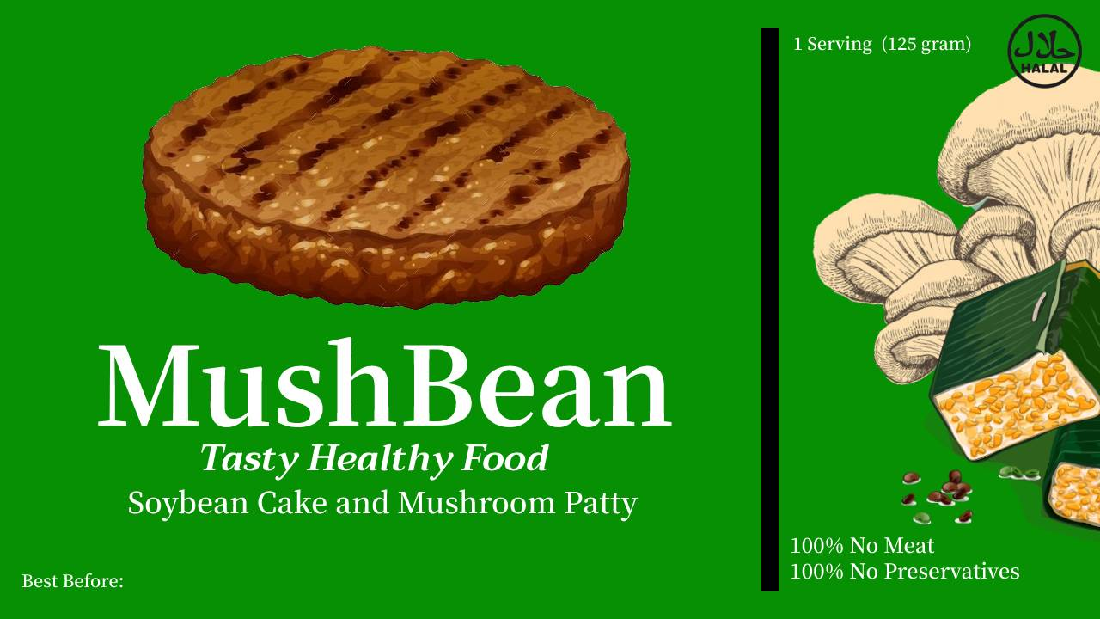
Picture 29. Logo Picture
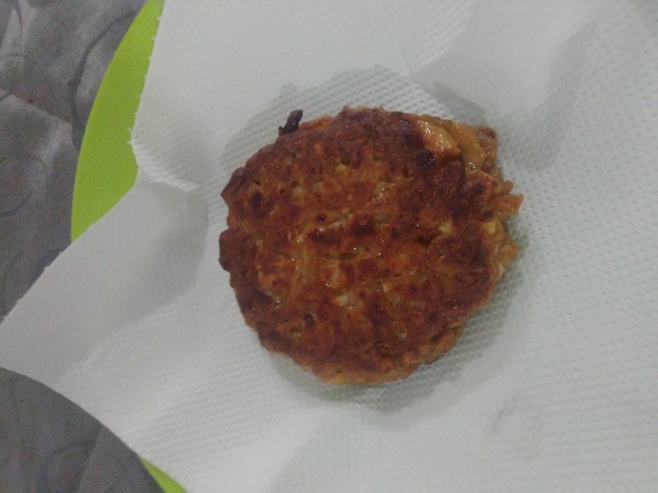
Picture 30. Product before packaging
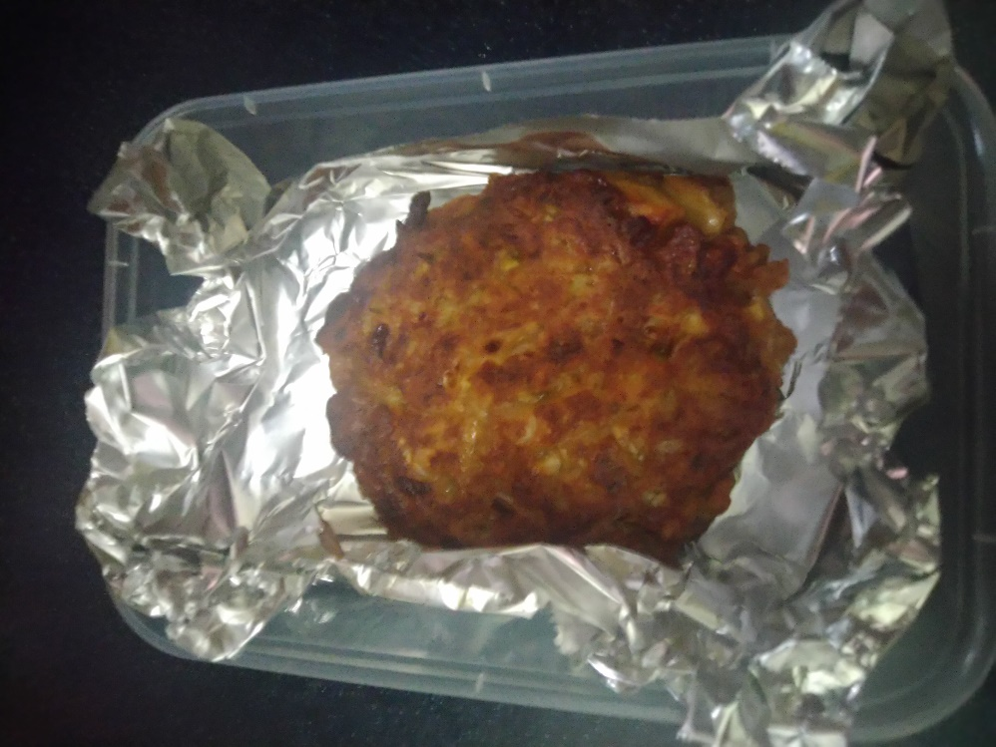
Picture 31. Product before packaging

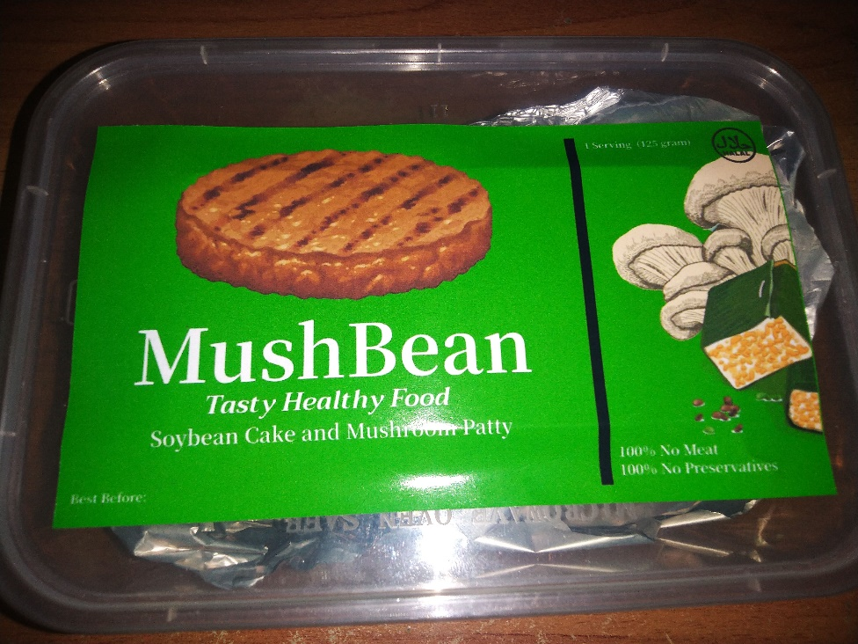
Picture 32. Product after packaging

