CHAPTER II
GENERAL DESCRIPTION OF W BALI - SEMINYAK
- History of W Bali - Seminyak
W Hotels is one of the hotel properties owned by Starwood Hotels and The Resorts are parallel to St. Regis and Luxury Collection as a brand
premium or luxury class. However, in 2016, Starwood has joined
with Marriot making it the largest hotel and resort group in the world.
Here is the early history of Starwood and W Hotels until finally joining
with Marriot.

STARWOOD
- Starwood Group was formed in 1991
- Starwood bought his first property in 1993
- In 1998 it acquired "Westin" and "ITT Sheraton"
- The "Westin" and "Sheraton" brands were formed in 1930 and 1937
- In 1998, Starwood inaugurated the "St. Regis ”His first hotel
- In the same year, 1998, Starwood inaugurated "W Hotels"
- In 2000, Starwood launched the "Four Points by Sheraton" brand
- On 2005, Starwood re-acquires "Le Meridien Hotels"
- 2006, Starwood introduces two of the latest "Aloft" hotel brands and "Element"
- In March 2015, Starwood re-released the 10th brand "Tribute Portfolio "
- October 2015, Starwood cooperates with "Design Hotels" and release it as a 11th brand.

- Barry Sternlicht is chairman and chief executive officer of Starwood (Marriot Group 2020)
MARRIOT + STARWOOD
In 2016, Starwood officially joined Marriott Group and publicly introduced as "Marriott + Starwood"
W HOTELS
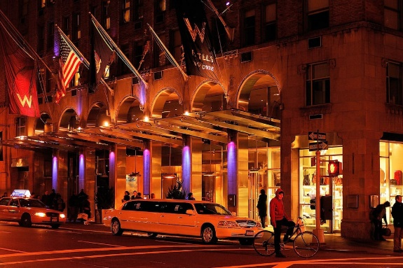
In 1998, W Hotel was first open in New York, and the building was the result of a renovation of the Doral Inn hotel in Manhattan. Some of the first W hotels are mostly building renovations from property which is already owned by Starwood (the group that houses W Hotels). W Hotel then increased the number of properties rapidly within 10 years at some parts in America

- The First W Hotel in New York
(W Manhattan 2020)
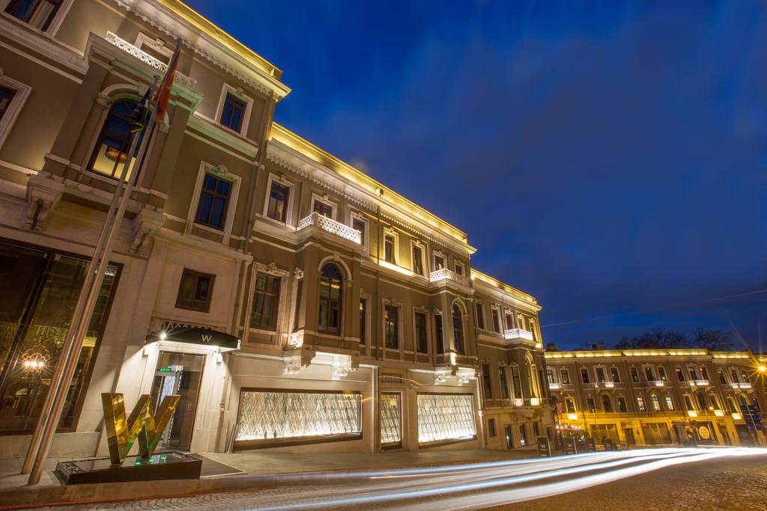
W Hotel opened its first hotel on the European continent, precisely in Istanbul in May 2008. Whereas W Barcelona is the first W hotel in West Europe and officially opened in October 2009. W Barcelona featuring a futuristic interior designed by architect Ricardo Bofill. When this, W Doha Hotels and Residences is one and only property belongs to W which located in the Middle East and North Africa, there are several properties which is currently being developed in Dubai and India.After experiencing success in England.

- The first W Hotel in Europe
(W hotel Istanbul 2009)

W SEMINYAK BALI
W Bali Seminyak has an area of ​​7.8 hectares and has a "modern" concept village” which is dominated by gravel, wood and stone elements. W Bali Seminyak has outdoor swimming pool with an area of ​​1,790 m
which is inspired by rice fields (terracing) Balinese style.

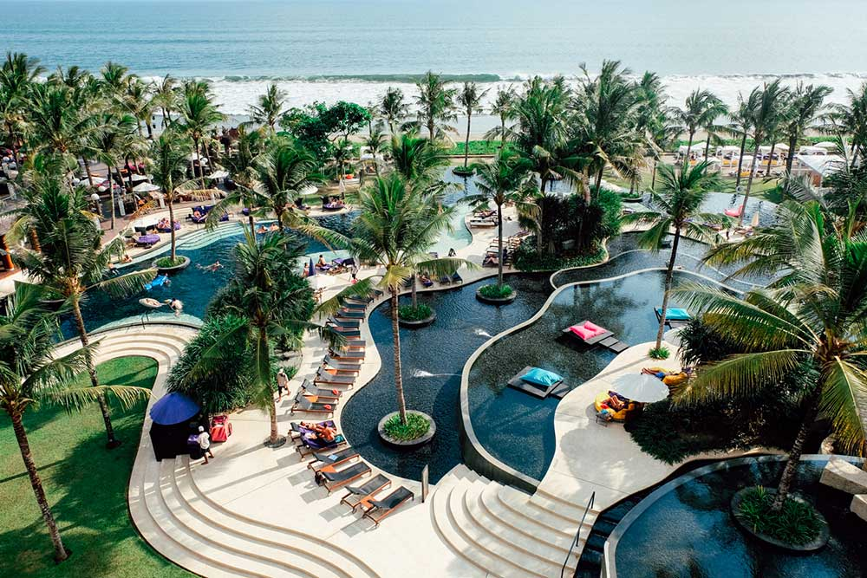
- W Bali Seminyak pool area (W Seminyak 2020)

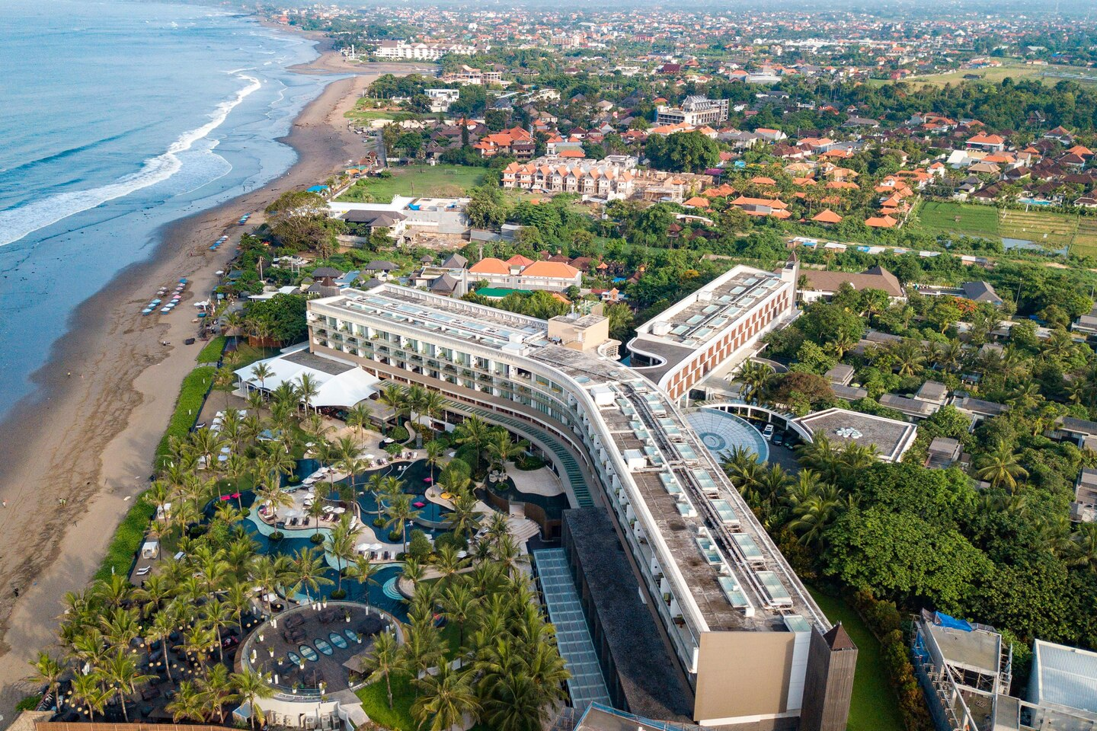

- W Hotel Seminyak Area View (W seminyak 2020)

- Hotel Facility
In its operational activities, W Seminyak Bali at Petitenget Kuta Utara provides various types of facilities including:
- Accommodation
W Bali has W Bali Seminyak has outdoor swimming pool with an area of ​​1,790 m which is inspired by rice fields (terracing) Balinese style.
Escape (hotel room) W Bali Seminyak is 151 rooms consisting
from 75 hotel rooms with garden views and 76 hotel rooms
facing the sea. Escape has an area of ​​64 m.

For villas, W Bali Seminyak provides 79 villas but only 64
villa for sale. The remaining 15 villas are given as living facilities
for expats (Important guest-W Bali Seminyak officials). 64 villas for sale consist of:
- 50 Marvelous One Bedroom Pool Villa (with extensive 225 m per villa)
- 10 Wow Two Bedroom Pool Villa (with an area of ​​352 m per villa) and
- 4 Extreme Wow Three Bedroom Pool Villa (with an area of ​​625 m per villa).

Lastly, the Suite is owned W Bali Seminyak totaled 6 rooms which is divided into:
- 4 Marvelous Suites (with an area of ​​127 m per room)
- 1 Wow Suite (with an area of ​​274 m)
- 1 Extreme Wow Suite (with an area of ​​532 m)

To find out the complete Hotel / Resort of W Seminyak as follows:
      - King Wonderful Garden View Escape Guest Room
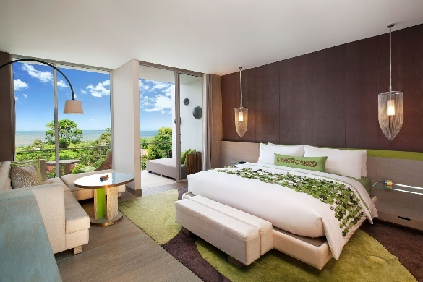
Sink into peaceful tranquility in our King Wonderful Garden View Escape Guest Room, which includes a W bed with a plush pillowtop mattress and 350-thread count Egyptian cotton sheets
Picture 2.2.6 King Wonderful Garden View
(W Seminyak 2020)

      - Wonderful Garden Escape Twin Bed, Bedroom
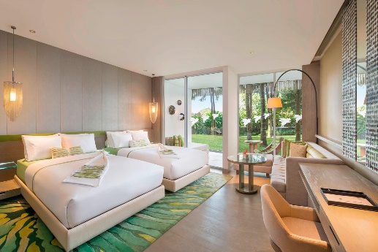
Floor-to-ceiling windows makes your guest room feel one with the tropics, where you'll awaken to chirping birds and a fresh breeze

Picture 2.2.7 Wonderful Garden Escape Twin Bed
(W Seminyak 2020)

      - Twin/Twin Spectacular Ocean Facing Escape Bedroom
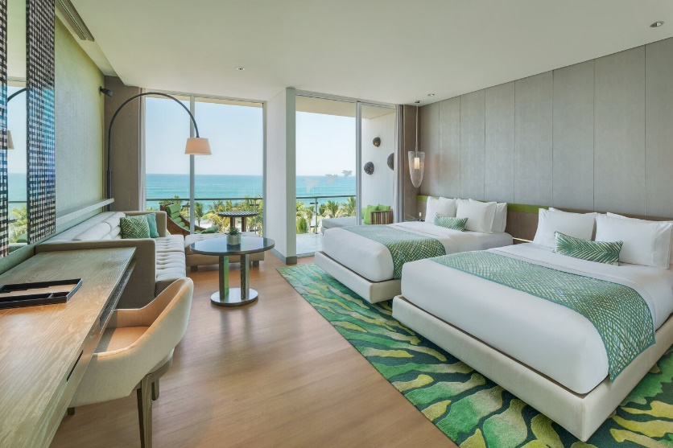
Experience the signature W bed with plush pillow-top mattress, 350-thread-count Egyptian cotton sheets and astonishingly soft goose-down duvet.

Picture 2.2.8 Spectacular Ocean Facing Escape
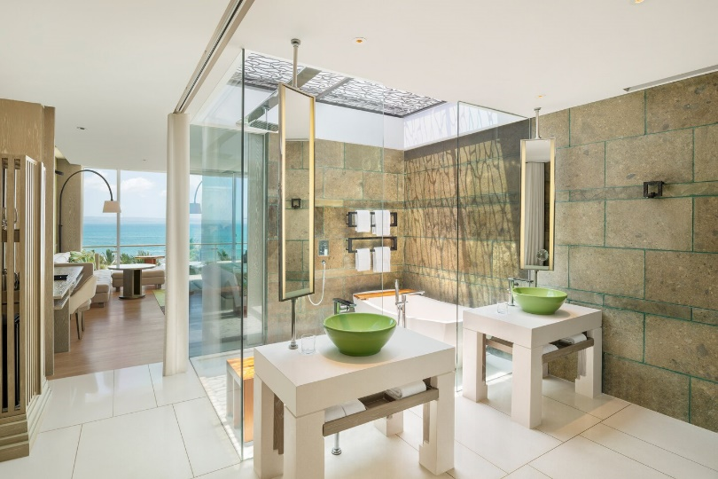
( W Seminyak 2020)
Picture 2.2.9 Spectacular Ocean Facing Escape Guest Bathroom ( W Seminyak 2020)

      - Marvelous SUITE
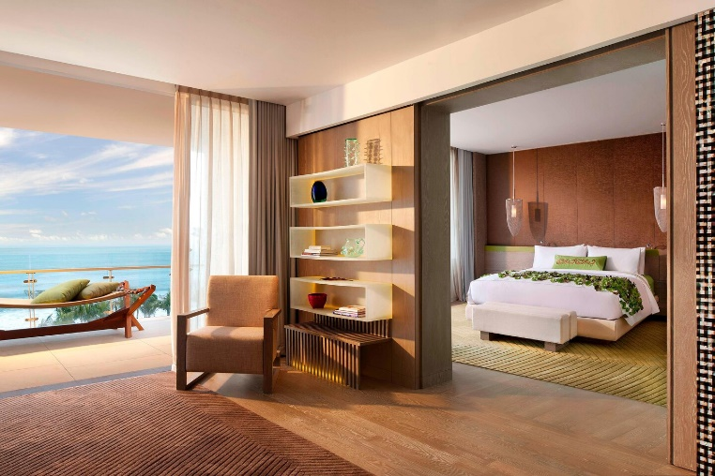
From your expansive balcony, take in the fiery Bali sunset from the Marvelous Suite. Relax into the comfy patio furniture and enjoy complimentary tea amenities

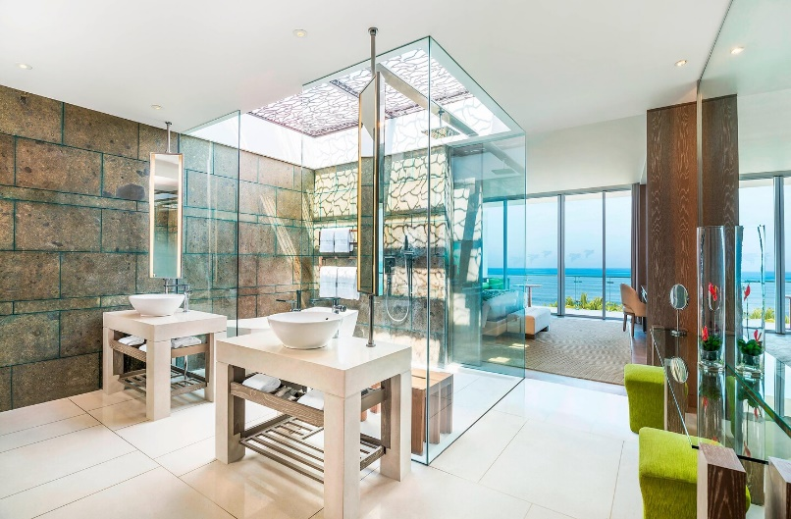
Picture 2.2.10 Marvelous SUITE
(W Seminyak 2020)
Picture 2.2.11 Marvelous Suite Bathroom with Skylight
( W Seminyak 2020)

      - WOW SUITE
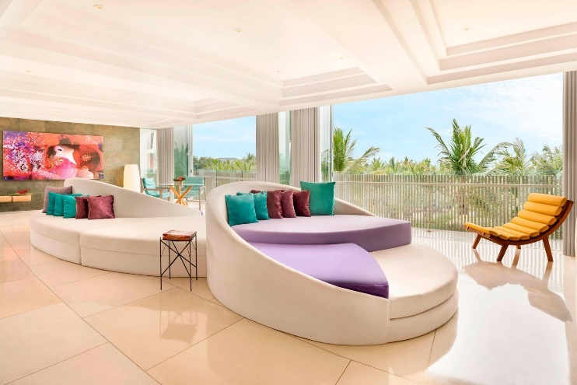
Lounge about. Our two-bedroom Wow Suite is made up of one master bedroom, a twin bedroom, spacious living room, two bathrooms, a large balcony and on top of it all, spectacular views of the Indian Ocean and the famous Bali sunset.

Picture 2.2.12 The living room of WOW Suite
(W Seminyak 2020)
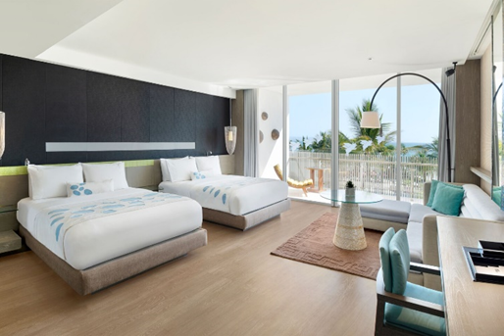
Picture 2.2.13 Queen Queen WOW SUITE (ocean view) (W Seminyak 2020)

      - Extreme WOW SUITE
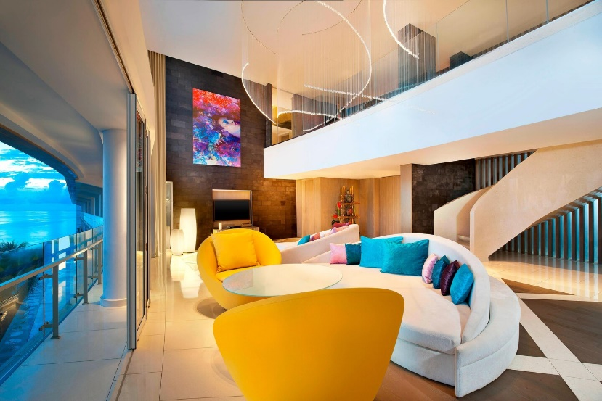
Bring yourself, start with an extensive balcony with full views of the Indian Ocean and the magnificent Bali sunset, to be appreciated on the outdoor waterbed and spa massage beds. What a perfect spot for enjoying everything you've ever dreamed about resort living.

Picture 2.2.14 The living room of Extreme Wow Suite
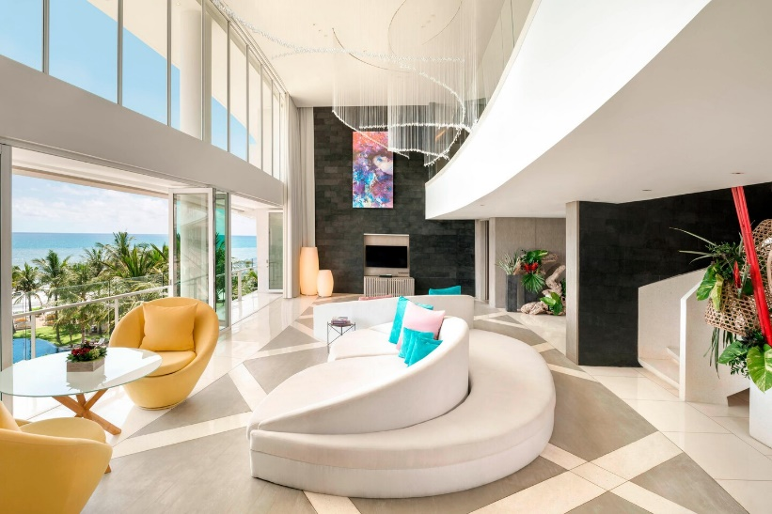
( W Seminyak 2020)

Picture 2.2.15 The living room of Extreme Wow Suite
(W Seminyak 2020)
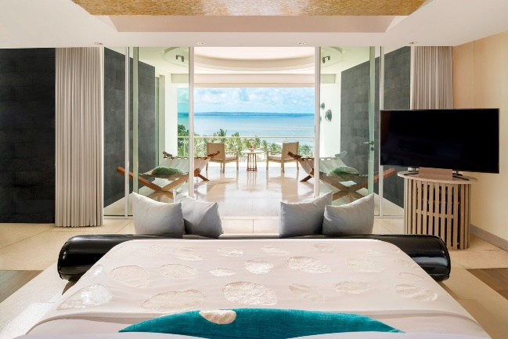
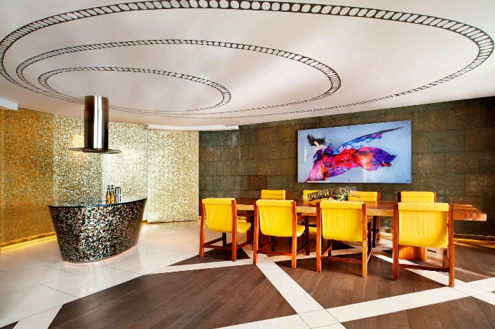
Picture 2.2.16 Extreme Wow Suite – Dining Room (W Seminyak 2020)
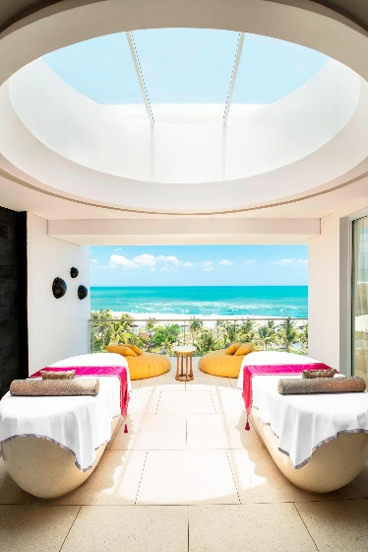
Picture 2.2.17 Master Bedroom of Extreme Wow (W seminyak 2020)
Picture 2.2.18 Extreme Wow Suite – Private Spa (W seminyak 2020)
      - Marvelous One Bedroom Pool Villa
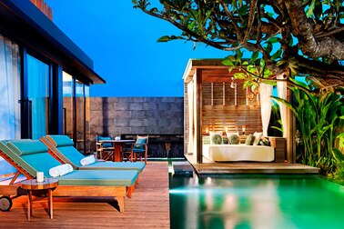
50 Marvelous One Bedroom Pool Villa (with extensive 225 m per villa)

Picture 2.2.19 The pool in One Bedroom Pool Villa
(W Seminyak 2020)
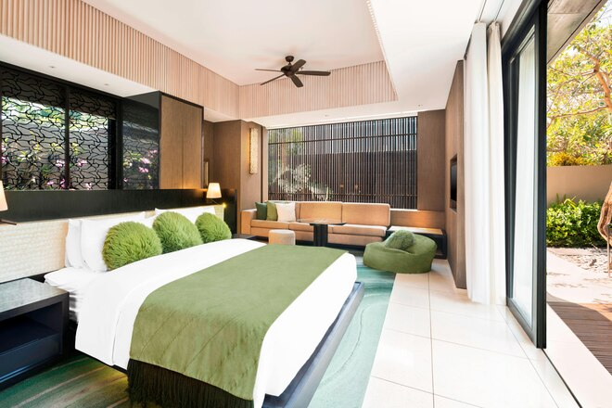

Picture 2.2.20 The Bedroom in One Bedroom Pool Villa
(W Seminyak 2020)

      - Wow Two Bedroom Pool Villa
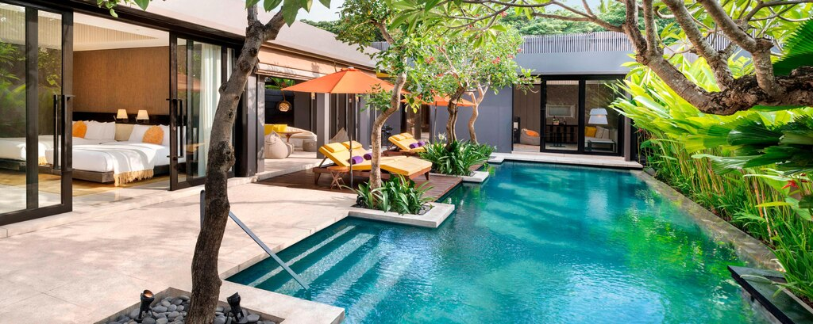
10 Wow Two Bedroom Pool Villa (with an area of ​​352 m per villa)
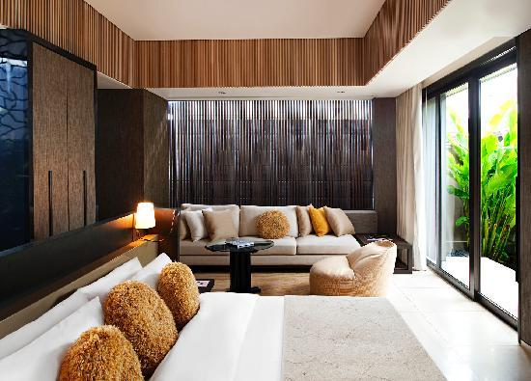
Picture 2.2.21 The Pool Area of Wow Villa (W Seminyak 2020)

Picture 2.2.22 The Master Bedroom of Wow Villa
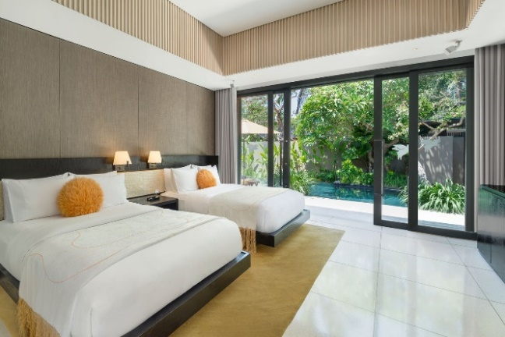
(W Seminyak 2020)

Picture 2.2.23 The twin bed, Bedroom of Wow villa
(W Seminyak 2020)
      - Extreme Wow 3 Bedroom Pool Villa
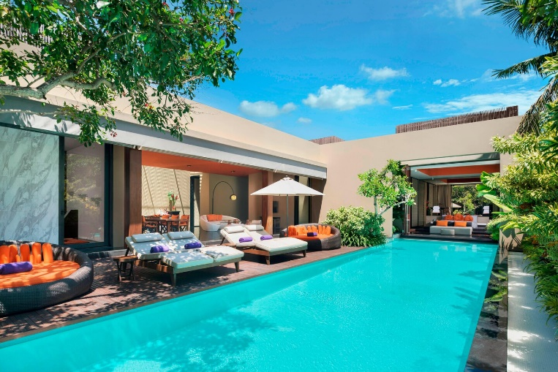
4 Extreme Wow Three Bedroom Pool Villa (with an area of ​​625 m per villa).
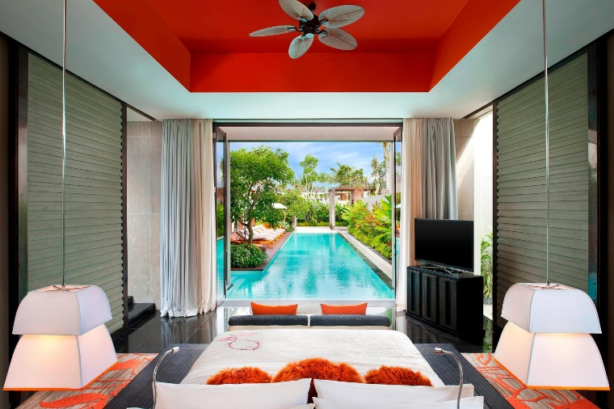
Picture 2.2.24 The Pool Area of Extreme Wow Villa (W Seminyak 2020)

Picture 2.2.25 View from the master bedroom
(W Seminyak 2020)

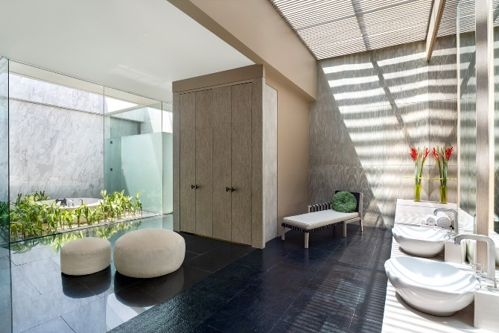
Picture 2.2.26 The Bathroom of Extreme Wow Villa(W Seminyak 2020)

- Food and Beverage Facilities
W Seminyak provides 8 outlets intended for guests, and also In Room Dining:
- Fire Restaurant
One of the Main restaurants of W Bali Seminyak is Fire Restaurant. The type of food served is westren cuisine. As well as Starfish Bloo, Fire is a semi fine dining restaurant.
Operational hour:
- starting at 7:00 a.m. -11.00 noon for breakfast.
- lunch until dinner at 12.00 noon - 11:00 a.m.
- Sunday brunch at 12.00 noon -4:00 p.m. This restaurant with a capacity of 130 people.

Sunday brunch on Fire was made a little differently from Starfish Bloo. Stick with the "all you can eat" system, but has a few different menus and food. Some among them are westren, seafood, Malaysian, Indian, carving station. In addition, Fire also provides ala carte menus such as pizza, steak, pasta, foie gras, lamb chop which includes the Sunday brunch package.
Facilities:
- Type of food: Grill
- Smoking area: available
- There is indoor and outdoor
- Wi-Fi: 24 hours non - stop
- Clothing: Casual and stylish
- Indoor air conditioned seats and outdoor terrace

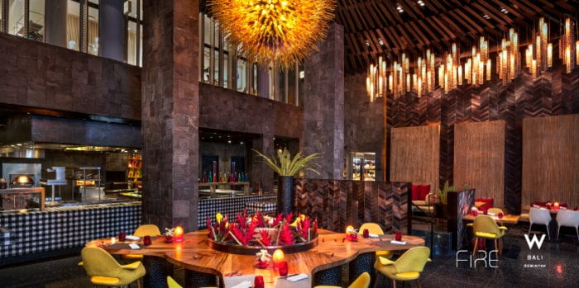

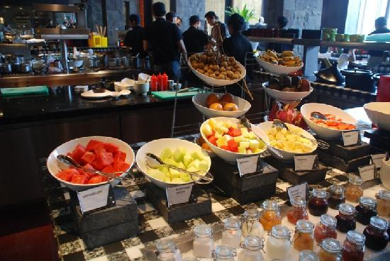
Picture 2.2.27 Fire Restaurant (W Seminyak 2020)

Picture 2.2.28 Some of the Display in Fire Restaurant(W Seminyak 2020)

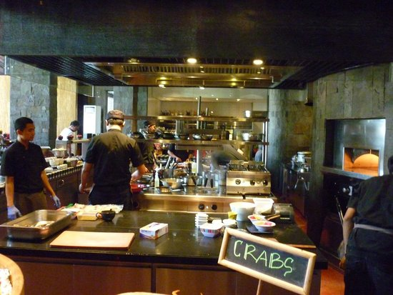
Picture 2.2.29 The Kitchen Staff Preparing Food (W Seminyak 2020)

- Starfish Bloo
Starfish Bloo uses the concept of semi fine dining and present Asian cuisine and some local specialties from Indonesia. In the morning, Starfish Bloo Restaurant also provides breakfast for hotel guests with view of Petitenget beach and pool area (Wet).

Breakfast available:
starting at 7:00 morning - 11:00 noon every day
(Monday - Sunday).

After 11:00 AM to 11:00 PM, Starfish Bloo will operate
like a restaurant in general (providing an ala carte menu in accordance with customer orders). The Starfish Bloo kitchen is also divided in 3 parts namely raw bar, front line and back kitchen.

Some favorite menus on Starfish Bloo are Blue Crab Taco, Soba Noodle and Seaweed Salad, Carpaccio of Hamachi and Salmon, Thai Beef Salad, Sesame Steamed Barramundi, Balinese Spring Roll and Peking Duck Rice Paper Roll.menu dishes with flavors that are so innovative and classic.

Only for Sundays, Starfish Bloo will provide "Sunday Brunch” with a maximum quota of up to 300 people.

Sunday brunch starts at
12.00 noon - 4.00 pm

with the system "all you can eat and eat all you can".
Food that available is also very varied, ranging from typical Indonesian food, Japan, barbecue station, seafood counter, pastry, bakery, dim sum, ice cream, tapas, and so much more.

Facilities:
- Type of food: Asian
- Smoking area: Available
- There are indoor and outdoor
- Wi - Fi: 24 hours non - stop
- Clothing: Smart casual
- Beachside dining

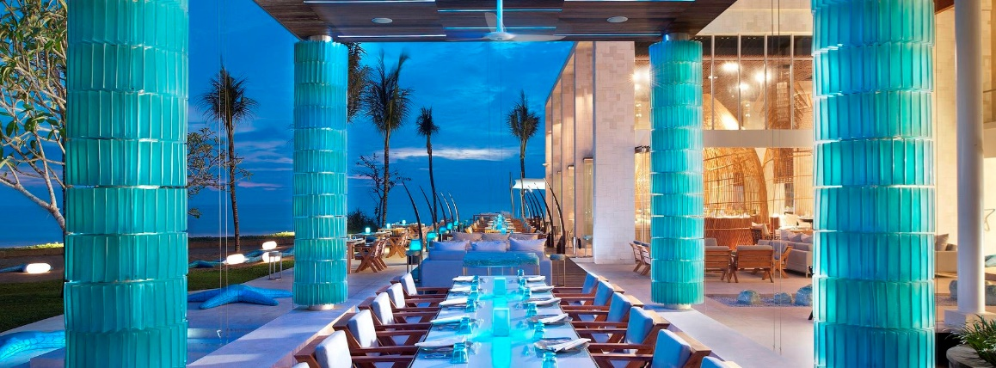
Picture 2.2.30 Starfish Bloo Restaurant (W Seminyak 2020)
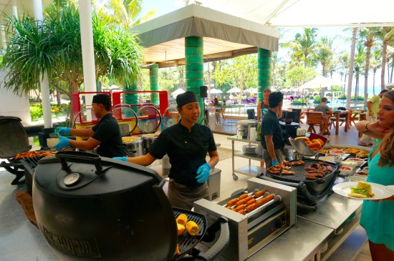
Picture 2.2.31 kitchen staff standby for Sunday brunch (W Seminyak 2020)

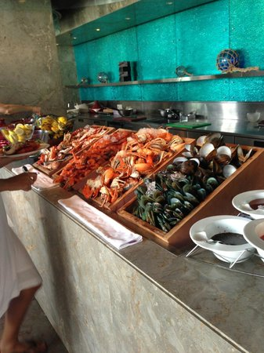
Picture 2.2.32 Seafood Buffet station (starfish bloo) (W Seminyak 2020)

- Woobar
Woobar is one of the main destinations of visitors when coming to W Bali Seminyak. It offers a la carte menu and a variety of snacks that can accompany visitors to relax while enjoying the atmosphere of the Petitenget Beach. The location of W Bali Seminyak is strategist, make Woobar never empty of visitors and become a major destination for foreign and local tourists.
From its name, Woobar is a "casual bar" with a capacity of more or less 200 people. Woobar is divided into 3 parts, namely Woosky, Woobase and Woobar it self. Woosky is used for special occasions such as wedding parties, birthdays party, new year party and yoga session (depending on request and request). Whereas Woobase is used for night club sessions, which are usually held
if there is a certain event With supporting properties such as speakers, lighting that supports as well as music that comes directly from the DJ table, Woobase atmosphere will turn into a night club of W Bali Seminyak. For Woobar, which is the main part, is used as favorite place to
enjoy a blistering day to a place to spend the rest of the night is fun.

Woobar operates from :
10:00 am - 1.00 a night and specifically at
Fridays and Saturdays, close at 2:00 p.m.

Woobar also provides various types of mocktails and cocktails that are listed in the menu, and can also adjusted to customer demand. In addition, Woobar also provides hundreds of types of wine, non-alcohol drinks like juices, milkshakes, smoothies and others.

Facilities:
- type of food: Tapas (Tapas are a wide variety of appetizers, or snacks, in Spanish cuisine. They may be cold (such as mixed olives and cheese) or warm (such as chopitos, which are battered, fried baby squid).
- Smoking area: Available
- There is indoor and outdoor
- Wi - Fi: 24 hours non - stop
- Clothing: Smart casual and trendy
- Beachside dining
- Indoor air conditioned areas

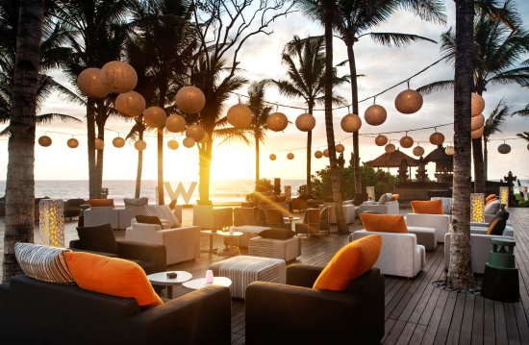
Picture 2.2.33 Woobar (W Seminyak 2020)

- W Lounge
W Lounge is located in the lobby of the W Bali Seminyak hotel. Can be said that W Lounge is very accessible because of its very strategic. With modern Balinese interiors, W Lounge has a capacity of more or less
180 People. W Lounge offers views to the swimming pool of W Bali Seminyak, that inspired by terraced rice fields (terracing).

W Lounge operates from:
- 8:00 a.m. - 11:00 noon for breakfast,
- 2:30 p.m. - 5.00 pm for Mad T Party (afternoon tea)
- 11:00 morning - 12.00 a night for all day dining.

In addition, W Lounge also provides
"Fuel Bar" which starts at 9:00 in the morning - 5.00 in the afternoon every day.

Fuel bar
is one of the events with the theme "DIY" or Do It Yo
urself, so visitors can choose their own juice ingredients to be processed.

Mad T Party Pricelist:
- Mad T - Party Food 165 k++
- Single Mad T-Party Cage 185 k++
- CoupleMad T-Party Cage 340 k++

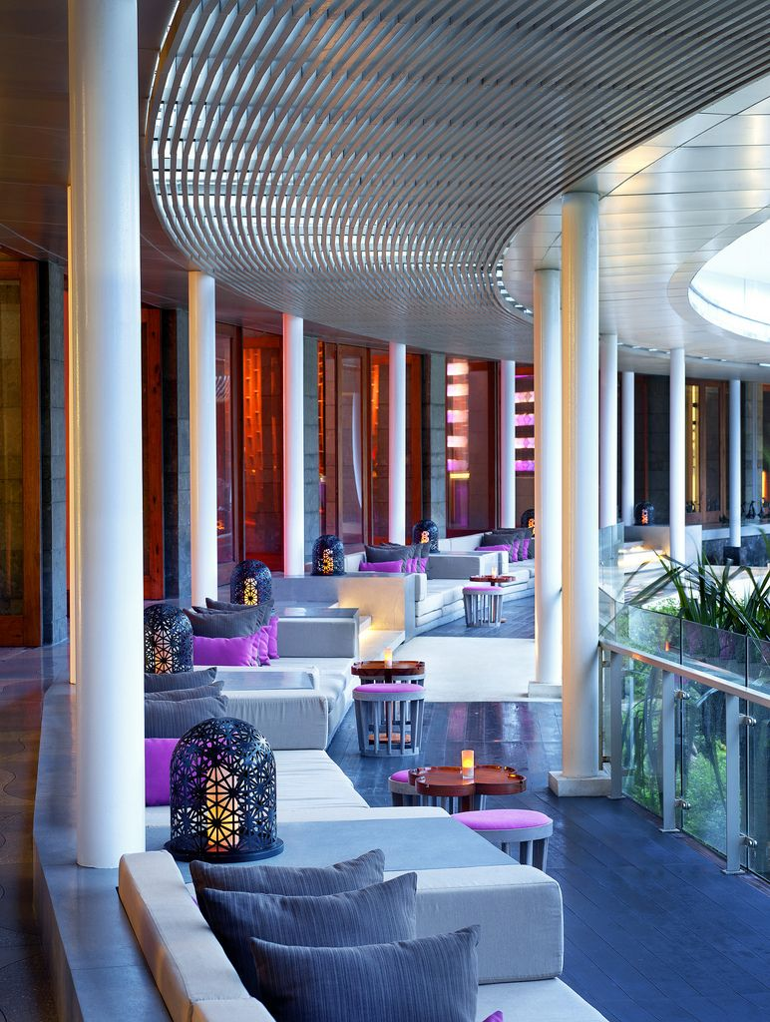

Picture.2.2.34 W Lounge(W Seminyak 2020)

- Ice Bar
Ice Bar is located inside Starfish Bloo and directly faces the beach so that visitors can enjoy the breeze of the Petitenget Beach. There is some favorite spots on Ice
Bar, which is sitting relaxed on the beach sand using bean bag that can be enjoyed while watching the sunset in the western horizon.
Ice Bar operates from
7:00 in the morning - 11:00 a.m.

For food menu, Ice Bar visitors can order menus from Starfish Bloo, such as Soba Seaweed Salad, Prawn Tom Yum, and Wagyu Roll. The capacity of the Ice Bar is around 50 people. Ice Bar is also one of the wine cellar, besides Woobase. Wine tower that located in the Ice Bar, can store approximately 120 bottles of wine.

Facilities:
- type of food: Asian
- Smoking area: Available
- There is indoor and outdoor
- Wi-Fi: 24 hours non-stop
- Clothing: Casual and stylish
- Beachside bar

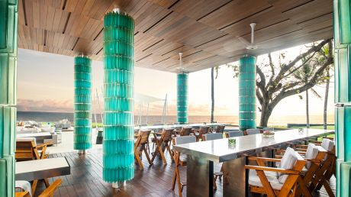
Picture 2.2.35. Ice Bar ( W Hotel) (W Seminyak 2020)

- Chill Bar
Chill Bar is located inside the Away Spa complex which operates 24 hours. Chill bar is intended for guests or visitors who want privacy because of its rather remote location. The menu that is offered at Chill Bar quite simple, like juice, coffee, salads, smoothies and snacks.
Designed with a unique and simple interior, Chill Bar is the place that suitable for relaxing. Surrounded by green gardens and shady trees, the roof is designed open
so that visitors can become one with nature.
In Chill Bar they provided a large sofa so the guests can feel more comfortable.

The Chill Bar is open from:
- 7:00 in the morning - 1.00 a night

Facilities:
- Type of food: Mediterranean
- Smoking area: Available
- Semi-outdoor area
- Wi-Fi: 24 hours non-stop
- Clothing: Casual and trendy
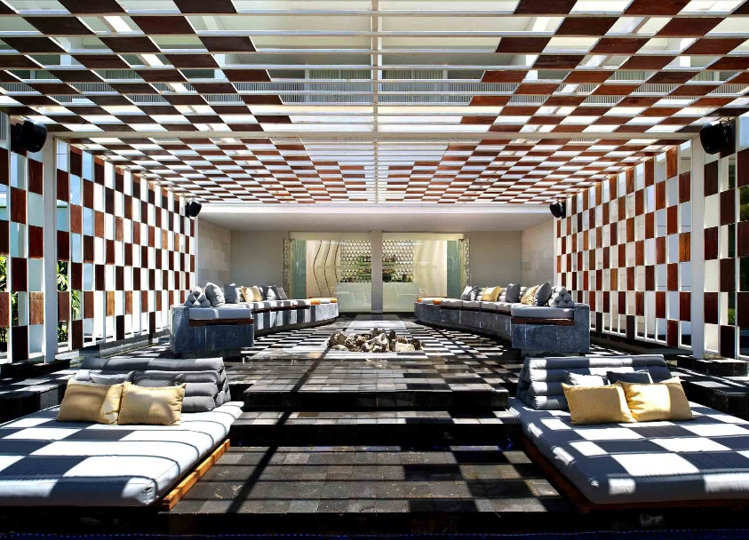
Picture 2.2.36. Chill Bar ( W Hotel) (W Seminyak 2020)

- Cellar
A special dining room for exclusive guests of W Bali Seminyak is located in Fire Restaurant Besides being able to eat while enjoying the interior of the Cellar artistically, this room can only accommodate 6 people. The room was created not too big so that guests' privacy is maintained.
In addition, another function of the Cellar is as a place for
wine storage called the wine cellar. There are approximately 100 types of wine that are stored in Cellar. For guests who want to enjoy a more private feel, you can order food from the Fire Restaurant and enjoy it at Cellar. Cellar open at 7:00 in the morning - 11:00 a night every day.
Facilities:
- type of food: Grill
- Smoking area: Not available
- Indoor air conditioned area
- Wi-Fi: 24 hours non-stop
- Clothing: Casual sophistication
- Private dining room
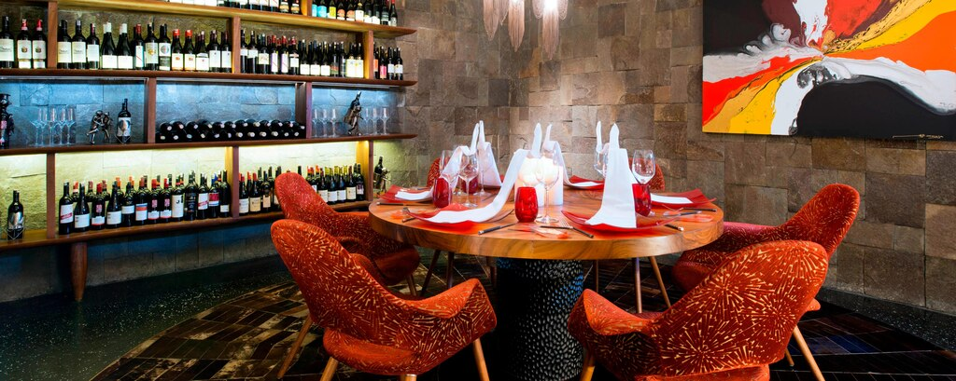
Picture 2.2.37. Cellar ( W Hotel) (W Seminyak 2020)

- 1 Bleow
When W Bali Seminyak guests want a more Private restaurant but in a larger capacity, 1 Below is a right choice. Located directly in front of the Fire Restaurant W Bali Seminyak entrance, making access between guests and servants easier and faster.
Capacity of 1 Below which is wider than Cellar, which is 16 people, makes 1 Below is a place for W Bali Seminyak guests to hold meeting, lunch or dinner, and private events and other.
1 Below opens from 7:00 a.m. - 11:00 a night every day.
Guests are also given the freedom to order food from Starfish Bloo, Fire, Woobar or W Lounge
because of the enactment of "Whatever / Whenever
Service " which is the motto of W Hotels,
" whatever you want, whenever you want it, as
long as it is legal, sky is the limit ".
1 Below will also give you the sensation of lunch or dinner which is unique because of one side of the wall is the translucent glass that has flowing water so that it looks like an artificial waterfall. The goal is to be private, but the visibility of guests does not become narrow. Apart from that lighting from the outside also helps give the sensation of "free" and "bright". That water flowing on the glass wall is also able to relax the eyes and minds of guests.
Facilities:
- type of food: Grill
- Smoking area: Not available
- Indoor air conditioned area
- Wi-Fi: 24 hours non-stop
- Clothing: Smart casual
- Private dining room
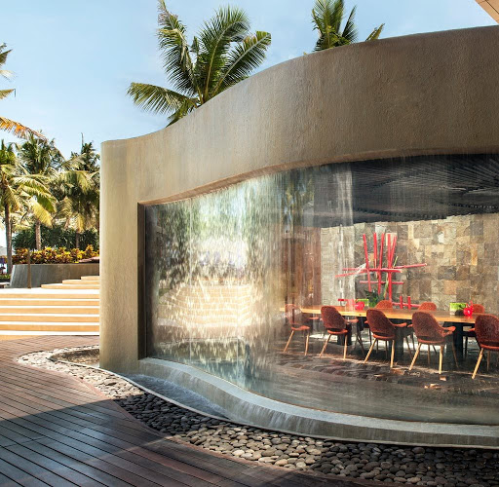
Picture 2.2.38. 1 Below ( W Hotel)
(W Seminyak 2020)

- Other Facility
- Spa (AWAY SPA W BALI )
Gorgeous and glamorous W insiders come to 24/7 AWAY Spa by W Hotels to escape the limelight. Experience a new level of relaxation at AWAY Spa at W Bali – Seminyak, where natural elements, innovative facilities and immaculate service await. Wake up thoroughly energized and refreshed as our beauty spa treatments bring out the best in you. Open 24/7, the spa operates on "Whatever/Whenever time - the first of its kind.
- Fitness Facility (FIT)
Stretch and strengthen in W 150-square-meter, state-of-the-art, fully-equipped FIT gym as you check out views of our garden and W Lounge through floor-to-ceiling windows. Energizing is easy, whether you prefer lifting, cycling or just jogging. Gym rats and fitness warriors will love the comprehensive array of treadmills, elliptical machines and stationary bikes mounted with LCD TVs (complimentary headphones available). With weight machines, free weights, yoga mats and speed ropes galore, you'll never be bored—it's easy to get started. If you like being part of a team, check out our action-packed selection of group exercise classes. Or if you prefer the inspiration of customized workouts, our Whatever/Whenever service will hook you up with a personal trainer, tough love optional. Enjoy complimentary access with your room key, and we'll send you on your way with fresh apples and chilled water. Did we mention that AWAY Spa is just next door for that reward after your reps?
- Music Studio (W Sound Suite)
With a rich history of fostering musical talent and pushing boundaries, W Hotels is introducing a new way for bands and DJs to get creative. And this time, it’s on the road. W Sound Suites, a private music studio at W Hotels giving touring musicians a space to record in an awe-inspiring location. Introducing W Hotels’ first ever private music recording studio and creative space. With enough room to host a proper entourage, the 50 SQM space includes a lounge, a live room and a main mixing room featuring the latest professional equipment from top tier brands. Make some music in paradise and have the ultimate destination recording experience.

- Ballrooms (Great rooms)
Great Room, which features a stunning wall built with Batu Alam, a natural Indonesian stone, that leads up to a spiral cone-shaped ceiling. A connecting pre-function terrace lets you take the in crowd outside. Accommodating up to 260 guests comfortably, this expansive space overlooks the breathtaking Ocean, a perfect vantage point for the famous Bali sunset. If you're thinking outside of the box, host your brainstorming session in one of our Escapes. Whatever you do, our chefs can customise the perfect menu to complement, while our signature cocktails add colour to any occasion, making us a highly sought after Seminyak wedding venue and one of the most popular meeting venues in Bali.

- Meeting Room (Strategy Room)
Choose the Strategy Room - We will engage and energize attendee and participants in your soiree or meeting. The unique Sensory Set Up gets ideas for your conference or board meeting flowing with mood music, signature scents and. more for one of the most out-of-the-box meeting venues in Seminyak.

- Shopping Outlets (W The Store)
Give in to spontaneous consumption. W Hotels - The Store’s got the goods for him, her or the house.

- Library (Wired & Words)
Full service WIRED business centre and a comprehensive library of books and DVD's. Library & Lounge is provided for guests who want to read various types of books by world writers. Here also provided internet facilities, watching films, and lounges. For guests who want to check out and still have to wait for the flight departure, they can also relax while enjoying the facilities provided.
- Vision, Mission, and Company Objective
- Vision
o fuel guests’ lust for life, W ignites an obsessive desire to soak it in, live it up and hit repeat.
- Mission
How we succeed? With a mission to fuel guests’ lust for life, W ignites an obsessive desire to soak it in, live it up and hit repeat. The brand’s provocative design, iconic Whatever/Whenever service and buzzing Living Rooms create an experience that is often copied but never matched. Innovative, inspiring and infectious, W Hotels’ super-charged energy celebrates guests’ endless appetite to discover what’s new/next in each destination, to see more, feel more, go longer, stay later.
- Company Objective
Who we are? W was born from the mix of eclectic cultures and vibrant energy of New York City. Today, W takes that 24/7 vigour worldwide, bringing the best of music, fashion, design and fuel to stunning destinations around the globe, we call it “SOAK IT IN AND LIVE IT UP”

W PASSIONS:
- Music: A part of W’s DNA, it ties everyone together amps up the vibe. Experience new/next music that channels to the beat of each destination.
- Fuel: Giving you the energy to look good, feel good, go longer, stay later. At W, it’s all about living life in balance with #detoxretoxrepeat as our ethos.
- Design: W design is bold and defies expectations – each hotel is inspired by unique aspects of the destination’s local culture and historical roots.
- Fashion: From emerging designers to local boutiques, W gives you insider access to the latest trends in each destination and a stage to show off your style.

LOUD AND PROUD: W is dedicated to promoting equality and giving a megaphone to inspiring voices that deserve to be heard. From collaborations and celebrations to events and speaker series, we’re all about breaking boundaries and living out loud. And that is W Character.

- Organizational structure of the W Hotel Seminyak

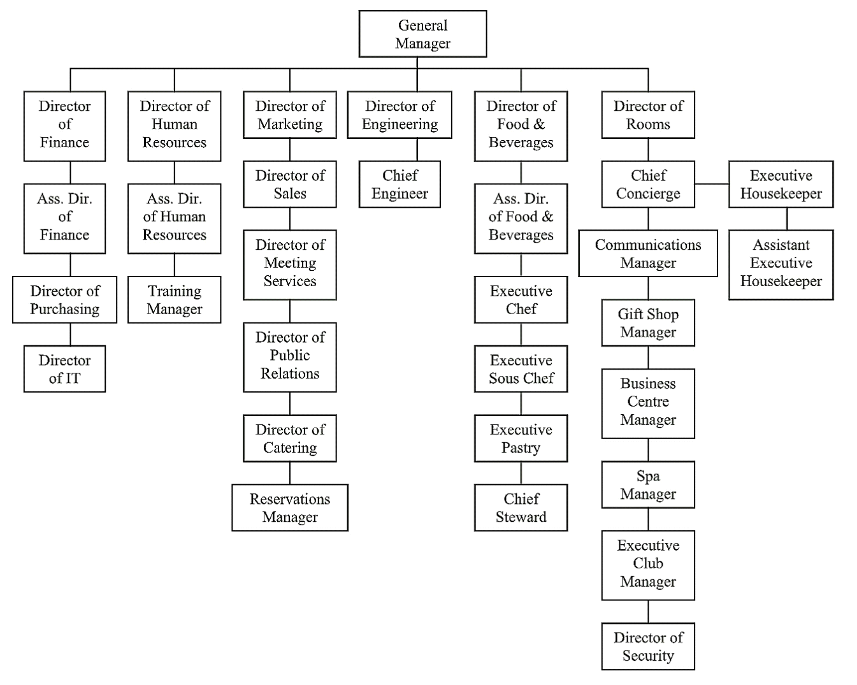

Table 2.4.1. Organization Structure of W Hotel Bali
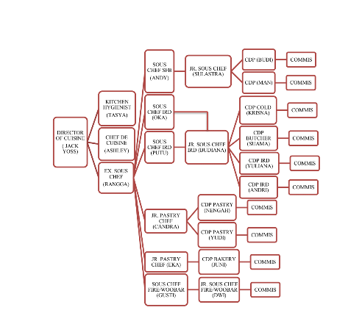
- Food & Beverage Production Organization Structure W Bali
Table 2.5.2 F&B Production Organization Structure W Bali

- Fire Restaurant Organization Structure W Bali

Table 2.6.3. Fire Restaurant Organization Structure

- Main Task in Fire Restaurant and IRD (In Room Dining)
The location of Fire Restaurant is quite easy to reach because it is located in the Wet area (pool area of ​​W Bali Seminyak). Breakfast at Fire starts at 7:00 Morning - 11:00 noon. Slightly different, Fire splits shifts based on the team. There are 3 teams that are divided, namely the breakfast team (5.00 in the morning), the lunch team (9:00 in the morning) and the dinner team (1.00 in the afternoon). For interns, come in at 6:00 in the morning (breakfast). So, as an apprentice will be given trust to look after 1 station out of 3 stations (dimsum / bread / egg).
After breakfast time has finished, the breakfast team immediately clean up the breakfast setup, including cleaning the station. there is and assisted by Steward. When finished, team breakfast preparing ingredients for the next breakfast in Fire preparation (back kitchen).

Main kitchen or known as In Room Dining (IRD) at W Bali Seminyak is the main production kitchen that handles several breakfast menus at Starfish Bloo, Fire and W Lounge. IRD is fully responsible for room service escape, villa and suite, And because of that, it is one only the kitchen is open 24 hours.
Besides being responsible for room service for all guests W Bali
Seminyak for 24 hours straight, IRD is also responsible for banqueting and event held at W Bali Seminyak, like a birthday party, coffee break, Sunday brunch, wedding party, seminars, anniversaries, gala dinners and events others according to guests' requests and needs. Menu provided by IRD very much, reaching hundreds and can be adjusted with guest request. While working at IRD, I always work at 7:00 a.m.

- Hygiene and Sanitation Standard in W Bali
- Personal Grooming
Grooming is an appearance that is always neat and awake whole. This is certainly important because of employee cleanliness when
processing or producing food affects the outcome of the food the. According to the SOP or standard operating procedure, grooming must always be considered.
The purpose of applying standard grooming in the kitchen both in the hotel and restaurant is:
- As a reference and benchmark in improving quality and quality hotel services.
- To find out personal hygiene standards that include personal Grooming, Health, habits, tidiness and cleanliness in the field culinary and tourism.
Some Grooming standards for male employees at W Bali Seminyak:
- Must wear a hat when working and in the kitchen area
- Has neat and clean nails
- Must not lengthen beard, mustache and beard
Some Grooming standards female employees at W Bali Seminyak:
- Must wear a hat when working and in the kitchen area
- Has neat and clean nails
- Not accepted / not allow it using nail polish
- Must tie their hair while working
- Can use makeup, but not too much to make it look natural
at W Bali Seminyak, the rules of grooming are quite strict. Example the case is that male employees who work in production kitchens are prohibited take care of mustache and beard (must be clean and always shaved). If there is violated, will be given a warning 3 times. If the last warning is ignored then will be given a warning letter and threatened to be fired if you get 3 warning letter from HRD.

- Kitchen
There are several goals for sanitation in the kitchen, including:
- Improve, maintain and restore good health in humans
- Product efficiency can be maximized
- Produce products that are healthy and safe from the influence of bacteria, germs and viruses that can be bad for health
There are also several benefits positive from sanitation such as:
- Prevent infectious diseases
- Prevents the onset of unpleasant odors
- Avoid pollution
- Reducing the percentage of sickness
- The environment becomes clean, healthy and comfortable Make sure the kitchen area is clean every time you enter and exit the kitchen

The kitchen is regularly cleaned by Steward once every morning. Starting from stoves, cabinets, floors, sinks, walls and large appliances that are difficult to reach (oven, standing mixer, trolley). The rest will be assisted by kitchen workers. Clean the work table, chiller, freezer according to the section.
Before going home, kitchen workers must clean the station
they work. For example, after making ice cream, workers must wash and clean the ice cream machine and wipe the engine. Because, before work the situation of the kitchen is clean and neat so that before leaving the kitchen must also the same as before, the situation of a clean and neat kitchen. This is certainly good for food hygiene because the environment of making food is clean so there will be small the possibility of food contracting bacteria or germs (this supported by cleanliness of workers and equipment used).

Not only kitchen cleanliness that must be considered, but cleanliness food storage is still important. Chiller and freezer does not mean free from germs because the temperature is cold so bacteria are difficult developing. Chiller and freezer must be regularly cleaned in order for food to be stored in it can be more durable and fresh. W Bali Seminyak have Rules for washing and cleaning chiller and freezer for each department every 1 week and scheduled Sunday as "washing chiller day and freezer at W Bali Seminyak ".

Step by step cleaning system that I learn during my internship at W Bali Seminyak:
- Empty the chiller by removing foodstuffs and shelves and rack to maximize the cleaning process
- Wash the shelf with water and soap
- Washing every container as well as checking the conditions of the container so that contamination does not occur during storage
- Dried the containers and classify food ingredients by it’s kind
- Clean the Chiller / freezer floor with soap.
- After foaming and rubbing using a floor brush, switch to another area which is the walls, doors and roof of the chiller
- Clean and scrub the walls, doors and roof of the chiller using soap
- Flush the chiller with clean water until it does not leave any residue foam and soap
- Clean the remaining water until it dries
- Wipe the walls, doors and roof to prevent moisture
- Rearrange the shelves, rack and container into chiller / freezer

- Ingredients
Food hygiene is influenced by the equipment used during production process. Kitchen utensils used must also be appropriate and routine replaced once every 6 months (if you have not worth using). General kitchen equipment such as knives, cutting boards, spoons, spatulas, pan and whisk must always be washed using soap and warm water after use. Especially for cutting board, steward routinely cleaning by soaking 2x cutting board a week with sanitizer liquid so that the area that are unreachable with soap, can be totalally clean. Cutting boards at W Bali Seminyak are classified by color:
- Red, used to cut and process raw meat
- White, used for cutting and process bread
- Green, used for cutting and processing fruits and vegetables
- Blue, used to cut and process seafood (fish and other sea animals)
- Chocolate, used for cutting and processing food products that already cooked
- Yellow, used for cutting and process cheese, butter and other dairy products.
Foods that are processed and will be consumed should meet the criteria that the food is suitable for eating and does not cause any disease, such as:
- Free from pollution at every stage of production and handling
- Free from unwanted physical, chemical changes, as a result from the influence of enzymes, microbial activity, rodents, insects, parasites and damage from cooking and drying process.
- Free from microorganisms and parasites that cause disease that can delivered by food.
- Dispose of waste material according to organic and non-organic category.

