APPENDIX
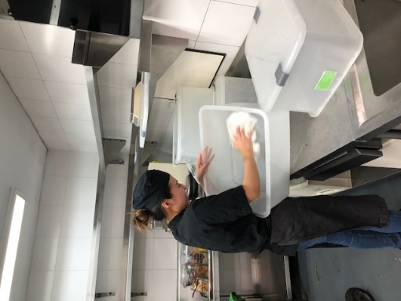
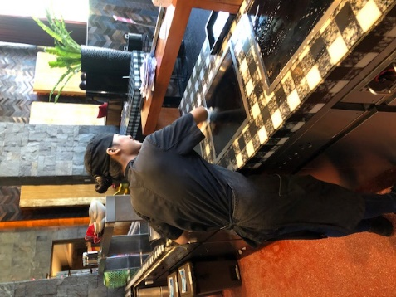
Picture.APPENDIX.65. Photo of The Writer Cleaning storage box (W Seminyak 2020)
Picture.APPENDIX.66. Photo of Culinary Trainees
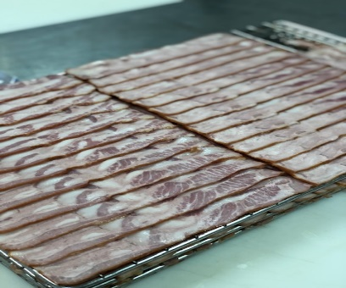
(W Seminyak 2020)
Picture.APPENDIX.67. Photo of The writer works (layering bacon) (W Seminyak 2020)

