INTERNSHIP FINAL REPORT
JW MARRIOTT HOTEL SURABAYA
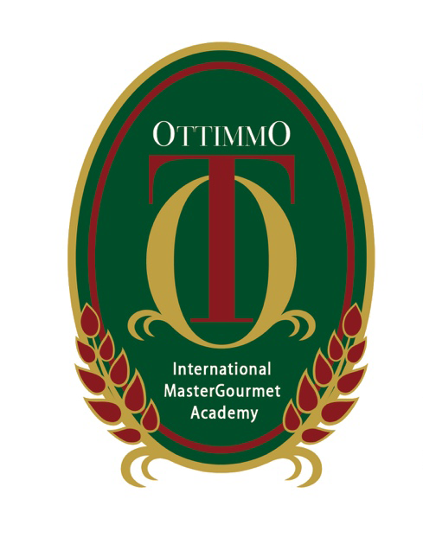

By:
Yeyen Puspita Jayaatmaja
1474130010073

STUDY PROGRAM OF CULINARY ART
AKADEMI KULINER DAN PATISERI
OTTIMMO INTERNASIONAL
SURABAYA
2017
INTERNSHIP FINAL REPORT
JW MARRIOTT HOTEL SURABAYA

Arranged by:
Yeyen Puspita Jayaatmaja
Done the internship period from July, 1 – December, 31 2016 at The Pavilion International Restaurant’s kitchen department, JW Marriott Hotel Surabaya

Approved by:

HR Manager Executive Chef

This final report has been approved and validated as requirement
to get an Academic Title of Diploma Degree, Study Program of Cullinary Arts

date:

Director of  Akademi Kuliner dan Patiseri  Ottimmo Internasional  Zaldy Iskandar, B.Sc  NIP. 19731025 1201 001 | Head of Culinary Art Study Program  Akademi Kuliner dan Patiseri  Ottimmo Internasional  Vindhya Tri Widayanti, STP., MP  NIP. 19901208 1402 014

