LAPORAN PRAKTEK KERJA LAPANGAN
HARRIS HOTEL & CONVENTION SURABAYA

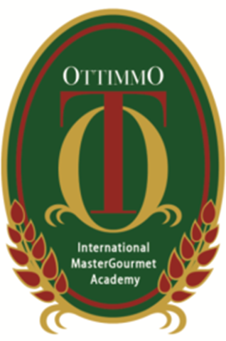

By :
Shelley Vania Pranoto
074130_94406_2014_0014

STUDY PROGRAM CULINARY ARTS DEPARTMENT
ACADEMY OF CULLINARY ART AND PATISERY
OTTIMMO INTERNATIONAL MASTER GOURMET ACADEMY
SURABAYA

2017

