INTERNSHIP FINAL REPORT
CUCA RESTAURANT

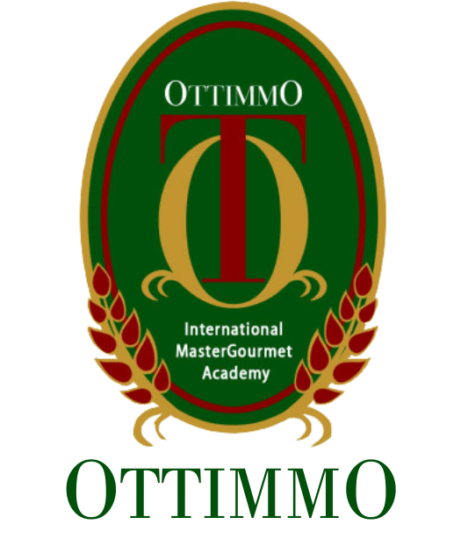

By:
Michael
074130_94406_2014_0033

STUDY PROGRAM OF CULINARY ARTS & CULINARY ACADEMY AND PATISSERIE OTTIMMO INTERNATIONAL
SURABAYA
2017

SIGNATURE PAGE

INTERNSHIP FINAL REPORT
CUCA RESTAURANT

Arranged by:
Michael
Done the internship period from July, 1 - December, 31 2016 at Kitchen Cuca restaurant

Co Supervisor

Wiliam Loo

This final report has been approved and validated as requirements to get an Academic title of Diploma degree, Study program of Culinary Arts

Date:……………………
Ottimmo International Mastergourmet Academy
Director,

Zaldy Iskandar, B.Sc.

i
SUMMARY
Internship work took place in Cuca restaurant, Jimbaran, Bali, which is located on jalan Yoga Perkanthi, Jimbaran, Bali, Indonesia. Internship activity was held on 1st July to 31 Desember 2016. And the activity is to know how to manage the restaurant with high standart. Because the head chef is Kevin Cherkas. Canadian Chef Kevin has an enviable track record developed in some of the world’s most outstanding restaurants.In Spain, he honed his skills at Michelin three-star Arzak Restaurant in San Sebastian, Michelin three-star El Bulli in Roses, and Michelin two-star La Broche in Madrid. He also left his mark in New York City during his tenure with Daniel Boulud at his highly regarded Michelin three-star Daniel. Most recently, Chef Kevin helmed BLU at Shangri-La Hotel, Singapore and prior to that Restaurant Lafite in Shangri-La Hotel, Kuala Lumpur.

Cuca is a semi fine dining restaurant, they over a “tapas”. Tapas means “penutup” in spanish, which means tapas usualy serves in a small plates on top of the glass (cover of the glass) to prevent the insects or another small animals into the glass. Sometimes the Spaniard eat this cullinary as a snack in accompany of drink a beer. Tapas are a wide variety of appetizers, or snacks, in Spanish cuisine. They may be cold (such as mixed olives and cheese) or hot (such as chopitos, which are battered, fried baby squid). In select bars in Spain, tapas have evolved into an entire, sophisticated cuisine. In Spain, patrons of tapas can order many different tapas and combine them to make a full meal. Cuca offer in small portions, so the customer can try more of the dish and meant to be shared

The internship aims is to know how is the kitchen flow, preparation for tomorow services, about the production, stock inventory, chiller and freezer inventory, FIFO and LIFO, dinner services, cooking technique, how to plating and many more.

ii

PREFACE
First of all, I am very grateful that I have the chance to complete my second internship by Taylor’s University and being a part of Cuca Flavor Restaurant Bali. I would like to express my special thanks of gratitude to the God because the opportunity to completed my second training with awesome feeling.
I would like to express my sincere and special thanks to Cuca Flavor Restaurant Bali for accepting me as one of their interns and guiding me during the internship. Special thank also I address to Ms. Ruth as a Admin Assistant Manager and Human Resources of Cuca Flavor Restaurant Bali and the one who interviewed and gave a chance to me to become a part of Cuca Flavor Restaurant to complete my second training. I also want to thank to Chef Kevin Cherkas as an Executive Chef also founder of Cuca Flavor Restaurant Bali, Chef Terry Chee as a head chef or chef de cuisine, and Chef William Loo as a sous chef. As well to the permanent staff of all the kitchen area, food and beverage area and admin (office) area in the restaurant. Without their support who gives me information and teach me a lot of things my internship would be very hard. Through ups and downs and their willingness to teach me into someone better. Thank you for the amazing experience inside and outside Cuca’s for this 6 months.
Last but not least, I would like to say thank you to my family for the financial support and unconditional love. I also give many thanks to my friends for their support and sharing information in order to finish my internship programme and internship report.

Denpasar, January 1st 2017

Iii
TABLE OF CONTENT

COVER……………………………………………………………………………..
SIGANTURE PAGE……………………………………………………………….i
SUMMARY………………………………………………………………………...ii
PREFACE…………………………………………………………………………..iii
TABLE OF CONTENT…………………………………………………………….iv
CHAPTER I INTRODUCTON
1.1 Background……………………………………………………………………..1
1.2 Objective………………………………………………………………………...2
1.3 Benefits…………………………………………………………………………..2
1.4 Time and Places…………………………………………………………………3
CHAPTER II RESULT AND DISCUSSION
2.1 Overview…………………………………………………………………………4
- History of Cuca Restaurant…………………………………………………4
- Organizational of Cuca Restaurant………………………………………...10
2.2 Result of Internship……………………………………………………………..11
- General Kitchen……………………………………………………………...11
- Part of the kitchen…………………………………………………………...13
- Baking pastry………………………………………………………………..15
- Activity during internship…………………………………………………..16
- Hygiene and sanitation………………………………………………………20
CHAPTER III CONCLUSION AND SUGGESTION
3.1 Conclusion……………………………………………………………………….25
3.2 Sugestion………………………………………………………………………...25

REFERENCE

iv

