INTERNSHIP FINAL REPORT

LE GALLERIA GOURMET KITCHEN AND CHOCOLATE

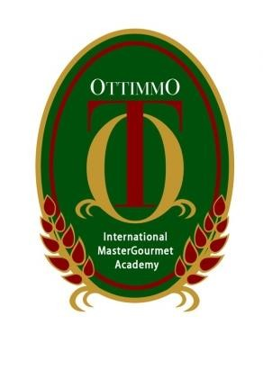

By:

Kim Woo Jin

(1474130010108)

STUDY PROGRAM OF CULINARY ART
AKADEMI KULINER DAN PATISERI
OTTIMMO INTERNASIONAL
SURABAYA

2017

