INTERNSHIP REPORT
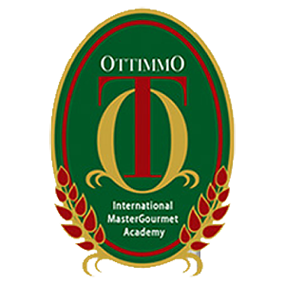CONRAD HOTEL & RESORT BALI

By:
Anthonius Raharjo

CULINARY ART DEPARTMENT
AKADEMI KULINER DAN PATISERI OTTIMMO
INTERNATIONAL
SURABAYA
2017

