CHAPTER 2
INGREDIENTS AND UTENSILS OVERVIEW

2.1 Description of The Material to be Used
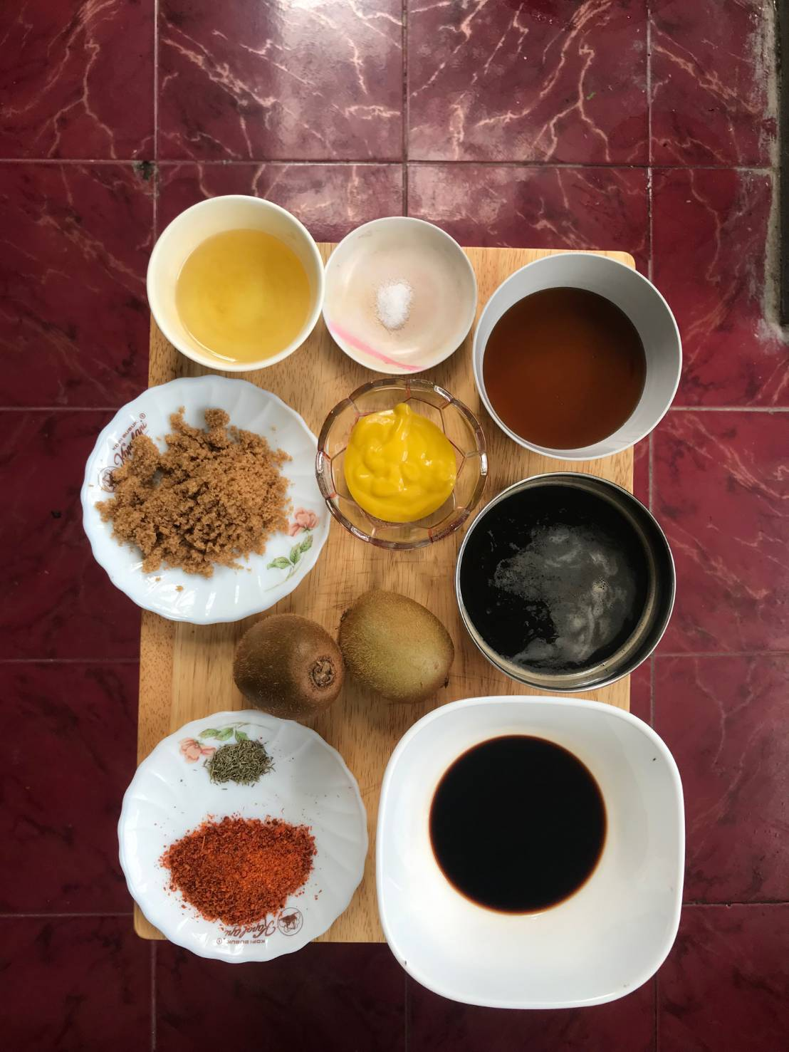
( 8 )
( 9 )
( 7 )
( 10 )
( 5 )
( 6 )
( 3 )
( 4 )
( 2 )
( 1 )

Picture 1. The Material to be Used
1. Whole Kiwi : Kiwi especially it’s skin is special ingredient for the sauce
2. Guiness Beer : Guiness Beer is one of ingredient to get the bitter taste and color for the sauce
3. Honey : Honey is the ingredient that contain sweetness in the sauce also make it thick
4. Mustard : Mustard is one of the most important ingredient to make sauce because it has a unique flavor and spicyness
5. Brown Sugar : Brown Sugar also give the sweetness and color on the sauce
6. Cooking Oil : Cooking oil is to sautee the chilli flakes so it will become spicier
7. Balsamic Vinegar : One of the most unique ingredient for the sauce because it’s flavor
8. Chilli Flakes : The ingredient that make the spicy flavor in the barbeque sauce
9. Dry Thyme : Dry thyme has a unique aromatic smell that make the sauce more special
10. Salt : Salt is to give the sauce a salty taste so it will become rich

2.2 The Tools Used During The Processing
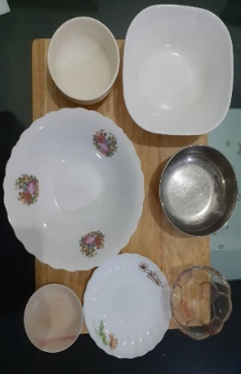
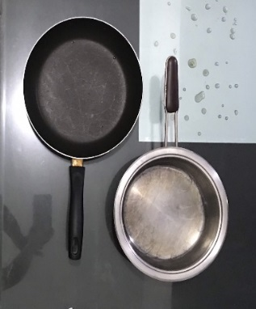
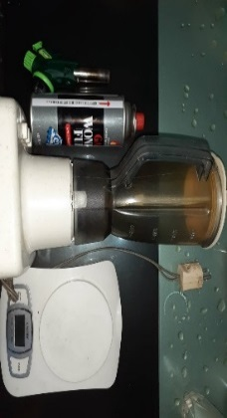
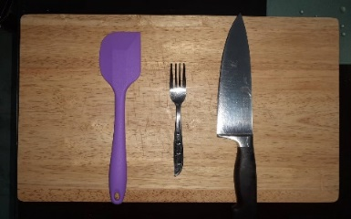
( 1 )
( 2 )
( 4 )
( 19 )
( 18 )
( 3 )
( 13 )
( 17 )
( 12 )
( 9 )
( 16 )
( 14 )
( 11 )
( 15 )
( 10 )
( 8 )
( 6 )
( 7 )
( 5 )

Picture 2. The Tools Used During The Processing
1. Wooden Cutting Board : Used to base for cutting the kiwi
2. Silicon Spatula : Used to stir the sauce
3. Fork : Used to hold the kiwi when it getting torched
4. Knife : Used to cut the kiwi
5. Portable Blow Torch : Used to removed the kiwi hair
6. Portable Blow Torch Gas : Used to turn on the flame for the torch
7. Blender : For blend the kiwi
8. Digital Scale : Used to measure all the ingredients
9. Non-Stick Pan : Used to sautee the chilli flakes
10. Sauce Pan : Used to boiling and simmering all the ingredients to make the sauce
11. Ceramic Bowl : Used to put Balsamic Vinegar
12. Aluminium Bowl : Used to put Guiness Beer
13. Glass Bowl : Used to put Mustard
14. Mini Plastik Plate : Used to put Oil
15. Big Ceramic Bowl : Used to put the Kiwi juice
16. Mini Glass Plate : Used to put Dry Thyme and Brown Sugar
17. Mini Plastik Plate : Used to put Salt
18. Stove : Used to cook the sauce
19. Mini Plastik Bowl : Used to put Honey

