RESEARCH AND DEVELOPMENT FINAL PRODUCT
CATFISH BONES STICK
(Healthy snack high in Calcium and Protein made with Catfish Bones)

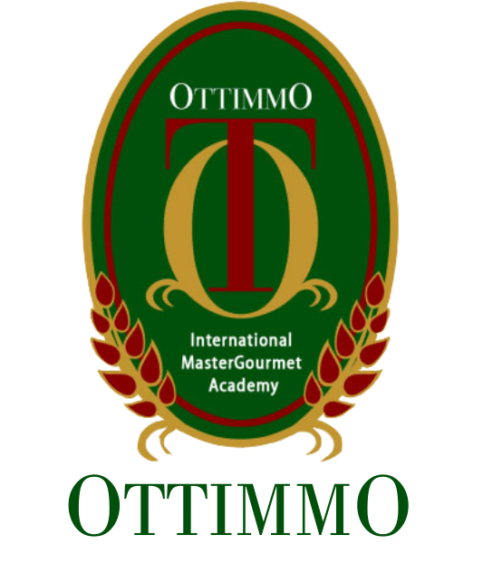
By
Joenathan Alfred
1874130010079

STUDY PROGRAM OF CULINARY ARTS
OTTIMMO INTERNATIONAL
MASTER GOURMET ACADEMY
SURABAYA
2020

